FOR IMMEDIATE RELEASE

MAY 27, 2021

**FOY VANCE RELEASES TWO NEW TRACKS “SAPLING” & “SIGNS OF LIFE”**

**LISTEN**[**HERE**](https://nam04.safelinks.protection.outlook.com/?url=https%3A%2F%2Flnk.to%2FSapling-SignsOfLife&data=04%7C01%7CSydneyWorden%40elektra.com%7C06ed9f4d0a23490a58aa08d92117d281%7C8367939002ec4ba1ad3d69da3fdd637e%7C0%7C0%7C637577208481271447%7CUnknown%7CTWFpbGZsb3d8eyJWIjoiMC4wLjAwMDAiLCJQIjoiV2luMzIiLCJBTiI6Ik1haWwiLCJXVCI6Mn0%3D%7C1000&sdata=2zn2aJbTuA%2F%2FIFpcu6UjDAtE8uWVKnDPZgoCaLYb5zo%3D&reserved=0)

**FORTHCOMING STUDIO ALBUM EXPECTED LATER THIS YEAR ON ED SHEERAN’S GINGERBREAD MAN RECORDS/ELEKTRA RECORDS**



*Photo Credit: Babysweet*

Award-winning Northern Irish singer/songwriter **Foy Vance** has released two brand new tracks “[Sapling](https://nam04.safelinks.protection.outlook.com/?url=https%3A%2F%2Fyoutu.be%2Fz18IKb3bcRs&data=04%7C01%7CSydneyWorden%40elektra.com%7C06ed9f4d0a23490a58aa08d92117d281%7C8367939002ec4ba1ad3d69da3fdd637e%7C0%7C0%7C637577208481271447%7CUnknown%7CTWFpbGZsb3d8eyJWIjoiMC4wLjAwMDAiLCJQIjoiV2luMzIiLCJBTiI6Ik1haWwiLCJXVCI6Mn0%3D%7C1000&sdata=JYW8xx5YZKSqCl3RXpNNcLy49cC%2BvxLnat%2BLTpmCAuY%3D&reserved=0)” and “[Signs Of Life](https://nam04.safelinks.protection.outlook.com/?url=https%3A%2F%2Fyoutu.be%2FAF9gdUsGefk&data=04%7C01%7CSydneyWorden%40elektra.com%7C06ed9f4d0a23490a58aa08d92117d281%7C8367939002ec4ba1ad3d69da3fdd637e%7C0%7C0%7C637577208481281442%7CUnknown%7CTWFpbGZsb3d8eyJWIjoiMC4wLjAwMDAiLCJQIjoiV2luMzIiLCJBTiI6Ik1haWwiLCJXVCI6Mn0%3D%7C1000&sdata=IySSMLNaNZ5zdKKsN5LMvOQoFvcH0EW2VOnYss3Z06g%3D&reserved=0)”. Both songs are available to stream and download starting today [HERE](https://nam04.safelinks.protection.outlook.com/?url=https%3A%2F%2Flnk.to%2FSapling-SignsOfLife&data=04%7C01%7CSydneyWorden%40elektra.com%7C06ed9f4d0a23490a58aa08d92117d281%7C8367939002ec4ba1ad3d69da3fdd637e%7C0%7C0%7C637577208481281442%7CUnknown%7CTWFpbGZsb3d8eyJWIjoiMC4wLjAwMDAiLCJQIjoiV2luMzIiLCJBTiI6Ik1haWwiLCJXVCI6Mn0%3D%7C1000&sdata=35NSPKEmUNuZsU6bsXn6vzWKxP0Xfw%2BLLPJlMRsPs9w%3D&reserved=0). “Sapling” and “Signs Of Life” will appear on Vance’s forthcoming fourth studio album *Signs Of Life* - expected later this year on Ed Sheeran’s Gingerbread Man Records/Elektra Records.

“Sapling” and “Signs Of Life” are two of the first tracks Vance wrote for the new album, and together they showed him the path forward. These are songs about birth and rebirth, degeneration and regeneration, life and death, which bloomed into existence while all around a global pandemic was doing the opposite.

“Sapling” begins with gently building piano chords as Vance sings: *“I once built a bower, I could build you a home.”* It was a promise to his partner, who’d moved from London to join the Bangor native in his adopted home in the Scottish Highlands, that he’d do more than simply offer a new domestic setting.

“When I wrote ‘Sapling’ I had a daughter and a son,” says Vance. “Between then and now, I proposed to my wife, married her the next day – she didn’t know anything about it, it was a secret wedding up in the woods near Kenmore. I flew her soul sister over from Australia to marry us. It was a beautiful, wild night. "

A warm, enveloping embrace of a song, “Signs Of Life” was written the day before Vance’s second son Sol was born, his name ultimately also serving as an acronym for the song and album title.

“‘Signs Of Life’ is about re-emergence,” explains Vance. “Me, in my own soft revolution, the world re-emerging in what we’re about to see as we hopefully go back to some semblance of normality. But just life in general – flowers growing through the cracks in Chernobyl. Life finds a way, doesn’t it?”

*Signs Of Life* will follow Vance’s critically acclaimed 2016 album *The Wild Swan,* which was executive produced by Elton John, who Vance supported on his Wonderful Crazy Tour that year. The album contained the BBC Radio 2 playlisted singles “Coco”, “Upbeat Feelgood”, and “Noam Chomsky Is A Soft Revolution” and saw Vance perform on NBC’s *Today* and CBS’s *The Late Late Show with James Corden*.

Vance recently launched [The Vinyl Supper](https://nam04.safelinks.protection.outlook.com/?url=https%3A%2F%2Fthevinylsupper.com%2F&data=04%7C01%7CSydneyWorden%40elektra.com%7C06ed9f4d0a23490a58aa08d92117d281%7C8367939002ec4ba1ad3d69da3fdd637e%7C0%7C0%7C637577208481291439%7CUnknown%7CTWFpbGZsb3d8eyJWIjoiMC4wLjAwMDAiLCJQIjoiV2luMzIiLCJBTiI6Ik1haWwiLCJXVCI6Mn0%3D%7C1000&sdata=o8FpG1SSdziosSU79yCyuJKfnfZRzYJoad13jMzr86k%3D&reserved=0), a podcast series in which he talks music, food and life stories with special guests and friends from the world of music, poetry and film. Season one features Anderson East, Atticus, Benny Blanco, Blake Mills, Bruce Cockburn, Chrissy Metz, Courteney Cox, Devin Dawson, Josh Groban, Keith Urban, and Passenger.

Stay tuned for full details of the new album and more from Foy Vance soon.

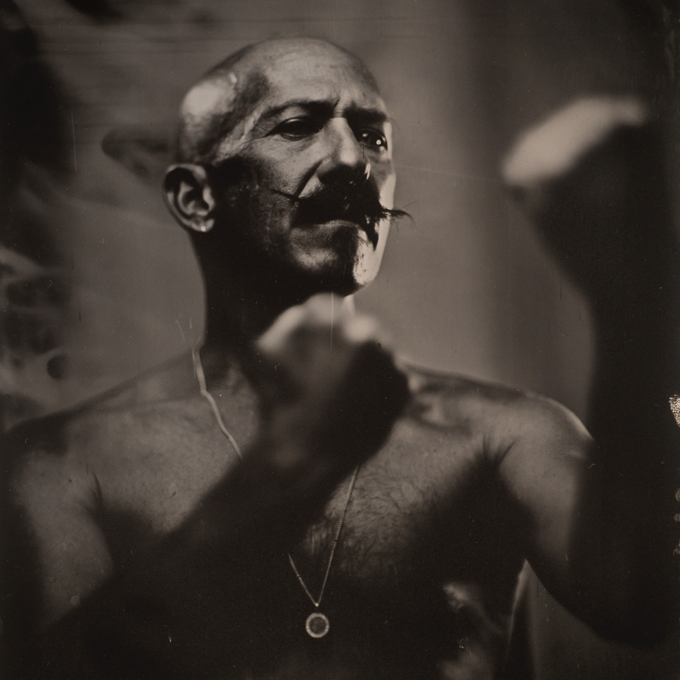

[FoyVance.com](https://nam04.safelinks.protection.outlook.com/?url=https%3A%2F%2Ffoyvance.com%2F&data=04%7C01%7CSydneyWorden%40elektra.com%7C06ed9f4d0a23490a58aa08d92117d281%7C8367939002ec4ba1ad3d69da3fdd637e%7C0%7C0%7C637577208481291439%7CUnknown%7CTWFpbGZsb3d8eyJWIjoiMC4wLjAwMDAiLCJQIjoiV2luMzIiLCJBTiI6Ik1haWwiLCJXVCI6Mn0%3D%7C1000&sdata=xB%2FTkMcvloNxoID05nrozCG1MFoR6Uqmv6lpse%2BjzIU%3D&reserved=0)

[Facebook](https://nam04.safelinks.protection.outlook.com/?url=https%3A%2F%2Fwww.facebook.com%2Ffoyvancemusic&data=04%7C01%7CSydneyWorden%40elektra.com%7C06ed9f4d0a23490a58aa08d92117d281%7C8367939002ec4ba1ad3d69da3fdd637e%7C0%7C0%7C637577208481301428%7CUnknown%7CTWFpbGZsb3d8eyJWIjoiMC4wLjAwMDAiLCJQIjoiV2luMzIiLCJBTiI6Ik1haWwiLCJXVCI6Mn0%3D%7C1000&sdata=QHk%2BKPJnkExMfxgQdGuFGFfANN8zFoNzb8d0TWl5vq8%3D&reserved=0) | [Twitter](https://nam04.safelinks.protection.outlook.com/?url=https%3A%2F%2Ftwitter.com%2Ffoyvance&data=04%7C01%7CSydneyWorden%40elektra.com%7C06ed9f4d0a23490a58aa08d92117d281%7C8367939002ec4ba1ad3d69da3fdd637e%7C0%7C0%7C637577208481301428%7CUnknown%7CTWFpbGZsb3d8eyJWIjoiMC4wLjAwMDAiLCJQIjoiV2luMzIiLCJBTiI6Ik1haWwiLCJXVCI6Mn0%3D%7C1000&sdata=Vkxn%2BqNqfLXo3nhlI2JzuNwFXRZn9mNT0IljcO8s4hE%3D&reserved=0) | [Instagram](https://nam04.safelinks.protection.outlook.com/?url=https%3A%2F%2Fwww.instagram.com%2Ffoyvance%2F&data=04%7C01%7CSydneyWorden%40elektra.com%7C06ed9f4d0a23490a58aa08d92117d281%7C8367939002ec4ba1ad3d69da3fdd637e%7C0%7C0%7C637577208481311422%7CUnknown%7CTWFpbGZsb3d8eyJWIjoiMC4wLjAwMDAiLCJQIjoiV2luMzIiLCJBTiI6Ik1haWwiLCJXVCI6Mn0%3D%7C1000&sdata=hhYXaz%2Fi8bvbc5Xf0ms6%2Fpjfl%2F0W3ljMbqwzPYJ%2B3o0%3D&reserved=0) | [YouTube](https://nam04.safelinks.protection.outlook.com/?url=https%3A%2F%2Fwww.youtube.com%2Fuser%2Ffoyvancemusic%2Ffeatured&data=04%7C01%7CSydneyWorden%40elektra.com%7C06ed9f4d0a23490a58aa08d92117d281%7C8367939002ec4ba1ad3d69da3fdd637e%7C0%7C0%7C637577208481311422%7CUnknown%7CTWFpbGZsb3d8eyJWIjoiMC4wLjAwMDAiLCJQIjoiV2luMzIiLCJBTiI6Ik1haWwiLCJXVCI6Mn0%3D%7C1000&sdata=tsjQJ%2FFyjxK6VxKJfBU9AWpeZMMk45sY585eC6hGoLo%3D&reserved=0)

**Press contact:**

Collin Citron | [CollinCitron@elektra.com](mailto:CollinCitron@elektra.com)