FOR IMMEDIATE RELEASE

SEPTEMBER 10, 2021

**FOY VANCE RELEASES NEW ALBUM**[***SIGNS OF LIFE***](https://nam04.safelinks.protection.outlook.com/?url=https%3A%2F%2Flnk.to%2FSigns-of-Life&data=04%7C01%7CSydneyWorden%40elektra.com%7C322a3a2cdcf54080c0f208d97463544e%7C8367939002ec4ba1ad3d69da3fdd637e%7C0%7C0%7C637668792237487140%7CUnknown%7CTWFpbGZsb3d8eyJWIjoiMC4wLjAwMDAiLCJQIjoiV2luMzIiLCJBTiI6Ik1haWwiLCJXVCI6Mn0%3D%7C1000&sdata=94nwagyhXM%2BNPRuV5KgYWgsvmHn1gC9wltyzckmd3Ts%3D&reserved=0)**AND ANNOUNCES 2022 WORLD TOUR**

**+ *AN EVENING WITH FOY VANCE* LIVESTREAM SHOW TONIGHT FROM LONDON’S ST PANCRAS OLD CHURCH**

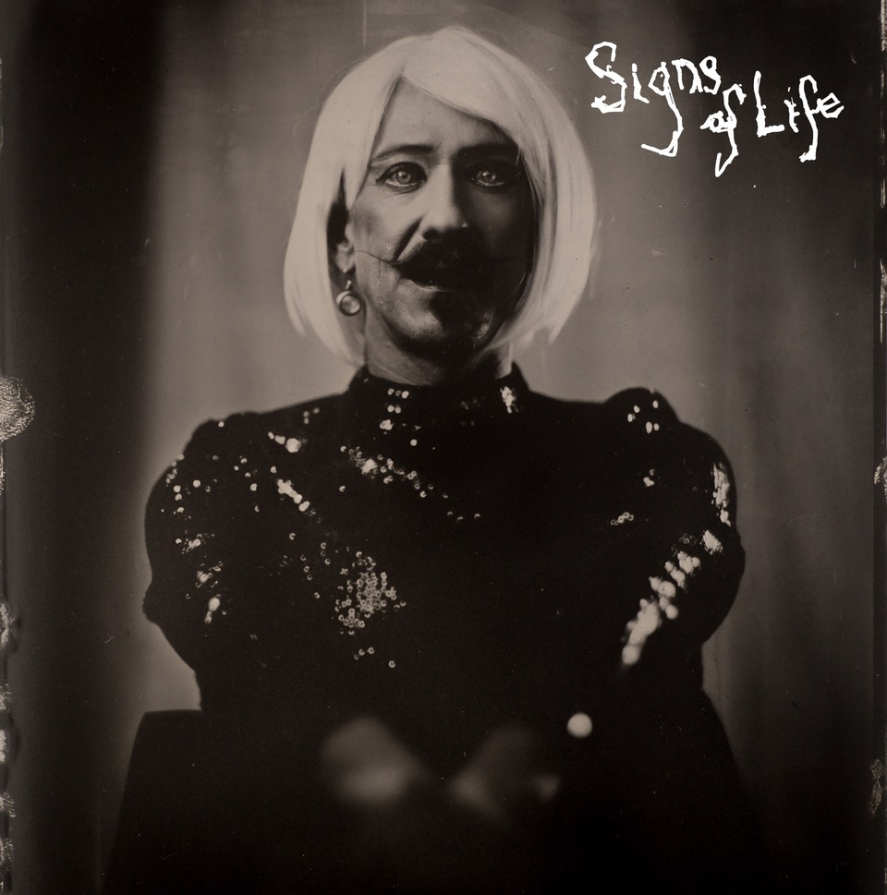

*“As always Foy has knocked it out of the park”*

**Ed Sheeran**

*“…harks back to Van Morrison’s better days, grainy and impassioned”*

**The New York Times**

Award-winning Northern Irish singer/songwriter **Foy Vance** has released his brand new studio album [***Signs Of Life***](https://nam04.safelinks.protection.outlook.com/?url=https%3A%2F%2Flnk.to%2FSigns-of-Life&data=04%7C01%7CSydneyWorden%40elektra.com%7C322a3a2cdcf54080c0f208d97463544e%7C8367939002ec4ba1ad3d69da3fdd637e%7C0%7C0%7C637668792237497147%7CUnknown%7CTWFpbGZsb3d8eyJWIjoiMC4wLjAwMDAiLCJQIjoiV2luMzIiLCJBTiI6Ik1haWwiLCJXVCI6Mn0%3D%7C1000&sdata=VaL866VvR3yzFa7XRC0rvy1qD7GiYoUk8dNbcX6YhgM%3D&reserved=0). The collection is available physically and digitally starting today via Ed Sheeran’s Gingerbread Man Records/Elektra Records [HERE](https://nam04.safelinks.protection.outlook.com/?url=https%3A%2F%2Flnk.to%2FSigns-of-Life&data=04%7C01%7CSydneyWorden%40elektra.com%7C322a3a2cdcf54080c0f208d97463544e%7C8367939002ec4ba1ad3d69da3fdd637e%7C0%7C0%7C637668792237497147%7CUnknown%7CTWFpbGZsb3d8eyJWIjoiMC4wLjAwMDAiLCJQIjoiV2luMzIiLCJBTiI6Ik1haWwiLCJXVCI6Mn0%3D%7C1000&sdata=VaL866VvR3yzFa7XRC0rvy1qD7GiYoUk8dNbcX6YhgM%3D&reserved=0). *Sings Of Life* is Vance’s fourth studio album and follows 2016’s critically acclaimed *The Wild Swan.*

Vance has also announced a 2022 world tour, which will include legs in the UK and Ireland, as well as North America. Tickets go on sale next Friday September 17 at 10:00am local time at [FoyVance.com](https://nam04.safelinks.protection.outlook.com/?url=https%3A%2F%2Fwww.foyvance.com%2F&data=04%7C01%7CSydneyWorden%40elektra.com%7C322a3a2cdcf54080c0f208d97463544e%7C8367939002ec4ba1ad3d69da3fdd637e%7C0%7C0%7C637668792237507126%7CUnknown%7CTWFpbGZsb3d8eyJWIjoiMC4wLjAwMDAiLCJQIjoiV2luMzIiLCJBTiI6Ik1haWwiLCJXVCI6Mn0%3D%7C1000&sdata=vURYwd7vNmvUqaj4XBy8m%2BTHw7RVKfkbpaHQKDR5%2BEM%3D&reserved=0). Next year’s tour follows *An Evening With Foy Vance*, Vance’s current sold-out UK & US run which started earlier this week and includes performances in Los Angeles, Nashville, and New York. This evening’s special solo performance at London’s St Pancras Old Church will be streaming live via Dice at 9:00pm BST, and will be available to US audiences at 9:00pm EST/PST with multiple broadcasts to follow. Tickets are available [HERE](https://nam04.safelinks.protection.outlook.com/?url=https%3A%2F%2Fdice.fm%2Fartist%2Ffoy-vance-anm2%3F_branch_match_id%3D784446080318749478&data=04%7C01%7CSydneyWorden%40elektra.com%7C322a3a2cdcf54080c0f208d97463544e%7C8367939002ec4ba1ad3d69da3fdd637e%7C0%7C0%7C637668792237517129%7CUnknown%7CTWFpbGZsb3d8eyJWIjoiMC4wLjAwMDAiLCJQIjoiV2luMzIiLCJBTiI6Ik1haWwiLCJXVCI6Mn0%3D%7C1000&sdata=E0112iXZhF%2BJFtNOyKXTh3zoOeFtmIuy%2FL%2FmqicWOGE%3D&reserved=0).

“As always Foy has knocked it out of the park,” comments Sheeran, who made his long-time friend and sometime touring partner Vance one of the first signings to his label Gingerbread Man Records. “I love giving him the creative freedom to do what he wants as I’m at the end of the day just a huge fan of his work. It’s such a joy to be able to put out such great bodies of work from him, I hope everyone enjoys it as much as me.”

"I feel like I’ve got a confidante in Ed, a real ally,” adds Vance. “In many ways he has found a way to afford me the ability to keep on making art the way I want to make it. It’s comforting to know that no matter what I wanted to do, he would fight for it.”

[*Signs Of Life*](https://nam04.safelinks.protection.outlook.com/?url=https%3A%2F%2Flnk.to%2FSigns-of-Life&data=04%7C01%7CSydneyWorden%40elektra.com%7C322a3a2cdcf54080c0f208d97463544e%7C8367939002ec4ba1ad3d69da3fdd637e%7C0%7C0%7C637668792237517129%7CUnknown%7CTWFpbGZsb3d8eyJWIjoiMC4wLjAwMDAiLCJQIjoiV2luMzIiLCJBTiI6Ik1haWwiLCJXVCI6Mn0%3D%7C1000&sdata=65to7WfNE%2BHqhKKmHAx873GbI%2FIoyZ1uZAi30Q%2FUMuM%3D&reserved=0) is the sound of a beloved singer-songwriter at the peak of his powers. Created out of the grimness of 2020, it’s an album of dawn after darkness, hope after despair, engagement after isolation, uplift after lockdown. Commenting on the album’s timely subject matter, Vance shared,“*Signs of Life* is about re-emergence – me in my own soft revolution, the world re-emerging in what we’re about to see as we hopefully go back to some semblance of normality,” explains Vance.

Album opener and lead track [“Sapling”](https://nam04.safelinks.protection.outlook.com/?url=https%3A%2F%2Fyoutu.be%2Fz18IKb3bcRs&data=04%7C01%7CSydneyWorden%40elektra.com%7C322a3a2cdcf54080c0f208d97463544e%7C8367939002ec4ba1ad3d69da3fdd637e%7C0%7C0%7C637668792237527112%7CUnknown%7CTWFpbGZsb3d8eyJWIjoiMC4wLjAwMDAiLCJQIjoiV2luMzIiLCJBTiI6Ik1haWwiLCJXVCI6Mn0%3D%7C1000&sdata=AlaGSBKXhcomcF%2FGIvP7KAWJkUQlz09k%2Bvkj%2BUizUO8%3D&reserved=0) was one of the first tracks Vance wrote for *Signs Of Life*, and it showed him the path forward. Vance sings: *“I once built a bower, I could build you a home.”* It was a promise to his partner, who’d moved from London to join the Bangor native in his adopted home in the Scottish Highlands, that he’d do more than simply offer a new domestic setting.

*Signs Of Life* was recorded in three locations: Vance’s Pilgrim studio at home on the shores of Loch Tay in Highland Perthshire, another recording set-up in a nearby Dunvarlich House, and at Plan B’s Kings X studio in London. The album was written and played more or less entirely by Vance, with assistance from young Northern Irish producer Gareth Dunlop.

*Signs Of Life*’s bold artwork reflects Vance's desire to embrace all sides of everything, all humanity's textures. Shot on a 160-year-old camera which does arresting things with colours and shading, the back image is of Vance as a bare-chested, bare-knuckle boxer. On the front, he's in a dress, blonde wig and theatrical make-up. “They’re just mad, striking images, and I loved the fact that it was male and female,” explains Vance. “You know, life’s extreme, life’s volatile, life explodes into reality sometimes, and stops just as quick. So to be struck by images on the cover made sense.”

**FOY VANCE PRESENTS SIGNS OF LIFE TOUR 2022**

**Tickets on sale September 17 at 10:00am local time from** [**FoyVance.com**](https://nam04.safelinks.protection.outlook.com/?url=https%3A%2F%2Fwww.foyvance.com%2F&data=04%7C01%7CSydneyWorden%40elektra.com%7C322a3a2cdcf54080c0f208d97463544e%7C8367939002ec4ba1ad3d69da3fdd637e%7C0%7C0%7C637668792237527112%7CUnknown%7CTWFpbGZsb3d8eyJWIjoiMC4wLjAwMDAiLCJQIjoiV2luMzIiLCJBTiI6Ik1haWwiLCJXVCI6Mn0%3D%7C1000&sdata=hurSPTZ%2FSuRYKKcOInWpuQlM%2FB350v6%2BbP3Gv2SdSUA%3D&reserved=0)

**UK and IE Dates**

March 22, 2022 - Cork, IE - Cyprus Avenue

March 23, 2022 - Dublin, IE - Olympia Theatre

March 25, 2022 - York, UK - York Barbican

March 26, 2022 - Edinburgh, UK - The Queen’s Hall

March 27, 2022 - Birmingham, UK - The Alexandra Theatre

March 29, 2022 - Manchester, UK - The Bridgewater Hall

March 30, 2022 - London, UK - Eventim Apollo

April 02, 2022 - Belfast, UK - SSE Arena

*With special guests Gareth Dunlop and The Late Heavy*

**North American Dates**

May 06, 2022 - Woodstock, NY - Levon Helm Studios

May 07, 2022 - Woodstock, NY - Levon Helm Studios

May 08, 2022 - Philadelphia, PA - Theatre of Living Arts

May 10, 2022 - Alexandria, VA - The Birchmere

May 11, 2022 - New York, NY - Webster Hall

May 13, 2022 - Boston, MA - Royale

May 14, 2022 - Homer, NY - Center for the Arts of Homer

May 15, 2022 - Toronto, ON - Queen Elizabeth Theatre

May 17, 2022 - Cincinnati, OH - Memorial Hall

May 20, 2022 - Minneapolis, MN - The Cedar Cultural Center

May 21, 2022 - Chicago, IL - Athenaeum Theatre

May 26, 2022 - Seattle, WA - Neptune Theatre

May 27, 2022 - Portland, OR - Aladdin Theater

May 31, 2022 - Los Angeles, CA - The Regent Theater

*With special guests Lee Rogers and Gareth Dunlop*

**AN EVENING WITH FOY VANCE TOUR 2021 (REMAINING DATES)**

September 06, 2021 -  Glasgow, UK - King Tuts -  **SOLD OUT**

September 07, 2021 - Leeds, UK -  Brudenell Social Club - **SOLD OUT**

September 09, 2021 - London, UK - Oslo - **SOLD OUT**

September 10, 2021 - London, UK - St. Pancras Church - **SOLD OUT**

September 12, 2021 - Belfast, UK - Empire - **SOLD OUT**

September 13, 2021 - Dublin, IE - Whelans - **SOLD OUT**

November 10, 2021 - Los Angeles, CA - Masonic Lodge at Hollywood Forever - **SOLD OUT**

November 12, 2021 - Nashville, TN - Ryman Auditorium **\*** - **SOLD OUT**

November 13, 2021 - Nashville, TN - Ryman Auditorium **\***

November 16, 2021 - New York, NY - Rockwood Music Hall Stage 2 - **SOLD OUT**

**\*** *Supporting Anderson East*

Tonight’s sold-out show at London’s St Pancras Old Church will be streaming live via Dice at 9:00pm BST, and will be available to US audiences at 9:00pm EST/PST with multiple broadcasts to follow. Tickets are available now from [Dice](https://nam04.safelinks.protection.outlook.com/?url=https%3A%2F%2Flink.dice.fm%2Ffoyvance&data=04%7C01%7CSydneyWorden%40elektra.com%7C322a3a2cdcf54080c0f208d97463544e%7C8367939002ec4ba1ad3d69da3fdd637e%7C0%7C0%7C637668792237537114%7CUnknown%7CTWFpbGZsb3d8eyJWIjoiMC4wLjAwMDAiLCJQIjoiV2luMzIiLCJBTiI6Ik1haWwiLCJXVCI6Mn0%3D%7C1000&sdata=a%2FZARgX52YhfqnCXH%2FfjAEDp9MF77aaORF8ytLpiDz4%3D&reserved=0) for $13.20.

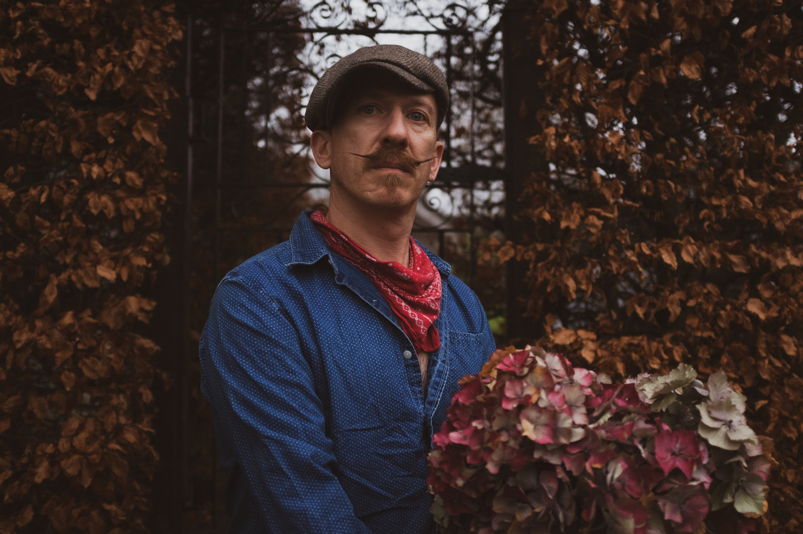

*Photo credit: Babysweet*

**About Foy Vance**

Hailing from Bangor in Northern Ireland, Vance independently released his debut album *Hope* in 2007, quickly garnering acclaim from fans and fellow musicians alike. His second full-length album, *Joy of Nothing*, released in 2013 on Glassnote Records, won the inaugural Northern Ireland Music Prize and saw Vance tour the globe with Ed Sheeran, Bonnie Raitt, Marcus Foster, Snow Patrol and Sir Elton John, as well as his own solo headline tours.

In 2015 Vance was became the second signing to Gingerbread Man Records, Ed Sheeran’s label division within Atlantic Records. His debut recording for the label, *The Wild Swan -* Executive Produced by Sir Elton John - contained the BBC Radio 2 playlisted singles “Coco”, “Upbeat Feelgood”, and “Noam Chomsky Is A Soft Revolution”, and saw Vance perform on NBC’s Today and CBS’s The Late Late Show with James Corden.

As a songwriter, Vance’s collaborations include co-writing four cuts including “Galway Girl” on Ed Sheeran’s 2017 album *Divide*. He has also worked with Alicia Keys, Rag N Bone Man, Keith Urban, Kacey Musgraves, Miranda Lambert, Plan B and Rudimental among many others, effortlessly switching between genres.

Last year, Vance launched the podcast series *The Vinyl Supper* in which he talks music, food and life stories with special guests and friends from the world of music, poetry and film. Recorded remotely during the global pandemic, series one featured Anderson East, Atticus, Benny Blanco, Blake Mills, Bruce Cockburn, Chrissy Metz, Courteney Cox, Devin Dawson, Josh Groban, Keith Urban and Passenger.

Foy Vance has headlined globally to sell-out crowds and splits his time between London and the Scottish Highlands with his family.

[FoyVance.com](https://nam04.safelinks.protection.outlook.com/?url=https%3A%2F%2Ffoyvance.com%2F&data=04%7C01%7CSydneyWorden%40elektra.com%7C322a3a2cdcf54080c0f208d97463544e%7C8367939002ec4ba1ad3d69da3fdd637e%7C0%7C0%7C637668792237537114%7CUnknown%7CTWFpbGZsb3d8eyJWIjoiMC4wLjAwMDAiLCJQIjoiV2luMzIiLCJBTiI6Ik1haWwiLCJXVCI6Mn0%3D%7C1000&sdata=GwVuMwsuDesz1Fg6j49l0Zt09krZoSf1rkYDYsKVPzc%3D&reserved=0)

[Facebook](https://nam04.safelinks.protection.outlook.com/?url=https%3A%2F%2Fwww.facebook.com%2Ffoyvancemusic&data=04%7C01%7CSydneyWorden%40elektra.com%7C322a3a2cdcf54080c0f208d97463544e%7C8367939002ec4ba1ad3d69da3fdd637e%7C0%7C0%7C637668792237547104%7CUnknown%7CTWFpbGZsb3d8eyJWIjoiMC4wLjAwMDAiLCJQIjoiV2luMzIiLCJBTiI6Ik1haWwiLCJXVCI6Mn0%3D%7C1000&sdata=pxrk%2FWf%2Fo5JiogUYIM7h2An5LW2xrb2Hq9SHlAPzckM%3D&reserved=0) | [Twitter](https://nam04.safelinks.protection.outlook.com/?url=https%3A%2F%2Ftwitter.com%2Ffoyvance&data=04%7C01%7CSydneyWorden%40elektra.com%7C322a3a2cdcf54080c0f208d97463544e%7C8367939002ec4ba1ad3d69da3fdd637e%7C0%7C0%7C637668792237547104%7CUnknown%7CTWFpbGZsb3d8eyJWIjoiMC4wLjAwMDAiLCJQIjoiV2luMzIiLCJBTiI6Ik1haWwiLCJXVCI6Mn0%3D%7C1000&sdata=5cF0F4Lhi9mqPX9qfACV8Dc%2BoWgb30n4kPXnHEe3%2FM4%3D&reserved=0) | [Instagram](https://nam04.safelinks.protection.outlook.com/?url=https%3A%2F%2Fwww.instagram.com%2Ffoyvance%2F&data=04%7C01%7CSydneyWorden%40elektra.com%7C322a3a2cdcf54080c0f208d97463544e%7C8367939002ec4ba1ad3d69da3fdd637e%7C0%7C0%7C637668792237557097%7CUnknown%7CTWFpbGZsb3d8eyJWIjoiMC4wLjAwMDAiLCJQIjoiV2luMzIiLCJBTiI6Ik1haWwiLCJXVCI6Mn0%3D%7C1000&sdata=4DoKAj83uSFtRxzIz0eUlScijsYTVNDR3SzeK%2FM82TA%3D&reserved=0) | [YouTube](https://nam04.safelinks.protection.outlook.com/?url=https%3A%2F%2Fwww.youtube.com%2Fuser%2Ffoyvancemusic%2Ffeatured&data=04%7C01%7CSydneyWorden%40elektra.com%7C322a3a2cdcf54080c0f208d97463544e%7C8367939002ec4ba1ad3d69da3fdd637e%7C0%7C0%7C637668792237557097%7CUnknown%7CTWFpbGZsb3d8eyJWIjoiMC4wLjAwMDAiLCJQIjoiV2luMzIiLCJBTiI6Ik1haWwiLCJXVCI6Mn0%3D%7C1000&sdata=LPHYQpCqTgVmzo2x4I3CJzI0l6QFAadoEQYDwPDzeL0%3D&reserved=0)

**Press contact:**

Collin Citron | [CollinCitron@elektra.com](mailto:CollinCitron@elektra.com)