FOR IMMEDIATE RELEASE

May 20, 2022

**GUCCIHIGHWATERS RELEASES MAJOR LABEL DEBUT EP *HEARTBREAK HIGHWAY***

**AVAILABLE NOW VIA PUBLIC CONSUMPTION | LISTEN** [**HERE**](https://nam04.safelinks.protection.outlook.com/?url=https%3A%2F%2Fguccihighwaters.lnk.to%2Fheartbreakhighway&data=05%7C01%7CDestinyDominguez%40elektra.com%7C20b9fe447a794ff4b6ed08da3a6d455c%7C8367939002ec4ba1ad3d69da3fdd637e%7C0%7C0%7C637886538262443625%7CUnknown%7CTWFpbGZsb3d8eyJWIjoiMC4wLjAwMDAiLCJQIjoiV2luMzIiLCJBTiI6Ik1haWwiLCJXVCI6Mn0%3D%7C3000%7C%7C%7C&sdata=zY%2FmZdrQkrlUMz41rXpqjpf4Y0xYbuy9lFjS8NPSVkk%3D&reserved=0)

**WATCH THE BRAND NEW MUSIC VIDEO FOR “BELIEVE”** [**HERE**](https://nam04.safelinks.protection.outlook.com/?url=https%3A%2F%2Fyoutu.be%2F3QpNxaBZKbM&data=05%7C01%7CDestinyDominguez%40elektra.com%7C20b9fe447a794ff4b6ed08da3a6d455c%7C8367939002ec4ba1ad3d69da3fdd637e%7C0%7C0%7C637886538262443625%7CUnknown%7CTWFpbGZsb3d8eyJWIjoiMC4wLjAwMDAiLCJQIjoiV2luMzIiLCJBTiI6Ik1haWwiLCJXVCI6Mn0%3D%7C3000%7C%7C%7C&sdata=11q3oVUtMKnTzIC4b9ntHglJDxjJ5%2FJuiO5o25%2BIM2A%3D&reserved=0)

**U.S. TOUR DATES WITH NOTHING,NOWHERE. CURRENTLY UNDERWAY**



*Photo credit: Jonathan Weiner*

Genre-defying artist, producer, and songwriter **guccihighwaters** has released his major label debut EP, ***heartbreak highway***. The six-track collection is available to stream and download beginning today via Public Consumption in partnership with Elektra Music Group [HERE](https://nam04.safelinks.protection.outlook.com/?url=https%3A%2F%2Fguccihighwaters.lnk.to%2Fheartbreakhighway&data=05%7C01%7CDestinyDominguez%40elektra.com%7C20b9fe447a794ff4b6ed08da3a6d455c%7C8367939002ec4ba1ad3d69da3fdd637e%7C0%7C0%7C637886538262443625%7CUnknown%7CTWFpbGZsb3d8eyJWIjoiMC4wLjAwMDAiLCJQIjoiV2luMzIiLCJBTiI6Ik1haWwiLCJXVCI6Mn0%3D%7C3000%7C%7C%7C&sdata=zY%2FmZdrQkrlUMz41rXpqjpf4Y0xYbuy9lFjS8NPSVkk%3D&reserved=0). To celebrate the EP’s arrival, guccihighwaters has unveiled a brand new official music video for intimate piano ballad, “[**believe**](https://nam04.safelinks.protection.outlook.com/?url=https%3A%2F%2Fyoutu.be%2F3QpNxaBZKbM&data=05%7C01%7CDestinyDominguez%40elektra.com%7C20b9fe447a794ff4b6ed08da3a6d455c%7C8367939002ec4ba1ad3d69da3fdd637e%7C0%7C0%7C637886538262599869%7CUnknown%7CTWFpbGZsb3d8eyJWIjoiMC4wLjAwMDAiLCJQIjoiV2luMzIiLCJBTiI6Ik1haWwiLCJXVCI6Mn0%3D%7C3000%7C%7C%7C&sdata=h60G%2BjGKUal59A2hmG3B4F1UynQFaZcNqgYiaLs9v0A%3D&reserved=0).” Watch the Ross Ginsberg-directed visual on guccihighwaters’ official YouTube channel [HERE](https://nam04.safelinks.protection.outlook.com/?url=https%3A%2F%2Fyoutu.be%2F3QpNxaBZKbM&data=05%7C01%7CDestinyDominguez%40elektra.com%7C20b9fe447a794ff4b6ed08da3a6d455c%7C8367939002ec4ba1ad3d69da3fdd637e%7C0%7C0%7C637886538262599869%7CUnknown%7CTWFpbGZsb3d8eyJWIjoiMC4wLjAwMDAiLCJQIjoiV2luMzIiLCJBTiI6Ik1haWwiLCJXVCI6Mn0%3D%7C3000%7C%7C%7C&sdata=h60G%2BjGKUal59A2hmG3B4F1UynQFaZcNqgYiaLs9v0A%3D&reserved=0).

“My goal with this new EP was to showcase how much I've grown over the years, especially with my lyrics and vocals,” shares guccihighwaters. “I’ve been having so much fun experimenting with new sounds, and I truly believe this is my best music yet. I’m so glad to put it out into the world.”

In late 2021, guccihighwaters holed up in a Los Angeles studio with producer Courtney Ballard [Waterparks]. He absorbed the spirit of diverse inspirations, ranging from Lionel Richie’s “Dancing on the Ceiling” and the *Drive* Original Motion Picture Soundtrack to The Weeknd. “Courtney played a bunch of eighties beats for me,” guccihighwaters recalls. “I was into a lot of synth-revival music, so it was cool to hear where it came from. I took the synths and the drum grooves and morphed my style to fit those elements. It felt natural.”

guccihighwaters announced his signing to Public Consumption last month alongside the release of tracks “[crash my car](https://nam04.safelinks.protection.outlook.com/?url=https%3A%2F%2Fyoutu.be%2FxHZuUDJ-X30&data=05%7C01%7CDestinyDominguez%40elektra.com%7C20b9fe447a794ff4b6ed08da3a6d455c%7C8367939002ec4ba1ad3d69da3fdd637e%7C0%7C0%7C637886538262599869%7CUnknown%7CTWFpbGZsb3d8eyJWIjoiMC4wLjAwMDAiLCJQIjoiV2luMzIiLCJBTiI6Ik1haWwiLCJXVCI6Mn0%3D%7C3000%7C%7C%7C&sdata=oKxa7zptIOczQxM1%2BqVLE8M2F3kTEqDNSAH4yikSIDc%3D&reserved=0)” and “[devil on my shoulder](https://nam04.safelinks.protection.outlook.com/?url=https%3A%2F%2Fyoutu.be%2FVwK5YABc2vo&data=05%7C01%7CDestinyDominguez%40elektra.com%7C20b9fe447a794ff4b6ed08da3a6d455c%7C8367939002ec4ba1ad3d69da3fdd637e%7C0%7C0%7C637886538262599869%7CUnknown%7CTWFpbGZsb3d8eyJWIjoiMC4wLjAwMDAiLCJQIjoiV2luMzIiLCJBTiI6Ik1haWwiLCJXVCI6Mn0%3D%7C3000%7C%7C%7C&sdata=Y%2BDt4KMq8iGvy7tQDHdQVI3qgoXoqluG%2BEWcp8hs4Vo%3D&reserved=0).” Earlier this month, he formally announced the *heartbreak highway* EP and unveiled the synth-driven single “[the chase](https://nam04.safelinks.protection.outlook.com/?url=https%3A%2F%2Fyoutu.be%2Fi7Ezg17FWY8&data=05%7C01%7CDestinyDominguez%40elektra.com%7C20b9fe447a794ff4b6ed08da3a6d455c%7C8367939002ec4ba1ad3d69da3fdd637e%7C0%7C0%7C637886538262599869%7CUnknown%7CTWFpbGZsb3d8eyJWIjoiMC4wLjAwMDAiLCJQIjoiV2luMzIiLCJBTiI6Ik1haWwiLCJXVCI6Mn0%3D%7C3000%7C%7C%7C&sdata=YwTUwlni4sHnPShA5NokK4iz2OrJbSdPWdfBsuGr0fo%3D&reserved=0)'' alongside an official music video. Signifying a new era in guccihighwaters’ ever-evolving sound, the EP’s early releases arrived to immediate praise from **Alt Press**, **Consequence**, **Ones To Watch**,and more.

guccihighwaters is currently on the road in North America supporting nothing,nowhere. The 25-city trek kicked off last month and will conclude on May 27 in New York, NY at Irving Plaza. The bill also includes Poorstacy, carolesdaughter, and Snarls. This fall, guccihighwaters will support nothing,nowhere. on tour in the UK and Europe. A complete list of upcoming tour dates can be found below. Tickets for all shows are available [HERE](https://nam04.safelinks.protection.outlook.com/?url=https%3A%2F%2Fwww.guccihighwaters.com%2F&data=05%7C01%7CDestinyDominguez%40elektra.com%7C20b9fe447a794ff4b6ed08da3a6d455c%7C8367939002ec4ba1ad3d69da3fdd637e%7C0%7C0%7C637886538262599869%7CUnknown%7CTWFpbGZsb3d8eyJWIjoiMC4wLjAwMDAiLCJQIjoiV2luMzIiLCJBTiI6Ik1haWwiLCJXVCI6Mn0%3D%7C3000%7C%7C%7C&sdata=zvDImcCfpd7cuQbPVNis1QncY45WRODzcfAOf8Jufxw%3D&reserved=0).

*heartbreak highway* follows guccihighwaters’ 2021 album *joke’s on you*. Arriving to widespread acclaim, **KERRANG!** promised, *“Whatever genre you label the tunes, the music of guccihighwaters**doesn’t joke around when it comes to conveying emotion in its rawest form*.*”* **Alt Press**lauded the *“accomplished artist poised to be a star,”* while**Ones To Watch**proclaimed, *“the sounds from singer/producer Morgan Murphy are as raw as it gets.”* **Billboard**applauded standout single “rock bottom” [feat. nothing,nowhere.] as *“the highlight of guccihighwaters’ joke’s on you album*,” and **NME**praised the track as *“an introspective blend of alt-rock and dark hip-hop flourishes - a marked progression from the online emo scene*.”

**guccihighwaters North American Tour Dates**

May 20, 2022 - Chicago, IL - House Of Blues

May 21, 2022 - Detroit, MI - The Majestic Theatre

May 22, 2022 - Cleveland, OH - Beachland Ballroom & Tavern

May 24, 2022 - Toronto, ON - The Opera House

May 25, 2022 - Pittsburgh, PA - Mr. Smalls Theatre

May 27, 2022 - New York, NY - Irving Plaza

**guccihighwaters UK and European Tour Dates**

November 12, 2022 - Leeds, UK - Drown U Out

November 13, 2022 - Oxford, UK - O2 Academy 2

November 14, 2022 - Nottingham, UK - Bodega Social Club

November 15, 2022 - Newcastle, UK - The Cluny

November 17, 2022 - Glasgow, UK - SWG3 Studio Warehouse

November 18, 2022 - Manchester, UK - Club Academy

November 19, 2022 - Dublin, Ireland - Dublin Academy Green Room

November 20, 2022 - Belfast, UK - Limelight 2

November 22, 2022 - Birmingham, UK - O2 Academy 2

November 23, 2022 - Bristol, UK - The Fleece

November 24, 2022 - London, UK - Electric Ballroom

November 26, 2022 - Brussels, Belgium - Ancienne Belgique

November 27, 2022 - Cologne, Germany - Kantine

November 28, 2022 - Haarlem, Netherlands - Patronaat

November 30, 2022 - Copenhagen, Denmark - Pumpehuset

December 01, 2022 - Hamburg, Germany - Uebel & Gefährlich

December 02, 2022 - Berlin, Germany - Gretchen

December 03, 2022 - Warsaw, Poland - Klub Proxima

December 05, 2022 - Prague, Czech Republic - Lucerna

December 06, 2022 - Budapest, Hungary - Akvarium Klub

December 07, 2022 - Vienna, Austria - Grelle Forelle

December 09, 2022 - Milan, Italy - Magnolia

December 10, 2022 - Zurich, Switzerland - Exil Club

December 11, 2022 - Munich, Germany - Freiheitshalle

December 12, 2022 - Paris, France - Les Etoiles

December 14, 2022 - Madrid, Spain - Sala Nazca

December 15, 2022 - Barcelona, Spain - Sala La Nau

**GUCCIHIGHWATERS**

***HEARTBREAK HIGHWAY* EP**

**LISTEN** [**HERE**](https://nam04.safelinks.protection.outlook.com/?url=https%3A%2F%2Fguccihighwaters.lnk.to%2Fheartbreakhighway&data=05%7C01%7CDestinyDominguez%40elektra.com%7C20b9fe447a794ff4b6ed08da3a6d455c%7C8367939002ec4ba1ad3d69da3fdd637e%7C0%7C0%7C637886538262599869%7CUnknown%7CTWFpbGZsb3d8eyJWIjoiMC4wLjAwMDAiLCJQIjoiV2luMzIiLCJBTiI6Ik1haWwiLCJXVCI6Mn0%3D%7C3000%7C%7C%7C&sdata=2cQxtzqnd%2FlFBw2fWTV7vGLyhp6JM8pc%2Bwp26w8gaOk%3D&reserved=0)

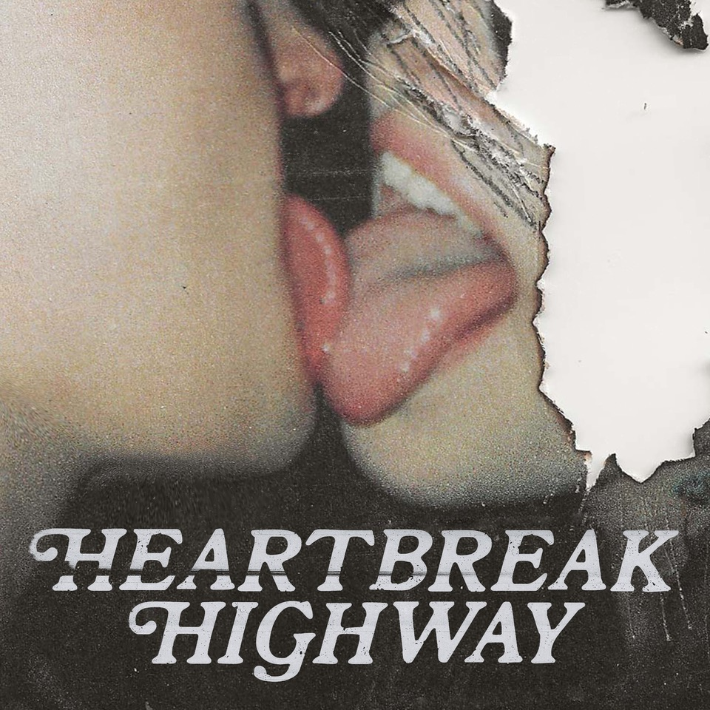

***heartbreak highway* EP Tracklisting**

1. crash my car

2. dancing with the stars

3. believe

4. devil on my shoulder

5. roses

6. the chase

**About guccihighwaters:**

guccihighwaters glides through a soundscape familiar enough to catch your attention, yet futuristic enough to hold it. The artist, singer, and producer not only blurs the lines between alternative, R&B, and hip-hop, but also the boundaries between yesterday, today, and tomorrow. Growing up in between Long Beach, NY and Ireland, he maintained a diehard passion for music. After discovering Yung Lean at 18-year-old, he crafted beats all night. A year into this evening ritual, he picked up a microphone and penned lyrics to anesthetize the pain of his first breakup. His first collection of songs comprised the *post death* EP in 2017. Among many standouts, the fan favorite “i’m  so sick of this” gathered 51.6 million Spotify streams and counting. In its wake, he unleashed music at a prolific pace, including multiple EPs and his 2021 full-length debut, *joke*’*s on you*. Along the way, he toured with Lund, Lil Lotus, Smrtdeath, guardin, and nothing,nowhere. Posting up hundreds of millions of streams and earning acclaim from *Billboard*, *OnesToWatch*, *NME*, *Upset*, *Kerrang!*, *Alternative Press*, and many others, he continues to look ahead on his  major label debut *heartbreak highway* EP for Public Consumption/Elektra Music Group.

# # #

**CONNECT WITH GUCCIHIGHWATERS**

[guccihighwaters.com](https://nam04.safelinks.protection.outlook.com/?url=https%3A%2F%2Fwww.guccihighwaters.com%2F&data=05%7C01%7CDestinyDominguez%40elektra.com%7C20b9fe447a794ff4b6ed08da3a6d455c%7C8367939002ec4ba1ad3d69da3fdd637e%7C0%7C0%7C637886538262599869%7CUnknown%7CTWFpbGZsb3d8eyJWIjoiMC4wLjAwMDAiLCJQIjoiV2luMzIiLCJBTiI6Ik1haWwiLCJXVCI6Mn0%3D%7C3000%7C%7C%7C&sdata=zvDImcCfpd7cuQbPVNis1QncY45WRODzcfAOf8Jufxw%3D&reserved=0)

[Facebook](https://nam04.safelinks.protection.outlook.com/?url=https%3A%2F%2Fwww.facebook.com%2FGuccihighwaters%2F&data=05%7C01%7CDestinyDominguez%40elektra.com%7C20b9fe447a794ff4b6ed08da3a6d455c%7C8367939002ec4ba1ad3d69da3fdd637e%7C0%7C0%7C637886538262599869%7CUnknown%7CTWFpbGZsb3d8eyJWIjoiMC4wLjAwMDAiLCJQIjoiV2luMzIiLCJBTiI6Ik1haWwiLCJXVCI6Mn0%3D%7C3000%7C%7C%7C&sdata=0ThkbLGwCOxC6mGJxFl8Fjl3dEjRbnoDeFm5Jqb8r%2Bg%3D&reserved=0)

[Instagram](https://nam04.safelinks.protection.outlook.com/?url=https%3A%2F%2Fwww.instagram.com%2Fguccihighwaters%2F%3Fhl%3Den&data=05%7C01%7CDestinyDominguez%40elektra.com%7C20b9fe447a794ff4b6ed08da3a6d455c%7C8367939002ec4ba1ad3d69da3fdd637e%7C0%7C0%7C637886538262599869%7CUnknown%7CTWFpbGZsb3d8eyJWIjoiMC4wLjAwMDAiLCJQIjoiV2luMzIiLCJBTiI6Ik1haWwiLCJXVCI6Mn0%3D%7C3000%7C%7C%7C&sdata=pwFkxaPOL%2B8H%2BTdMPM%2F79Ox%2Fqc6%2FcE%2F9ZFDLvnOpn8Y%3D&reserved=0)

[Twitter](https://nam04.safelinks.protection.outlook.com/?url=https%3A%2F%2Ftwitter.com%2Fguccihighwaters%3Flang%3Den&data=05%7C01%7CDestinyDominguez%40elektra.com%7C20b9fe447a794ff4b6ed08da3a6d455c%7C8367939002ec4ba1ad3d69da3fdd637e%7C0%7C0%7C637886538262599869%7CUnknown%7CTWFpbGZsb3d8eyJWIjoiMC4wLjAwMDAiLCJQIjoiV2luMzIiLCJBTiI6Ik1haWwiLCJXVCI6Mn0%3D%7C3000%7C%7C%7C&sdata=YjZgC9trJn%2Fsmi%2FKZpjeot5ekIqetz2%2FmsyBcpji6wA%3D&reserved=0)

[YouTube](https://nam04.safelinks.protection.outlook.com/?url=https%3A%2F%2Fwww.youtube.com%2Fchannel%2FUCu-ENC7K6ir9acR5HEJAWAw&data=05%7C01%7CDestinyDominguez%40elektra.com%7C20b9fe447a794ff4b6ed08da3a6d455c%7C8367939002ec4ba1ad3d69da3fdd637e%7C0%7C0%7C637886538262599869%7CUnknown%7CTWFpbGZsb3d8eyJWIjoiMC4wLjAwMDAiLCJQIjoiV2luMzIiLCJBTiI6Ik1haWwiLCJXVCI6Mn0%3D%7C3000%7C%7C%7C&sdata=jaXXCezvzfoc6kz6X%2FMMAav5wVOIM58VjiDUlFlRQao%3D&reserved=0)

**Press Contacts:**

Collin Citron / [CollinCitron@Elektra.com](mailto:CollinCitron@Elektra.com)

Sarah Goldstein / [SarahGoldstein@Elektra.com](mailto:SarahGoldstein@Elektra.com)