GAMES WE PLAY ANNOUNCES MAJOR LABEL DEBUT GET A JOB EP
OUT AUGUST 12 VIA FUELED BY RAMEN/DCD2 RECORDS | PRE-ORDER HERE

BRAND NEW SINGLE “ST. GIRLFRIEND” AVAILABLE NOW
LISTEN HERE | WATCH THE VISUALIZER HERE

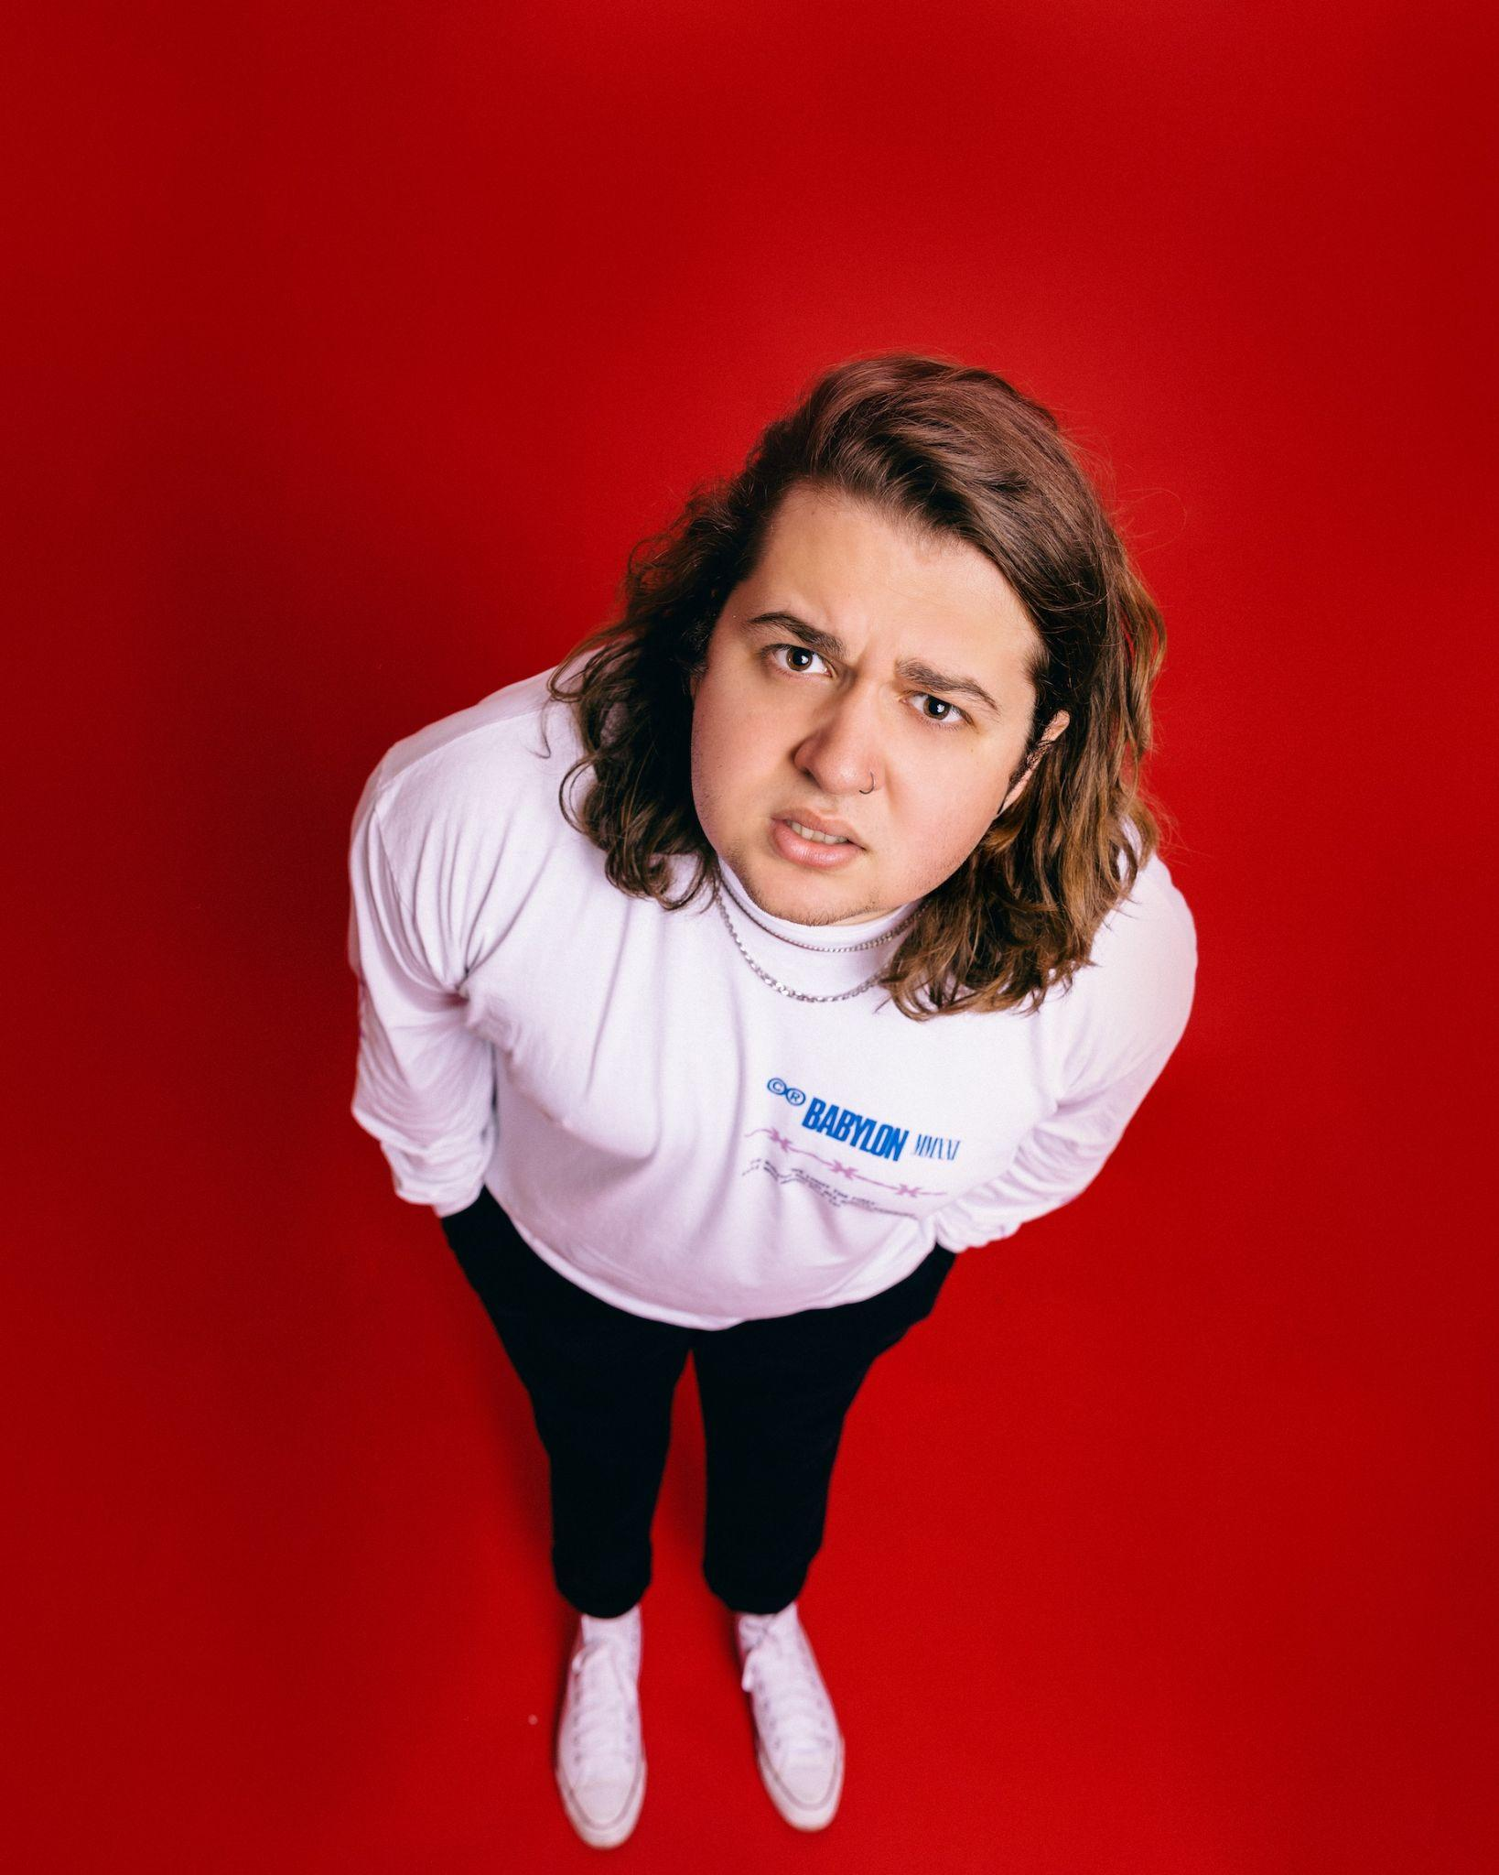
Photo credit: Alice Baxley
DOWNLOAD HI-RED PRESS IMAGE HERE

“Big, catchy hooks and lyrics that are equal parts spiteful and playful” Consequence

“Emotionally self-aware lyrics, big heavy riffs and a brilliantly fun attitude” Rock Sound

“Radiating pop-punk-esque melodies that provide a mesmerizing atmosphere paired with glowing crisp vocals” New Noise

June 24, 2022 - Miami-born and Los Angeles-based singer, songwriter, multi-instrumentalist, producer, and pop-punk provocateur Games We Play (a.k.a Emmyn Calleiro) has announced his major label debut EP, Get A Job. The five-track collection is set to arrive on August 12th via Fueled By Ramen/DCD2 Records, and is available for pre-order beginning today HERE.

To celebrate the announcement, Games We Play has unveiled his brand new single “St. Girlfriend”. The anthemic track is available now on all streaming platforms HERE. Watch an accompanying visualizer for the song HERE.

“It’s a love song about not being cool,” shares Games We Play on “St. Girlfriend”. “In sixth grade, my buddy went on a date to the mall with a girl. He was wearing very light-colored khakis. Midway through the date, he just shit everywhere, and she didn’t notice! I thought it was the funniest thing in the world that we have these real stories about pooping your pants.”

Games We Play announced his Fueled By Ramen/DCD2 Records signing last month in an exclusive interview with Consequence. Watch how Games We Play signed featuring DCD2 Records Founder and Fall Out Boy bassist and visionary Pete Wentz HERE. To herald the announcement, Games We Play unveiled an official music video for his viral breakout single “I Hope You’re Happy”. Watch it on Fueled By Ramen’s official YouTube channel HERE. In the clip, Emmyn’s contagious enthusiasm, bold personality, and hilarious sense of humor come to life on screen as the magnetic pop-punk refrain resounds with chantable turn-of-the-century bliss.

This evening, Games We Play will wrap a 17-city U.S. tour supporting The Band CAMINO at Pittsburgh, PA’s Stage AE. This summer, he will return to the road for select dates on Sad Summer Festival 2022, and appearances at Four Chords Music Festival, Furnace Fest, and more. A complete list of upcoming tour dates can be found below.

Get A Job EP Tracklisting
1. Deadbeat
2. I Hope You’re Happy
3. St. Girlfriend
4. Kristina
5. Get A Job

Games We Play Tour Dates
Supporting The Band CAMINO
June 24, 2022 - Pittsburgh, PA - Stage AE

Sad Summer Festival 2022
July 12, 2022 - Dallas, TX - Gilley’s Dallas - Outside
July 13, 2022 - Houston, TX - The Lawn at White Oak Music Hall
July 15, 2022 - Orlando, FL - Orlando Amphitheater
July 16, 2022 - Atlanta, GA - Coca Cola Roxy

Festival Dates
July 23, 2022 - Gonzalez, TX - Guadalupe River
September 10, 2022 - Pittsburgh, PA - Four Chords Music Festival
September 23, 2022 - Birmingham, AL - Furnace Fest

ABOUT GAMES WE PLAY:
Practically predestined to play pop punk, Games We Play a.k.a. Emmyn Calleiro sings the kinds of hooks you text your ex (and not because you still care or anything!) and rotates between instruments with quiet confidence. The Miami-born and Los Angeles-based singer, songwriter, multi-instrumentalist, and producer turns up with an upbeat and undeniable sound—like a one-man Warped Tour, but with a propensity for 21st century virality. He’s not afraid to be honest about his ups and downs, representing the feelings of every kid (and adult) who doesn’t have it easy. After falling in love with pop punk by way of Blink-182, Emmyn learned bass and drums in church as he simultaneously perfected his guitar and vocal skills. Dropping out in eighth grade, mom and dad even let him fly to New York at 15-years-old for his first recording session. Eventually, the family relocated to Nashville where Emmyn could focus on music. Games We Play made waves with the Senior Year EP during 2018. Getting married and moving in with his wife Dani, she pushed him to go all out. In 2021, he unleashed “Deadbeat” and organically attracted an audience on TikTok with a series of highly candid and utterly hilarious posts. A preview for the hyper-charged punkified banger “I Hope You’re Happy” exploded, amassing millions of views, and leading to a record deal with Fueled By Ramen/DCD2 Records. Allow him to introduce himself on his 2022 major label debut Get A Job EP.

Instagram | Twitter | Facebook | YouTube | TikTok

Press contacts:
Collin Citron / collincitron@elektra.com
Sydney Worden / sydneyworden@elektra.com

