GOJIRA
ANNOUNCE NEW ALBUM FORTITUDE

SHARE NEW SINGLE & MUSIC VIDEO - “BORN FOR ONE THING”

ALBUM PRE-ORDERS AVAILABLE AT WWW.GOJIRA-MUSIC.COM

FORTITUDE ARRIVES APRIL 30TH

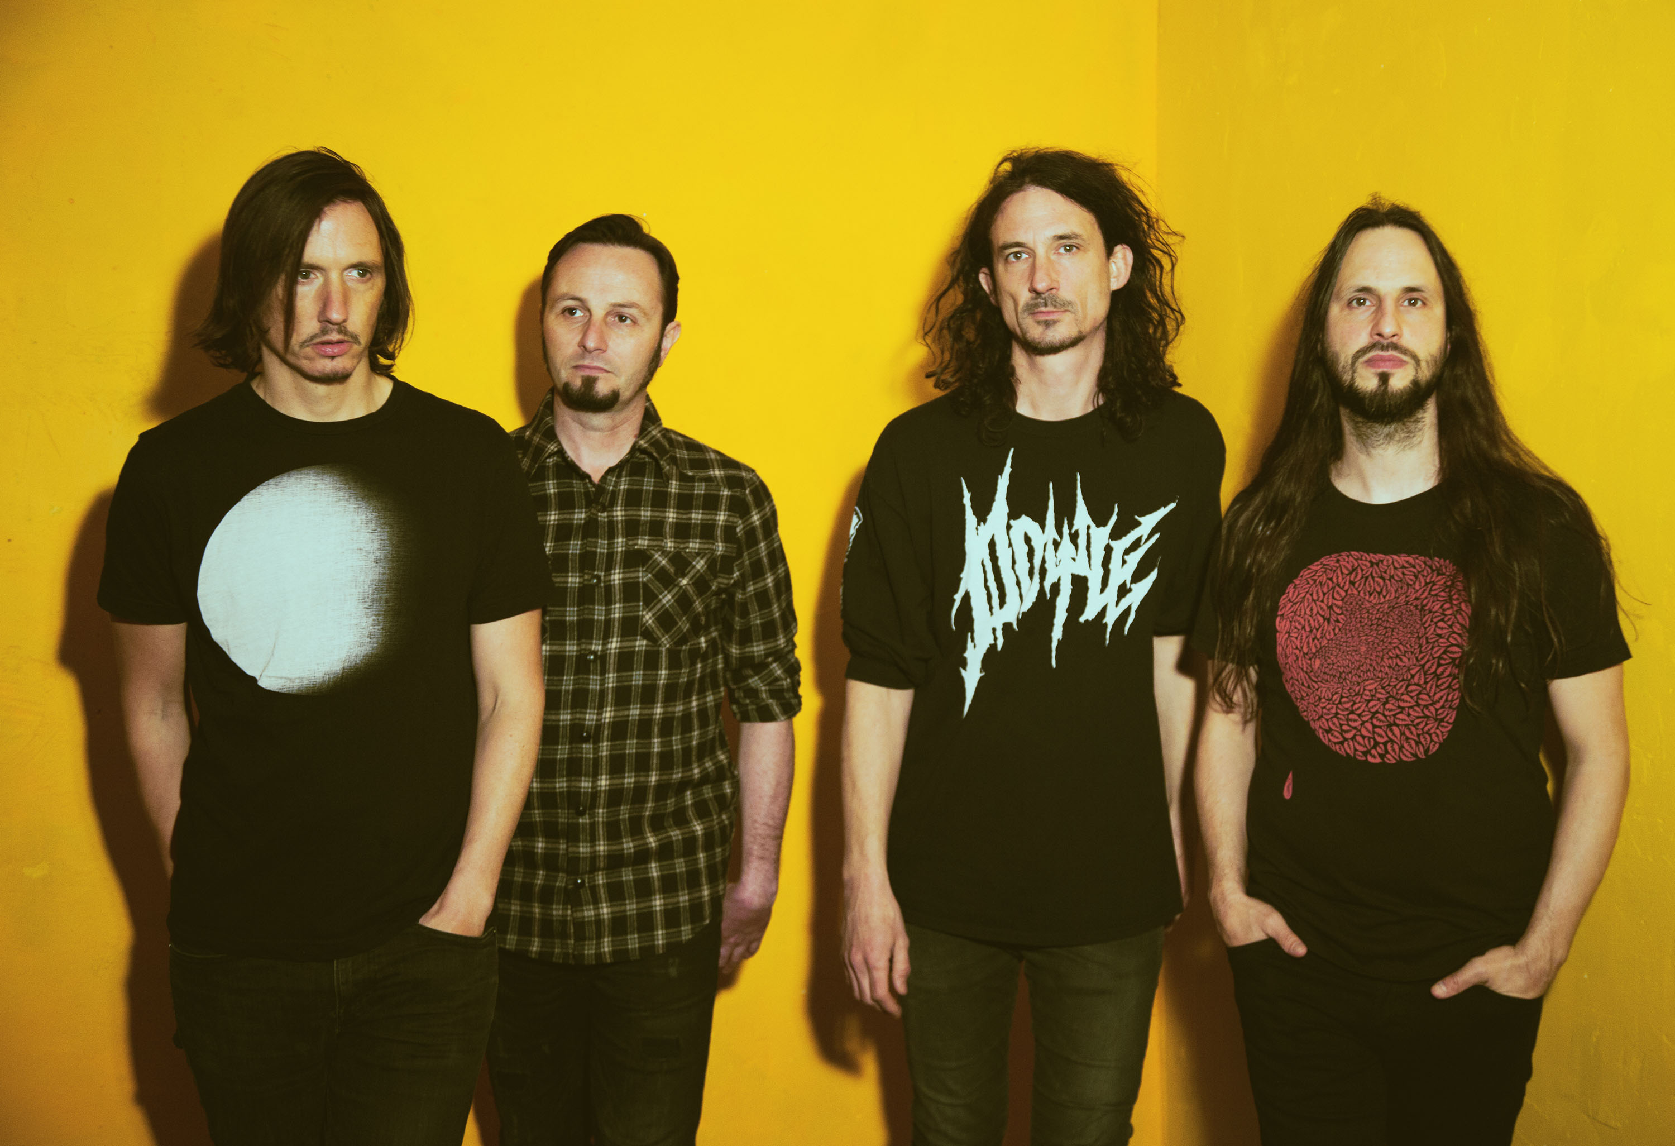
PHOTO CREDIT: GABRIELLE DUPLANTIER

FEBRUARY 17, 2021 - 2x Grammy® nominated band Gojira have announced details of their long-awaited new album, FORTITUDE, which will be released April 30th via Roadrunner Records [album artwork / tracklist below]. Today, the band has shared the forthcoming album’s first single, “Born For One Thing,” which is available on all streaming platforms and accompanied by a Charles De Meyer directed official music video shot in France and Belgium. Available for pre-order today, FORTITUDE stands out as Gojira’s first album in five years and the follow-up to 2016’s Grammy® nominated LP MAGMA.

As if shedding skin and baring armor in its place, “Born For One Thing” represents a natural evolution for the acclaimed French band: hyper-focused but unhinged, confrontational and yet compassionate. “We have to practice detaching ourselves from everything, beginning with actual things,” vocalist / guitarist Joe Duplantier says of the song’s anti-consumerist message, which was partially inspired by the Tibetan and Thai philosophers he read in his youth back in France. “Own less possessions, and give what you don’t need away, because one day we’ll have to let everything go, and if we don’t, we’ll just become ghosts stuck between dimensions.”

Recorded and Produced by Joe Duplantier at Silver Cord Studio - Gojira’s Ridgewood, Queens, headquarters – and mixed by Andy Wallace (Nirvana, Rage Against The Machine), FORTITUDE is a collection of songs urging humanity to imagine a new world—and then make it happen. The band initially laid the foundation for FORTITUDE last year with the surprise release of the 2020 single “Another World.” NPR hailed the track as “an apocalyptic banger,” while STEREOGUM declared, “Gojira are one of this century’s most important underground metal institutions.” Voted by fans as the #1 release on REVOLVER’s “5 Most Anticipated Albums of 2021,” FORTITUDE continues Gojira’s career-long tradition of harnessing their music as a vehicle for environmental activism with songs like “Amazonia” and “The Chant” not only surveying critical cases, but also catalyzing listeners to take action.

On 2016’s MAGMA, Gojira found strength—and crossover success—through a singular commitment to self-reflection. The intensely personal record, penned in memory of the Duplantier brothers' late mother, was a painful significant turning point for the French group. The album earned the band two GRAMMY nominations - ‘Best Metal Performance’ and ‘Best Rock Album,’ and upon release, MAGMA took the #1 spot on BILLBOARD’s ‘Hard Rock Albums’ chart, a first for a French band. MAGMA also asserted itself as one of the most acclaimed albums of 2016, earning METAL HAMMER’s coveted “Album of the Year” title while also landing on ROLLING STONE’s “Top 20 Metal Albums of 2016,” and CONSEQUENCE OF SOUNDS’s “Top 50 Albums of 2016” / “Top 10 Metal Albums of 2016” lists.

Gojira’s widely anticipated tour dates supporting Deftones have been rescheduled for 2021. Check out the dates below, and for more information on Gojira’s international live schedule visit www.gojira-music.com.

GOJIRA
FORTITUDE

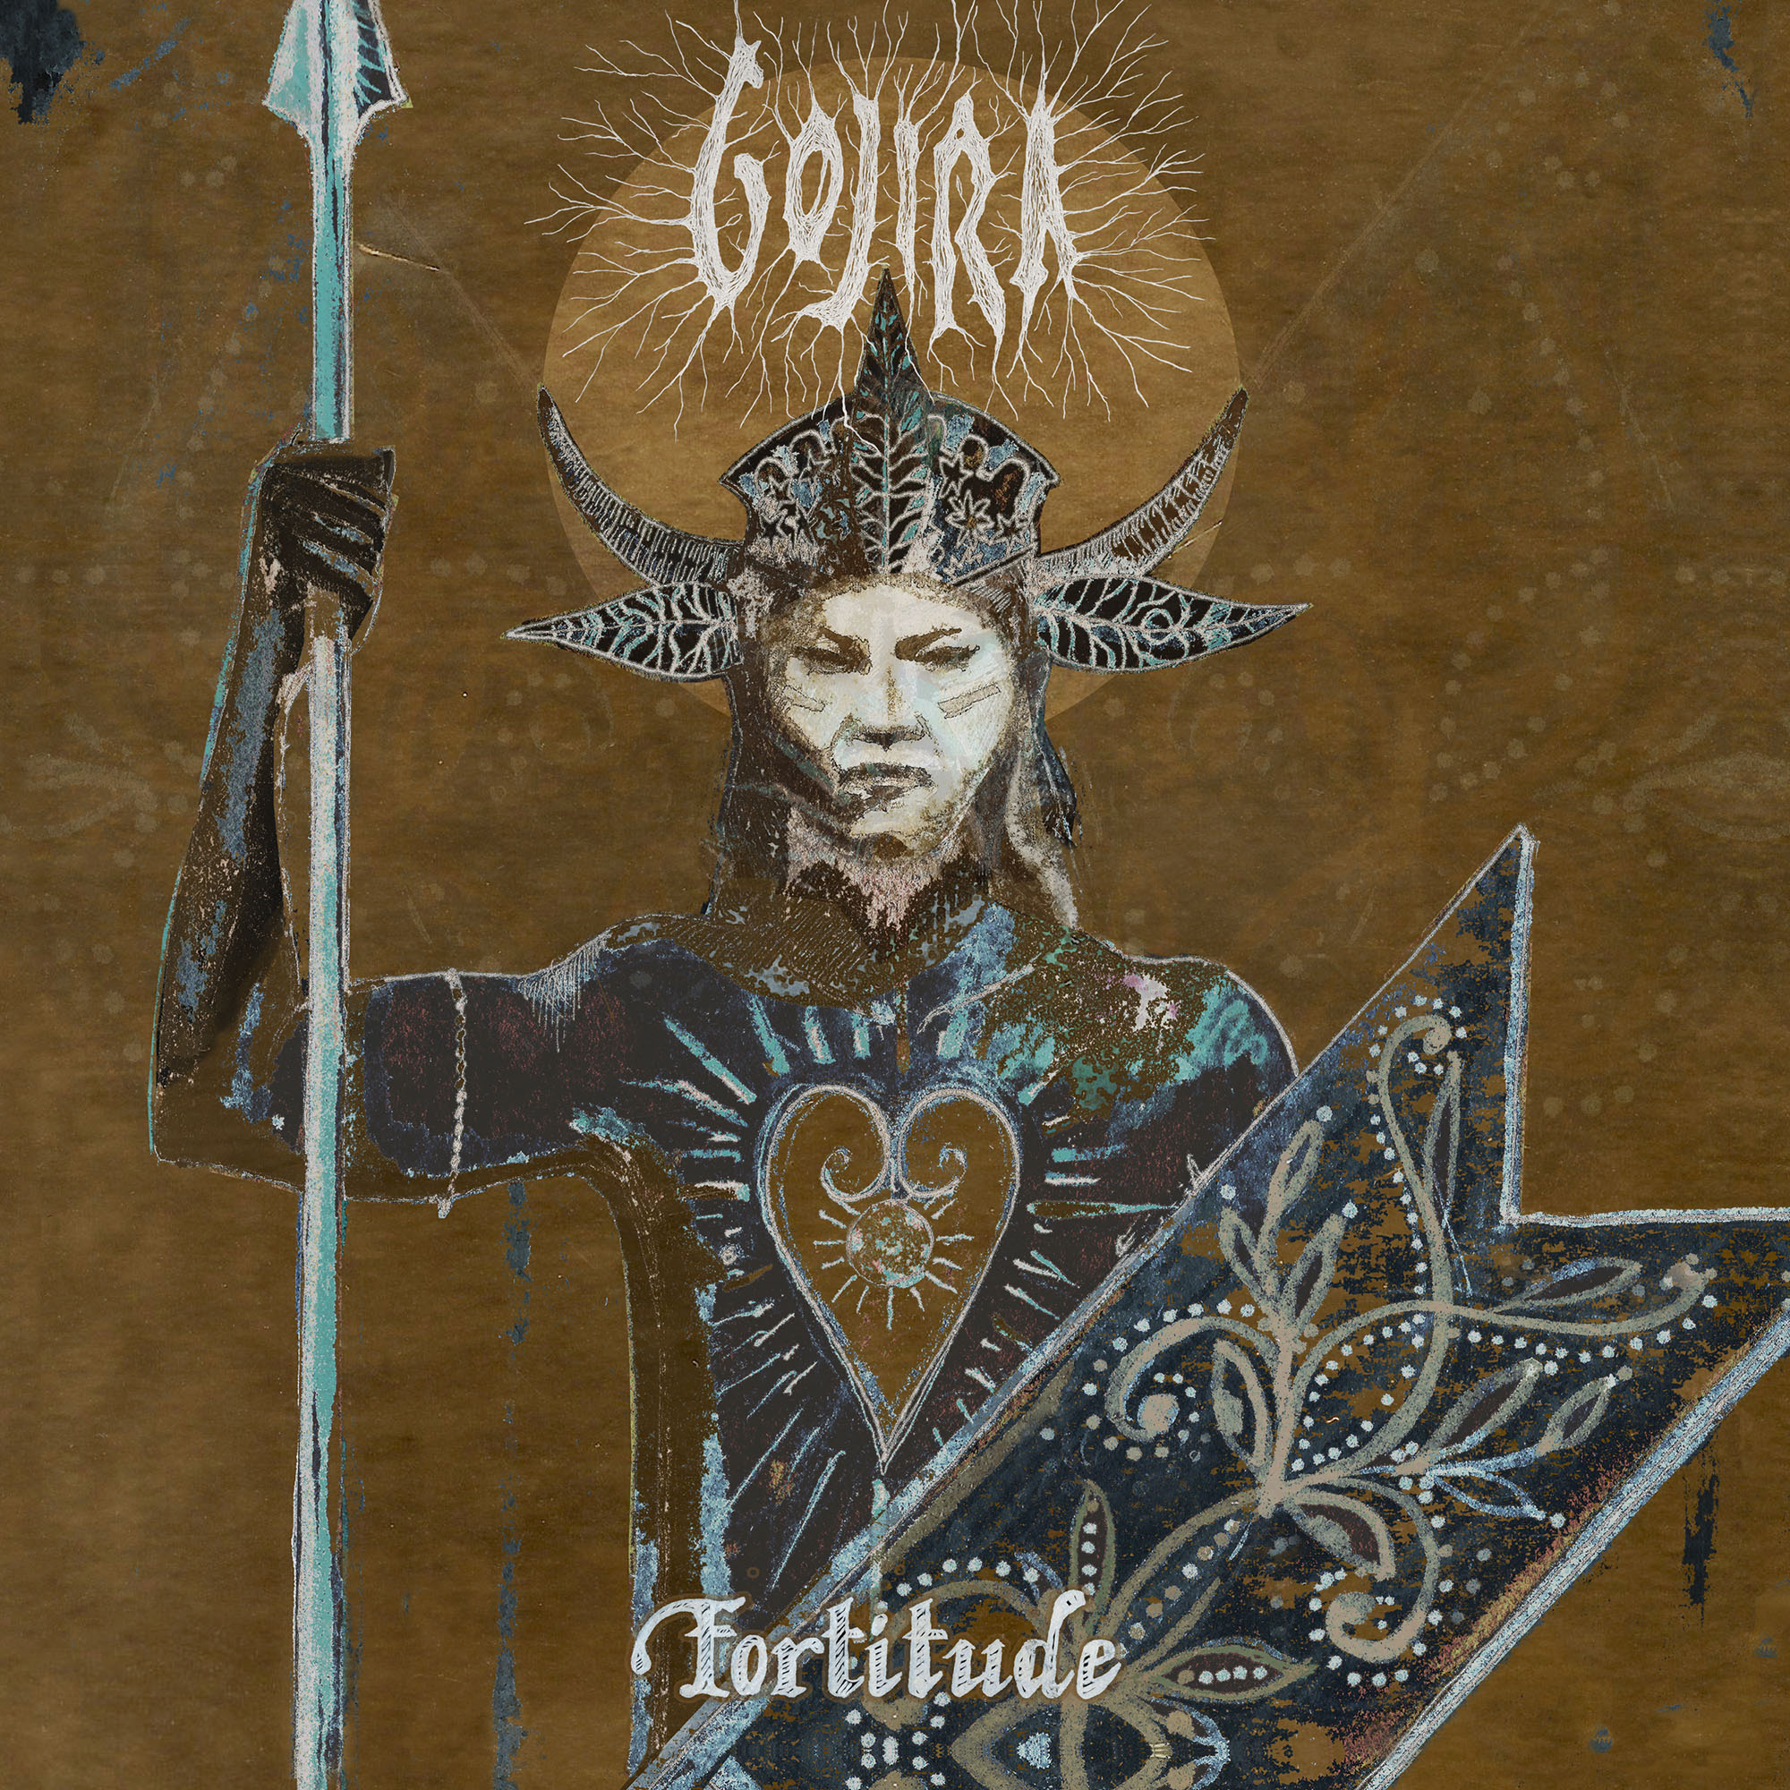
ALBUM ARTWORK BY JOE DUPLANTIER

- “Born For One Thing”
- “Amazonia”
- “Another World”
- “Hold On”
- “New Found”
- “Fortitude”
- “The Chant”
- “Sphinx”
- “Into The Storm”
- “The Trails”
- “Grind”

2021 TOUR DATES:
August 12 – Minneapolis, MN @ The Armory
August 14 – Milwaukee, WI @ Eagles Ballroom
August 15 – Sterling Heights, MI @ Michigan Lottery Amphitheatre at Freedom Hill
August 17 – Chicago, IL @ Huntington Bank Pavilion
August 19 – Toronto, ON, Canada @ RBC Echo Beach
August 20 – Laval, QC, Canada @ Place Bell
August 21 – Uncasville, CT @ Mohegan Sun Arena
August 23 – Boston, MA @ Agganis Arena
August 24 – New York, NY @ The Rooftop at Pier 17
August 27 – Philadelphia, PA @ The Met Philadelphia
August 28 – Asbury Park, NJ @ Stone Pony Summerstage
August 29 – Washington, DC @ The Anthem
August 31 – Pittsburgh, PA @ Petersen Events Center, University of Pittsburgh
September 2 – Indianapolis, IN @ Amphitheater at White River State Park
September 3 – Nashville, TN @ Nashville Municipal Auditorium
September 4 – Atlanta, GA @ Cadence Bank Amphitheatre at Chastain Park
September 6 – Irving, TX @ The Pavilion at Toyota Music Factory
September 7 – Houston, TX @ White Oak Music Hall
September 8 – San Antonio, TX @ AT&T Center
September 10 – Denver, CO @ Pepsi Center
September 11 – Albuquerque, NM @ Isleta Amphitheatre
September 14 – Phoenix, AZ @ Arizona Federal Theatre
September 17 – Los Angeles, CA @ Greek Theatre
September 18 – San Francisco, CA @ Bill Graham Civic Auditorium
September 21 – Seattle, WA @ WAMU Theater
September 22 – Portland, OR @ Theatre of the Clouds at Moda Center

About Gojira:
Gojira treat heavy music as a living and breathing entity, morphing, transforming, and changing in each iteration. After 2016’s MAGMA crashed the Top 25 of the Billboard Top 200, the history-making French band garnered a pair of 2017 Grammy® nominations, including “Best Rock Album” and “Best Metal Performance” for “Silvera.” REVOLVER cited its 2012 predecessor L’Enfant Sauvage as #2 among the “25 Best Albums of the 2010s.” Meanwhile, ROLLING STONE named their 2005 breakthrough From Mars To Sirius one of “The 100 Greatest Metal Albums of All Time.” Handpicked to open for Metallica by none other than frontman James Hetfield, they have toured with Slayer, Slipknot, and more in addition to headlining tours around the world. The group’s forthcoming seventh full-length album, Fortitude, undoubtedly sees them push the envelope as they change heavy music once again in 2021.

###

For more information on Gojira, contact:
Ross Anderson | RossAnderson@Elektra.com

Follow Gojira:
Official | Facebook | Instagram | Twitter | YouTube

