GOJIRA
RELEASE NEW ALBUM FORTITUDE

SHARE “THE CHANT” OFFICIAL MUSIC VIDEO

“AMAZONIA” FUNDRAISING INITIATIVE RAISES OVER $300K
IN SUPPORT OF THE ARTICULATION OF INDIGENOUS PEOPLES OF BRAZIL

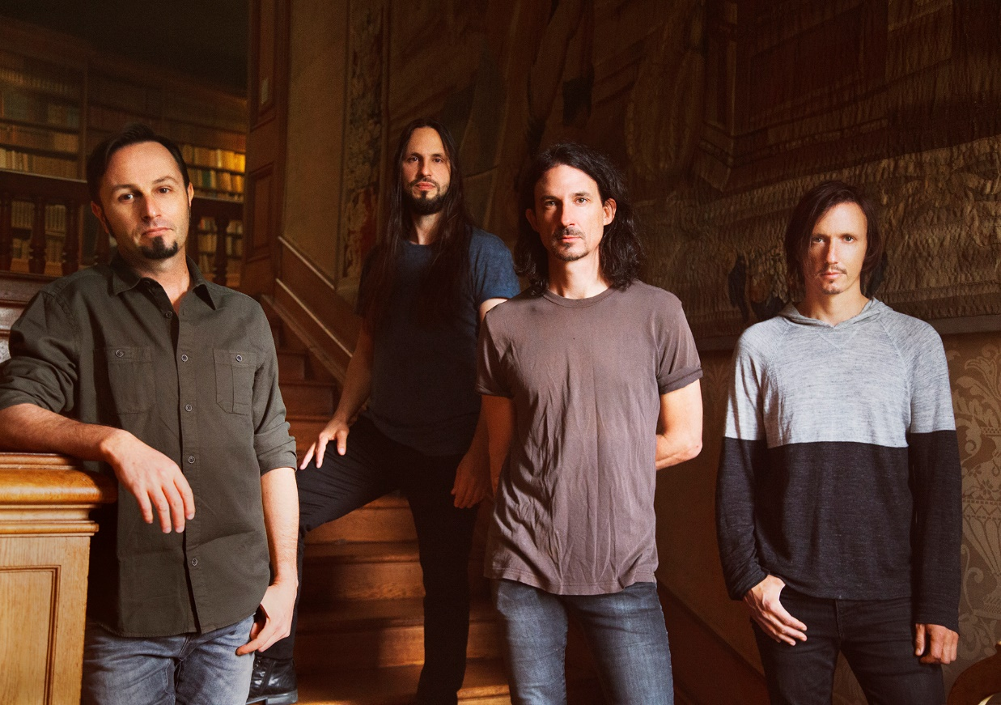
PHOTO CREDIT: GABRIELLE DUPLANTIER

APRIL 30, 2021 - 2x Grammy® nominated band Gojira have released their widely anticipated new album FORTITUDE, which is available today on all streaming platforms with physical copies available at www.gojira-music.com [album artwork / tracklist below]. Today the band has also shared an official music video for “The Chant,” which is streaming now on their YouTube channel. Written / conceived by the band’s own Joe Duplantier and directed by Russell Brownley, the cinematic video was filmed on location in India’s West Bengal region in December of 2019. It examines the plight of refugee children from Tibet who fled their homeland in an attempt to preserve their culture following China’s invasion of the country in 1949.

Duplantier commented on the significance of the video stating, “This work is inspired by the reading of Tenzin Tsundue’s poetry. A righteous Tibetan activist, that describes the cultural genocide perpetrated on its people. We’ve always been sensitive to the Tibetan struggle. One of the wisest and most compassionate traditions, victim of the worst human rights violations imaginable since its invasion in 1949. Tibetan culture inspired many of our lyrics and had a deep impact on our approach of philosophy and art in general. Our thoughts go out to all Tibetans. We’re hoping that we’ll see their land free from oppression in our lifetime.”

The center piece of an album-long call to action, “The Chant” is a slow-burning track featuring some of Gojira’s most melodic material to date. Where past anthems were driven by nuanced dynamics and technical guitar arrangements, “The Chant” is a self-described “healing ritual” emanating primordial warmth, culminating in a harmony-stacked chorus that bridges the gap between ancient hymnals and contemporary rock.

“The Chant” follows early album singles “Another World,” “Born For One Thing,” “Into The Storm,” and “Amazonia,” the latter of which was launched alongside a fundraising initiative to benefit the indigenous owned NGO The Articulation of Indigenous Peoples of Brazil (APIB) who advocate for environmental and cultural rights of indigenous tribes in the Amazon. Working with the social good-focused digital platform Propeller, Gojira curated a month long charitable campaign featuring an auction of one-of-a-kind items from the band and members of Metallica, Tool, Slipknot, Slayer, Slash and more, alongside a raffle for a customized signature Joe Duplantier guitar and a hand painted drum head by Gojira's Mario Duplantier. All totaled, the philanthropic effort far surpassed the initial goal of $75k raising over $300k for APIB, which will be put toward aiding the indigenous tribes of the Amazon who have suffered immensely - victims of deforestation, land loss, forced labor, violence, and harassment.

Recorded and Produced by Joe Duplantier at Silver Cord Studio - Gojira’s Ridgewood, Queens, headquarters – and mixed by Andy Wallace (Nirvana, Rage Against The Machine), FORTITUDE is Gojira’s first album in five years and the follow-up to 2016’s Grammy® nominated LP MAGMA. A collection of songs urging humanity to imagine a new world—and then make it happen, FORTITUDE has been earning widespread critical praise with NPR hailing “Another World” as “an apocalyptic banger,” and PASTE calling “Into The Storm” a “much-needed revolutionary anthem.” Named one of PITCHFORK’s “Most Anticipated Albums of Spring 2021,” STEREOGUM declared, “hearing this band operating at their peak is a life-affirming thing,” while REVOLVER attested “FORTITUDE, could spark a revolution.”

On 2016’s MAGMA, Gojira found strength—and crossover success—through a singular commitment to self-reflection. The intensely personal record, penned in memory of the Duplantier brothers' late mother, was a painful significant turning point for the French group. The album earned the band two GRAMMY nominations - ‘Best Metal Performance’ and ‘Best Rock Album,’ and upon release, MAGMA took the #1 spot on BILLBOARD’s ‘Hard Rock Albums’ chart, a first for a French band. MAGMA also asserted itself as one of the most acclaimed albums of 2016, earning METAL HAMMER’s coveted “Album of the Year” title while also landing on ROLLING STONE’s “Top 20 Metal Albums of 2016,” and CONSEQUENCE OF SOUNDS’s “Top 50 Albums of 2016” / “Top 10 Metal Albums of 2016” lists.

Gojira’s widely anticipated tour dates supporting Deftones have been rescheduled for 2021. Check out the dates below, and for more information on Gojira’s international live schedule visit www.gojira-music.com.

GOJIRA
FORTITUDE

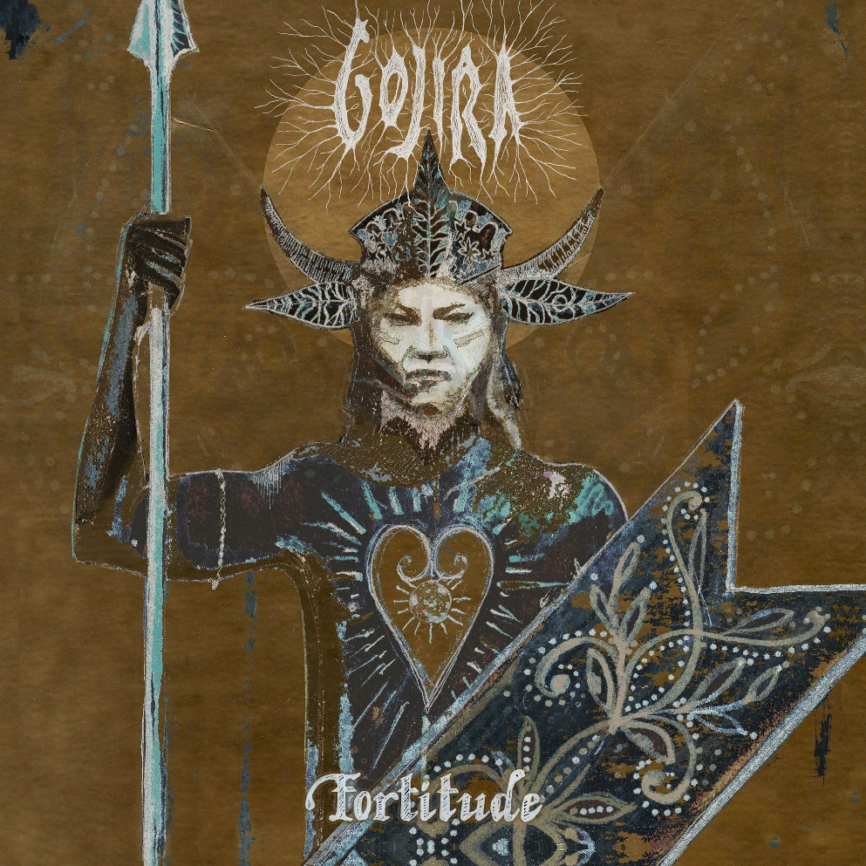
ALBUM ARTWORK BY JOE DUPLANTIER

- “Born For One Thing”
- “Amazonia”
- “Another World”
- “Hold On”
- “New Found”
- “Fortitude”
- “The Chant”
- “Sphinx”
- “Into The Storm”
- “The Trails”
- “Grind”

2021 TOUR DATES:
August 12 – Minneapolis, MN @ The Armory
August 14 – Milwaukee, WI @ Eagles Ballroom
August 15 – Sterling Heights, MI @ Michigan Lottery Amphitheatre at Freedom Hill
August 17 – Chicago, IL @ Huntington Bank Pavilion
August 19 – Toronto, ON, Canada @ RBC Echo Beach
August 20 – Laval, QC, Canada @ Place Bell
August 21 – Uncasville, CT @ Mohegan Sun Arena
August 23 – Boston, MA @ Agganis Arena
August 24 – New York, NY @ The Rooftop at Pier 17
August 27 – Philadelphia, PA @ The Met Philadelphia
August 28 – Asbury Park, NJ @ Stone Pony Summerstage
August 29 – Washington, DC @ The Anthem
August 31 – Pittsburgh, PA @ Petersen Events Center, University of Pittsburgh
September 2 – Indianapolis, IN @ Amphitheater at White River State Park
September 4 – Atlanta, GA @ Cadence Bank Amphitheatre at Chastain Park
September 6 – Irving, TX @ The Pavilion at Toyota Music Factory
September 7 – Houston, TX @ White Oak Music Hall
September 8 – San Antonio, TX @ AT&T Center
September 10 – Denver, CO @ Pepsi Center
September 11 – Albuquerque, NM @ Isleta Amphitheatre
September 14 – Phoenix, AZ @ Arizona Federal Theatre
September 17 – Los Angeles, CA @ Greek Theatre
September 18 – San Francisco, CA @ Bill Graham Civic Auditorium
September 21 – Seattle, WA @ WAMU Theater
September 22 – Portland, OR @ Theatre of the Clouds at Moda Center

About Gojira:
Gojira treat heavy music as a living and breathing entity, morphing, transforming, and changing in each iteration. After 2016’s MAGMA crashed the Top 25 of the Billboard Top 200, the history-making French band garnered a pair of 2017 Grammy® nominations, including “Best Rock Album” and “Best Metal Performance” for “Silvera.” REVOLVER cited its 2012 predecessor L’Enfant Sauvage as #2 among the “25 Best Albums of the 2010s.” Meanwhile, ROLLING STONE named their 2005 breakthrough From Mars To Sirius one of “The 100 Greatest Metal Albums of All Time.” Handpicked to open for Metallica by none other than frontman James Hetfield, they have toured with Slayer, Slipknot, and more in addition to headlining tours around the world. The group’s forthcoming seventh full-length album, Fortitude, undoubtedly sees them push the envelope as they change heavy music once again in 2021.

###

For more information on Gojira, contact:
Ross Anderson | RossAnderson@Elektra.com

Follow Gojira:
Official | Facebook | Instagram | Twitter | YouTube

