GOJIRA SHARE “SPHINX” MUSIC VIDEO

U.S. FALL HEADLINE TOUR DATES
WITH SPECIAL GUESTS KNOCKED LOOSE & ALIEN WEAPONRY UNDERWAY

NEW ALBUM FORTITUDE AVAILABLE EVERYWHERE

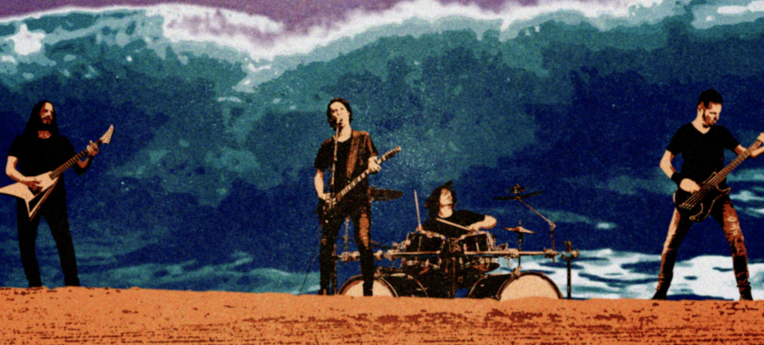

OCTOBER 28, 2021 - 2x Grammy® nominated band Gojira have shared an official music video for “Sphinx,” a standout track from their acclaimed new album FORTITUDE. Directed and animated by Zev Deans, the music video sees Gojira delivering a pulverizing performance at the feet of the infamous Egyptian colossus. Watch it HERE.

Gojira are currently out on a U.S. headline tour featuring special guests Knocked Loose and Alien Weaponry. The tour continues tonight in Rochester, NY and will run through a performance on November 10th in North Charleston, SC [full itinerary below]. Furthermore, Gojira are set for a 2022 U.S. run supporting Deftones which will kick off on April 14th in Portland, OR. For tickets and for more information on Gojira’s live schedule visit www.gojira-music.com.

Earlier this year Gojira made a stunning global chart impact with their celebrated new album FORTITUDE. The French band’s new studio album entered Billboard’s ‘Top Albums’ chart at #1, while also claiming the #1 spot on Billboard’s ‘Top Current Albums,’ ‘Current Rock Albums,’ and ‘Current Hard Music Albums’ tallies. The release also marked a career high debut on the ‘Billboard 200’ for Gojira, arriving at #12, with several career high chart positions and Top 10 debuts in countries around the globe including: France (#2), United Kingdom (#6), Australia (#3), Germany (#8), Belgium (#2), Netherlands (#4), Denmark (#3), Portugal (#4), Finland (#2), and Norway (#10).

FORTITUDE is highlighted by the singles “Another World,” “Born For One Thing,” “Into The Storm,” “The Chant,” and “Amazonia” which launched alongside ‘Operation Amazonia,’ a philanthropic effort aimed at ending genocide and ecocide in the Amazon. Working with the social good-focused digital platform Propeller, Gojira launched a charitable campaign raising over 300K through an auction and raffle of one-of-a-kind items from the band and their friends in Metallica, Tool, Slipknot, Slayer, Slash and more. All proceeds are to be donated to the indigenous owned NGO The Articulation of Indigenous Peoples of Brazil (APIB) who advocate for environmental and cultural rights of indigenous tribes in the Amazon. Recently Gojira’s Joe Duplantier journeyed to the Amazon to protest harmful legislation and visit the site of a recently constructed ‘healing house,’ funded by the operation, which will ensure the birthright and health of the indigenous Guarani-Kaiowa community.

Recorded and Produced by Joe Duplantier at Silver Cord Studio - Gojira’s Ridgewood, Queens, headquarters – and mixed by Andy Wallace (Nirvana, Rage Against The Machine), FORTITUDE is Gojira’s first album in five years and the follow-up to 2016’s Grammy® nominated LP MAGMA. A collection of songs urging humanity to imagine a new world—and then make it happen, FORTITUDE has been earning widespread critical praise with THE GUARDIAN, REVOLVER, METAL HAMMER, KERRANG!, and ROLLING STONE all naming it one of their “Best Albums of 2021 So Far" with the latter remarking “It’s all the rage of death metal mixed with the conscience of punk rock and the musicality of progressive rock.” NPR hailed “Another World” as “an apocalyptic banger,” and PASTE called “Into The Storm” a “much-needed revolutionary anthem.” STEREOGUM declared, “hearing this band operating at their peak is a life-affirming thing,” while REVOLVER attested “FORTITUDE, could spark a revolution.”

[Tour Itinerary Below]

GOJIRA 2021 - 2022 U.S.TOUR DATES:
10/28 – 11/7: with Knocked Loose & Alien Weaponry
^Knocked Loose Only
4/14 – 5/28: with Deftones

October 28 – Rochester, NY @ Main Street Armory
October 29 – Cleveland, OH @ The Agora (SOLD OUT)
October 30 – Albany, NY @ The Albany Capital Center
November 1 – Richmond, VA @ The National
November 2 – Knoxville, TV @ Knoxville Civic Auditorium and Coliseum
November 3 – Chattanooga, TN @ The Signal (SOLD OUT)
November 5 – Madison, WI @ The Sylvee
November 6 – St. Louis, MO @ The Factory
November 7 – Fort Wayne, IN @ Clyde Theatre
November 9 – Huntsville, Al @ Mars Music Hall^
November 10 – North Charleston, SC @ North Charleston Coliseum^
April 14 – Portland, OR @ Veterans Memorial Coliseum
April 16 – Seattle, WA @ WaMu Theatre
April 18 – San Francisco, CA @ Bill Graham Civic Auditorium
April 20 – Los Angeles, CA @ Greek Theatre
April 22 – Las Vegas, NV @ The Cosmopolitan
April 23 – Phoenix, AZ @ Arizona Federal Theatre
April 25 – Denver, CO @ Ball Arena
April 28 – Albuquerque, NM @ Isleta Amphitheatre
April 30 – Houston TX @ White Oak Music Hall
May 2 – Irving, TX @ The Pavilion at Toyota Music Factory
May 3 – San Antonio, TX @ AT & T Center
May 6 – Atlanta, GA @ Cadence Bank Amphitheatre at Chastain Park
May 7 – Nashville, TN @ Municipal Auditorium
May 8 – Cincinnati, OH @ ICON Music Center
May 10 – Indianapolis, IN @TCU Amphitheater at White River State Park
May 11 – Pittsburgh, PA @ Petersen Events Center
May 13 – Boston, MA @ Agganis Arena
May 14 – Asbury Park, NJ @ Stone Pony Summer Stage
May 15 – New York City, NY @ Pier 17
May 17 – Washington DC @ The Anthem
May 18 – Philadelphia, PA @ The Met
May 19 – Uncasville, CT @ Mohegan Sun Arena
May 21 – Laval, QC @ Place Bell
May 22 – Toronto, ON @ Echo Beach
May 24 – Detroit, MI @ Michigan Lottery Amphitheatre at Freedom Hill
May 26 – Milwaukee, WI @ Eagles Ballroom
May 27 – Chicago, IL @ Huntington Bank Pavilion at Northerly Island
May 28 – Minneapolis, MN @ The Armory

About Gojira:
Gojira treat heavy music as a living and breathing entity, morphing, transforming, and changing in each iteration. After 2016’s MAGMA crashed the Top 25 of the Billboard Top 200, the history-making French band garnered a pair of 2017 Grammy® nominations, including “Best Rock Album” and “Best Metal Performance” for “Silvera.” REVOLVER cited its 2012 predecessor L’Enfant Sauvage as #2 among the “25 Best Albums of the 2010s.” Meanwhile, ROLLING STONE named their 2005 breakthrough From Mars To Sirius one of “The 100 Greatest Metal Albums of All Time.” Handpicked to open for Metallica by none other than frontman James Hetfield, they have toured with Slayer, Slipknot, and more in addition to headlining tours around the world. The group’s forthcoming seventh full-length album, Fortitude, undoubtedly sees them push the envelope as they change heavy music once again in 2021.

###

For more information on Gojira, contact:
Ross Anderson | RossAnderson@Elektra.com

Follow Gojira:
Official | Facebook | Instagram | Twitter | YouTube

