GOJIRA
ANNOUNCE FALL U.S. HEADLINE TOUR

DATES BEGIN OCTOBER 11TH IN SALT LAKE CITY, UT
FEATURING SPECIAL GUESTS KNOCKED LOOSE & ALIEN WEAPONRY

PRE-SALE TICKETS AVAILABLE BEGINNING MAY 4TH

NEW ALBUM FORTITUDE OUT NOW

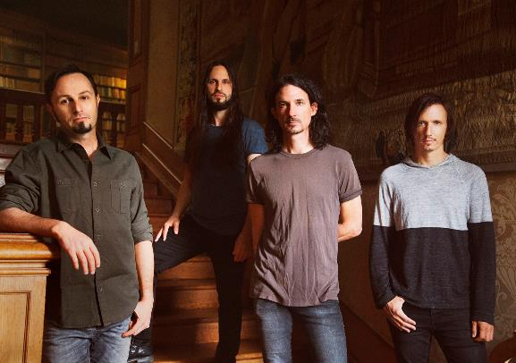

MAY 3, 2021 - 2x Grammy® nominated band Gojira have announced details of a fall U.S. headline tour. The new dates, which will feature special guests Knocked Loose and Alien Weaponry, are set to kick of October 11th in Salt Lake City, Utah at The Union and continue through a performance at Cleveland, Ohio’s The Agora on October 29th [full itinerary below]. Pre-sale tickets for the tour will be available starting tomorrow, May 4th at 10:00AM local time with general on sale starting Friday, May 7th at 10:00AM local time. The new headline dates will follow Gojira’s summer run supporting Deftones which gets underway August 12th at The Armory in Minneapolis, MN and includes two Gojira only headline dates on September 3rd in Chattanooga, TN and September 20th in Boise, ID. For tickets and for more information on Gojira’s live schedule visit www.gojira-music.com.

News of the U.S. headline tour follows the recent release of Gojira’s acclaimed new album FORTITUDE, which is available now on all streaming platforms. The powerful collection is highlighted by the singles “Another World,” “Born For One Thing,” “Into The Storm,” “Amazonia,” and most recently “The Chant,” a slow-burning track featuring some of Gojira’s most melodic material to date. Just last week the band shared an official music video for “The Chant,” which was written / conceived by the band’s own Joe Duplantier and directed by Russell Brownley. Filmed on location in India’s West Bengal region in December of 2019, the cinematic video examines the plight of refugee children from Tibet who fled their homeland in an attempt to preserve their culture following China’s invasion of the country in 1949.

Furthermore, Gojira recently concluded a month long fundraising initiative in support of the indigenous owned NGO The Articulation of Indigenous Peoples of Brazil (APIB) who advocate for environmental and cultural rights of indigenous tribes in the Amazon. Working with the social good-focused digital platform Propeller, the month long charitable campaign raised over 300K through an auction and raffle of one-of-a-kind items from the band and their friends in Metallica, Tool, Slipknot, Slayer, Slash and more. All proceeds will be donated to APIB to support their work aiding the indigenous tribes of the Amazon who have suffered immensely - victims of deforestation, land loss, forced labor, violence, and harassment.

Recorded and Produced by Joe Duplantier at Silver Cord Studio - Gojira’s Ridgewood, Queens, headquarters – and mixed by Andy Wallace (Nirvana, Rage Against The Machine), FORTITUDE is Gojira’s first album in five years and the follow-up to 2016’s Grammy® nominated LP MAGMA. A collection of songs urging humanity to imagine a new world—and then make it happen, FORTITUDE has been earning widespread critical praise with NPR hailing “Another World” as “an apocalyptic banger,” and PASTE calling “Into The Storm” a “much-needed revolutionary anthem.” Named one of PITCHFORK’s “Most Anticipated Albums of Spring 2021,” STEREOGUM declared, “hearing this band operating at their peak is a life-affirming thing,” while REVOLVER attested “FORTITUDE, could spark a revolution.”

On 2016’s MAGMA, Gojira found strength—and crossover success—through a singular commitment to self-reflection. The intensely personal record, penned in memory of the Duplantier brothers' late mother, was a painful significant turning point for the French group. The album earned the band two GRAMMY nominations - ‘Best Metal Performance’ and ‘Best Rock Album,’ and upon release, MAGMA took the #1 spot on BILLBOARD’s ‘Hard Rock Albums’ chart, a first for a French band. MAGMA also asserted itself as one of the most acclaimed albums of 2016, earning METAL HAMMER’s coveted “Album of the Year” title while also landing on ROLLING STONE’s “Top 20 Metal Albums of 2016,” and CONSEQUENCE OF SOUNDS’s “Top 50 Albums of 2016” / “Top 10 Metal Albums of 2016” lists.

[Tour Itinerary / Admat Below]

2021 TOUR DATES:
8/12 – 9/22: with Deftones
10/11 – 10/29: with Knocked Loose & Alien Weaponry
^ Gojira Only
* Festival Date

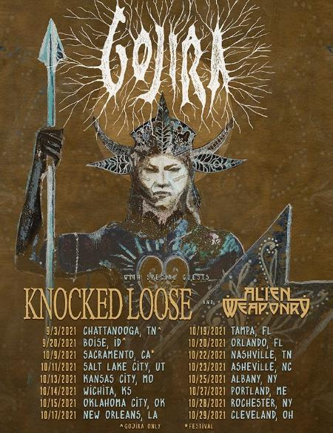
August 12 – Minneapolis, MN @ The Armory
August 14 – Milwaukee, WI @ Eagles Ballroom
August 15 – Sterling Heights, MI @ Michigan Lottery Amphitheatre at Freedom Hill
August 17 – Chicago, IL @ Huntington Bank Pavilion
August 19 – Toronto, ON, Canada @ RBC Echo Beach
August 20 – Laval, QC, Canada @ Place Bell
August 21 – Uncasville, CT @ Mohegan Sun Arena
August 23 – Boston, MA @ Agganis Arena
August 24 – New York, NY @ The Rooftop at Pier 17
August 27 – Philadelphia, PA @ The Met Philadelphia
August 28 – Asbury Park, NJ @ Stone Pony Summerstage
August 29 – Washington, DC @ The Anthem
August 31 – Pittsburgh, PA @ Petersen Events Center, University of Pittsburgh
September 2 – Indianapolis, IN @ Amphitheater at White River State Park
September 3 – Chattanooga, TN @ The Signal^
September 4 – Atlanta, GA @ Cadence Bank Amphitheatre at Chastain Park
September 6 – Irving, TX @ The Pavilion at Toyota Music Factory
September 7 – Houston, TX @ White Oak Music Hall
September 8 – San Antonio, TX @ AT&T Center
September 10 – Denver, CO @ Pepsi Center
September 11 – Albuquerque, NM @ Isleta Amphitheatre
September 14 – Phoenix, AZ @ Arizona Federal Theatre
September 17 – Los Angeles, CA @ Greek Theatre
September 18 – San Francisco, CA @ Bill Graham Civic Auditorium
September 20 – Boise, ID @ Revolution Center^
September 21 – Seattle, WA @ WAMU Theater
September 22 – Portland, OR @ Theatre of the Clouds at Moda Center
October 9 – Sacramento, CA @ Aftershock*
October 11 – Salt Lake City, UT @ The Union
October 13 – Kansas City, MO @ Arvest Bank Theatre at The Midland
October 14 – Wichita, KS @ The Cotillion
October 15 – Oklahoma City, OK @ Diamond Ballroom
October 17 – New Orleans, LA @ Civic Theatre
October 19 – Tampa, FL @ Jannus Live
October 20 – Orlando, FL @ Hard Rock Live
October 22 – Nashville, TN @ Marathon Music Works
October 23 – Asheville, NC @ Thomas Wolfe Auditorium
October 25 – Albany, NY @ Upstate Concert Hall
October 27 – Portland, ME @ State Theatre
October 28 – Rochester, NY @ Main Street Armory
October 29 – Cleveland, OH @ The Agora

GOJIRA
FORTITUDE

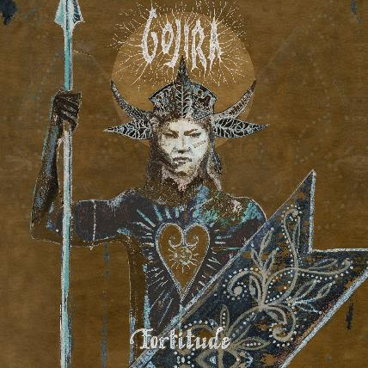
ALBUM ARTWORK BY JOE DUPLANTIER

- “Born For One Thing”
- “Amazonia”
- “Another World”
- “Hold On”
- “New Found”
- “Fortitude”
- “The Chant”
- “Sphinx”
- “Into The Storm”
- “The Trails”
- “Grind”

About Gojira:
Gojira treat heavy music as a living and breathing entity, morphing, transforming, and changing in each iteration. After 2016’s MAGMA crashed the Top 25 of the Billboard Top 200, the history-making French band garnered a pair of 2017 Grammy® nominations, including “Best Rock Album” and “Best Metal Performance” for “Silvera.” REVOLVER cited its 2012 predecessor L’Enfant Sauvage as #2 among the “25 Best Albums of the 2010s.” Meanwhile, ROLLING STONE named their 2005 breakthrough From Mars To Sirius one of “The 100 Greatest Metal Albums of All Time.” Handpicked to open for Metallica by none other than frontman James Hetfield, they have toured with Slayer, Slipknot, and more in addition to headlining tours around the world. The group’s forthcoming seventh full-length album, Fortitude, undoubtedly sees them push the envelope as they change heavy music once again in 2021.

###

For more information on Gojira, contact:
Ross Anderson | RossAnderson@Elektra.com

Follow Gojira:
Official | Facebook | Instagram | Twitter | YouTube

