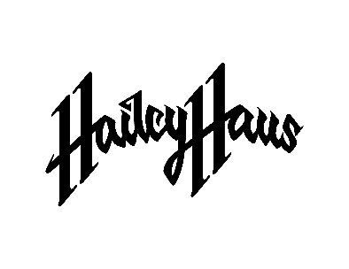
POP SINGER-SONGWRITER HAILEY HAUS DEBUTS BOLD NEW SINGLE “FLAVOR OF THE MONTH”
ANNOUNCES SIGNING TO ARCADE RECORDS, A JOINT VENTURE WITH ELEKTRA RECORDS
LISTEN TO THE TRACK HERE | WATCH THE VISUALIZER HERE

CREDIT: HUNTER LYON
DOWNLOAD HI-RES PRESS IMAGE HERE
(June 14, 2022) – LOS ANGELES, CA – Pop singer-songwriter and producer Hailey Haus has unveiled her new single, “Flavor of the Month,” her debut release with multi-GRAMMY® Award-nominated producer Gregg Wattenberg’s Arcade Records, a joint venture with Elektra Records. The bold pop track blends understated guitar threads around clever verses about fictional boys-of-the-month. Co-written by Haus and produced by David Burris, a snippet of the song caught fire on TikTok, amassing 9M+ views on the platform in advance of today’s release, plus 1M+ additional views across socials. Listen to “Flavor of the Month” HERE and watch the companion visualizer HERE.
“It’s a story about taking the power back in a sense,” Haus revealed about the single. “At the time, I was single, and I was trying to find the right guy. I talked to a handful of boys over this one year. In my mind, I’m looking for my husband. Behind my back, some girl said, ‘Oh my Gosh, Hailey always has a flavor of the month.’ I was so bothered, because I’m not trying to talk to a million guys for no reason; I’m looking for the right person to commit my life to. One day, I thought what she said would be a hilarious concept for a song, so I made it my own.”
She added, “I am beyond grateful for the opportunity to partner with Arcade x Elektra to make this lifelong dream a reality. They have made me feel supported and a part of the family. I am so optimistic about our future ahead!”
Of the new signing, Wattenberg said, “Hailey’s powerful voice was an immediate standout, and when I learned more about her story and creative process, I knew this was an artist who needed to share her message. She is absolutely the only artist I’ve worked with that can record and produce her own vocals at the highest level. That’s rare.”
Haus constructs emotionally charged pop upheld by a foundation of alternative experimentation and creative lyricism. Raised as a “pastor’s kid,” she originally hails from Oakland, CA and is currently based in Dallas, TX. Haus typically spent hours at church worship practice, realizing at a young age she wanted to pursue music. At barely nine-years-old, she cooked up songs on her parents’ computer, burned them onto CDs, and tried to sell them. Due to her father’s profession, the family bounced around the country from the Bay Area to San Diego to Nashville to Atlanta to Dallas. Drawn to worldbuilders and storytellers such as Katy Perry, Post Malone, and Jon Bellion, Haus also taught herself how to properly produce. Throughout 2019, she wholeheartedly plunged into production, penning music at a prolific pace. Following an anxiety attack, she produced, wrote, and recorded the independent single “Anxiety” in 2020, eventually catching the attention of Wattenberg (John Legend, Train, Tom Morello) and inked a record deal.
She chose the name Hailey Haus with the surname as an homage to her great-great-great uncle Oskar Schindler (the inspiration for Schindler’s List). “My parents raised me to honor our family legacy,” she explained. “I felt like I needed to make that part of my artistry in some way, so my family helped me decide on the German spelling for house as ‘Haus.’”
“Each one of my songs is a room or an object of this figurative house I’m building,” she elaborated about her artist surname. “I’ll wake up in the middle of the night and dream about a room, and the theme finally clicks. I’m building a world for listeners to escape to. It’s a space where you’ll cry at moments, and you’ll laugh at moments.”
Once you visit this house with Hailey and experience the blueprint of her mind, you may never want to leave. Now, she welcomes everyone into this place with her debut release. Stay tuned for more coming soon.

HAILEY HAUS
“FLAVOR OF THE MONTH”
AVAILABLE HERE
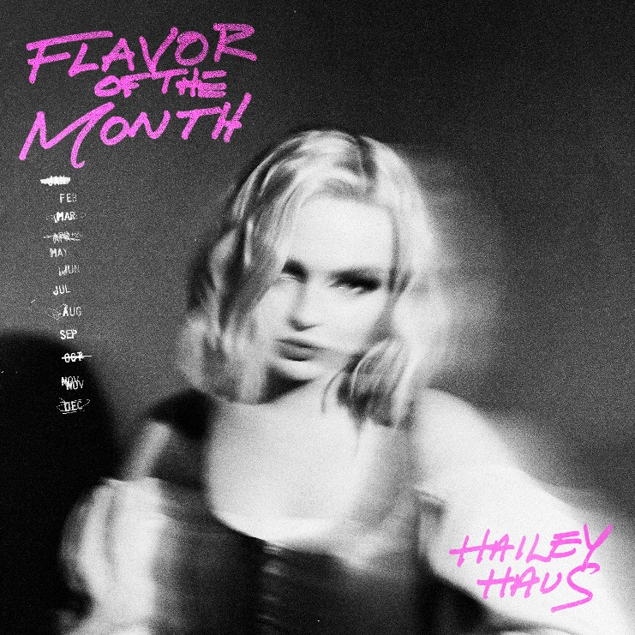
DOWNLOAD HI-RES ARTWORK HERE
FOLLOW HAILEY HAUS:
TikTok | Instagram | Twitter

# # #

MEDIA CONTACT:
Nathalie Rubin
nathalierubin@elektra.com

