**HASTINGS RETURNS WITH BRAND NEW SINGLE**

**“HURT MY FEELINGS”**

**LISTEN** [**HERE**](https://nam04.safelinks.protection.outlook.com/?url=http%3A%2F%2Fhastings.lnk.to%2Fhurtmyfeelings&data=05%7C01%7CDestinyDominguez%40elektra.com%7Cc970f9fd22544d01a7b908da4aebf3e3%7C8367939002ec4ba1ad3d69da3fdd637e%7C0%7C0%7C637904674519962244%7CUnknown%7CTWFpbGZsb3d8eyJWIjoiMC4wLjAwMDAiLCJQIjoiV2luMzIiLCJBTiI6Ik1haWwiLCJXVCI6Mn0%3D%7C3000%7C%7C%7C&sdata=Z7yJuJ7zv3%2B80pWJ80jW75Wgo8EQ9t2SNIQ8l7hs0Ps%3D&reserved=0) **| WATCH THE VISUALIZER** [**HERE**](https://nam04.safelinks.protection.outlook.com/?url=https%3A%2F%2Fyoutu.be%2FLDZwyH9wGI4&data=05%7C01%7CDestinyDominguez%40elektra.com%7Cc970f9fd22544d01a7b908da4aebf3e3%7C8367939002ec4ba1ad3d69da3fdd637e%7C0%7C0%7C637904674519962244%7CUnknown%7CTWFpbGZsb3d8eyJWIjoiMC4wLjAwMDAiLCJQIjoiV2luMzIiLCJBTiI6Ik1haWwiLCJXVCI6Mn0%3D%7C3000%7C%7C%7C&sdata=SkJ1klSc3IYwvGVGACgEWeQbJhF%2FobZdx9Pgz9JQk7E%3D&reserved=0)

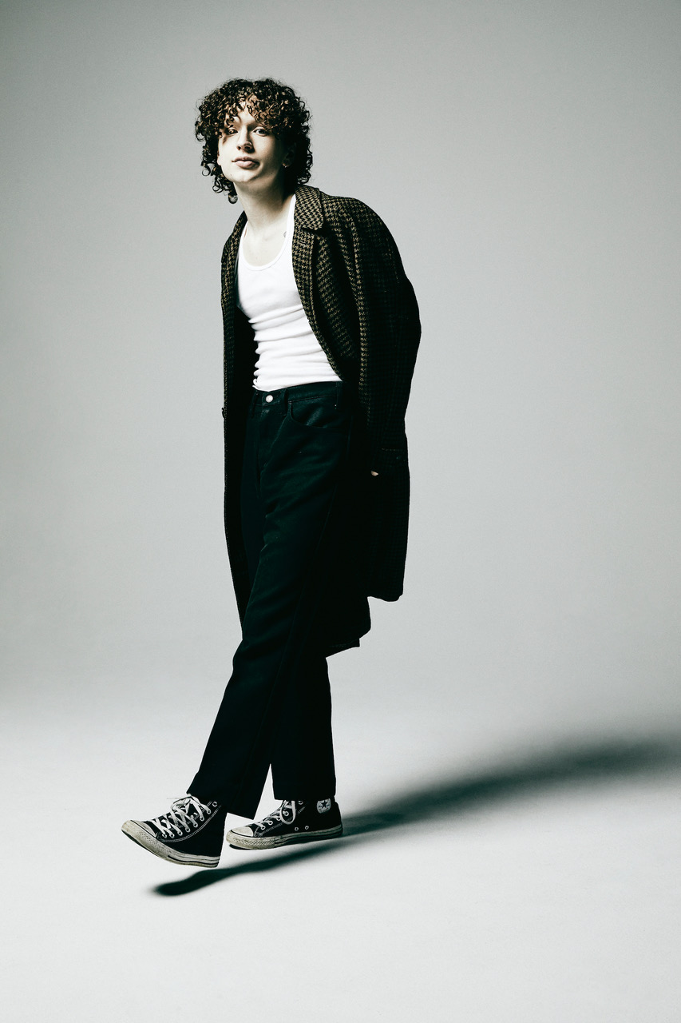

*Photo credit: Jimmy Fontaine*

**JUNE 10, 2022** - Rising Nashville-based singer, songwriter, and producer **Hastings** has returned with his brand new single **“**[**Hurt My Feelings**](https://nam04.safelinks.protection.outlook.com/?url=http%3A%2F%2Fhastings.lnk.to%2Fhurtmyfeelings&data=05%7C01%7CDestinyDominguez%40elektra.com%7Cc970f9fd22544d01a7b908da4aebf3e3%7C8367939002ec4ba1ad3d69da3fdd637e%7C0%7C0%7C637904674519962244%7CUnknown%7CTWFpbGZsb3d8eyJWIjoiMC4wLjAwMDAiLCJQIjoiV2luMzIiLCJBTiI6Ik1haWwiLCJXVCI6Mn0%3D%7C3000%7C%7C%7C&sdata=Z7yJuJ7zv3%2B80pWJ80jW75Wgo8EQ9t2SNIQ8l7hs0Ps%3D&reserved=0)**.”** The addictive track arrives alongside an official visualizer, which is streaming now on Hastings’ [official YouTube channel](https://nam04.safelinks.protection.outlook.com/?url=https%3A%2F%2Fyoutu.be%2FLDZwyH9wGI4&data=05%7C01%7CDestinyDominguez%40elektra.com%7Cc970f9fd22544d01a7b908da4aebf3e3%7C8367939002ec4ba1ad3d69da3fdd637e%7C0%7C0%7C637904674519962244%7CUnknown%7CTWFpbGZsb3d8eyJWIjoiMC4wLjAwMDAiLCJQIjoiV2luMzIiLCJBTiI6Ik1haWwiLCJXVCI6Mn0%3D%7C3000%7C%7C%7C&sdata=SkJ1klSc3IYwvGVGACgEWeQbJhF%2FobZdx9Pgz9JQk7E%3D&reserved=0). “Hurt My Feelings” is available now via DBLBLK Records [HERE](https://nam04.safelinks.protection.outlook.com/?url=http%3A%2F%2Fhastings.lnk.to%2Fhurtmyfeelings&data=05%7C01%7CDestinyDominguez%40elektra.com%7Cc970f9fd22544d01a7b908da4aebf3e3%7C8367939002ec4ba1ad3d69da3fdd637e%7C0%7C0%7C637904674519962244%7CUnknown%7CTWFpbGZsb3d8eyJWIjoiMC4wLjAwMDAiLCJQIjoiV2luMzIiLCJBTiI6Ik1haWwiLCJXVCI6Mn0%3D%7C3000%7C%7C%7C&sdata=Z7yJuJ7zv3%2B80pWJ80jW75Wgo8EQ9t2SNIQ8l7hs0Ps%3D&reserved=0).

Hastings expanded on the single, “*This song came together so seamlessly. I wrote it from a place of past toxic relationships and just needing a reason to ‘give it up.’ I finished it the day before I went on my first tour and it quickly turned into my favorite to perform.*”

“Hurt My Feelings” marks Hastings’ first new music of 2022 and follows the December release of his self-titled debut EP. Hastings began rolling out the EP with the release of his first-ever single “[Heart’s Not In It](https://nam04.safelinks.protection.outlook.com/?url=https%3A%2F%2Fhastings.lnk.to%2Fheartsnotinit&data=05%7C01%7CDestinyDominguez%40elektra.com%7Cc970f9fd22544d01a7b908da4aebf3e3%7C8367939002ec4ba1ad3d69da3fdd637e%7C0%7C0%7C637904674519962244%7CUnknown%7CTWFpbGZsb3d8eyJWIjoiMC4wLjAwMDAiLCJQIjoiV2luMzIiLCJBTiI6Ik1haWwiLCJXVCI6Mn0%3D%7C3000%7C%7C%7C&sdata=blSEdDpugXNH5jRlY33gIXVeBxOFRtkMg0pQTaGRI64%3D&reserved=0),” which arrived to immediate critical praise, with **Billboard** applauding, “*‘Heart’s Not In It’ shows off his easy, immediate melodicism… the interplay between a looped guitar riff and thwacking synths explodes into a glorious pop sing-along*.” **Teen Vogue** praised the “*funky, guitar-based track*” in their Best New Music list, while **The Honey Pop** proclaimed, “*We have a feeling you’re going to be hearing his name for a long time*.” “[Chapstick](https://nam04.safelinks.protection.outlook.com/?url=https%3A%2F%2Fhastings.lnk.to%2FChapstick&data=05%7C01%7CDestinyDominguez%40elektra.com%7Cc970f9fd22544d01a7b908da4aebf3e3%7C8367939002ec4ba1ad3d69da3fdd637e%7C0%7C0%7C637904674519962244%7CUnknown%7CTWFpbGZsb3d8eyJWIjoiMC4wLjAwMDAiLCJQIjoiV2luMzIiLCJBTiI6Ik1haWwiLCJXVCI6Mn0%3D%7C3000%7C%7C%7C&sdata=fM5LHW%2B0Nd4%2BP2FTH25DlgKa9vA%2B29DmUeJKT%2F0vlOo%3D&reserved=0)” was championed by **Sweety High** for its “*irresistible chorus*,” while “[Blank Me](https://nam04.safelinks.protection.outlook.com/?url=https%3A%2F%2Fwww.youtube.com%2Fwatch%3Fv%3DBQzDV0a5z_I%26feature%3Dyoutu.be&data=05%7C01%7CDestinyDominguez%40elektra.com%7Cc970f9fd22544d01a7b908da4aebf3e3%7C8367939002ec4ba1ad3d69da3fdd637e%7C0%7C0%7C637904674519962244%7CUnknown%7CTWFpbGZsb3d8eyJWIjoiMC4wLjAwMDAiLCJQIjoiV2luMzIiLCJBTiI6Ik1haWwiLCJXVCI6Mn0%3D%7C3000%7C%7C%7C&sdata=8vgUyasdGSL4NXCoAANl5Dk%2Fg79oZ9hax97%2BUJ2jwKM%3D&reserved=0)” became an instant fan-favorite in Hastings’ live show.

Last month, Hastings made his festival debut at Alabama’s Hangout Festival after wrapping up dates supporting The Band CAMINO on the first leg of their headline tour. The five-week trek saw him perform to sold out crowds across North America at venues including Los Angeles’s The Novo and New York City’s Terminal 5. Hastings recently spoke with tourmates The Band CAMINO and flor about the run in an exclusive interview with **SPIN**. Watch [HERE](https://nam04.safelinks.protection.outlook.com/?url=https%3A%2F%2Fwww.spin.com%2F2022%2F06%2Fband-camino-flor-hastings-artist%2F&data=05%7C01%7CDestinyDominguez%40elektra.com%7Cc970f9fd22544d01a7b908da4aebf3e3%7C8367939002ec4ba1ad3d69da3fdd637e%7C0%7C0%7C637904674519962244%7CUnknown%7CTWFpbGZsb3d8eyJWIjoiMC4wLjAwMDAiLCJQIjoiV2luMzIiLCJBTiI6Ik1haWwiLCJXVCI6Mn0%3D%7C3000%7C%7C%7C&sdata=kbVGHoZtdRYYHUjP5UlZB%2FBNVwomfofTmnybiE9lx6M%3D&reserved=0). The Band CAMINO also welcomed him onstage to perform “Roses”, which he co-wrote, at Nashville, TN’s famed Ryman Auditorium. Watch [HERE](https://nam04.safelinks.protection.outlook.com/?url=https%25253A%25252F%25252Fwww.instagram.com%25252Fp%25252FCUNs-7MrJn6%25252F&data=04%25257C01%25257CSydneyWorden%252540elektra.com%25257Ccaa65cc1de844667766b08d993d1f025%25257C8367939002ec4ba1ad3d69da3fdd637e%25257C0%25257C0%25257C637703352188592646%25257CUnknown%25257CTWFpbGZsb3d8eyJWIjoiMC4wLjAwMDAiLCJQIjoiV2luMzIiLCJBTiI6Ik1haWwiLCJXVCI6Mn0%25253D%25257C1000&sdata=yG1IGvJP4j64glHXLto28siksEQA6KTAWufVu%25252BI%25252BhaA%25253D&reserved=0).

Hastings is expected to return to the road in the coming months. Stay tuned for upcoming tour dates.

**HASTINGS**

**“HURT MY FEELINGS”**

[**AVAILABLE NOW**](https://nam04.safelinks.protection.outlook.com/?url=http%3A%2F%2Fhastings.lnk.to%2Fhurtmyfeelings&data=05%7C01%7CDestinyDominguez%40elektra.com%7Cc970f9fd22544d01a7b908da4aebf3e3%7C8367939002ec4ba1ad3d69da3fdd637e%7C0%7C0%7C637904674519962244%7CUnknown%7CTWFpbGZsb3d8eyJWIjoiMC4wLjAwMDAiLCJQIjoiV2luMzIiLCJBTiI6Ik1haWwiLCJXVCI6Mn0%3D%7C3000%7C%7C%7C&sdata=Z7yJuJ7zv3%2B80pWJ80jW75Wgo8EQ9t2SNIQ8l7hs0Ps%3D&reserved=0)

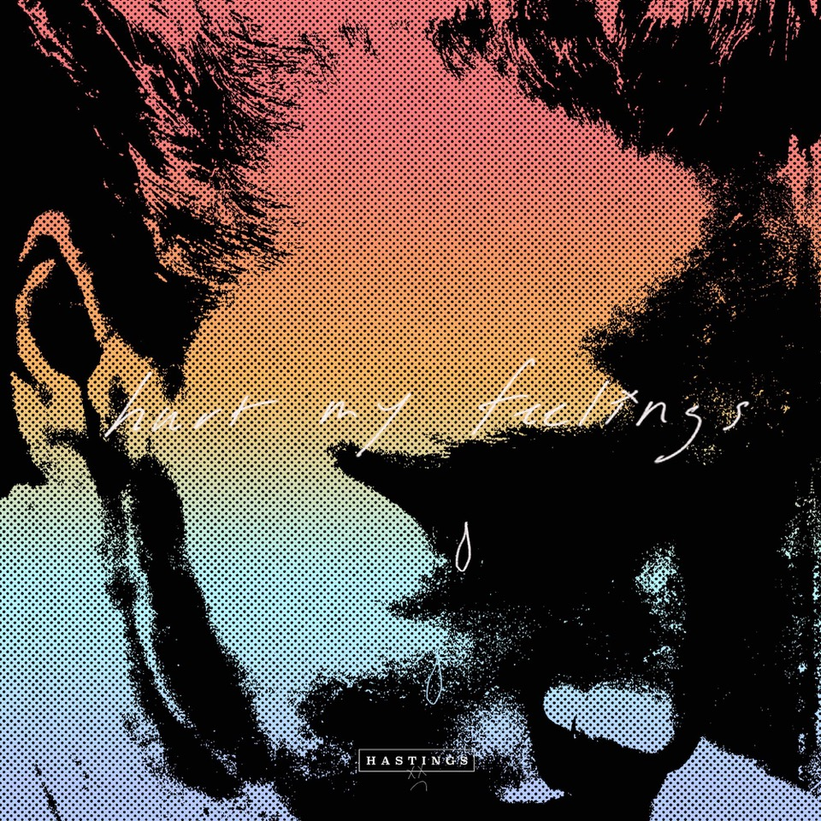

**About Hastings:**

Every once in a while, you’ll hear a song that nudges you to walk across the room and introduce yourself to a stranger, FaceTime your ex, or even change your life. Hastings strives to make those kinds of songs. The Nashville-based singer, songwriter, multi-instrumentalist, and producer couples straightforward lyrical eloquence with guitar-shaped soundscapes and traffic-stopping vocal acrobatics. Growing up between Florida, Michigan, and Tennessee, he cut his teeth by playing drums on his father’s worship team at the age of three before learning guitar and piano. After getting his drivers license at 16-years-old, he asked his parents to let him move to Nashville to pursue music - and his dad tossed him the keys. Hastings integrated himself into the city’s scene slowly but surely, in between finishing his GED. During 2018, he serendipitously met Garrison Burgess of The Band CAMINO and wound-up living with him and spending countless hours writing and recording together. Behind the scenes, he co-wrote the single “Roses” for The Band CAMINO and “Don’t Blame Me” for Kingston Hythe. Simultaneously, his solo demos caught the attention of DBLBLK Records. Now, he presents a sharp and scorching signature style on his debut *Hastings* EP.

**CONNECT WITH HASTINGS**

[Website](https://nam04.safelinks.protection.outlook.com/?url=https%25253A%25252F%25252Fwww.imhastings.com%25252F&data=04%25257C01%25257CSydneyWorden%252540elektra.com%25257Ccaa65cc1de844667766b08d993d1f025%25257C8367939002ec4ba1ad3d69da3fdd637e%25257C0%25257C0%25257C637703352188602624%25257CUnknown%25257CTWFpbGZsb3d8eyJWIjoiMC4wLjAwMDAiLCJQIjoiV2luMzIiLCJBTiI6Ik1haWwiLCJXVCI6Mn0%25253D%25257C1000&sdata=pu0%25252BWjs1DfWrTaauDAXbc4elGQ%25252FPER4RRJbLbJyqiYA%25253D&reserved=0)

[Instagram](https://nam04.safelinks.protection.outlook.com/?url=https%25253A%25252F%25252Fwww.instagram.com%25252Fimhastings%25252F&data=04%25257C01%25257CSydneyWorden%252540elektra.com%25257Ccaa65cc1de844667766b08d993d1f025%25257C8367939002ec4ba1ad3d69da3fdd637e%25257C0%25257C0%25257C637703352188602624%25257CUnknown%25257CTWFpbGZsb3d8eyJWIjoiMC4wLjAwMDAiLCJQIjoiV2luMzIiLCJBTiI6Ik1haWwiLCJXVCI6Mn0%25253D%25257C1000&sdata=5DKgPKsynwLNjg%25252BWIrXC3aYl5grM0AT8gtIXXY%25252FgGYY%25253D&reserved=0)

[YouTube](https://nam04.safelinks.protection.outlook.com/?url=https%25253A%25252F%25252Fwww.youtube.com%25252Fchannel%25252FUCOiD5tZQ6MlNjom-eGCsgXA%25252Ffeatured&data=04%25257C01%25257CSydneyWorden%252540elektra.com%25257Ccaa65cc1de844667766b08d993d1f025%25257C8367939002ec4ba1ad3d69da3fdd637e%25257C0%25257C0%25257C637703352188612620%25257CUnknown%25257CTWFpbGZsb3d8eyJWIjoiMC4wLjAwMDAiLCJQIjoiV2luMzIiLCJBTiI6Ik1haWwiLCJXVCI6Mn0%25253D%25257C1000&sdata=jWWYDBIc1%25252F%25252B3StTCc7SwQz9Q8E4T9ubABeujYoEs%25252B9M%25253D&reserved=0)

[Twitter](https://nam04.safelinks.protection.outlook.com/?url=https%25253A%25252F%25252Ftwitter.com%25252Fimhastingss&data=04%25257C01%25257CSydneyWorden%252540elektra.com%25257Ccaa65cc1de844667766b08d993d1f025%25257C8367939002ec4ba1ad3d69da3fdd637e%25257C0%25257C0%25257C637703352188612620%25257CUnknown%25257CTWFpbGZsb3d8eyJWIjoiMC4wLjAwMDAiLCJQIjoiV2luMzIiLCJBTiI6Ik1haWwiLCJXVCI6Mn0%25253D%25257C1000&sdata=Tr6lTKbqjTrGHOjEw%25252FhNUOIVze0zN0aiNDcbhjlK2J4%25253D&reserved=0)

[TikTok](https://nam04.safelinks.protection.outlook.com/?url=https%25253A%25252F%25252Fwww.tiktok.com%25252F%252540imhastingss%25253F&data=04%25257C01%25257CSydneyWorden%252540elektra.com%25257Ccaa65cc1de844667766b08d993d1f025%25257C8367939002ec4ba1ad3d69da3fdd637e%25257C0%25257C0%25257C637703352188622610%25257CUnknown%25257CTWFpbGZsb3d8eyJWIjoiMC4wLjAwMDAiLCJQIjoiV2luMzIiLCJBTiI6Ik1haWwiLCJXVCI6Mn0%25253D%25257C1000&sdata=L%25252Fw4jdMytbT%25252FBpAHvBpyHDU%25252F%25252BxsNErHm8iNdl5F8Yuc%25253D&reserved=0)

**For all press inquiries, please contact:**

Sarah Goldstein - [sarahgoldstein@elektra.com](mailto:sarahgoldstein@elektra.com)

Collin Citron - [collincitron@elektra.com](mailto:collincitron@elektra.com)