**HO99O9 DETAIL NEW ALBUM “*SKIN”* OUT MARCH 11TH**

**PRODUCED BY TRAVIS BARKER WITH FEATURES FROM COREY TAYLOR, BUN B, SAUL WILLIAMS AND JASIAH**

**WATCH THE VIDEO FOR “**[**NUGE SNIGHT**](https://nam04.safelinks.protection.outlook.com/?url=https%3A%2F%2Fwww.youtube.com%2Fwatch%3Fv%3D4Nm_gy0CfLI&data=04%7C01%7CDestinyDominguez%40elektra.com%7Ceabe723b1ea64470b07c08d9ed996611%7C8367939002ec4ba1ad3d69da3fdd637e%7C0%7C0%7C637802065396987451%7CUnknown%7CTWFpbGZsb3d8eyJWIjoiMC4wLjAwMDAiLCJQIjoiV2luMzIiLCJBTiI6Ik1haWwiLCJXVCI6Mn0%3D%7C3000&sdata=La%2BeeSgRvbVos2ODZsNGpDZLwLGuJQChQgTKukiA8Uc%3D&reserved=0)**”**

**ANNOUNCE HEADLINE TOUR**

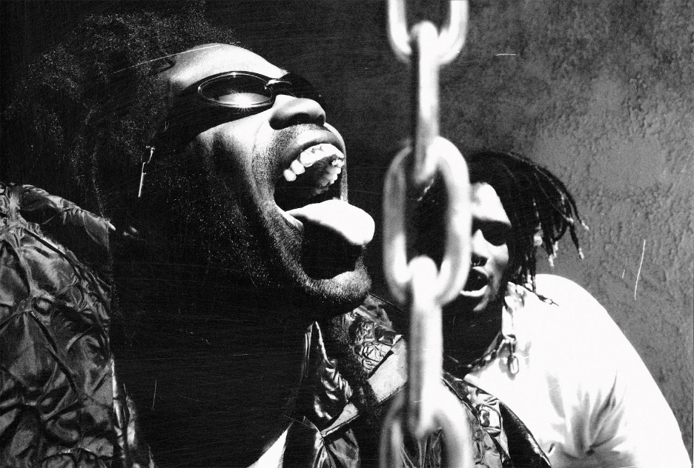

LA punks Ho99o9 (horror) have announced their sophomore album *Skin* out March 25th via DTA records. The album, fully produced by Travis Barker, will feature Corey Taylor, Bun B, Saul Williams and Jasiah. *Skin* is the most refined project from Ho99o9 to date while still being noisier and more aggressive than their earlier work. It’s a searing document of a world on fire, distilling all of the turbulence and free-floating confusion and anxiety of our present moment into 12 tightly wound tracks that signal a new era for Ho99o9 and the sonic movement they’re spearheading. Today you can watch the video for their new track “Nuge Snight”, the first song that came out of the Barker collaboration.

The band was recently announced as support on the upcoming Slipknot tour and today they’ve announced a headline tour of their own. Kicking off April 15th with a hometown show in LA at the Echoplex and wrapping a month later in Houston the 22 date tour will make stops in San Francisco, Chicago, DC, New York, Atlanta and many more (full dates below).

When the duo of Yeti Bones and theOGM who make up Ho99o9 kicked in the doors in 2014 with an iconically off-the-rails set at the AFROPUNK festival, they set a noisy new standard for industrial-grade, punk-influenced hip-hop, colliding the DMX and Bone Thugs they grew up listening to in Jersey headfirst with bands like Bad Brains and the Ninjasonik that they absorbed after discovering the NYC DIY scene. With a steady stream of mixtapes, EPs, singles, and their 2017 debut LP *United States of Horror*, they’ve continued to raise the bar for sonic chaos, drawing critical raves, building a cultishly devoted following, and earning the respect of iconic audio anarchists like Mike Patton (who invited them to open for Mr. Bungle and Dead Cross) and The Prodigy (who featured them on the 2018 single “Fight Fire With Fire”) among others.

**Watch the video for “BATTERY NOT INCLUDED”**: [https://www.youtube.com/watch?v=CVer3xql9Jo](https://nam04.safelinks.protection.outlook.com/?url=https%3A%2F%2Fwww.youtube.com%2Fwatch%3Fv%3DCVer3xql9Jo&data=04%7C01%7CDestinyDominguez%40elektra.com%7Ceabe723b1ea64470b07c08d9ed996611%7C8367939002ec4ba1ad3d69da3fdd637e%7C0%7C0%7C637802065397143688%7CUnknown%7CTWFpbGZsb3d8eyJWIjoiMC4wLjAwMDAiLCJQIjoiV2luMzIiLCJBTiI6Ik1haWwiLCJXVCI6Mn0%3D%7C3000&sdata=Qio71AMGtDWkQRdDFweg20ybs75qx8kMk%2BvXqBWH17o%3D&reserved=0)

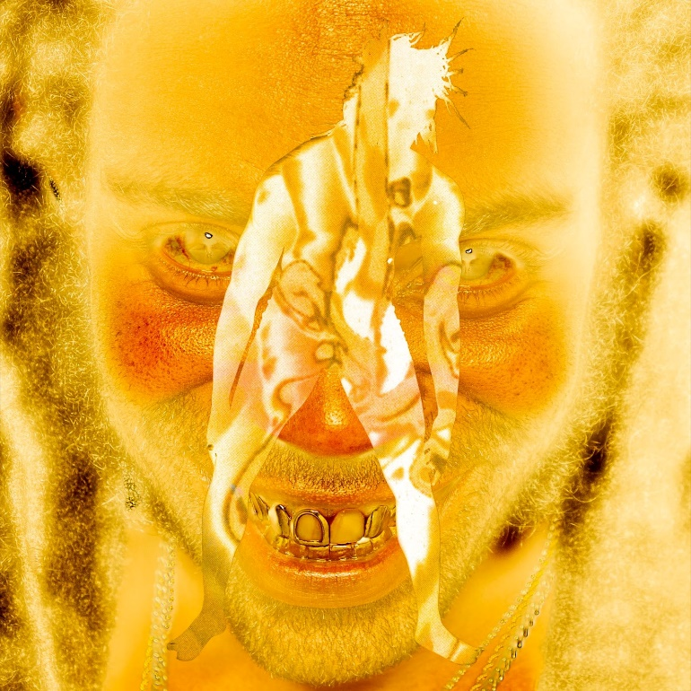

Album Art Credit - Jesse Draxler

***SKIN* TRACKLISTING**

NUGE SNIGHT

BATTERY NOT INCLUDED

BITE MY FACE ft. COREY TAYLOR

SLO BREAD ft. BUN B

THE WORLD, THE FLESH, THE DEVIL

PROTECT MY BITCH PT. 2

…SPEAK OF THE DEVIL

SKINHEAD ft. SAUL WILLIAMS

LOWER THAN SCUM

DEVIL AT THE CROSSROADS

LIMITS ft. JASIAH

DEAD OR ASLEEP

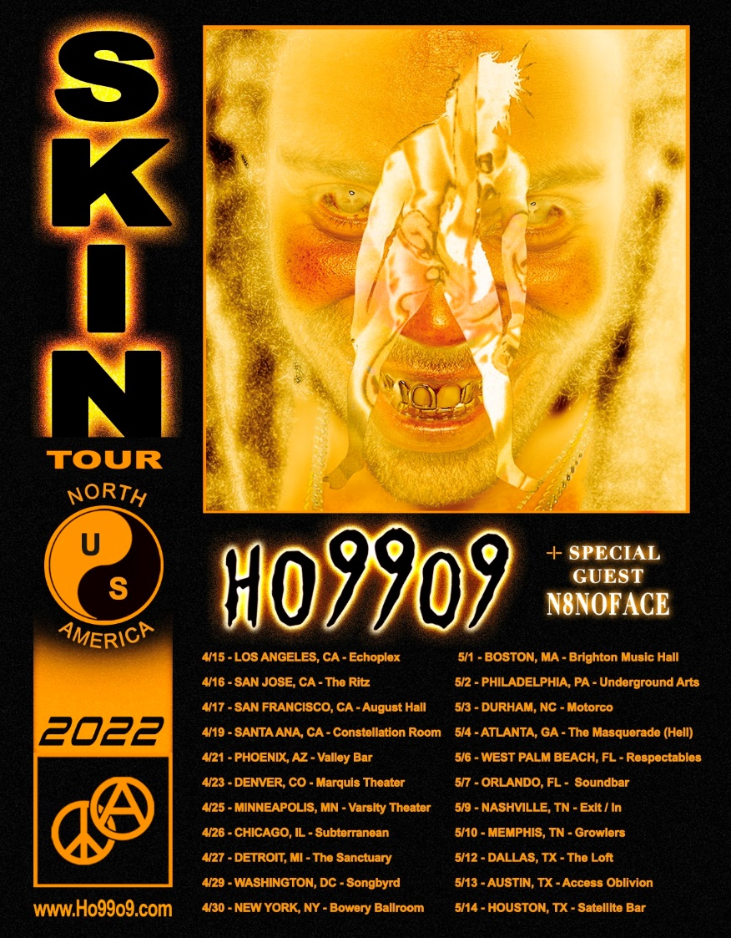

***SKIN* TOUR DATES**

April 15 - Los Angeles - Echoplex

April 16 - San Jose - The Ritz

April 17 - San Francisco - August Hall

April 19 - Santa Ana - Constellation Room

April 21 - Phoenix - Valley Bar

April 23 - Denver - Marquis Theater

April 25 - Minneapolis - Varsity Theater

April 26 - Chicago - Subterranean

April 27 - Detroit - The Sanctuary

April 29 - Washington D.C. - Songbyrd

April 30 - New York City - Bowery Ballroom

May 1 - Boston - Brighton Music Hall

May 2 - Philadelphia - Underground Arts

May 3 - Durham, NC - Motorco

May 4 - Atlanta - The Masquerade (HELL)

May 6 - West Palm Beach - Respectables

May 7 - Orlando - Henao Center

May 9 - Nashville - Exit/In

May 10 - Memphis - Growlers

May 12 - Dallas - The Loft

May 13 - Austin - SS Oblivion @ Cheer Up Charlies

May 14 - Houston - Satellite Bar