For Immediate Release
April 30, 2020
THE HIGHWOMEN UNVEIL OFFICIAL MUSIC VIDEO FOR “CROWDED TABLE”
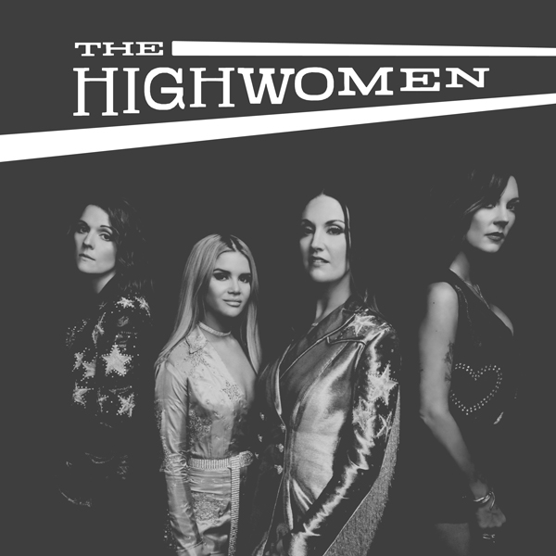
The official music video for The Highwomen’s “Crowded Table” is debuting today. Watch/ share HERE.
Filmed throughout the making of their acclaimed, self-titled debut album, the video features appearances by the collaborative movement’s founding members—Brandi Carlile, Natalie Hemby, Maren Morris and Amanda Shires—along with Sheryl Crow, Jason Isbell, Yola, Tim and Phil Hanseroth and more. The “anthem for our time” (“CBS This Morning”) and “hymn of togetherness and support” (Rolling Stone) also serves as the centerpiece of Campbell Soup Company’s new commercial, “We All Want a House with a Crowded Table.” Watch/share here.
Produced by GRAMMY Award-winning producer Dave Cobb, The Highwomen debuted at #1 on Billboard’s Top Country Albums chart and landed on numerous year-end lists including NPR Music, Rolling Stone, Billboard, Esquire, Variety, Entertainment Weekly, Vulture, Stereogum, The Atlantic, Slate, American Songwriter, Consequence of Sound, Paste and the Los Angeles Times among many others. The album’s release also resulted in a Group of the Year nomination at the 55th ACM Awards making The Highwomen the first all-female group to be nominated in the category since the Dixie Chicks in 2003.
Overwhelming critical praise for The Highwomen…
“this is a much-needed shot in the arm from talented female
singer-songwriters.”—American Songwriter
“The album is groundbreaking. It pays homage to the best parts of classic country music, displaying expert instrumentation, tight harmonies and ringing vocals. Yet, it is unafraid to challenge the genre’s norms and shortcomings in a way that is nonabrasive.”—Associated Press
“Feminist, communal, and unapologetic, it’s very 2019. But in so powerfully celebrating something too often treated as taboo, it’s also classic outlaw fare.”—The Atlantic
“a new supergroup that believes that if you’re going to dream, you might as well dream big…whose sweet harmonies and straightforward melody look back into country’s past while its empowering lyrics keep their eyes fixed on the future.”—The A.V. Club
“Raw vulnerability is a show of strength, and the Highwomen
offered up ample proof of that”—Billboard
“a beautiful and harmonious message of love, laughter and open hands welcoming all to
the party. The music has a classic, timeless Country feel and uses poetry, storytelling and empathy to create the sound of freedom.”—CMA Close Up
“a natural and overdue fit for the world of country music…They see the work
that needs to be done, and they’re doing it, whatever it takes—in spite of the struggle, in
spite of and against the people who underestimate them, they’re making it work. What
could be more country than that?”—Consequence of Sound
“goose-bump-inducing harmonies…As solo singer-songwriters, the women
are formidable; together, they are sublime.”—Entertainment Weekly
“Pooling their strengths in this supergroup creates a Voltron that radiates heart,
humor, and high times.”—Entertainment Weekly
“they are devastating, charming, and, above all, undeniable…Listening
doesn't just feel good, but vital.”—Esquire
“exemplifies the strength and spirit of The Highwomen and sets a
positive tone for what’s to come.”—Forbes
“a powerful and poignant message”—Grammy.com
“four of the best songwriters, singers and musicians working today”—Nashville Scene
“an all-female supergroup that’s just daring country
radio to shut it out.”—New York Magazine
“a haunting, powerful tribute to the resilience of women through
the ages.”—The New York Times
“They wield that power with purpose, grace, humor and, above all, great music that
stands entirely on its own.” —NPR All Things Considered
“subject wise, timing wise; perfect and wonderful”—NPR Music
“The supergroup we’ve been waiting for is finally here, and it’s perfect.”—Nylon
“The Highwomen are taking the music industry by storm…a group of talented,
powerful women making their mark on music.”—Paste
“The Highwaymen have often been called country’s best supergroup, but the
Highwomen are better. They do here what the men never could—stretch the notions
of what country can and must become.”—Pitchfork
“This isn’t a song. This isn’t a supergroup. It’s a motherfucking movement.”—Refinery29
“as powerful as musical storytelling gets.”— Rolling Stone
“The Highwomen is a country album for the ages, filled with joy, laughter, tears,
pain, and shit-kicking honky-tonk soul.”—Rolling Stone Country
“The project is void of any filters or artificial flash, their voices so pure as they directly connect with the listener. The group’s poignant lyrics embrace honesty, observation and acknowledgement of the past with a grasp on a progressive future, making The Highwomen an important figure not only in music, but the modern world.”—Sounds Like Nashville
“The Highwomen are the country supergroup this moment demands…The
album is a creative triumph and a meaningful cultural artifact; the joy and resilience
emanating off it is worth a fortune.”—Stereogum
“an album that’s purely country—one that proves what at least half of the
population already knows: women have stories that are worth telling. The Highwomen
delivered a genuine take on our stories, borrowing from the best of the country genre,
while taking it in a new direction.”—Texas Monthly
“a polished melding of minds and talents...the band’s resistance lies in their very
existence as women who refuse to accept the status quo.”—Texas Observer
“The Highwomen aren’t just redesigning women, they’re redesigning the way the fairer
sex are seen in the music industry—whether that’s in country…or in pop.”—UPROXX
“a debut album with instant-classic potential.”—USA Today
“If you believe there can be such a thing as an instant country
classic, ‘The Highwomen’ is that.”—Variety
“Carlile, Hemby, Morris, and Shires are claiming their place in the Highwaymen’s lineage of heroic lore and in country music’s rich tradition of female supergroups.”—Vulture
“flawless realizations of a timeless goal of country songs: identifying and spotlighting
real-life experiences unexplored before.”—The Wall Street Journal
“flush with generosity, virtue and goodwill”—The Washington Post
“Ace musicianship, beautiful harmonies and an important
sociopolitical message”—Wide Open Country
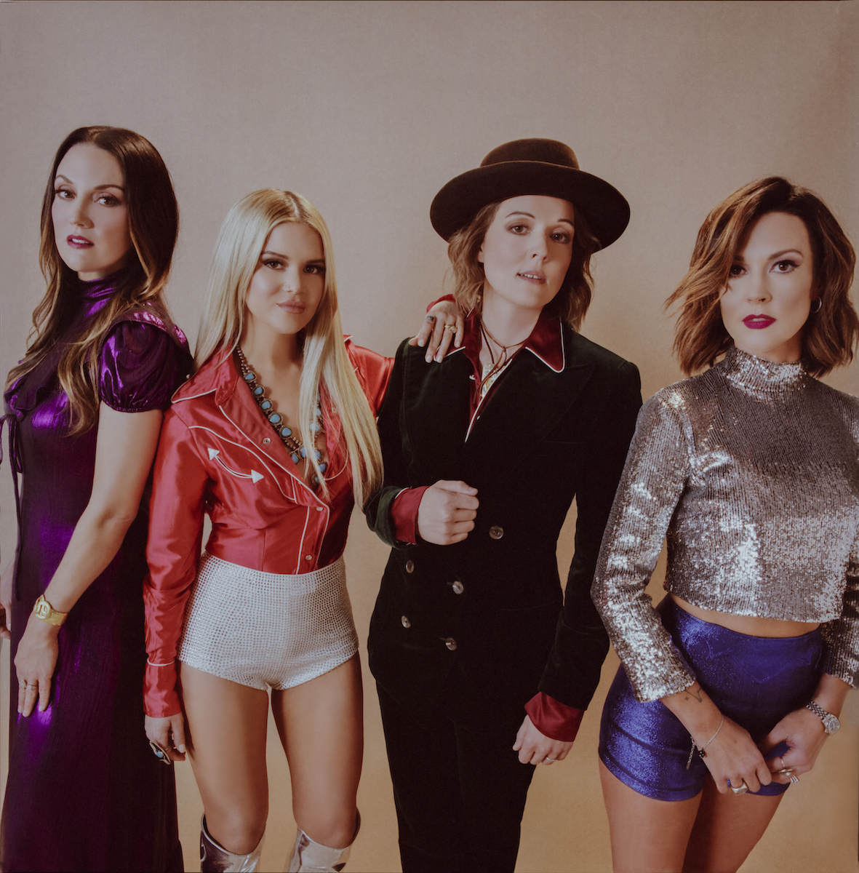
Photo credit: Alysse Gafkjen
THE HIGHWOMEN TRACK LIST
1. Highwomen (written by Jimmy Webb, Amanda Shires, Brandi Carlile)
2. Redesigning Women (written by Natalie Hemby, Rodney Clawson)
3. Loose Change (written by Maren Morris, Maggie Chapman, Daniel Layus)
4. Crowded Table (written by Natalie Hemby, Lori McKenna, Brandi Carlile)
5. My Name Can’t Be Mama (written by Brandi Carlile, Maren Morris, Amanda Shires)
6. If She Ever Leaves Me (written by Amanda Shires, Jason Isbell, Chris Thompkins)
7. Old Soul (written by Maren Morris, Luke Dick, Laura Veltz)
8. Don’t Call Me (written by Amanda Shires, Peter Levin)
9. My Only Child (written by Natalie Hemby, Amanda Shires, Miranda Lambert)
10. Heaven Is A Honky Tonk (written by Brandi Carlile, Natalie Hemby, Ray LaMontagne)
11. Cocktail And A Song (written by Amanda Shires)
12. Wheels Of Laredo (written by Tim Hanseroth, Brandi Carlile, Phil Hanseroth)
www.thehighwomen.com
For more information, please contact Asha Goodman 615.320.7753,
Catherine Snead 615.320.7753 or Carla Sacks 212.741.1000 at Sacks & Co., asha.goodman@sacksco.com, catherine.sneak@sacksco.com or carla@sacksco.com.

