For Immediate Release September 16, 2019
THE HIGHWOMEN DEBUTS AT #1 ON BILLBOARD’S TOP COUNTRY ALBUMS CHART, #10 ON THE BILLBOARD 200 AND
#4 ON BILLBOARD’S TOP CURRENT ALBUMS CHART
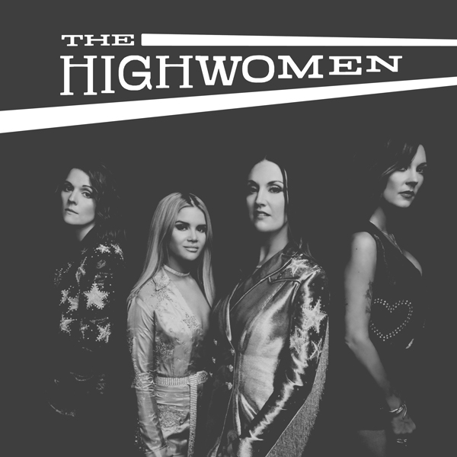
The Highwomen—the self-titled release from acclaimed collaborative movement formed by Brandi Carlile, Natalie Hemby, Maren Morris and Amanda Shires—debuts this week at #1 on Billboard’s Top Country Albums chart, #10 on the all-genre Billboard 200 and #4 on Billboard’s Top Current Albums chart with over 34,000 equivalent units sold.
Produced by GRAMMY Award-winning producer Dave Cobb, the album was released earlier this month via Low Country Sound/Elektra Records (stream/purchase here) and continues to receive overwhelming critical praise…
“this is a much needed shot in the arm from talented female singer-songwriters.”
—American Songwriter
“The album is groundbreaking. It pays homage to the best parts of classic country music, displaying expert instrumentation, tight harmonies and ringing vocals. Yet, it is unafraid to challenge the genre’s norms and shortcomings in a way that is nonabrasive.”—Associated Press
“Feminist, communal, and unapologetic, it’s very 2019. But in so powerfully celebrating something too often treated as taboo, it’s also classic outlaw fare.” —The Atlantic
“a new supergroup that believes that if you’re going to dream, you might as well dream big…whose sweet harmonies and straightforward melody look back into country’s past while its empowering lyrics keep their eyes fixed on the future.” —The A.V. Club
“Raw vulnerability is a show of strength, and the Highwomen offered up ample proof of that”
—Billboard
“a beautiful and harmonious message of love, laughter and open hands welcoming all to the party. The music has a classic, timeless Country feel and uses poetry, storytelling and empathy to create the sound of freedom.”—CMA Close Up
“a natural and overdue fit for the world of country music…They see the work that needs to be done, and they’re doing it, whatever it takes—in spite of the struggle, in spite of and against the people who underestimate them, they’re making it work. What could be more country than that?” —Consequence of Sound
“goose-bump-inducing harmonies…As solo singer-songwriters, the women are formidable; together, they are sublime.” —Entertainment Weekly
“they are devastating, charming, and, above all, undeniable…Listening doesn't just feel good, but vital.”—Esquire
“…exemplifies the strength and spirit of The Highwomen and sets a positive tone for what’s to come.” —Forbes
“a powerful and poignant message”—Grammy.com
“…four of the best songwriters, singers and musicians working today…”—Nashville Scene
“…an all-female supergroup that’s just daring country radio to shut it out.”
—New York Magazine
“a haunting, powerful tribute to the resilience of women through the ages.”
—The New York Times
“They wield that power with purpose, grace, humor and, above all, great music that stands entirely on its own.” —NPR All Things Considered
“subject wise, timing wise; perfect and wonderful”—NPR Music
“The supergroup we’ve been waiting for is finally here, and it’s perfect.” —Nylon
“The Highwomen are taking the music industry by storm…a group of talented, powerful women making their mark on music.” —Paste
“This isn’t a song. This isn’t a supergroup. It’s a motherfucking movement.”—Refinery29
“…as powerful as musical storytelling gets.”— Rolling Stone
“The Highwomen is a country album for the ages, filled with joy, laughter, tears, pain, and shit-kicking honky-tonk soul.”—Rolling Stone Country
“The project is void of any filters or artificial flash, their voices so pure as they directly connect with the listener. The group’s poignant lyrics embrace honesty, observation and acknowledgement of the past with a grasp on a progressive future, making The Highwomen an important figure not only in music, but the modern world.” —Sounds Like Nashville
“The Highwomen are the country supergroup this moment demands…The album is a creative triumph and a meaningful cultural artifact; the joy and resilience emanating off it is worth a fortune.”—Stereogum
“an album that’s purely country—one that proves what at least half of the population already knows: women have stories that are worth telling. The Highwomen delivered a genuine take on our stories, borrowing from the best of the country genre, while taking it in a new direction.”
—Texas Monthly
“a polished melding of minds and talents...the band’s resistance lies in their very existence as women who refuse to accept the status quo.” —Texas Observer
“a debut album with instant-classic potential.” —USA Today
“If you believe there can be such a thing as an instant country classic, ‘The Highwomen’ is that.” —Variety
“Carlile, Hemby, Morris, and Shires are claiming their place in the Highwaymen’s lineage of heroic lore and in country music’s rich tradition of female supergroups.”—Vulture
“…flawless realizations of a timeless goal of country songs: identifying and spotlighting real-life experiences unexplored before.”—The Wall Street Journal
“flush with generosity, virtue and goodwill”—The Washington Post
“Ace musicianship, beautiful harmonies and an important sociopolitical message…”
—Wide Open Country
In advance of the release, The Highwomen made their live concert debut at Newport Folk Festival earlier this summer. Of the landmark performance, and their only confirmed concert to date, Billboard praises, “set a sky-high standard with a performance that was the sum of its extraordinary parts,” while Rolling Stone declares, “it was clear that country music’s newest supergroup’s first time on stage had been a triumph.” The Highwomen also performed several songs with Dolly Parton at the festival as part of the all-female headline set curated by Carlile. Of the collaboration, Consequence of Sound proclaims, “now etched in legend as one of Newport Folk’s most memorable moments…a lifetime musical zenith.”
Continually demonstrating the importance of inclusion and collaboration, The Highwomen are joined by several guest musicians, vocalists and songwriters across the album. The project features Sheryl Crow (vocals, background vocals, bass), Yola (vocals, background vocals), Cobb (acoustic/electric guitar), Jason Isbell (acoustic/electric guitar), Phil Hanseroth (bass, background vocals), Tim Hanseroth (guitar, background vocals), Chris Powell (drums) and Peter Levin (piano and keyboards) with songs written by Carlile, Hemby, Morris, Shires, Isbell, the Hanseroth twins, Rodney Clawson, Lori McKenna, Miranda Lambert and Ray LaMontagne among many others.
“Anyone can be a Highwoman,” Carlile notes. “It’s about banding together, abandoning as much ego as humanly possible, holding one another up and amplifying other women every chance we get. Shoulder to shoulder. One push, one love.”
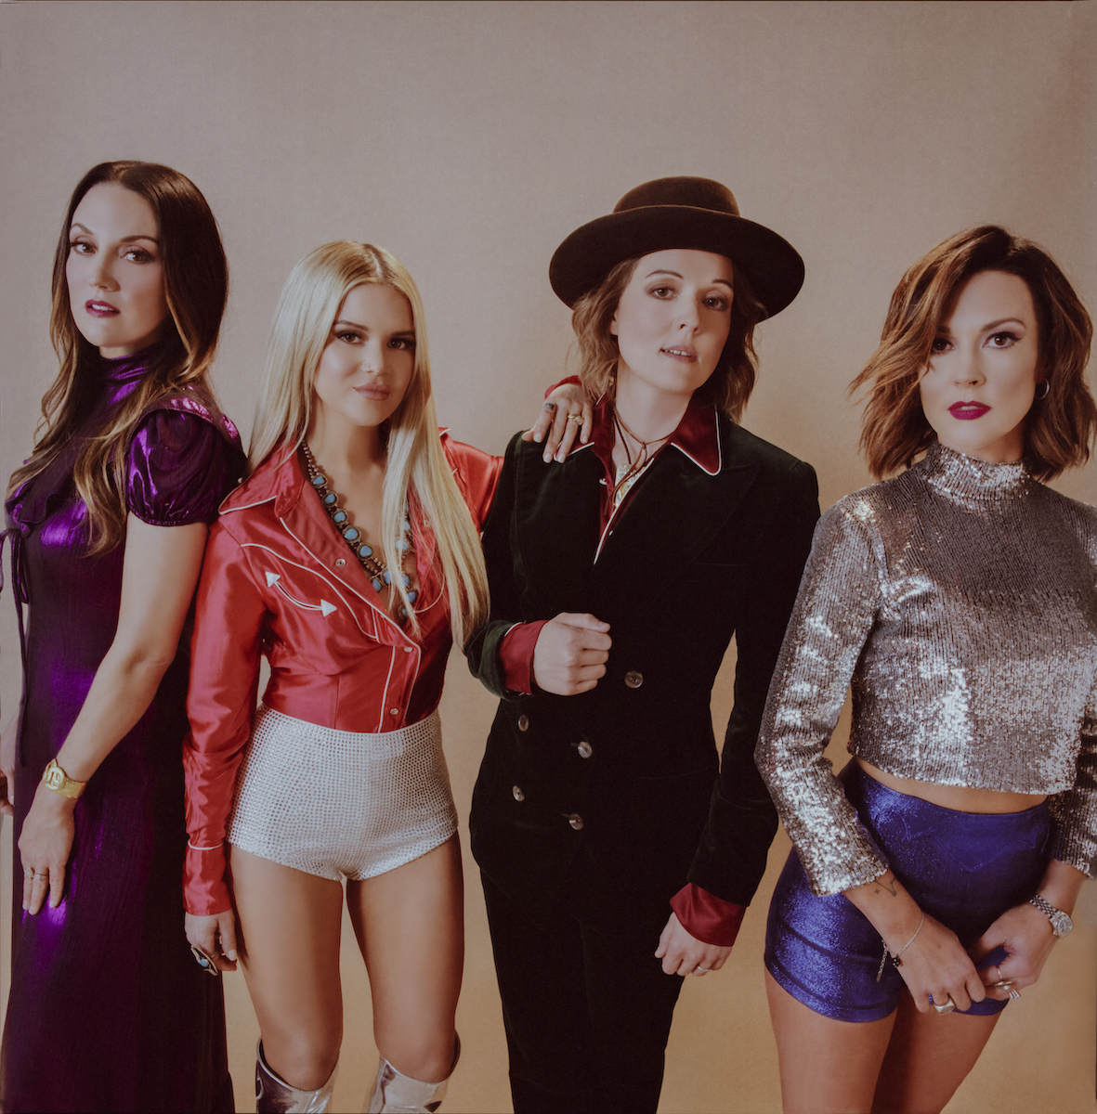
Photo credit: Alysse Gafkjen
THE HIGHWOMEN TRACK LIST
1. Highwomen (written by Jimmy Webb, Amanda Shires, Brandi Carlile)
2. Redesigning Women (written by Natalie Hemby, Rodney Clawson)
3. Loose Change (written by Maren Morris, Maggie Chapman, Daniel Layus)
4. Crowded Table (written by Natalie Hemby, Lori McKenna, Brandi Carlile)
5. My Name Can’t Be Mama (written by Brandi Carlile, Maren Morris, Amanda Shires)
6. If She Ever Leaves Me (written by Amanda Shires, Jason Isbell, Chris Thompkins)
7. Old Soul (written by Maren Morris, Luke Dick, Laura Veltz)
8. Don’t Call Me (written by Amanda Shires, Peter Levin)
9. My Only Child (written by Natalie Hemby, Amanda Shires, Miranda Lambert)
10. Heaven Is A Honky Tonk (written by Brandi Carlile, Natalie Hemby, Ray LaMontagne)
11. Cocktail And A Song (written by Amanda Shires)
12. Wheels Of Laredo (written by Tim Hanseroth, Brandi Carlile, Phil Hanseroth)
www.thehighwomen.com

