AUDIO UP MEDIA’S FOUR-PART SCRIPTED HALLOWEEN PODCAST HALLOWEEN IN HELL – STARRING DANA DENTATA, MACHINE GUN KELLY, TOMMY LEE, 24KGOLDN & IANN DIOR – PREMIERES FIRST TWO EPISODES TODAY

MUSICIAN AND DRUMMER, TOMMY LEE, SET TO PLAY THE DEVIL AND DRUM IN FEATURED TRACK FOR THE PODCAST

FIRST BATCH OF ORIGINAL MUSIC FEATURING 24KGOLDN, IANN DIOR & DANA DENTATA RELEASES TODAY AS SPECIAL FOUR-TRACK BUNDLE VIA SONY MUSIC RECORDS & AUDIO UP MUSIC

STREAM EPISODES HERE; GET MUSIC HERE
WATCH VISUAL TRAILER HERE; AUDIO TRAILER HERE
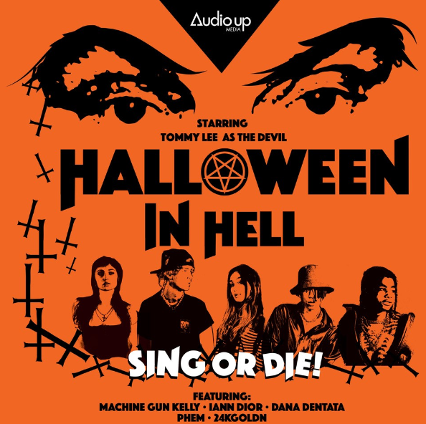

October 19th, 2020 – Audio Up Media’s highly anticipated four-part Halloween podcast HALLOWEEN IN HELL, has released its first two episodes today, along with its first batch of original music. Music icon and founding member + drummer of Mötley Crüe, Tommy Lee, recently released his new album ANDRO and joined the Halloween In Hell cast. Lee is set to play the role of the devil, as well as, contribute drums on the original podcast track “Climb” that was written for the series by Audio Up Media CEO, Jared Gutstadt, alongside Machine Gun Kelly and 24kGoldn, who also perform on the song. The first four original singles released today include “Toxic Relations” and “Find Him Kill Him” by Dana Dentata, “In Hell It’s Always Halloween” by iann dior, and “Sex Drugs N Rock N Roll” by 24kGoldn. This four-track bundle released through Sony Music RECORDS and Audio Up Music, and is available now through all digital and streaming platforms. Stream the first two episodes of the podcast HERE. Listen to the new music HERE.

Taking homage from music horror hits like “The Rocky Horror Picture Show” and the dark comedy of “The Nightmare Before Christmas,” HALLOWEEN IN HELL is set during Halloween, where 24kGoldn and metal mistress Dana Dentata find themselves trapped on a soundstage reminiscent of Hell, with a sadistic host who has lured them into a competition. It is there they must impress a jury of the damned (R.Kelly & Phil Spector) and rescue themselves from the clutches of evil. With each of the main cast playing fictional versions of themselves, these acclaimed musical cross-genre performers beckon listeners to follow them on a journey to hell and back. The star-studded cast includes multi-platinum Interscope Records recording artist, actor and Billboard chart topper pop culture icon, Machine Gun Kelly, rock legend Tommy Lee, acclaimed musician and performance artist Dana Dentata, multi-platinum 10K Projects recording artist iann dior, multi-platinum RECORDS/Columbia Records’ recording artist 24kGoldn, and musician/writer PHEM.

The podcast was conceived and produced by Audio Up Media CEO, Jared Gutstadt, and Machine Gun Kelly, and was written by Jimmy Jellinek. Original music (penned and produced by Gutstadt, alongside the cast) will debut in every episode and then be made available across all digital and streaming platforms. The series will be accompanied by a four-part making-of documentary to be released as bonus content.

“The ‘In Hell…’ franchise is something that will continue beyond Halloween,” says Audio Up Media CEO, Jared Gutstadt. “We have already begun production on ‘New Year’s In Hell,’ which will continue the adventure with original music and another sadistic plot meant. This ongoing series is produced to entertain and create great tent pole moments for podcast listeners surrounding various holidays and traditions that occur year round.”

Watch the official visual trailer for HALLOWEEN IN HELL HERE. Listen to the audio trailer HERE.

About Audio Up Media:
Audio Up is a podcast content production studio, housing a world of infinite, audio-based properties. Ran by founder and CEO Jared Gutstadt (formerly of the Jingle Punks), Audio Up is building an ecosystem of premium entertainment content within the music and audio space. From fictional scripted podcasts, which include a Marvel-like universe of musicals, where the records themselves become the story foundation, to one-on-one interview formats, Audio Up’s goal is to create a new and innovative form of IP. They are bringing audio blockbusters to life and taking this media from black and white, into technicolor. Current properties include the riveting top 20 crime podcast Where The Bodies Are Buried, Michael Cohen’s new chart-topping podcast Mea Culpa, and Tom Green’s The Tom Green Interview. Their recent project Make It Up As We Go, includes Scarlett Burke, Miranda Lambert, Lindsay Ell and other huge country entertainment; and upcoming projects feature Halloween in Hell starring Machine Gun Kelly, 24kGoldn and iann dior, as well as, Uncle Drank: The Totally Hammered Podcast starring Gary Busy and Dennis Quaid to name a few.

