HAMZAA
RETURNS WITH EXPLOSIVE NEW SINGLE & VIDEO
“IN BETWEEN (FT. MIRAA MAY)”

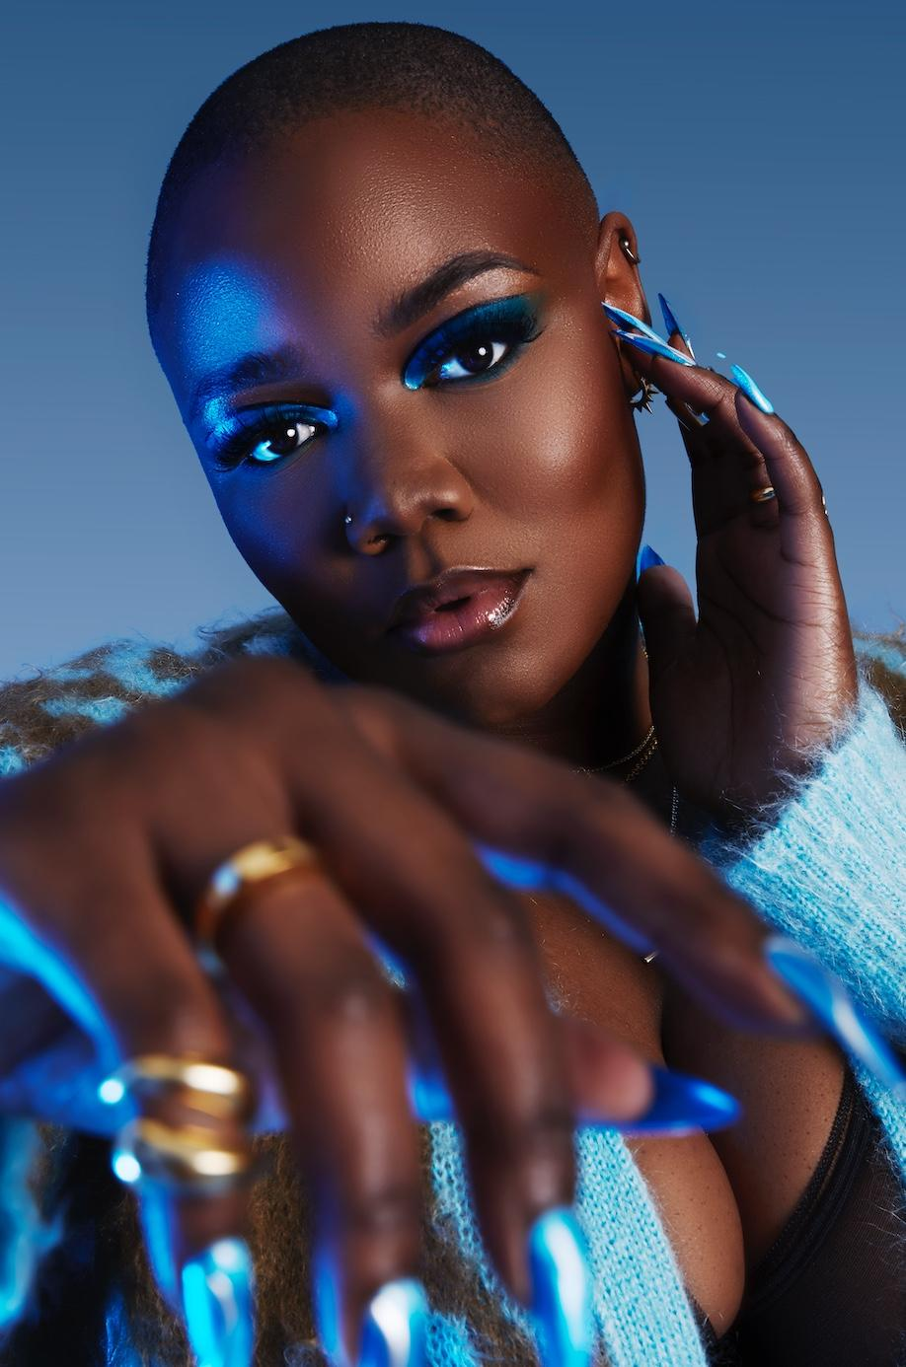
Download high res assets here

“One to watch” – The Guardian

“Essential listening from the UK Soul newbie” – Complex

“there is certainly no ceiling on her potential” – Guap

APRIL 23, 2021 – London singer/songwriter Hamzaa has debuted her fresh new sound on the explosive new single “In Between,” heralding her position as a pop powerhouse in the making. The single, premiered by DJ Target on BBC Radio 1Xtra, features fellow London artist on the rise Miraa May and comes alongside an official video which sees the pair own their story and the screen. “In Between” is available now on all streaming platforms, with the official video streaming now on Hamzaa’s official YouTube channel.

Intertwined with new sonic territory is a reclamation of control and newfound clear vision – Hamzaa has taken back the creative reigns of her artistry and honed her craft as an extraordinarily talented, genre-defying and multi-faceted artist. On the new single, Hamzaa says “This record is about two powerful women coming together with a firm and unshakeable message. You can either be the peace, or the motion between the chaos and watch me grow cause we’re not stopping or changing for anyone!"

Breaking onto the scene in 2018, Hamzaa caught the world’s attention with breakout single ‘Breathing Pt. 2’ featuring Wretch 32 and Ghetts (whose #2 album Hamzaa recently featured on), taken from her 2019 EP First Signs Of Me, followed by second EP Phases. Aged just 21, Hamzaa has been named by The Guardian and The Times as “one to watch,” has played sold out shows including a headline show at London’s Scala, critical acclaim (including a 4 star review from the Evening Standard), supported Anne-Maire and Mahalia on their UK tours, played BBC Radio 1’s Big Weekend and more. She’s been tipped as one to watch by both 1Xtra and Capital Xtra, backed across Noisey and Grazia by Julie Adenuga, playlisted on Radio 1 via BBC Introducing, performed a Radio 1Xtra Spotlight Session and has fans in the likes of MTV, Stormzy and Jorja Smith.

(Single art below)

HAMZAA
“In Between” feat. Miraa May
AVAILABLE NOW
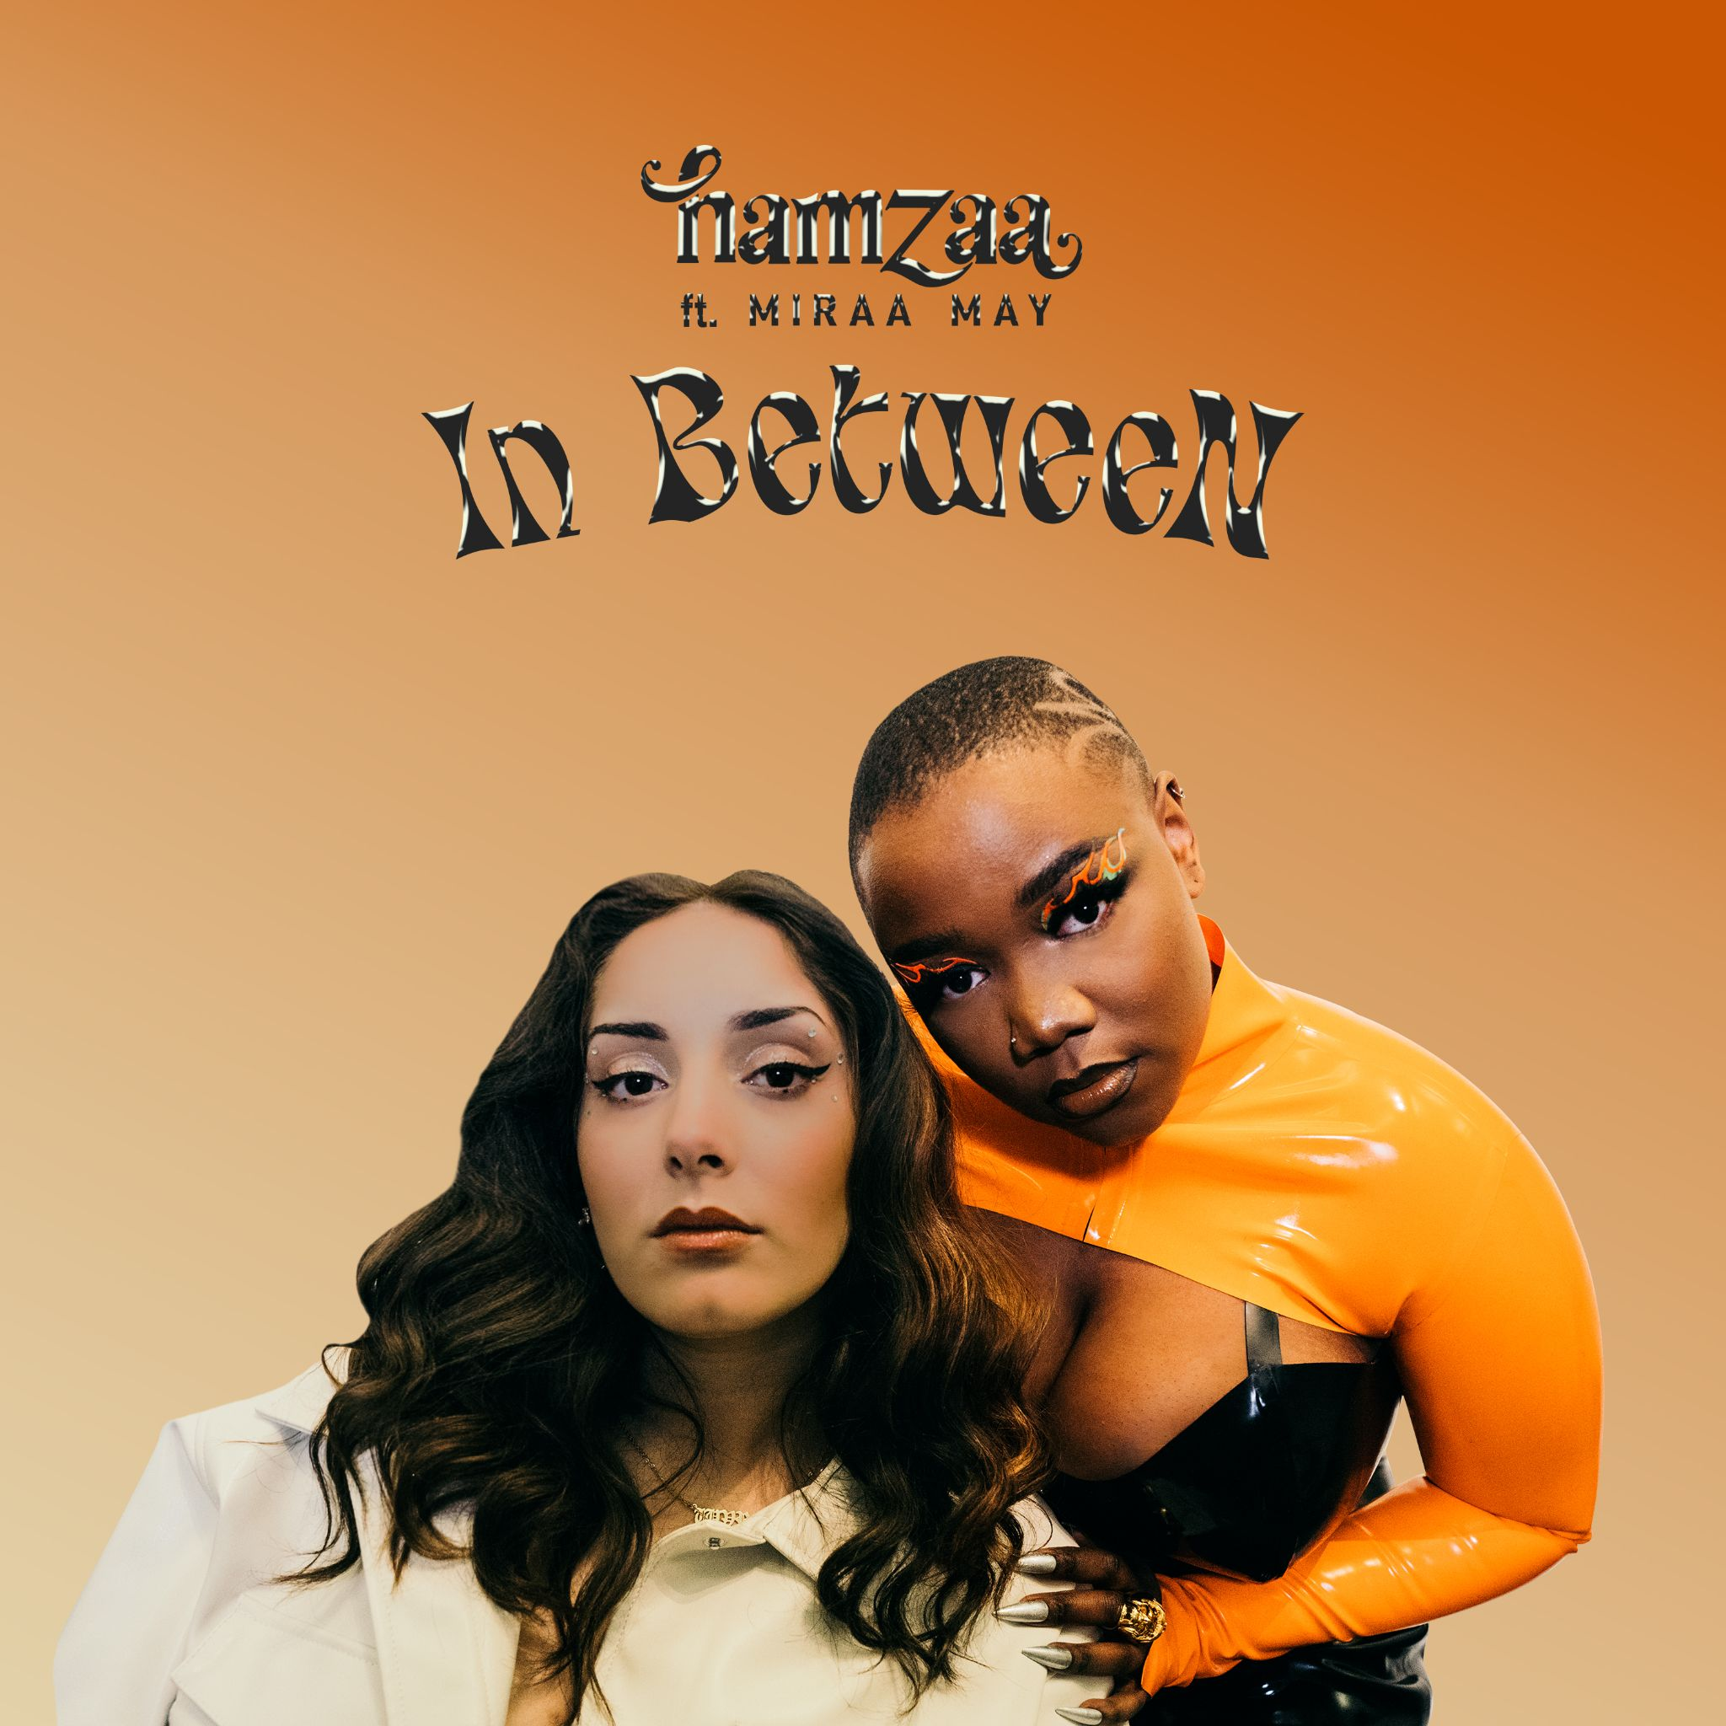

CONNECT WITH HAMZAA
Instagram
YouTube
Twitter
Facebook

For US press inquiries, please contact:
Sarah Goldstein
sarahgoldstein@elektra.com

