HASTINGS ARRIVES WITH DEBUT SINGLE “HEART’S NOT IN IT”
OFFICIAL LYRIC VIDEO STREAMING NOW

AUGUST 25, 2021 - Nashville-based singer-songwriter Hastings has arrived with his debut single “Heart’s Not In It.” Produced by Mike Robinson, the track paints a picture of fleeting unrequited love over boisterous synths, funky guitars, and a driving beat. The single is accompanied by a lyric video which is streaming now on Hastings’ official YouTube channel. “Heart’s Not In It” is available now on all streaming platforms via DBLBLK Records.

Hastings commented, “I just want you to pull emotion from the music. It can be whatever you’re feeling. Maybe after you listen, you’ll want to call your ex… A lot of these songs are about breakups, relationships, and life. Maybe you can relate to some of my experiences, I’m just sharing what I go through.”

Stay tuned for more from Hastings soon.
About Hastings:
Every once in a while, you’ll hear a song that nudges you to walk across the room and introduce yourself to a stranger, FaceTime your ex, or even change your life. Hastings strives to make those kinds of songs. The Nashville-based singer, songwriter and multi-instrumentalist couples straightforward lyrical eloquence with guitar-shaped soundscapes and traffic-stopping vocal acrobatics. Growing up between Florida, Michigan, and Tennessee, he cut his teeth by playing drums on his father’s worship team at the age of three before learning guitar and piano. After getting his drivers license at 16-years-old, he asked his parents to let him move to Nashville to pursue music - and his dad tossed him the keys. Hastings integrated himself into the city’s scene slowly but surely, in between finishing his GED. During 2018, he serendipitously met Garrison Burgess of The Band CAMINO and wound-up living with him and spending countless hours writing and recording together. Behind the scenes, he co-wrote the single “Roses” for The Band CAMINO and “Don’t Blame Me” for Kingston Hythe. Simultaneously, his solo demos caught the attention of DBLBLK Records. Now, he presents a sharp and scorching signature style on a series of singles led by “Heart’s Not In It.”

HASTINGS
“Heart’s Not In It”
AVAILABLE NOW
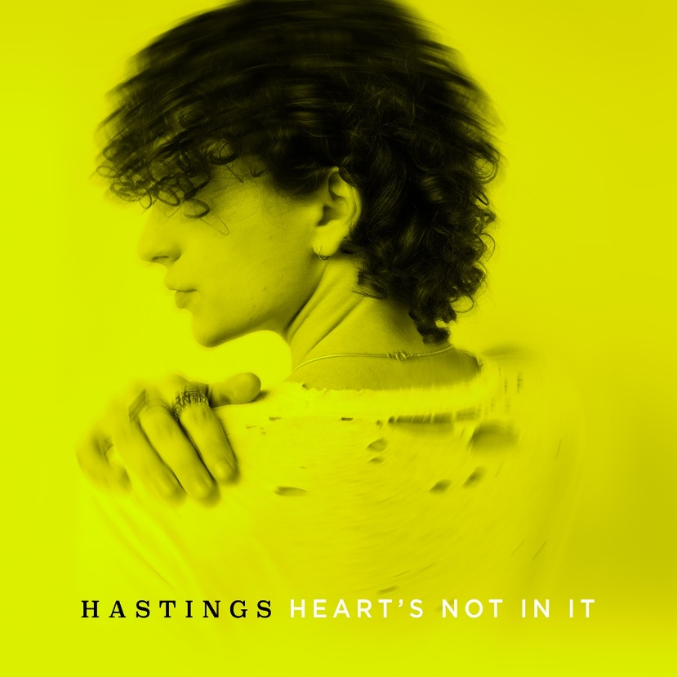

CONNECT WITH HASTINGS
Website
Instagram
YouTube
Twitter
TikTok
For all press inquiries, please contact:
Sarah Goldstein - sarahgoldstein@elektra.com
Collin Citron - collincitron@elektra.com

