HIGHLY SUSPECT ANNOUNCE U.S. FALL HEADLINE TOUR

“THE MIDNIGHT DEMON CLUB TOUR”
TO FEATURE SPECIAL GUESTS ARTIKAL SOUND SYSTEM, DEAD POET SOCIETY, AND TIGER CUB ON SELECT DATES

TICKET PRE-SALES BEGIN JULY 13TH AT 10:00AM LOCAL
PUBLIC ON SALE STARTS JULY 15TH AT 10:00AM LOCAL

WIDELY ANTICIPATED NEW ALBUM THE MIDNIGHT DEMON CLUB ARRIVES SEPTEMBER 9TH

NEW TRACKS “NATURAL BORN KILLER” & “PINK LULLABYE” STREAMING NOW

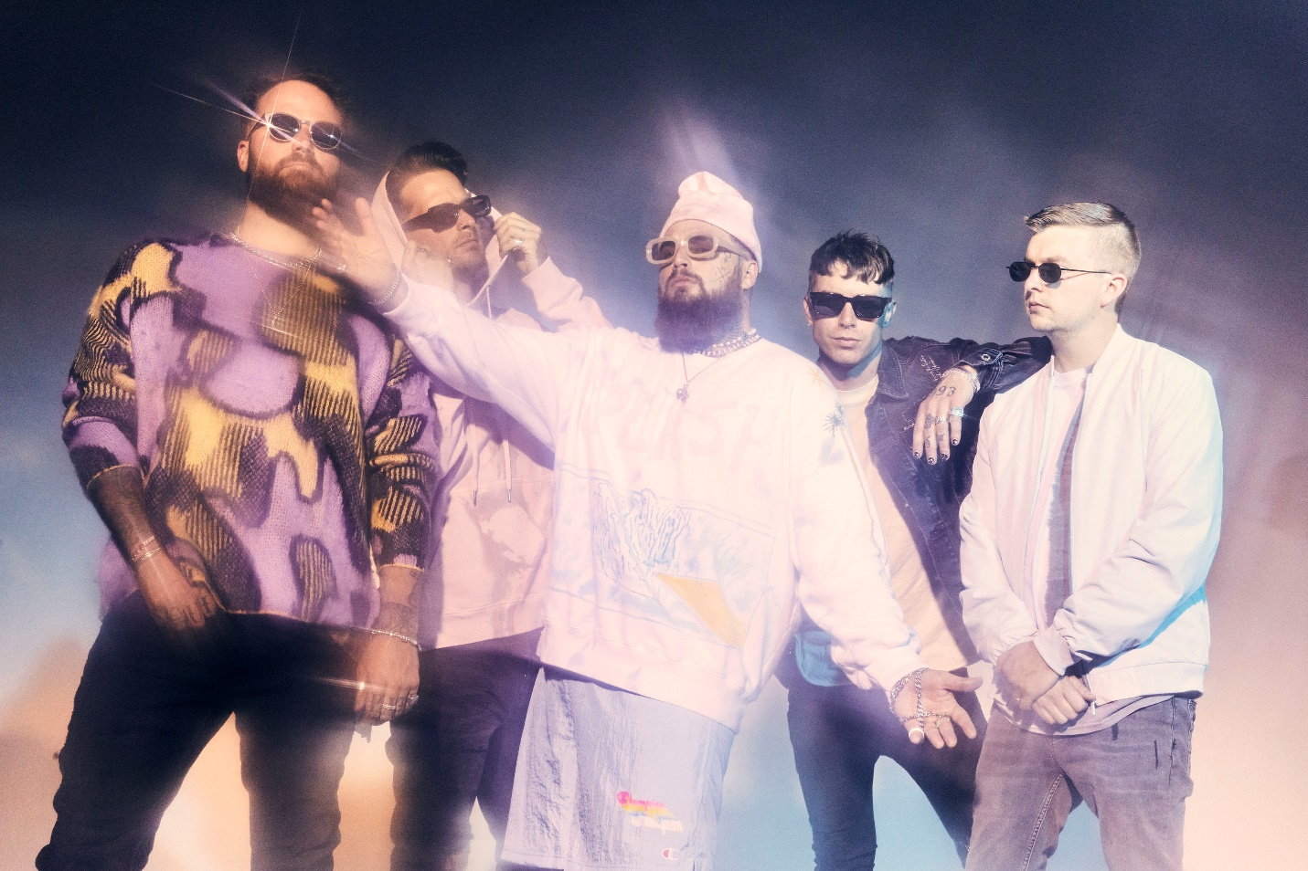
PHOTO CREDIT: JIMMY FONTAINE

JULY 12, 2022 – Roadrunner Records / FRKST band Highly Suspect have announced details of a fall headline tour of the U.S. which will see the group touring the states for the first time behind their anxiously awaited fourth full-length album, The Midnight Demon Club, out on September 9th. Featuring support from special guests Artikal Sound System, Dead Poet Society, and Tiger Cub on select dates, the “Midnight Demon Club Tour” will kick off on September 15th in Minneapolis, MN and includes stops in Nashville, Atlanta, New York City, Chicago, Detroit, Dallas and more. Additionally, the tour will include a special performance at the legendary Red Rocks Amphitheatre in Morrison, CO on October 20th which will see the band joined by iann dior, Spiritbox, and Destroy Boys as support [see tour itinerary below]. Fans can sign-up for access to pre-sale tickets for the tour HERE by pre-saving The Midnight Demon Club. Ticket pre-sales will begin on July 13th at 10:00AM local time with public on sale starting July 15th at 10:00AM local time. For tickets and more information on Highly Suspect’s fall tour and remaining international dates, visit www.highlysuspect.net.

Last month Highly Suspect surprised fans with news of their widely anticipated new album, The Midnight Demon Club. The three-time GRAMMY® Award-nominated band also shared two new tracks: “Natural Born Killer” (streaming HERE) and “Pink Lullabye” (streaming HERE) with “Natural Born Killer” joined by an Andrew Sandler directed music video streaming on the band’s official YouTube channel.

Regarding the LP, lead vocalist and guitarist Johnny Stevens a.k.a. “Terrible Johnny” shared, “Life comes at you fast. We are constantly reminded of this, and perhaps no greater occurrence will spark the imagination more than the death of a loved one. In my experience, it’s during these moments of processing great loss that the mind is completely focused on ‘what if’s’ as we try and escape what is. The Midnight Demon Club is about becoming the best version of yourself after tragedy, so it’s a second chance on life with a happier mindset. The Midnight Demon Club is all about having fun and keeping it moving. Because as we all know, this life is way too short.”

Stevens also remarked on lead single “Natural Born Killer” explaining, “I’m always fighting for my place out here in this world. And there are two mindsets one could have - rollover and mope about the hard shit or just be a motherfucking life beast and smash all your challenges at hand. And if you’re really a badass, have fun doing it. That’s the flow. That’s the essence of being a natural born killer.”

The Midnight Demon Club finds Highly Suspect at a turning point. Produced by Highly Suspect and WZRD BLD, the 12-track offering teems with truth barely contained in fits of metallic exorcism and hip-hop-induced beat-craft. Stoned musings about a world on the brink of destruction ride over gorgeously uneasy orchestration and vocal transmissions that drip with sadness, longing, rage, and confidence all at once [tracklisting / album art below].

Never content to follow, Highly Suspect push rock music forward by trusting their instincts and raising a middle finger to everything else. The multi-GRAMMY® Award-nominated and gold-certified band - Johnny Stevens [vocals, guitar], Ryan Meyer [drums, vocals], Rich Meyer [bass, vocals], Matt Kofos [guitar] and Mark Schwartz [synths] - don’t just talk about burning the rules and breaking the mold; they actually do so. The band’s chemically imbalanced mix of gritty guitars, haunting piano, off-kilter synths, hip-hop production, cinematic vision, and beautifully possessed vocals transformed them into a phenomenon beloved by a diehard global fanbase known as “MCID” [My Crew Is Dope].

After grinding it out as an underground curiosity, they scraped a path to mainstream infamousness with their 2015 full-length debut, Mister Asylum. It earned a GRAMMY® Award nomination in the category of “Best Rock Album” as the single “Lydia” received a nomination for “Best Rock Song” was certified gold by the RIAA. The 2016 follow-up The Boy Who Died Wolf roared to life with the gold-selling “My Name Is Human,” which catapulted to #1 on the Billboard Mainstream Rock Chart and garnered a GRAMMY® Nomination for “Best Rock Song.” 2019’s MCID affirmed them as the rare outfit who could collaborate with Young Thug and Gojira on the same album. Loudwire hailed the latter among the “50 Best Rock Albums of 2019.” With hundreds of millions of streams and sold out shows on multiple continents, Highly Suspect charge ahead of the pack again on 2022’s The Midnight Demon Club with no compromises and no apologies as they challenge rock to be dangerous and maybe even life-changing again.

[ALBUM ARTWORK / TRACKLISTING / TOUR ITINERARY BELOW]

HIGHLY SUSPECT
THE MIDNIGHT DEMON CLUB

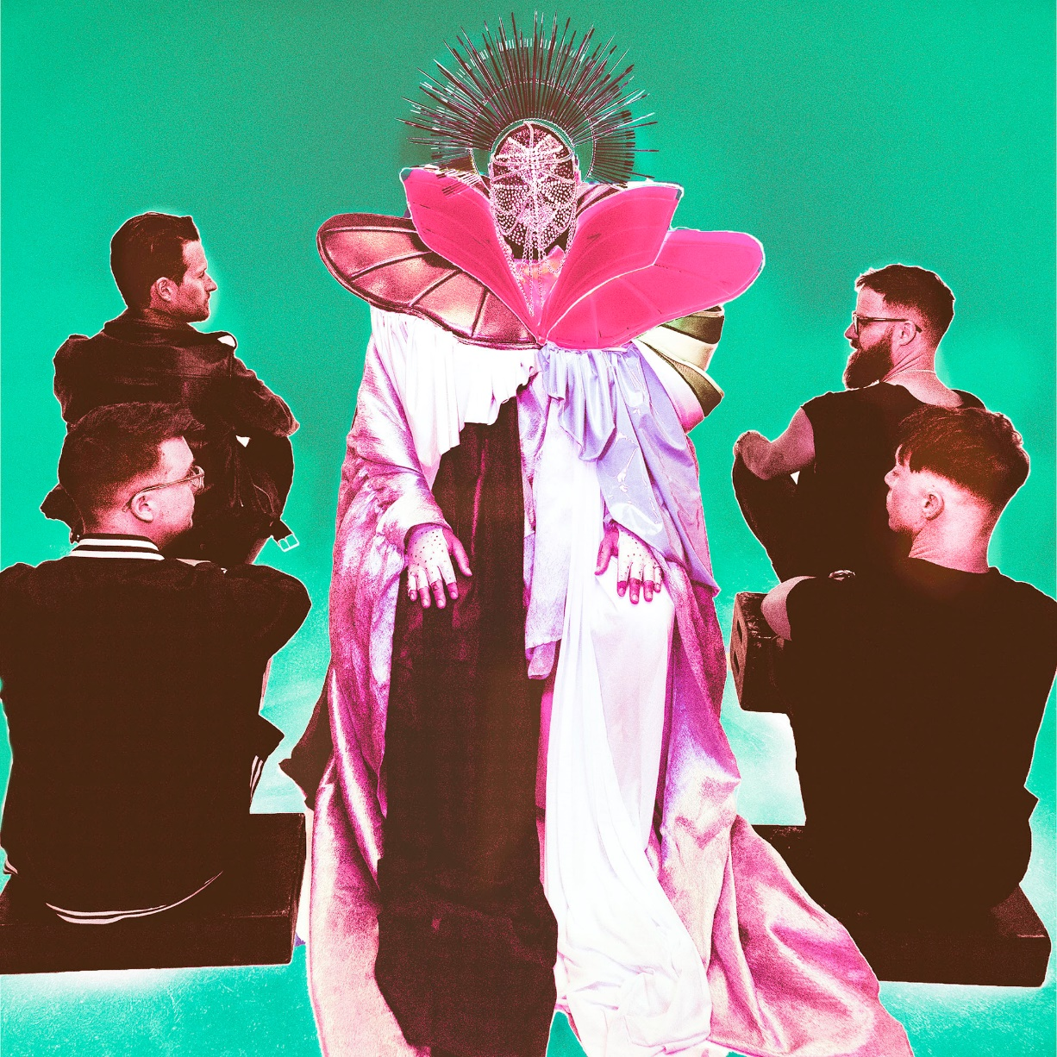

- The Sound
- Natural Born Killer
- Ice Cold
- Midnight Demon Club
- Caught On Fire
- Wild Eyed Son
- Pink Lullabye
- New California
- Need To Say
- Cool Kids
- Love Like This
- Evangeline

HIGHLY SUSPECT
“MIDNIGHT DEMON CLUB TOUR”
www.highlysuspect.net/#tour

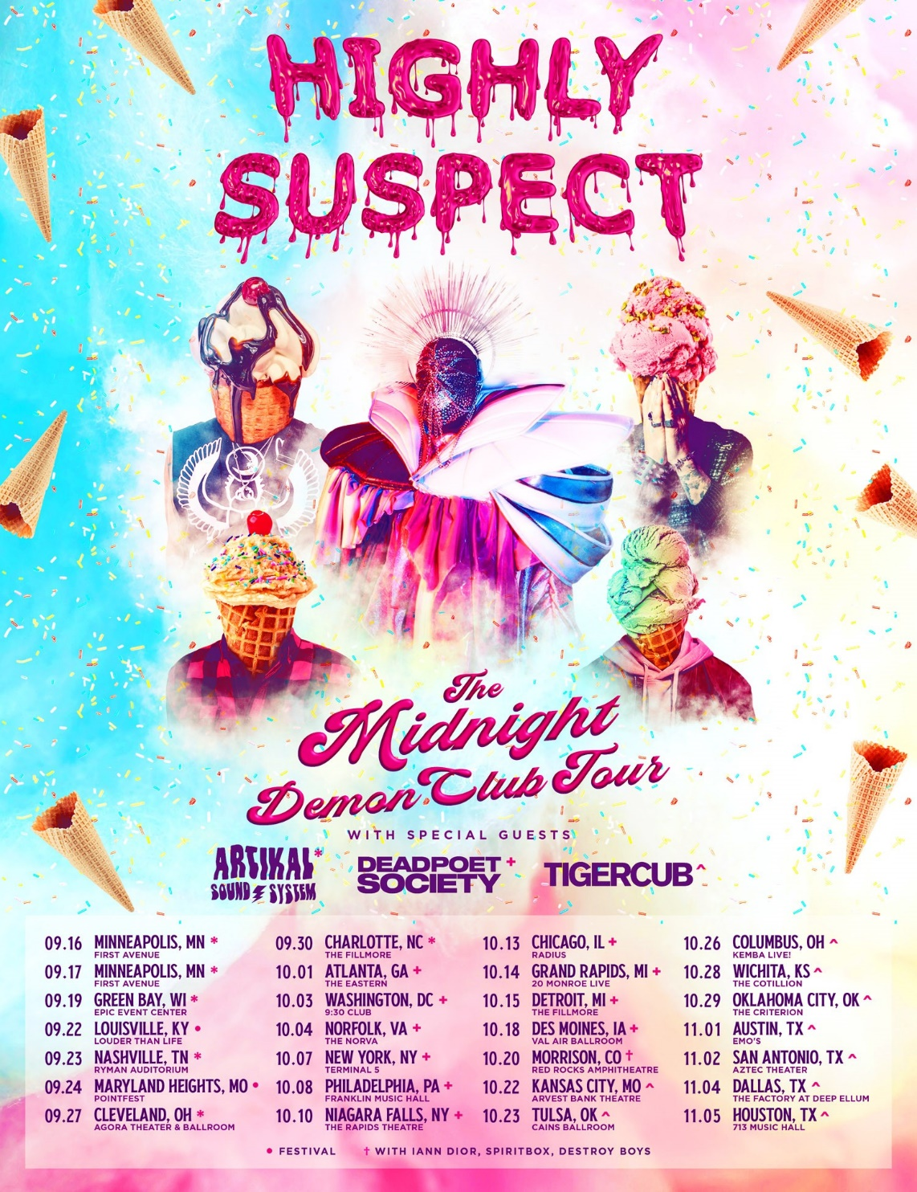
9/16 - Minneapolis, MN - First Avenue
9/17 - Minneapolis, MN - First Avenue
9/19 - Green Bay, WI - EPIC Event Center
9/22 - Louisville, KY - Louder Than Life 2022*
9/23 - Nashville, TN - Ryman Auditorium
9/24 - Maryland Heights, MO - Pointfest*
9/27 - Cleveland, OH - Agora Theater & Ballroom
9/30 - Charlotte, NC - The Fillmore
10/1 - Atlanta, GA - The Eastern
10/3 - Washington, DC - 9:30 Club
10/4 - Norfolk, VA - The NorVa
10/7 - New York, NY - Terminal 5
10/8 - Philadelphia, PA- Franklin Music Hall
10/10 - Niagara Falls, NY - The Rapids Theatre
10/13 - Chicago, IL - Radius
10/14 - Grand Rapids, MI - 20 Monroe Live
10/15 - Detroit, MI - The Fillmore
10/18 - Des Moines, IA - Val Air Ballroom
10/20 - Morrison, CO - Red Rocks Amphitheatre
10/22 - Kansas City, MO - Arvest Bank Theatre
10/23 - Tulsa, OK - Cains Ballroom
10/26 - Columbus, OH – KEMBA Live!
10/28 - Wichita, KS - The Cotillion
10/29 - Oklahoma City, OK - The Criterion
11/4 - Dallas, TX - The Factory at Deep Ellum
11/5 - Houston, TX - 713 Music Hall

9/15 - 9/30: with Artikal Sound System
10/4 - 10/18: with Dead Poet Society
10/20: with iann Dior, Spiritbox, and Destroy Boys
10/22 - 11/5: with Tiger Cub
* Festival Date
FOR MORE INFORMATION ON HIGHLY SUSPECT:
OFFICIAL SITE / SPOTIFY / APPLE MUSIC / YOUTUBE / INSTAGRAM / TWITTER / FACEBOOK

CONTACT:
LILY GOLIGHTLY / LILY@THREEHUNDRED.BIZ
ROSS ANDERSON / ROSSANDERSON@ELEKTRA.COM

###

