HIGHLY SUSPECT
RETURN WITH NEW ALBUM THE MIDNIGHT DEMON CLUB

SHARE TWO NEW TRACKS “NATURAL BORN KILLER” & “PINK LULLABYE”

OFFICIAL MUSIC VIDEO FOR “NATURAL BORN KILLER” STREAMING NOW

THE MIDNIGHT DEMON CLUB ARRIVES SEPTEMBER 9TH

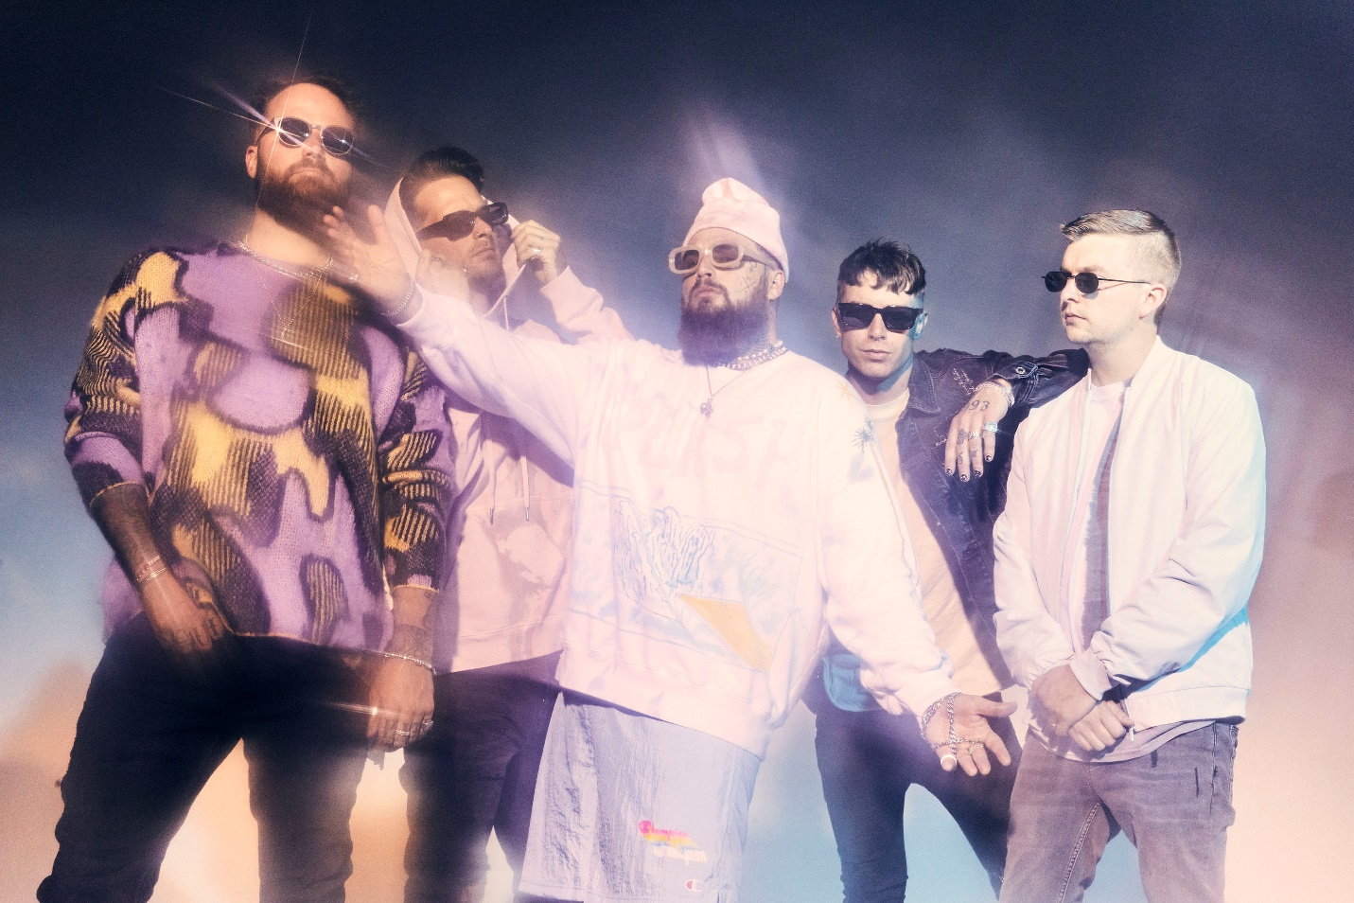
PHOTO CREDIT: JIMMY FONTAINE

JUNE 22, 2022 – Roadrunner Records / FRKST band Highly Suspect have announced details of their anxiously awaited fourth full-length album, The Midnight Demon Club, which will arrive on September 9th. It is available for pre-order / pre-save at all streaming platforms now. The three-time GRAMMY® Award-nominated band have also shared two new tracks: “Natural Born Killer” (streaming HERE) and “Pink Lullabye” (streaming HERE) with “Natural Born Killer” joined by an Andrew Sandler directed music video streaming on the band’s official YouTube channel.

Regarding the LP, lead vocalist and guitarist Johnny Stevens a.k.a. “Terrible Johnny” shared, “Life comes at you fast. We are constantly reminded of this, and perhaps no greater occurrence will spark the imagination more than the death of a loved one. In my experience, it’s during these moments of processing great loss that the mind is completely focused on ‘what if’s’ as we try and escape what is. The Midnight Demon Club is about becoming the best version of yourself after tragedy, so it’s a second chance on life with a happier mindset. The Midnight Demon Club is all about having fun and keeping it moving. Because as we all know, this life is way too short.”

Stevens also remarked on lead single “Natural Born Killer” explaining, “I’m always fighting for my place out here in this world. And there are two mindsets one could have - rollover and mope about the hard shit or just be a motherfucking life beast and smash all your challenges at hand. And if you’re really a badass, have fun doing it. That’s the flow. That’s the essence of being a natural born killer.”

The Midnight Demon Club finds Highly Suspect at a turning point. Produced by Highly Suspect and WZRD BLD, the 12-track offering teems with truth barely contained in fits of metallic exorcism and hip-hop-induced beat-craft. Stoned musings about a world on the brink of destruction ride over gorgeously uneasy orchestration and vocal transmissions that drip with sadness, longing, rage, and confidence all at once [tracklisting / album art below].

Right now, the band are canvasing Europe on “The Devils In The Detail Tour.” The trek visits multiple countries before wrapping up at Lollapalooza in Paris, France on July 17. They’ll head back to the United States for appearances at Louder Than Life in Louisville, KY on September 22nd and Pointfest in Maryland Heights, MO on September 24th [tour itinerary below]. For tickets and more information on Highly Suspect’s upcoming tour dates, visit www.highlysuspect.net.

Never content to follow, Highly Suspect push rock music forward by trusting their instincts and raising a middle finger to everything else. The multi-GRAMMY® Award-nominated and gold-certified band - Johnny Stevens [vocals, guitar], Ryan Meyer [drums, vocals], Rich Meyer [bass, vocals], Matt Kofos [guitar] and Mark Schwartz [synths] - don’t just talk about burning the rules and breaking the mold; they actually do so. The band’s chemically imbalanced mix of gritty guitars, haunting piano, off-kilter synths, hip-hop production, cinematic vision, and beautifully possessed vocals transformed them into a phenomenon beloved by a diehard global fanbase known as “MCID” [My Crew Is Dope].

After grinding it out as an underground curiosity, they scraped a path to mainstream infamousness with their 2015 full-length debut, Mister Asylum. It earned a GRAMMY® Award nomination in the category of “Best Rock Album” as the single “Lydia” received a nomination for “Best Rock Song” was certified gold by the RIAA. The 2016 follow-up The Boy Who Died Wolf roared to life with the gold-selling “My Name Is Human,” which catapulted to #1 on the Billboard Mainstream Rock Chart and garnered a GRAMMY® Nomination for “Best Rock Song.” 2019’s MCID affirmed them as the rare outfit who could collaborate with Young Thug and Gojira on the same album. Loudwire hailed the latter among the “50 Best Rock Albums of 2019.” With hundreds of millions of streams and sold out shows on multiple continents, Highly Suspect charge ahead of the pack again on 2022’s The Midnight Demon Club with no compromises and no apologies as they challenge rock to be dangerous and maybe even life-changing again.

[ALBUM ARTWORK / TRACKLISTING / TOUR ITINERARY BELOW]

HIGHLY SUSPECT
THE MIDNIGHT DEMON CLUB

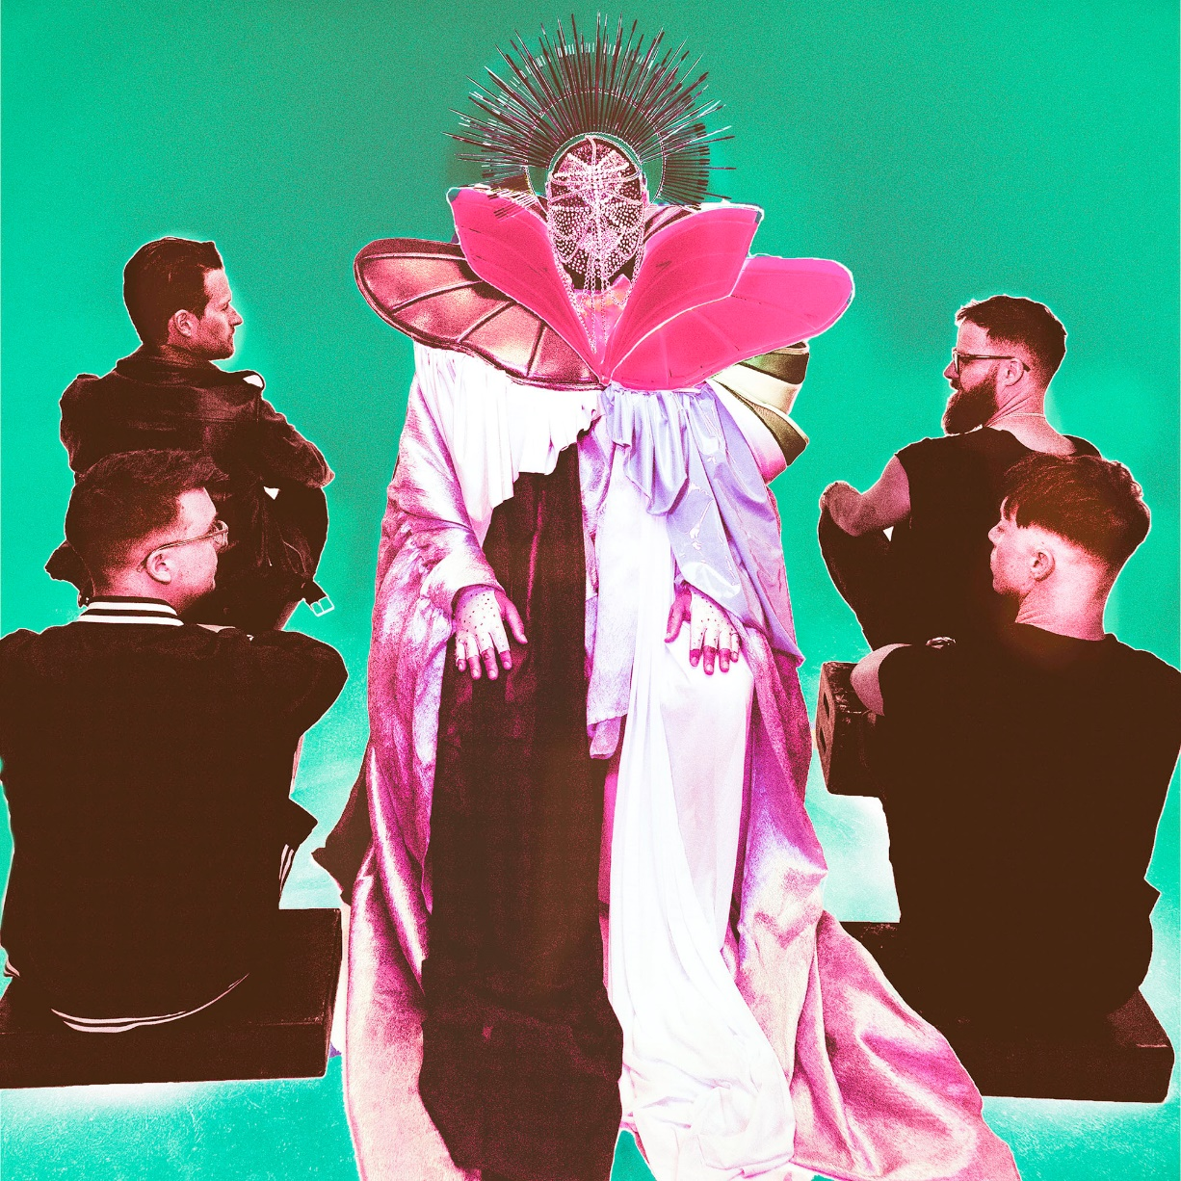

- The Sound
- Natural Born Killer
- Ice Cold
- Midnight Demon Club
- Caught On Fire
- Wild Eyed Son
- Pink Lullabye
- New California
- Need To Say
- Cool Kids
- Love Like This
- Evangeline

TOUR DATES
6/22- Warsaw, Poland - Proxima
6/23 - Krakow, Poland - Klub Kwadrat
6/27 - Glasgow, UK - SWG3
6/30 - Manchester, UK - 02 Ritz Manchester
7/1 - Camden, UK - Electric Ballroom
7/2 - Camden, UK - Electric Ballroom
7/4 - Bristol, UK - Marble Factory
7/5 - Birmingham, UK - 02 Institute
7/7 - Madrid, Spain - Mad Cool Festival 2022
7/9 - Vienna, Austria - Simm City
7/11 - Berlin, Germany - Festsaal Kreuzberg Biergarten
7/12 - Cologne, Germany - Die Kantine
7/14 - Hamburg, Germany - Markthalle
7/15 - Utrecht, Netherlands - Tivoli Vredenburg
7/17 - Paris, France - Lollapalooza
9/22 - Louisville, KY - Louder Than Life 2022
9/24 - Maryland Heights, MO - Pointfest 2022
FOR MORE INFORMATION ON HIGHLY SUSPECT:
OFFICIAL SITE / SPOTIFY / APPLE MUSIC / YOUTUBE / INSTAGRAM / TWITTER / FACEBOOK

CONTACT:
LILLY GOLIGHTLY / LILY@THREEHUNDRED.BIZ
ROSS ANDERSON / ROSSANDERSON@ELEKTRA.COM

###

