JAKE SCOTT ANNOUNCES MASSIVE FALL U.S. HEADLINE TOUR
NEW SINGLE “SHE’S NOT YOU” OUT NOW – LISTEN HERE
WATCH THE “SHE’S NOT YOU” LIVE PERFORMANCE VIDEO HERE
WATCH SCOTT’S PERFORMANCE WITH RUSSELL DICKERSON ON GOOD MORNING AMERICA HERE
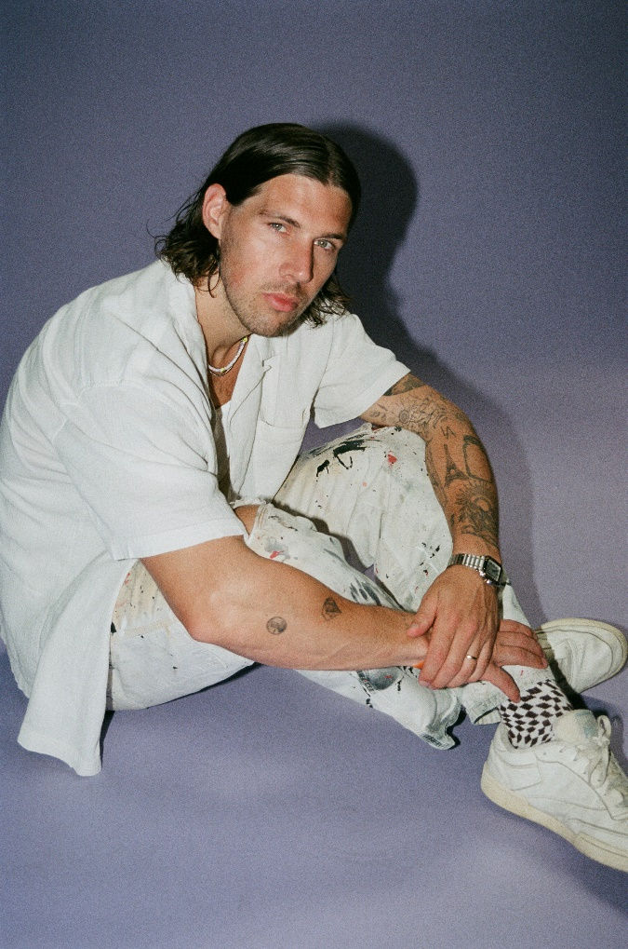
DOWNLOAD HI-RES PRESS IMAGE HERE
CREDIT: RACHEL PALUMBO
“With a knack for catchy melodies, his songs make for easy listening supported by buoyant pop production, heartfelt narratives, and a buttery voice to boot.” –BILLBOARD
“… rounded out by lyrical sincerity.” –CONSEQUENCE OF SOUND
“Scott is humble, but extremely talented” –AMERICAN SONGWRITER
(July 25, 2022) – LOS ANGELES, CA – Pop singer-songwriter, producer, and multi-instrumentalist Jake Scott today announced his massive fall headline tour across the U.S. Dubbed The Lavender Tour, the 21-date trek kicks off on Saturday, October 15 in San Diego and hits major cities including Nashville, Philadelphia, Boston, Chicago, New York, and more before concluding in Los Angeles at the El Rey Theatre on Sunday, November 20. The full routing is included below. The upcoming run also follows Scott’s first-ever North American headline tour earlier this year, which completely sold out and required venue upgrades in multiple cities due to popular demand. The general public on-sale begins Friday, July 29 at 10:00am local time on JakeScottMusic.com.
Scott also unveiled his new single “She’s Not You” on Friday, July 22 along with a companion live performance video, captured in Los Angeles. Co-written by Scott and co-produced alongside Eren Cannata (Walk the Moon, Tones & I, Jake Wesley Rogers), the love song couples Scott’s sincere songwriting with melodic, guitar-driven beats. Listen HERE and watch the performance visual HERE.
Of the new track, Scott said: “‘She’s Not You’ is the story of finding the perfect person who still can’t compare to the one you lost.”
He continued, “The Lavender Tour is a huge milestone for me. These are the biggest rooms I’ve played yet and I’m so excited about the show we’ve put together. I promise I’m going to give you everything I’ve got!”
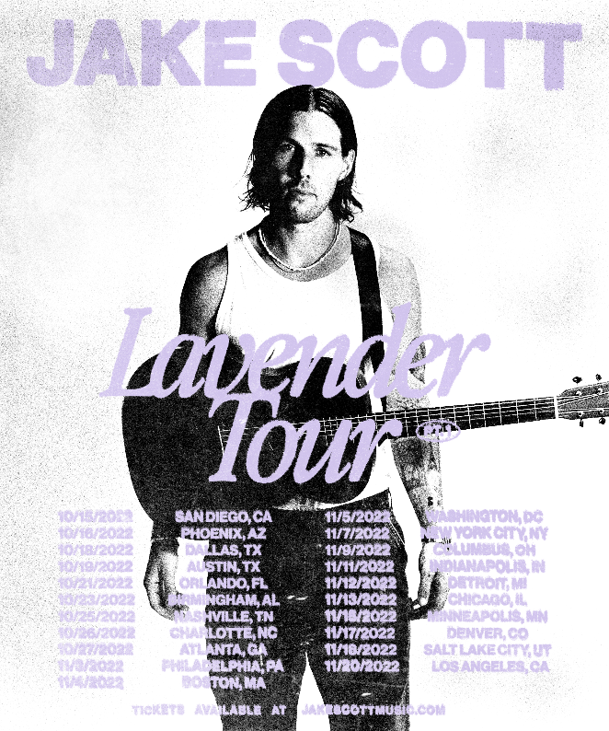
HI-RES TOUR ADMAT AVAILABLE HERE
Earlier this year, Scott made his national television debut on The Kelly Clarkson Show – performing his anthemic, anecdotal track “Texas Girl” – and was named one of People Magazine’s “Emerging Artists” to watch. Additionally, his 2021 collaboration with multi-Platinum country star Russell Dickerson – “She Likes It” – became RIAA Certified Gold and has amassed 100M+ total streams in the U.S. alone. The song is currently in the Top 30 and climbing at Country Radio, and on Monday, July 18, Scott and Dickerson delivered a stellar live performance of the track on Good Morning America. Watch it HERE. Along with being a featured artist on “She Likes It,” Scott co-produced, mixed, and co-wrote the song with Dickerson – underscoring his skill as a dynamic musician and producer.
Scott recently surpassed 500M+ total career streams and is currently in the studio working on his much-anticipated debut project with Elektra Records. More details will be revealed soon.
ABOUT JAKE SCOTT:
Delivering impactful anthems with impressive consistency and grinding tirelessly, Jake Scott has quietly arrived as a proven pop maverick with a dynamic style and a whole lot to say. Born in Fayetteville, Arkansas and currently based in Los Angeles, the artist initially transformed into an independent phenomenon before signing with Elektra Records. Beyond co-writing for the likes of Jason Mraz, Aloe Blacc, and Carrie Underwood, he unveiled music at a prolific pace before doubling down and dropping one song per month from the beginning of 2018 through the end of 2020. Audiences embraced favorites such as “Like No One Does,” “Tuesdays,” “Favorite T-Shirt,” “She,” and “I Don’t Miss You.” In addition to building a diehard fan base, gathering millions of streams, attracting hundreds of thousands of followers across social media, and racking up praise in the press, Scott also has an impressive touring history – sharing the stage with LANY and Ben Rector, and selling out his first headline tour across North America in early 2022.
JAKE SCOTT
“SHE’S NOT YOU”
AVAILABLE HERE
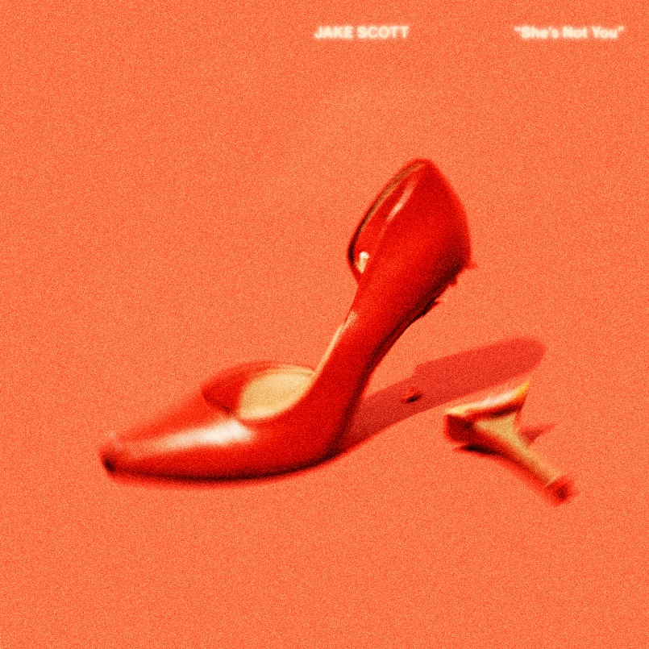
DOWNLOAD HI-RES ARTWORK HERE
JAKE SCOTT | THE LAVENDER TOUR:
October 15 – San Diego, CA @ The Observatory North Park
October 16 – Phoenix, AZ @ Crescent Ballroom
October 18 – Dallas, TX @ House of Blues
October 19 – Austin, TX @ Scoot Inn
October 21 – Orlando, FL @ Plaza Live
October 23 – Birmingham, AL @ Iron City
October 25 – Nashville, TN @ Marathon Music Works
October 26 – Charlotte, NC @ The Fillmore
October 27 – Atlanta, GA @ Variety Playhouse
November 3 – Philadelphia, PA @ Brooklyn Bowl
November 4 – Boston, MA @ Royale
November 5 – Washington, D.C. @ 9:30 Club
November 7 – New York, NY @ Webster Hall
November 9 – Columbus, OH @ Newport Music Hall
November 11 – Indianapolis, IN @ Deluxe at Old National Centre
November 12 – Detroit, MI @ Majestic Theater
November 13 – Chicago, IL @ House of Blues
November 15 – Minneapolis, MN @ First Avenue
November 17 – Denver, CO @ Gothic Theatre
November 18 – Salt Lake City, UT @ The Union
November 20 – Los Angeles, CA @ El Rey Theatre
FOLLOW JAKE SCOTT:
WEBSITE | INSTAGRAM | FACEBOOK | TWITTER | YOUTUBE
# # #
JAKE SCOTT MEDIA CONTACTS:
Glenn Fukushima
Glenn.Fukushima@300Elektra.com
Ross Anderson
Ross.Anderson@300Elektra.com
Nathalie Rubin
Nathalie.Rubin@300Elektra.com
Sydney Worden
Sydney.Worden@300Elektra.com

