JAKE SCOTT SHARES MELODIC NEW SONG, “GREEN EYES”
LISTEN HERE | WATCH THE LYRIC VIDEO HERE
WATCH SCOTT’S NATIONAL TV DEBUT ON THE KELLY CLARKSON SHOW HERE
CURRENTLY ON TOUR WITH BEN RECTOR IN THE U.S.

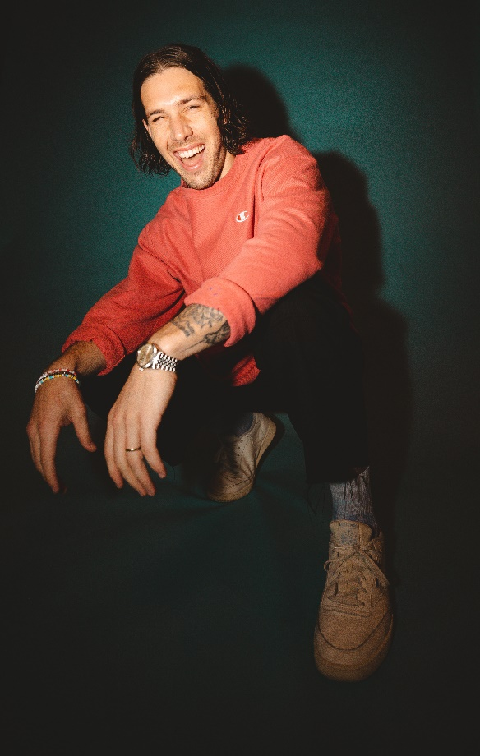
Photo Credit: Rachel Deeb
Download Hi-Res HERE

“With a knack for catchy melodies, his songs make for easy listening supported by buoyant pop production, heartfelt narratives, and a buttery voice to boot.” –BILLBOARD

“His R&B-infused pop sound is rounded out by lyrical sincerity.” –CONSEQUENCE OF SOUND

“Scott is humble, but extremely talented” –AMERICAN SONGWRITER

JUNE 3, 2022 – LOS ANGELES, CA – Pop singer-songwriter, producer, and multi-instrumentalist Jake Scott has released his new song, “Green Eyes.” Co-written and co-produced by Scott and Josh Kerr (Kelsea Ballerini, Keith Urban, Camila Cabello), the melodic track blends stripped-down guitars with Scott’s heartfelt vocals. In true Jake Scott fashion, the offering chronicles his love story with his wife Rachel, illustrated by vivid and honest lyricism. “Green Eyes” is out today on all streaming services, with a companion lyric video available to watch HERE.
“‘Green Eyes’ is about that first spark, that moment of connection with someone new. It makes the simple sacred and if you’re lucky, becomes the start of a story you’ll tell forever,” said Scott.

In March, Scott made his national television debut on The Kelly Clarkson Show, performing his anthemic, anecdotal track “Texas Girl.” Scott hails from Arkansas – a state that rivals Texas – and ended up falling for his wife – a Dallas native – regardless. At the top of the year, he also sold out every date on his first ever North American headline tour. Additionally, Scott’s 2021 collaboration with multi-platinum country star Russell Dickerson – “She Likes It” – is now RIAA Certified Gold and has amassed nearly 100M total global streams. The song is currently #38 on the Mediabase Country chart, and #35 on Billboard Country Airplay as well. Along with being a featured artist on the track, Scott also co-penned the song with Dickerson, underscoring his prowess as a songwriter.
Scott is currently on the road supporting Ben Rector on tour, which hits Houston, TX at 713 Music Hall this evening. The full itinerary of dates can be found below, with all tickets available HERE.

Named one of People Magazine’s “Emerging Artists” to watch, Scott is currently in the studio working on his first full-length project with Elektra Records. Stay tuned for more to come, including more live shows this year.

JAKE SCOTT
“GREEN EYES”
AVAILABLE HERE
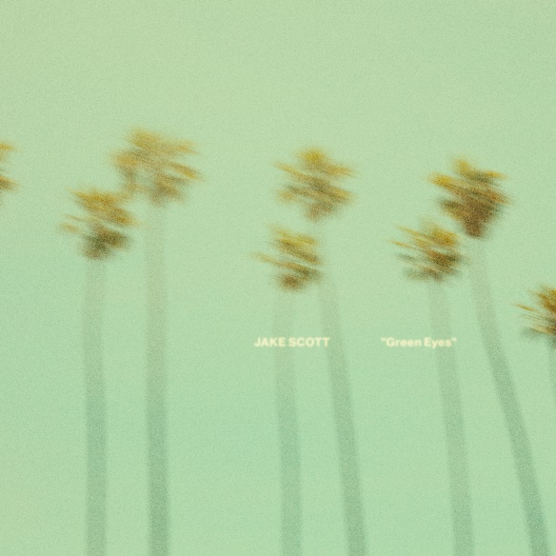
Hi-Res Artwork Available HERE

JAKE SCOTT ON TOUR:
6/3 Houston, TX 713 Music Hall *
6/4 Irving, TX The Pavilion at Toyota Music Factory *
6/5 Oklahoma City, OK Zoo Amphitheatre *

*Opening for Ben Rector

FOLLOW JAKE SCOTT:
WEBSITE | INSTAGRAM | FACEBOOK | TWITTER | YOUTUBE

# # #

JAKE SCOTT MEDIA CONTACTS:

Glenn Fukushima
GlennFukushima@Elektra.com
Ross Anderson
RossAnderson@Elektra.com
Nathalie Rubin
NathalieRubin@Elektra.com
Sydney Worden
SydneyWorden@Elektra.com

