FOR IMMEDIATE RELEASE

FEBRUARY 14, 2022

**JC STEWART DEBUTS NEW SINGLE “LOVE LIKE THAT”**

**LISTEN**[**HERE**](https://nam04.safelinks.protection.outlook.com/?url=https%3A%2F%2Flnk.to%2FJC-LoveLikeThat&data=04%7C01%7CDestinyDominguez%40elektra.com%7C17955fde4854478b3e6d08d9efcafaa9%7C8367939002ec4ba1ad3d69da3fdd637e%7C0%7C0%7C637804477338275189%7CUnknown%7CTWFpbGZsb3d8eyJWIjoiMC4wLjAwMDAiLCJQIjoiV2luMzIiLCJBTiI6Ik1haWwiLCJXVCI6Mn0%3D%7C3000&sdata=1pbbMAbUjSVBky10NDUe9QXACr7POjx6g2KIfIKqn3c%3D&reserved=0)



*“Expect even bigger things to come from the Elektra signee.”* **– Billboard**

*“JC’s distinctive sound has captured the attention of many.” –* **Uproxx**

*“Worthy of your attention.”***– E! News**

Just in time for Valentine’s Day, rising Elektra Recording artist **JC Stewart** has unveiled his brand new single [**“Love Like That”**](https://nam04.safelinks.protection.outlook.com/?url=https%3A%2F%2Flnk.to%2FJC-LoveLikeThat&data=04%7C01%7CDestinyDominguez%40elektra.com%7C17955fde4854478b3e6d08d9efcafaa9%7C8367939002ec4ba1ad3d69da3fdd637e%7C0%7C0%7C637804477338275189%7CUnknown%7CTWFpbGZsb3d8eyJWIjoiMC4wLjAwMDAiLCJQIjoiV2luMzIiLCJBTiI6Ik1haWwiLCJXVCI6Mn0%3D%7C3000&sdata=1pbbMAbUjSVBky10NDUe9QXACr7POjx6g2KIfIKqn3c%3D&reserved=0). Showcasing his signature lovelorn lyricism, the track is available to stream and download starting today [HERE](https://nam04.safelinks.protection.outlook.com/?url=https%3A%2F%2Flnk.to%2FJC-LoveLikeThat&data=04%7C01%7CDestinyDominguez%40elektra.com%7C17955fde4854478b3e6d08d9efcafaa9%7C8367939002ec4ba1ad3d69da3fdd637e%7C0%7C0%7C637804477338275189%7CUnknown%7CTWFpbGZsb3d8eyJWIjoiMC4wLjAwMDAiLCJQIjoiV2luMzIiLCJBTiI6Ik1haWwiLCJXVCI6Mn0%3D%7C3000&sdata=1pbbMAbUjSVBky10NDUe9QXACr7POjx6g2KIfIKqn3c%3D&reserved=0).

“Love Like That” expresses an intimate, all-encompassing emotion within a soaring production. Passionately heartfelt yet introspective and tender, JC’s magnetic voice delivers a heartfelt apology to a love interest for not being there when it really mattered. His words are supported by a potent pop hook, swooning backing vocals and shimmering beats. While the song’s remorse is undeniable, there’s a positive feeling that this relationship can move onto a brighter future.

JCshares, *“I wrote ‘Love Like That’ after I’d had a few tough conversations with the people I loved around me. I realized I’d been fully prioritizing work over everything else and forgetting about the stuff that actually matters in life. This song is really an apology to those people and a promise to always put them first.”*

JC wrote ‘Love Like That’ with the Grammy-winning Koz (Dua Lipa) and the track’s producers The 23rd (Griff, Sigrid).

“Love Like That” arrives alongside a performance of the song for [Mahogany Sessions](https://nam04.safelinks.protection.outlook.com/?url=https%3A%2F%2Fyoutu.be%2Fv7nBvDB9Tz0&data=04%7C01%7CDestinyDominguez%40elektra.com%7C17955fde4854478b3e6d08d9efcafaa9%7C8367939002ec4ba1ad3d69da3fdd637e%7C0%7C0%7C637804477338275189%7CUnknown%7CTWFpbGZsb3d8eyJWIjoiMC4wLjAwMDAiLCJQIjoiV2luMzIiLCJBTiI6Ik1haWwiLCJXVCI6Mn0%3D%7C3000&sdata=YP%2FxEG9uyomLURB1kgjYai%2FXyy%2BMBkaTozbTfbnL3%2Bw%3D&reserved=0). JC’s elegantly authentic voice continues to shine just as brightly in a stripped-back setting, as it allows the nuances of his songwriting to become even more vulnerable. Accompanied by a four-piece gospel group, “Love Like That” takes on a melancholy ambience. While the studio version has an undercurrent of optimism, this session version feels like an acceptance that the wrongs he sings of can’t be put right.

2022 has already seen JC Stewart feature on “24/7” by Billen Ted (Mae Muller, 220 KID) and headline the January Revive tour for Abbie McCarthy’s Good Karma Club. His long-awaited ‘The tour after the tour that didn’t tour’ European tour begins in May and includes his biggest London show to date, and festival appearances at Boardmasters, Hurricane, Pinkpop, Rock Werchter and Southside. Please see his [official website](https://nam04.safelinks.protection.outlook.com/?url=https%3A%2F%2Fwww.iamjcstewart.com%2F&data=04%7C01%7CDestinyDominguez%40elektra.com%7C17955fde4854478b3e6d08d9efcafaa9%7C8367939002ec4ba1ad3d69da3fdd637e%7C0%7C0%7C637804477338275189%7CUnknown%7CTWFpbGZsb3d8eyJWIjoiMC4wLjAwMDAiLCJQIjoiV2luMzIiLCJBTiI6Ik1haWwiLCJXVCI6Mn0%3D%7C3000&sdata=UbXeavVGorJnZhrXGyAgiZwspC6pMYfR%2FRb%2BL26Spqw%3D&reserved=0) for ticket details.

JC Stewart has collaborated with an array of contemporary artists - Niall Horan, Lewis Capaldi, 220 Kid, Tom Odell, Jonasu and Kina – and was nominated for Best Push Performance at the 2021 MTV VMAs. The young Northern Irish artist also went viral on a global scale when Jennifer Aniston shared his [quarantine-themed twist](https://nam04.safelinks.protection.outlook.com/?url=https%3A%2F%2Fwww.instagram.com%2Fp%2FB-7of0jnL-A%2F&data=04%7C01%7CDestinyDominguez%40elektra.com%7C17955fde4854478b3e6d08d9efcafaa9%7C8367939002ec4ba1ad3d69da3fdd637e%7C0%7C0%7C637804477338275189%7CUnknown%7CTWFpbGZsb3d8eyJWIjoiMC4wLjAwMDAiLCJQIjoiV2luMzIiLCJBTiI6Ik1haWwiLCJXVCI6Mn0%3D%7C3000&sdata=VmIFk86n0N6w5tfxY1166cB4RjHxeXUdDOyv7czlYos%3D&reserved=0) on the ‘Friends’ theme. The video quickly surpassed 5 million views and resulted in JCappearing on [*Good Morning America*](https://nam04.safelinks.protection.outlook.com/?url=https%3A%2F%2Fwww.instagram.com%2Fp%2FB_kxbBEnNLC%2F&data=04%7C01%7CDestinyDominguez%40elektra.com%7C17955fde4854478b3e6d08d9efcafaa9%7C8367939002ec4ba1ad3d69da3fdd637e%7C0%7C0%7C637804477338275189%7CUnknown%7CTWFpbGZsb3d8eyJWIjoiMC4wLjAwMDAiLCJQIjoiV2luMzIiLCJBTiI6Ik1haWwiLCJXVCI6Mn0%3D%7C3000&sdata=lP%2FeEmIYPZZWHwrGU1x13ZaFdOenAyEC%2FgeUccvKMmM%3D&reserved=0)*, TODAY, Access Hollywood,* and more.

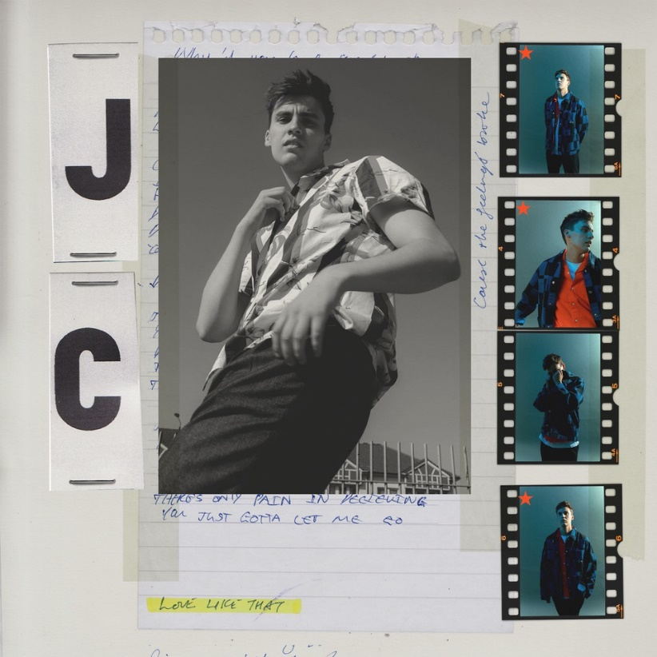

**JC STEWART - “LOVE LIKE THAT”**

**LISTEN**[**HERE**](https://nam04.safelinks.protection.outlook.com/?url=https%3A%2F%2Flnk.to%2FJC-LoveLikeThat&data=04%7C01%7CDestinyDominguez%40elektra.com%7C17955fde4854478b3e6d08d9efcafaa9%7C8367939002ec4ba1ad3d69da3fdd637e%7C0%7C0%7C637804477338275189%7CUnknown%7CTWFpbGZsb3d8eyJWIjoiMC4wLjAwMDAiLCJQIjoiV2luMzIiLCJBTiI6Ik1haWwiLCJXVCI6Mn0%3D%7C3000&sdata=1pbbMAbUjSVBky10NDUe9QXACr7POjx6g2KIfIKqn3c%3D&reserved=0)

**Contact with JC Stewart:**

[**Official site**](https://nam04.safelinks.protection.outlook.com/?url=http%3A%2F%2Fiamjcstewart.com%2F&data=04%7C01%7CDestinyDominguez%40elektra.com%7C17955fde4854478b3e6d08d9efcafaa9%7C8367939002ec4ba1ad3d69da3fdd637e%7C0%7C0%7C637804477338275189%7CUnknown%7CTWFpbGZsb3d8eyJWIjoiMC4wLjAwMDAiLCJQIjoiV2luMzIiLCJBTiI6Ik1haWwiLCJXVCI6Mn0%3D%7C3000&sdata=hHgc3DRYBEmPFUBEj1r%2F952j1IlWNkLcSFZjaLuy4zA%3D&reserved=0) | [**YouTube**](https://nam04.safelinks.protection.outlook.com/?url=https%3A%2F%2Fwww.youtube.com%2Fchannel%2FUCsM9RTCKh-XEiLan59m5ycA&data=04%7C01%7CDestinyDominguez%40elektra.com%7C17955fde4854478b3e6d08d9efcafaa9%7C8367939002ec4ba1ad3d69da3fdd637e%7C0%7C0%7C637804477338275189%7CUnknown%7CTWFpbGZsb3d8eyJWIjoiMC4wLjAwMDAiLCJQIjoiV2luMzIiLCJBTiI6Ik1haWwiLCJXVCI6Mn0%3D%7C3000&sdata=ZgafrNEctqnQtonIuoy2jHNaaC%2FIz259uy5sHfO7YqQ%3D&reserved=0) | [**Instagram**](https://nam04.safelinks.protection.outlook.com/?url=https%3A%2F%2Fwww.instagram.com%2Fjcstewart%2F&data=04%7C01%7CDestinyDominguez%40elektra.com%7C17955fde4854478b3e6d08d9efcafaa9%7C8367939002ec4ba1ad3d69da3fdd637e%7C0%7C0%7C637804477338275189%7CUnknown%7CTWFpbGZsb3d8eyJWIjoiMC4wLjAwMDAiLCJQIjoiV2luMzIiLCJBTiI6Ik1haWwiLCJXVCI6Mn0%3D%7C3000&sdata=3G%2Fm1wSftilsvxAdJxhHE7BKR0mn%2FxBWYJXJy%2BG3ItY%3D&reserved=0) | [**Facebook**](https://nam04.safelinks.protection.outlook.com/?url=https%3A%2F%2Fwww.facebook.com%2FJCStewart%2F&data=04%7C01%7CDestinyDominguez%40elektra.com%7C17955fde4854478b3e6d08d9efcafaa9%7C8367939002ec4ba1ad3d69da3fdd637e%7C0%7C0%7C637804477338275189%7CUnknown%7CTWFpbGZsb3d8eyJWIjoiMC4wLjAwMDAiLCJQIjoiV2luMzIiLCJBTiI6Ik1haWwiLCJXVCI6Mn0%3D%7C3000&sdata=wCBVQIqTTJHdJp%2Bgcaq67lz3BjfecJvQ%2F5eVqSQniWU%3D&reserved=0) | [**Twitter**](https://nam04.safelinks.protection.outlook.com/?url=https%3A%2F%2Ftwitter.com%2Fjcstewart&data=04%7C01%7CDestinyDominguez%40elektra.com%7C17955fde4854478b3e6d08d9efcafaa9%7C8367939002ec4ba1ad3d69da3fdd637e%7C0%7C0%7C637804477338431423%7CUnknown%7CTWFpbGZsb3d8eyJWIjoiMC4wLjAwMDAiLCJQIjoiV2luMzIiLCJBTiI6Ik1haWwiLCJXVCI6Mn0%3D%7C3000&sdata=7tARSZyDgAeRslN5ZAefPy0uJeGLHeo7RGlORGyiYnM%3D&reserved=0)

**PRESS CONTACT:**

Collin Citron

[CollinCitron@elektra.com](mailto:CollinCitron@elektra.com)