FOR IMMEDIATE RELEASE

JUNE 25, 2021

**JC STEWART RELEASES NEW SINGLE AND MUSIC VIDEO “LOUD”**

**LISTEN**[**HERE**](https://nam04.safelinks.protection.outlook.com/?url=https%3A%2F%2Fsunshineboy.co%2Floud&data=04%7C01%7CSydneyWorden%40elektra.com%7Cb332604badf04f20cce208d937dd5e6b%7C8367939002ec4ba1ad3d69da3fdd637e%7C0%7C0%7C637602246187885209%7CUnknown%7CTWFpbGZsb3d8eyJWIjoiMC4wLjAwMDAiLCJQIjoiV2luMzIiLCJBTiI6Ik1haWwiLCJXVCI6Mn0%3D%7C1000&sdata=B3QTLmDAv7BrWMGKCe6rJxebRw5OCvXTdAhsrPm7dHY%3D&reserved=0)**/ WATCH THE VIDEO**[**HERE**](https://nam04.safelinks.protection.outlook.com/?url=https%3A%2F%2Fyoutu.be%2FyMeEDatwAt0&data=04%7C01%7CSydneyWorden%40elektra.com%7Cb332604badf04f20cce208d937dd5e6b%7C8367939002ec4ba1ad3d69da3fdd637e%7C0%7C0%7C637602246187885209%7CUnknown%7CTWFpbGZsb3d8eyJWIjoiMC4wLjAwMDAiLCJQIjoiV2luMzIiLCJBTiI6Ik1haWwiLCJXVCI6Mn0%3D%7C1000&sdata=tvIVVRkRQsDCj1hcu8h6QPL4snt3e4xPj1J4LxRNitY%3D&reserved=0)

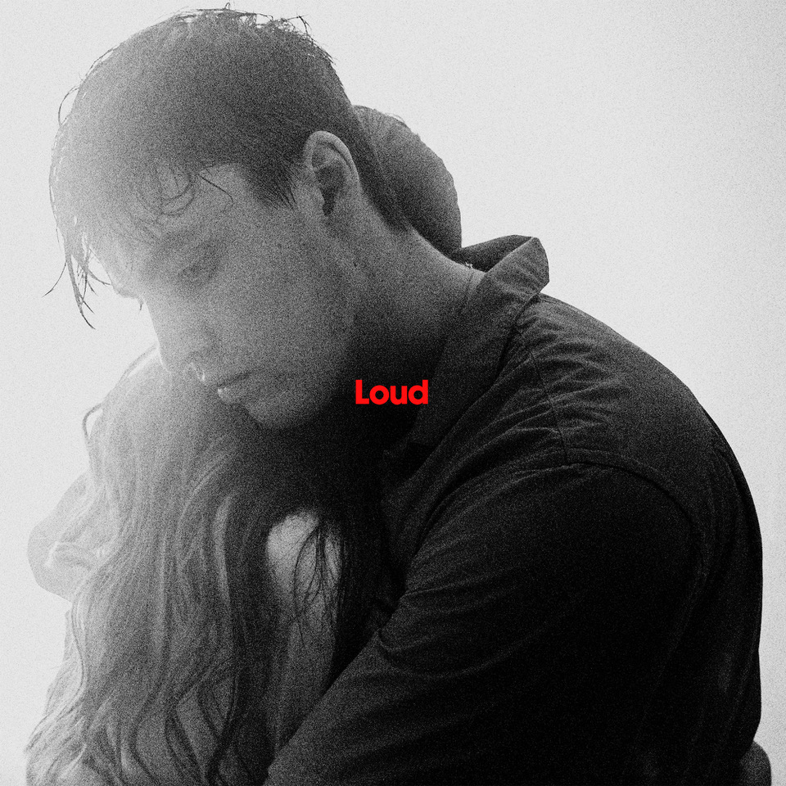

*“Expect even bigger things to come from the Elektra signee.”***– Billboard**

*“JC’s distinctive sound has captured the attention of many.” –***Uproxx**

*“JC Stewart’s own ascent continues.”***– Wonderland**

*“Supremely emotional.”***– Clash**

*“Worthy of your attention.”***– E! News**

Rising Elektra recording artist **JC Stewart** has returned with **“Loud”**, his second single of 2021. The song is available to stream and download starting today [HERE](https://nam04.safelinks.protection.outlook.com/?url=https%3A%2F%2Fsunshineboy.co%2Floud&data=04%7C01%7CSydneyWorden%40elektra.com%7Cb332604badf04f20cce208d937dd5e6b%7C8367939002ec4ba1ad3d69da3fdd637e%7C0%7C0%7C637602246187895198%7CUnknown%7CTWFpbGZsb3d8eyJWIjoiMC4wLjAwMDAiLCJQIjoiV2luMzIiLCJBTiI6Ik1haWwiLCJXVCI6Mn0%3D%7C1000&sdata=8gdBEkvIta%2F4frxqLxVRKe8EKvqw6KSpXyt%2FQHFKfbY%3D&reserved=0). Watch the track’s official music video on JC’s YouTube channel [HERE](https://nam04.safelinks.protection.outlook.com/?url=https%3A%2F%2Fyoutu.be%2FyMeEDatwAt0&data=04%7C01%7CSydneyWorden%40elektra.com%7Cb332604badf04f20cce208d937dd5e6b%7C8367939002ec4ba1ad3d69da3fdd637e%7C0%7C0%7C637602246187905195%7CUnknown%7CTWFpbGZsb3d8eyJWIjoiMC4wLjAwMDAiLCJQIjoiV2luMzIiLCJBTiI6Ik1haWwiLCJXVCI6Mn0%3D%7C1000&sdata=EvHdbmJjt6we58KkCY2X6ls5l3JfkztmKYlMBF03s2k%3D&reserved=0).

“Loud” marks JC’s most beautiful, elegant, and reflective release to date. The track pushes JC’s lovelorn lyricism to the forefront, this time with a twist, as JC is heartbroken by separation rather than a break-up. It is classically melodic yet infused with vibrant sonic touches, constantly evolving from fragile piano to a wall-of-sound, rich with soothing vocal harmonies and commanding percussion. JC wrote “Loud” earlier this year when he spent a few days alone by theKent coast. The track was produced by GRAMMY® Award-winner Koz, best known for his work on both of Dua Lipa’s hit albums, and mixed by Matty Green (Dermot Kennedy, Louis Tomlinson).

For the track’s music video,JCis joined byhis girlfriend, model[Annabelle Hoy](https://nam04.safelinks.protection.outlook.com/?url=https%3A%2F%2Fwww.instagram.com%2Fannabellehoy%2F%3Fhl%3Den&data=04%7C01%7CSydneyWorden%40elektra.com%7Cb332604badf04f20cce208d937dd5e6b%7C8367939002ec4ba1ad3d69da3fdd637e%7C0%7C0%7C637602246187905195%7CUnknown%7CTWFpbGZsb3d8eyJWIjoiMC4wLjAwMDAiLCJQIjoiV2luMzIiLCJBTiI6Ik1haWwiLCJXVCI6Mn0%3D%7C1000&sdata=%2BjHcBXnLiTCt%2BXkIJ%2F%2BWQRPlZu7LCzUDYa2PTMxZp2E%3D&reserved=0), who is also featured on the single’s artwork. Drawing on water as a symbolic representation of being submerged by life’s challenges, the visual exudes a beautiful power in its simplicity. The videowas created by[Collective Films](https://nam04.safelinks.protection.outlook.com/?url=https%3A%2F%2Fwww.cltv.film%2F&data=04%7C01%7CSydneyWorden%40elektra.com%7Cb332604badf04f20cce208d937dd5e6b%7C8367939002ec4ba1ad3d69da3fdd637e%7C0%7C0%7C637602246187915189%7CUnknown%7CTWFpbGZsb3d8eyJWIjoiMC4wLjAwMDAiLCJQIjoiV2luMzIiLCJBTiI6Ik1haWwiLCJXVCI6Mn0%3D%7C1000&sdata=EM92RAzn7Zk3c7WT2D9PAn%2Bs775afJM42ZTCj%2BZMKto%3D&reserved=0), who previously worked with JC on last year’s[livestream show and interview](https://nam04.safelinks.protection.outlook.com/?url=https%3A%2F%2Fyoutu.be%2FXwzdEbuHbR0&data=04%7C01%7CSydneyWorden%40elektra.com%7Cb332604badf04f20cce208d937dd5e6b%7C8367939002ec4ba1ad3d69da3fdd637e%7C0%7C0%7C637602246187915189%7CUnknown%7CTWFpbGZsb3d8eyJWIjoiMC4wLjAwMDAiLCJQIjoiV2luMzIiLCJBTiI6Ik1haWwiLCJXVCI6Mn0%3D%7C1000&sdata=CnlkfSfWNy2GszroJ5BIckDwqfXfPE%2FdI5C98jMWpOg%3D&reserved=0).

*“The concept of the video stemmed around the fact that sometimes, when I’m feeling overwhelmed, it can feel like being underwater. Both intense and silent. Overwhelming and solitary,”*JC shared. *“I thought the water symbolised what I felt for the few months before I wrote the song and wanted to make that the main focal point. Having my girlfriend in it, who the song is about, was also incredibly special and something I’ll be able to cherish forever.”*

JC is set to make a long-awaited return to the stage in the UK this summer. He will appear at Latitude Festival (July 22-25), and is scheduled to perform two headline shows: a homecoming gig at Belfast’s Ulster Hall (September 2) and his biggest London show to date at the O2 Academy Islington (September 22). Remaining tickets are available [HERE](https://nam04.safelinks.protection.outlook.com/?url=https%3A%2F%2Fsunshineboy.co%2Fsept-shows-2021&data=04%7C01%7CSydneyWorden%40elektra.com%7Cb332604badf04f20cce208d937dd5e6b%7C8367939002ec4ba1ad3d69da3fdd637e%7C0%7C0%7C637602246187925178%7CUnknown%7CTWFpbGZsb3d8eyJWIjoiMC4wLjAwMDAiLCJQIjoiV2luMzIiLCJBTiI6Ik1haWwiLCJXVCI6Mn0%3D%7C1000&sdata=bH%2F65OYCTUajDIuesMPJ2snts4jSFZZSISFTE7MUzcc%3D&reserved=0).

JC Stewart kicked off2021in style, when he was named asMTV’sfirst globalPushartist of the year. His previous single["Break My Heart"](https://nam04.safelinks.protection.outlook.com/?url=https%3A%2F%2Flnk.to%2FJCStewart-BreakMyHeart&data=04%7C01%7CSydneyWorden%40elektra.com%7Cb332604badf04f20cce208d937dd5e6b%7C8367939002ec4ba1ad3d69da3fdd637e%7C0%7C0%7C637602246187925178%7CUnknown%7CTWFpbGZsb3d8eyJWIjoiMC4wLjAwMDAiLCJQIjoiV2luMzIiLCJBTiI6Ik1haWwiLCJXVCI6Mn0%3D%7C1000&sdata=Iw58YEtlf%2BP7YRk3VPMFYwKPAc%2B1ITbK7juL%2FQnYrdM%3D&reserved=0)continues to fire his momentum upwards. Co-written withNiall Horanand broadening his already engaging pop appeal, the track has helped JC achieve a growing following of millions of monthly listeners, and extensive airplay across the United Kingdom.

Emerging from Northern Ireland,JC Stewartpossesses all the traits of a global star. His music is powered by a voice as real and powerful as the heartfelt emotions he explores. Yet while his talent is remarkable, his personality is relatable. His sharp wit and inclusive nature are immensely popular across his social media, a following which exploded after Jennifer Aniston shared his[quarantine-themed twist](https://nam04.safelinks.protection.outlook.com/?url=https%3A%2F%2Fwww.instagram.com%2Fp%2FB-7of0jnL-A%2F&data=04%7C01%7CSydneyWorden%40elektra.com%7Cb332604badf04f20cce208d937dd5e6b%7C8367939002ec4ba1ad3d69da3fdd637e%7C0%7C0%7C637602246187935173%7CUnknown%7CTWFpbGZsb3d8eyJWIjoiMC4wLjAwMDAiLCJQIjoiV2luMzIiLCJBTiI6Ik1haWwiLCJXVCI6Mn0%3D%7C1000&sdata=7TBGtbAi93y7vPrOx%2F4vgAmCM6M7CHFxoo2MTYLJQIE%3D&reserved=0) on the *Friends* theme last year. The video quickly surpassed 5 million views and resulted in JCappearing on [*Good Morning America*](https://nam04.safelinks.protection.outlook.com/?url=https%3A%2F%2Fwww.instagram.com%2Fp%2FB_kxbBEnNLC%2F&data=04%7C01%7CSydneyWorden%40elektra.com%7Cb332604badf04f20cce208d937dd5e6b%7C8367939002ec4ba1ad3d69da3fdd637e%7C0%7C0%7C637602246187945175%7CUnknown%7CTWFpbGZsb3d8eyJWIjoiMC4wLjAwMDAiLCJQIjoiV2luMzIiLCJBTiI6Ik1haWwiLCJXVCI6Mn0%3D%7C1000&sdata=9PfDyXKHkmc4FzmUhIjrSUPdEqKn7rhf9RCDF%2Bx6koI%3D&reserved=0)*, TODAY, Access Hollywood,*and more.

JC’s growing following includes some famous fans too. Last year JC teamed up with 220 Kid for the track[“Too Many Nights"](https://nam04.safelinks.protection.outlook.com/?url=https%3A%2F%2F220kid.lnk.to%2FTooManyNights&data=04%7C01%7CSydneyWorden%40elektra.com%7Cb332604badf04f20cce208d937dd5e6b%7C8367939002ec4ba1ad3d69da3fdd637e%7C0%7C0%7C637602246187955162%7CUnknown%7CTWFpbGZsb3d8eyJWIjoiMC4wLjAwMDAiLCJQIjoiV2luMzIiLCJBTiI6Ik1haWwiLCJXVCI6Mn0%3D%7C1000&sdata=uoYBvtqeneB6gPrZ%2Fv37Lvn%2BAKm7OEMBe3KqiGPRu5Y%3D&reserved=0), while his debut EP ["When The Light Hits The Room"](https://nam04.safelinks.protection.outlook.com/?url=https%3A%2F%2Fsunshineboy.co%2Fwhenthelighthitstheroom&data=04%7C01%7CSydneyWorden%40elektra.com%7Cb332604badf04f20cce208d937dd5e6b%7C8367939002ec4ba1ad3d69da3fdd637e%7C0%7C0%7C637602246187955162%7CUnknown%7CTWFpbGZsb3d8eyJWIjoiMC4wLjAwMDAiLCJQIjoiV2luMzIiLCJBTiI6Ik1haWwiLCJXVCI6Mn0%3D%7C1000&sdata=Hk8unSvdxBvYrOxIzQLfdO%2BnnUakzFiaAXin%2F%2B%2FeUSA%3D&reserved=0) was co-written with the BRIT / Ivor Novello winner Tom Odell. His first major collaboration came when he co-wrote“Hollywood”, a song which later featured on Lewis Capaldi’s chart-topping debut album.



[**Official site**](https://nam04.safelinks.protection.outlook.com/?url=http%3A%2F%2Fiamjcstewart.com%2F&data=04%7C01%7CSydneyWorden%40elektra.com%7Cb332604badf04f20cce208d937dd5e6b%7C8367939002ec4ba1ad3d69da3fdd637e%7C0%7C0%7C637602246187965154%7CUnknown%7CTWFpbGZsb3d8eyJWIjoiMC4wLjAwMDAiLCJQIjoiV2luMzIiLCJBTiI6Ik1haWwiLCJXVCI6Mn0%3D%7C1000&sdata=GVfZZPOVIIZmL2bEvpQFYF2TJy72TnGn8%2BClTZBbHUA%3D&reserved=0)

[**Spotify**](https://nam04.safelinks.protection.outlook.com/?url=https%3A%2F%2Fopen.spotify.com%2Fartist%2F2TAqN8fwfaKauvviN4pOsv%3Fsi%3DM3wsUX3mQdKIYPDsAWD6ow&data=04%7C01%7CSydneyWorden%40elektra.com%7Cb332604badf04f20cce208d937dd5e6b%7C8367939002ec4ba1ad3d69da3fdd637e%7C0%7C0%7C637602246187965154%7CUnknown%7CTWFpbGZsb3d8eyJWIjoiMC4wLjAwMDAiLCJQIjoiV2luMzIiLCJBTiI6Ik1haWwiLCJXVCI6Mn0%3D%7C1000&sdata=y7cG9HcmzYQVvQ1YrBBhO7wgcmjFdAyIMCdOHWr8%2Fu0%3D&reserved=0)

[**Apple Music**](https://nam04.safelinks.protection.outlook.com/?url=https%3A%2F%2Fmusic.apple.com%2Fgb%2Fartist%2Fjc-stewart%2F1377757399&data=04%7C01%7CSydneyWorden%40elektra.com%7Cb332604badf04f20cce208d937dd5e6b%7C8367939002ec4ba1ad3d69da3fdd637e%7C0%7C0%7C637602246187975154%7CUnknown%7CTWFpbGZsb3d8eyJWIjoiMC4wLjAwMDAiLCJQIjoiV2luMzIiLCJBTiI6Ik1haWwiLCJXVCI6Mn0%3D%7C1000&sdata=rRk0rx0JWdMEn48uk24mOTh2gB7gxEJQO2E3a2CRyL4%3D&reserved=0)

[**YouTube**](https://nam04.safelinks.protection.outlook.com/?url=https%3A%2F%2Fwww.youtube.com%2Fchannel%2FUCsM9RTCKh-XEiLan59m5ycA&data=04%7C01%7CSydneyWorden%40elektra.com%7Cb332604badf04f20cce208d937dd5e6b%7C8367939002ec4ba1ad3d69da3fdd637e%7C0%7C0%7C637602246187975154%7CUnknown%7CTWFpbGZsb3d8eyJWIjoiMC4wLjAwMDAiLCJQIjoiV2luMzIiLCJBTiI6Ik1haWwiLCJXVCI6Mn0%3D%7C1000&sdata=%2FAH9DBrFHiUYC1hI2dS6rPSz0TiRRw5Kqq0CdrPgRTE%3D&reserved=0)

[**Instagram**](https://nam04.safelinks.protection.outlook.com/?url=https%3A%2F%2Fwww.instagram.com%2Fjcstewart%2F&data=04%7C01%7CSydneyWorden%40elektra.com%7Cb332604badf04f20cce208d937dd5e6b%7C8367939002ec4ba1ad3d69da3fdd637e%7C0%7C0%7C637602246187985143%7CUnknown%7CTWFpbGZsb3d8eyJWIjoiMC4wLjAwMDAiLCJQIjoiV2luMzIiLCJBTiI6Ik1haWwiLCJXVCI6Mn0%3D%7C1000&sdata=R07gRheL%2FaUDCUFcer7ktRD6ayLoCXDzy2uRXRF%2Fb8E%3D&reserved=0)

[**Facebook**](https://nam04.safelinks.protection.outlook.com/?url=https%3A%2F%2Fwww.facebook.com%2FJCStewart%2F&data=04%7C01%7CSydneyWorden%40elektra.com%7Cb332604badf04f20cce208d937dd5e6b%7C8367939002ec4ba1ad3d69da3fdd637e%7C0%7C0%7C637602246187995136%7CUnknown%7CTWFpbGZsb3d8eyJWIjoiMC4wLjAwMDAiLCJQIjoiV2luMzIiLCJBTiI6Ik1haWwiLCJXVCI6Mn0%3D%7C1000&sdata=aTj%2BmnrCPFPR%2F8Je1Shng780cd0qzBxJW7HuC56uejc%3D&reserved=0)

[**Twitter**](https://nam04.safelinks.protection.outlook.com/?url=https%3A%2F%2Ftwitter.com%2Fjcstewart&data=04%7C01%7CSydneyWorden%40elektra.com%7Cb332604badf04f20cce208d937dd5e6b%7C8367939002ec4ba1ad3d69da3fdd637e%7C0%7C0%7C637602246187995136%7CUnknown%7CTWFpbGZsb3d8eyJWIjoiMC4wLjAwMDAiLCJQIjoiV2luMzIiLCJBTiI6Ik1haWwiLCJXVCI6Mn0%3D%7C1000&sdata=zbaSMZn5wuE1ZF90pXy324bZGqtMUfRTes0X1aCWNO8%3D&reserved=0)

**PRESS CONTACTS:**

Collin Citron

[CollinCitron@elektra.com](mailto:CollinCitron@elektra.com)

Glenn Fukushima

[GlennFukushima@elektra.com](mailto:GlennFukushima@elektra.com)