FOR IMMEDIATE RELEASE

JANUARY 08, 2021

**JC STEWART SHARES NEW SINGLE AND VIDEO “BREAK MY HEART”**

**LISTEN / WATCH** [**HERE**](https://nam04.safelinks.protection.outlook.com/?url=https%3A%2F%2Flnk.to%2FJCStewart-BreakMyHeart&data=04%7C01%7CSydneyWorden%40elektra.com%7C4d373cc3960942a5b70508d8b3e404bd%7C8367939002ec4ba1ad3d69da3fdd637e%7C0%7C0%7C637457139267469564%7CUnknown%7CTWFpbGZsb3d8eyJWIjoiMC4wLjAwMDAiLCJQIjoiV2luMzIiLCJBTiI6Ik1haWwiLCJXVCI6Mn0%3D%7C1000&sdata=Uv2uHDbugscvEcQA95GRV8D8I0x%2BohPaMhyFa4%2FkR%2FA%3D&reserved=0)

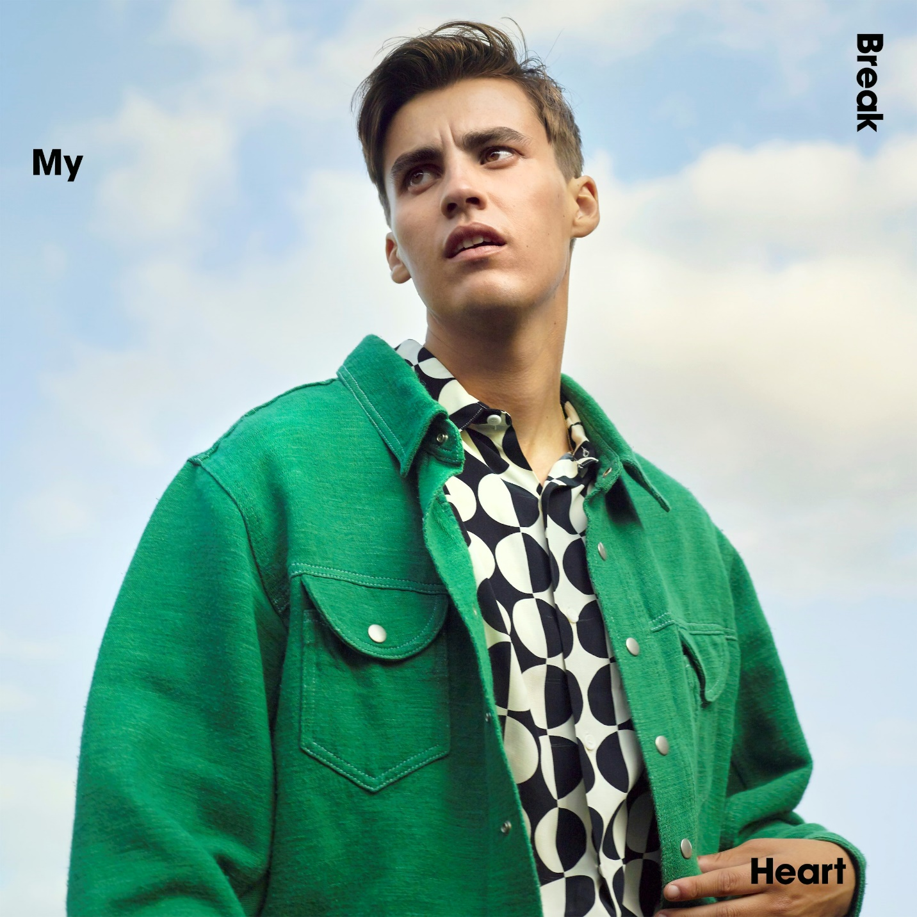

*“Expect even bigger things to come from the Elektra signee.”* **– Billboard**

*“Stewart excels at keening, heart-on-sleeve balladry that mixes raw emotion with classic pop chord progressions and a voice of angelic purity.” –* **Sunday Times Culture**

*“JC Stewart’s own ascent continues.”* **– Wonderland**

*“Supremely emotional.”* **– Clash**

*“Worthy of your attention.”***– E! News**

Over the course of the last year, **JC Stewart** has made the kind of progress that makes him an artist to watch for 2021. He has already achieved a growing following of millions of monthly listeners, plus extensive airplay across the United Kingdom. And he’s set to make an immediate impact on the year ahead as he shares his new single **“**[**Break My Heart**](https://nam04.safelinks.protection.outlook.com/?url=https%3A%2F%2Flnk.to%2FJCStewart-BreakMyHeart&data=04%7C01%7CSydneyWorden%40elektra.com%7C4d373cc3960942a5b70508d8b3e404bd%7C8367939002ec4ba1ad3d69da3fdd637e%7C0%7C0%7C637457139267479556%7CUnknown%7CTWFpbGZsb3d8eyJWIjoiMC4wLjAwMDAiLCJQIjoiV2luMzIiLCJBTiI6Ik1haWwiLCJXVCI6Mn0%3D%7C1000&sdata=8Z1qoTU56H%2FAzStTdzlYZ1xE9ePc9MzWVxSMCBK6zfQ%3D&reserved=0)”, which he co-wrote with **Niall Horan**. It’s accompanied by an [official video](https://nam04.safelinks.protection.outlook.com/?url=https%3A%2F%2Fyoutu.be%2FDLY7nVsq2-s&data=04%7C01%7CSydneyWorden%40elektra.com%7C4d373cc3960942a5b70508d8b3e404bd%7C8367939002ec4ba1ad3d69da3fdd637e%7C0%7C0%7C637457139267479556%7CUnknown%7CTWFpbGZsb3d8eyJWIjoiMC4wLjAwMDAiLCJQIjoiV2luMzIiLCJBTiI6Ik1haWwiLCJXVCI6Mn0%3D%7C1000&sdata=odDHL8O8Y2cYSoEl7v69M6iUp%2FhFy0SP12OyPXPs3T0%3D&reserved=0) which was directed by [Charlie Sarsfield](https://nam04.safelinks.protection.outlook.com/?url=https%3A%2F%2Fwww.charliesarsfield.com%2F&data=04%7C01%7CSydneyWorden%40elektra.com%7C4d373cc3960942a5b70508d8b3e404bd%7C8367939002ec4ba1ad3d69da3fdd637e%7C0%7C0%7C637457139267489545%7CUnknown%7CTWFpbGZsb3d8eyJWIjoiMC4wLjAwMDAiLCJQIjoiV2luMzIiLCJBTiI6Ik1haWwiLCJXVCI6Mn0%3D%7C1000&sdata=47mNr2dD2%2FTt1I7GIIIqag80elkrfB%2B9ytNBJhS3LTU%3D&reserved=0) (Stormzy, Dermot Kennedy), who also directed the video for JC’s previous single “[I Need You To Hate Me](https://nam04.safelinks.protection.outlook.com/?url=https%3A%2F%2Fyoutu.be%2F2sFvGqTjlxM&data=04%7C01%7CSydneyWorden%40elektra.com%7C4d373cc3960942a5b70508d8b3e404bd%7C8367939002ec4ba1ad3d69da3fdd637e%7C0%7C0%7C637457139267489545%7CUnknown%7CTWFpbGZsb3d8eyJWIjoiMC4wLjAwMDAiLCJQIjoiV2luMzIiLCJBTiI6Ik1haWwiLCJXVCI6Mn0%3D%7C1000&sdata=nZuE4eqB%2BG9%2BWwaut5RCe%2FZX%2F3botPopbFxtV4oAz9I%3D&reserved=0)”.

“Break My Heart” follows fan-favorite singles “[I Need You To Hate Me](https://nam04.safelinks.protection.outlook.com/?url=https%3A%2F%2Flnk.to%2Fineedyoutohateme&data=04%7C01%7CSydneyWorden%40elektra.com%7C4d373cc3960942a5b70508d8b3e404bd%7C8367939002ec4ba1ad3d69da3fdd637e%7C0%7C0%7C637457139267499540%7CUnknown%7CTWFpbGZsb3d8eyJWIjoiMC4wLjAwMDAiLCJQIjoiV2luMzIiLCJBTiI6Ik1haWwiLCJXVCI6Mn0%3D%7C1000&sdata=IIyUEnM%2F5nPORCxc15L2%2FwV%2BLDBcmcHls7SdTZ8AsyU%3D&reserved=0)” and “[Lying That You Love Me](https://nam04.safelinks.protection.outlook.com/?url=https%3A%2F%2Flnk.to%2Fltylm&data=04%7C01%7CSydneyWorden%40elektra.com%7C4d373cc3960942a5b70508d8b3e404bd%7C8367939002ec4ba1ad3d69da3fdd637e%7C0%7C0%7C637457139267499540%7CUnknown%7CTWFpbGZsb3d8eyJWIjoiMC4wLjAwMDAiLCJQIjoiV2luMzIiLCJBTiI6Ik1haWwiLCJXVCI6Mn0%3D%7C1000&sdata=O4dAKx3fWukw04oKbifC8FF13%2BWShG0gIOvbnvanOE4%3D&reserved=0)”. The song is a melodic firecracker of alt-pop energy. JC’s gift for exploring the nuances of relationships remains a key strength, this time with a tale of a romance that has to be all or nothing.

*“‘Break My Heart’ is big, fast, and fun,”* says JC. *“It’s about someone who can catch you so off guard that they can ruin a city for you and tear your life apart. But sometimes that can be addicting.”*

That story is extended in the track’s accompanying video. Matching the song’s bursts of energy with rapid fire cuts and a cinematic sheen, the video features JC as one-half of a couple who share an erratic relationship. It switches between a whirlwind of ups and downs: the joy of hitting the open road and blissed out moment home alone, juxtaposed with awkward silences and icy stares.

“Break My Heart” is also JC’s first ever vinyl release. The 7” vinyl is packaged with a personally signed poster and features an acoustic version of “Break My Heart” on the b-side. It’s available [here](https://nam04.safelinks.protection.outlook.com/?url=https%3A%2F%2Feurostore.warnermusic.com%2Fuk%2Fbreak-my-heart-7inch-vinyl-signed-poster.html&data=04%7C01%7CSydneyWorden%40elektra.com%7C4d373cc3960942a5b70508d8b3e404bd%7C8367939002ec4ba1ad3d69da3fdd637e%7C0%7C0%7C637457139267509534%7CUnknown%7CTWFpbGZsb3d8eyJWIjoiMC4wLjAwMDAiLCJQIjoiV2luMzIiLCJBTiI6Ik1haWwiLCJXVCI6Mn0%3D%7C1000&sdata=oHblnDCV%2FmB1WjWf9pRVRlG5F%2FTh0TUYFRWrbzuHxE8%3D&reserved=0).

Last year, JC followed a series of attention-grabbing singles with his debut EP [*When The Light Hits The Room*](https://nam04.safelinks.protection.outlook.com/?url=https%3A%2F%2Fsunshineboy.co%2Fwhenthelighthitstheroom&data=04%7C01%7CSydneyWorden%40elektra.com%7C4d373cc3960942a5b70508d8b3e404bd%7C8367939002ec4ba1ad3d69da3fdd637e%7C0%7C0%7C637457139267509534%7CUnknown%7CTWFpbGZsb3d8eyJWIjoiMC4wLjAwMDAiLCJQIjoiV2luMzIiLCJBTiI6Ik1haWwiLCJXVCI6Mn0%3D%7C1000&sdata=mxzTQtxq0RmiNwpFJ46Q%2FSe1fJG0HcAYW268SLqsr6Q%3D&reserved=0), which was co-written with BRIT Award-winning singer/songwriter Tom Odell,and produced by the GRAMMY® Award-nominee Two Inch Punch (Rex Orange County, Sam Smith, Rag N Bone Man). JC then reached a new audience with his 220 Kid collaboration “[Too Many Nights](https://nam04.safelinks.protection.outlook.com/?url=https%3A%2F%2F220kid.lnk.to%2FTooManyNights&data=04%7C01%7CSydneyWorden%40elektra.com%7C4d373cc3960942a5b70508d8b3e404bd%7C8367939002ec4ba1ad3d69da3fdd637e%7C0%7C0%7C637457139267519528%7CUnknown%7CTWFpbGZsb3d8eyJWIjoiMC4wLjAwMDAiLCJQIjoiV2luMzIiLCJBTiI6Ik1haWwiLCJXVCI6Mn0%3D%7C1000&sdata=WDLkJQBmqr%2BFJYEebA7O9QDAqtDpnU2VfSGhv5eHFLg%3D&reserved=0)”. His [quarantine-themed parody](https://nam04.safelinks.protection.outlook.com/?url=https%3A%2F%2Fwww.instagram.com%2Fp%2FB-7of0jnL-A%2F&data=04%7C01%7CSydneyWorden%40elektra.com%7C4d373cc3960942a5b70508d8b3e404bd%7C8367939002ec4ba1ad3d69da3fdd637e%7C0%7C0%7C637457139267519528%7CUnknown%7CTWFpbGZsb3d8eyJWIjoiMC4wLjAwMDAiLCJQIjoiV2luMzIiLCJBTiI6Ik1haWwiLCJXVCI6Mn0%3D%7C1000&sdata=xA8HzsY2cH9%2F74XuFAZnJFgBfH7t53JA%2BxYTsY%2FddGo%3D&reserved=0) of the *Friends* theme also went viral with the help of Jennifer Aniston, as it quickly surpassed 5 million views and resulted in himappearing on [*Good Morning America*](https://nam04.safelinks.protection.outlook.com/?url=https%3A%2F%2Fwww.instagram.com%2Fp%2FB_kxbBEnNLC%2F&data=04%7C01%7CSydneyWorden%40elektra.com%7C4d373cc3960942a5b70508d8b3e404bd%7C8367939002ec4ba1ad3d69da3fdd637e%7C0%7C0%7C637457139267529524%7CUnknown%7CTWFpbGZsb3d8eyJWIjoiMC4wLjAwMDAiLCJQIjoiV2luMzIiLCJBTiI6Ik1haWwiLCJXVCI6Mn0%3D%7C1000&sdata=Q1f%2B2DYbixi7irjZ21F1TVpMWnaunBxIcu4Xgoa%2Be48%3D&reserved=0)*, TODAY, Access Hollywood,* and more.

The young Northern Irish musician crafts songs which feel both timeless and contemporary, and tell stories that reflect the day-to-day experiences of his generation. While he’s an exceptional songwriter, as further evidenced by co-writing “Hollywood” from Lewis Capaldi’s chart-topping debut album, his interviews and social media presence demonstrate a self-deprecating sense of humor. That combination of emotive, addictive songs delivered by a big personality shines through at his live shows, which he’ll hopefully return to soon.

[**Official site**](https://nam04.safelinks.protection.outlook.com/?url=http%3A%2F%2Fiamjcstewart.com%2F&data=04%7C01%7CSydneyWorden%40elektra.com%7C4d373cc3960942a5b70508d8b3e404bd%7C8367939002ec4ba1ad3d69da3fdd637e%7C0%7C0%7C637457139267539521%7CUnknown%7CTWFpbGZsb3d8eyJWIjoiMC4wLjAwMDAiLCJQIjoiV2luMzIiLCJBTiI6Ik1haWwiLCJXVCI6Mn0%3D%7C1000&sdata=Pq%2F89g%2FZUFuQQfzRHzf9G1GrGY32aNBwZFro7ApCibY%3D&reserved=0)

[**Spotify**](https://nam04.safelinks.protection.outlook.com/?url=https%3A%2F%2Fopen.spotify.com%2Fartist%2F2TAqN8fwfaKauvviN4pOsv%3Fsi%3DM3wsUX3mQdKIYPDsAWD6ow&data=04%7C01%7CSydneyWorden%40elektra.com%7C4d373cc3960942a5b70508d8b3e404bd%7C8367939002ec4ba1ad3d69da3fdd637e%7C0%7C0%7C637457139267539521%7CUnknown%7CTWFpbGZsb3d8eyJWIjoiMC4wLjAwMDAiLCJQIjoiV2luMzIiLCJBTiI6Ik1haWwiLCJXVCI6Mn0%3D%7C1000&sdata=sFh%2FnUESuaajaB0Rv%2BEvLGQaXgVyyreW%2FJ9fXrdaAfk%3D&reserved=0)

[**Apple Music**](https://nam04.safelinks.protection.outlook.com/?url=https%3A%2F%2Fmusic.apple.com%2Fgb%2Fartist%2Fjc-stewart%2F1377757399&data=04%7C01%7CSydneyWorden%40elektra.com%7C4d373cc3960942a5b70508d8b3e404bd%7C8367939002ec4ba1ad3d69da3fdd637e%7C0%7C0%7C637457139267539521%7CUnknown%7CTWFpbGZsb3d8eyJWIjoiMC4wLjAwMDAiLCJQIjoiV2luMzIiLCJBTiI6Ik1haWwiLCJXVCI6Mn0%3D%7C1000&sdata=fvfQ1YhVJfT6LAr0gUNZM%2B58j2hD4eEDfbtni6agI4s%3D&reserved=0)

[**YouTube**](https://nam04.safelinks.protection.outlook.com/?url=https%3A%2F%2Fwww.youtube.com%2Fchannel%2FUCsM9RTCKh-XEiLan59m5ycA&data=04%7C01%7CSydneyWorden%40elektra.com%7C4d373cc3960942a5b70508d8b3e404bd%7C8367939002ec4ba1ad3d69da3fdd637e%7C0%7C0%7C637457139267549510%7CUnknown%7CTWFpbGZsb3d8eyJWIjoiMC4wLjAwMDAiLCJQIjoiV2luMzIiLCJBTiI6Ik1haWwiLCJXVCI6Mn0%3D%7C1000&sdata=gU6DnbrtbQqhvvZrMmIVsEtH5lHKpl1gsnwhlbT8IW4%3D&reserved=0)

[**Instagram**](https://nam04.safelinks.protection.outlook.com/?url=https%3A%2F%2Fwww.instagram.com%2Fjcstewart%2F&data=04%7C01%7CSydneyWorden%40elektra.com%7C4d373cc3960942a5b70508d8b3e404bd%7C8367939002ec4ba1ad3d69da3fdd637e%7C0%7C0%7C637457139267549510%7CUnknown%7CTWFpbGZsb3d8eyJWIjoiMC4wLjAwMDAiLCJQIjoiV2luMzIiLCJBTiI6Ik1haWwiLCJXVCI6Mn0%3D%7C1000&sdata=3SV8YTzf7TBTwD6%2BCpfVxmFHSewFsNsRdNXdM1s%2BQgw%3D&reserved=0)

[**Facebook**](https://nam04.safelinks.protection.outlook.com/?url=https%3A%2F%2Fwww.facebook.com%2FJCStewart%2F&data=04%7C01%7CSydneyWorden%40elektra.com%7C4d373cc3960942a5b70508d8b3e404bd%7C8367939002ec4ba1ad3d69da3fdd637e%7C0%7C0%7C637457139267559511%7CUnknown%7CTWFpbGZsb3d8eyJWIjoiMC4wLjAwMDAiLCJQIjoiV2luMzIiLCJBTiI6Ik1haWwiLCJXVCI6Mn0%3D%7C1000&sdata=SecJmE6mVkWyUOHV7UuV3zPf%2FgA0PooK1RL%2B8X%2BlMfs%3D&reserved=0)

[**Twitter**](https://nam04.safelinks.protection.outlook.com/?url=https%3A%2F%2Ftwitter.com%2Fjcstewart&data=04%7C01%7CSydneyWorden%40elektra.com%7C4d373cc3960942a5b70508d8b3e404bd%7C8367939002ec4ba1ad3d69da3fdd637e%7C0%7C0%7C637457139267559511%7CUnknown%7CTWFpbGZsb3d8eyJWIjoiMC4wLjAwMDAiLCJQIjoiV2luMzIiLCJBTiI6Ik1haWwiLCJXVCI6Mn0%3D%7C1000&sdata=13ZfeOi2Yjyj04uy%2BDwLcS4AzwxlwSiD8IA37I4ADVg%3D&reserved=0)

**PRESS CONTACTS:**

Collin Citron

[CollinCitron@elektra.com](mailto:CollinCitron@elektra.com)

Glenn Fukushima

[GlennFukushima@elektra.com](mailto:GlennFukushima@elektra.com)