FOR IMMEDIATE RELEASE

SEPTEMBER 24, 2021

**JC STEWART SHARES NEW SINGLE “DON’T SAY YOU LOVE ME”**

**LISTEN**[**HERE**](https://nam04.safelinks.protection.outlook.com/?url=https%3A%2F%2Fsunshineboy.co%2Fdontsayyouloveme&data=04%7C01%7CSydneyWorden%40elektra.com%7Ce7f0fe234252463f563608d97f608fe9%7C8367939002ec4ba1ad3d69da3fdd637e%7C0%7C0%7C637680874986358018%7CUnknown%7CTWFpbGZsb3d8eyJWIjoiMC4wLjAwMDAiLCJQIjoiV2luMzIiLCJBTiI6Ik1haWwiLCJXVCI6Mn0%3D%7C1000&sdata=LQ0V9fkOmEijoo0h%2BQinlAZla%2FwZcoPQjSeTDsZmwHg%3D&reserved=0)**/ WATCH THE VIDEO**[**HERE**](https://nam04.safelinks.protection.outlook.com/?url=https%3A%2F%2Fyoutu.be%2FAttzBSqi0CA&data=04%7C01%7CSydneyWorden%40elektra.com%7Ce7f0fe234252463f563608d97f608fe9%7C8367939002ec4ba1ad3d69da3fdd637e%7C0%7C0%7C637680874986368018%7CUnknown%7CTWFpbGZsb3d8eyJWIjoiMC4wLjAwMDAiLCJQIjoiV2luMzIiLCJBTiI6Ik1haWwiLCJXVCI6Mn0%3D%7C1000&sdata=z1D0Fi2GKbJsc0A%2Fe7x1lpyh8utj9fy0n5iBTDN9jrY%3D&reserved=0)

**THE FIRST SONG FROM HIS FORTHCOMING SECOND EP**

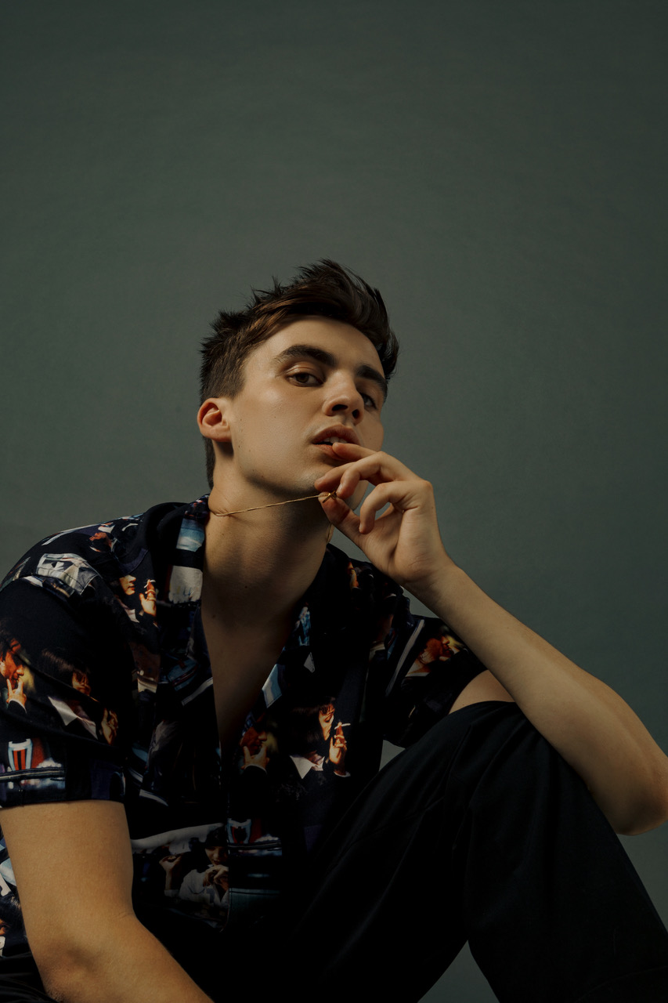

*“Expect even bigger things to come from the Elektra signee.”* **– Billboard**

*“JC’s distinctive sound has captured the attention of many.” –* **Uproxx**

*“Worthy of your attention.”***– E! News**

Fresh off a nomination at the 2021 MTV Video Music Awards, rising Elektra Recording artist **JC Stewart** has shared his brand new single **“Don’t Say You Love Me”**. The song is available to stream and download now [**HERE**](https://nam04.safelinks.protection.outlook.com/?url=https%3A%2F%2Fsunshineboy.co%2Fdontsayyouloveme&data=04%7C01%7CSydneyWorden%40elektra.com%7Ce7f0fe234252463f563608d97f608fe9%7C8367939002ec4ba1ad3d69da3fdd637e%7C0%7C0%7C637680874986368018%7CUnknown%7CTWFpbGZsb3d8eyJWIjoiMC4wLjAwMDAiLCJQIjoiV2luMzIiLCJBTiI6Ik1haWwiLCJXVCI6Mn0%3D%7C1000&sdata=diagnk9qyogloAQJZK%2BRnDW%2F4%2Fu32Ce2%2F2RrfHTO4nE%3D&reserved=0). Watch an accompanying official music video for the track on JC’s YouTube channel [**HERE**](https://nam04.safelinks.protection.outlook.com/?url=https%3A%2F%2Fyoutu.be%2FAttzBSqi0CA&data=04%7C01%7CSydneyWorden%40elektra.com%7Ce7f0fe234252463f563608d97f608fe9%7C8367939002ec4ba1ad3d69da3fdd637e%7C0%7C0%7C637680874986378013%7CUnknown%7CTWFpbGZsb3d8eyJWIjoiMC4wLjAwMDAiLCJQIjoiV2luMzIiLCJBTiI6Ik1haWwiLCJXVCI6Mn0%3D%7C1000&sdata=NI%2Fn3B2A6rHxnQcNvicYefWq6a9tEM%2F5q4awmIXz%2Flk%3D&reserved=0). “Don’t Say You Love Me” will appear on JC’s eagerly anticipated second EP, which will be released later this year.

“Don’t Say You Love Me” is already an established fan favorite after being the opening song inJC’s live show for several years – and one listenreveals precisely whyhe always chose to introduce himself to new audiences with the track. It brings everything that makes him an undeniable rising star into one three-minute pop package. It simmers with drama, as it escalates from introspective singer-songwriter verses before erupting into an immediately memorable hook.

Meanwhile, JC’s talent for delivering vulnerable stories of lost love into songs of huge appeal reaches new heights. It’s a simple message about something that almost everyone goes through: if we have to split up, let’s at least limit the pain we’ll put ourselves through by making it a clean break.

*“‘Don’t Say You Love Me’ is a song I wrote over three years ago. I opened the live set with it for years and it always made me feel alive as soon as the first beat kicked in,”* JC shares. *“I wrote it about needing to leave someone and having to stand up for yourself and have the courage to walk away from something when it would probably be easier to stay.”*

*“This song has been something I have been planning to get out to the world for a long, long time and I am so glad that that time has finally come,”* he adds.

JC Stewart wrote “Don’t Say You Love Me” with Sam Merrifield (Mimi Webb) and the song’s producer Nathaniel ‘Detonate’ Ledwidge. It was subsequently completed with mixing from the Grammy-nominated Matty Green (Dua Lipa, Dermot Kennedy).

The emotions behind “Don’t Say You Love Me” fuelJC’s impassioned and heart-felt performance in the accompanying video, which was directed by [Nathan Barlow](https://nam04.safelinks.protection.outlook.com/?url=https%3A%2F%2Fvimeo.com%2Fnathanbarlow&data=04%7C01%7CSydneyWorden%40elektra.com%7Ce7f0fe234252463f563608d97f608fe9%7C8367939002ec4ba1ad3d69da3fdd637e%7C0%7C0%7C637680874986378013%7CUnknown%7CTWFpbGZsb3d8eyJWIjoiMC4wLjAwMDAiLCJQIjoiV2luMzIiLCJBTiI6Ik1haWwiLCJXVCI6Mn0%3D%7C1000&sdata=mGC16o6JoUczu2K7MzDzx5C4gadZARNM1IcMoF7dnc0%3D&reserved=0).  But its overall atmosphere is one that instead builds excitement for his live show.JC begins the song alone before his band is revealed, as the climate around them builds into a tumultuous storm. It ends with him crowd-surfing above an audience of real fans before he drops to the ground – the storm has passed and a new ray of optimism shines through.

JC Stewart started 2021on a high when he was named asMTV’sfirst global Pushartist of the year. His single ["Break My Heart"](https://nam04.safelinks.protection.outlook.com/?url=https%3A%2F%2Fyoutu.be%2FDLY7nVsq2-s&data=04%7C01%7CSydneyWorden%40elektra.com%7Ce7f0fe234252463f563608d97f608fe9%7C8367939002ec4ba1ad3d69da3fdd637e%7C0%7C0%7C637680874986388015%7CUnknown%7CTWFpbGZsb3d8eyJWIjoiMC4wLjAwMDAiLCJQIjoiV2luMzIiLCJBTiI6Ik1haWwiLCJXVCI6Mn0%3D%7C1000&sdata=d%2Bu%2BZa2msI09f%2FCGP%2FTt44vZI0SXiPw0t0ylhsNi%2Fhc%3D&reserved=0)then continued to fire his momentum forward. Co-written withNiall Horan, the trackbroadened his already engaging pop appeal. His most recent single, ["Loud"](https://nam04.safelinks.protection.outlook.com/?url=https%3A%2F%2Fyoutu.be%2FyMeEDatwAt0&data=04%7C01%7CSydneyWorden%40elektra.com%7Ce7f0fe234252463f563608d97f608fe9%7C8367939002ec4ba1ad3d69da3fdd637e%7C0%7C0%7C637680874986388015%7CUnknown%7CTWFpbGZsb3d8eyJWIjoiMC4wLjAwMDAiLCJQIjoiV2luMzIiLCJBTiI6Ik1haWwiLCJXVCI6Mn0%3D%7C1000&sdata=HH3aeb4mSbg12fcbeyS5w%2FnelXtc7q%2BYSW3yVuIVIRI%3D&reserved=0), again reiterated his phenomenal ascension. JC recently performed at the Latitude Festival, and supported The Vamps on a run of UK tour dates. Details for his next run of headline shows will be revealed soon.

Emerging from Northern Ireland,JC Stewartpossesses all the traits needed to become a globally recognised artist. His music is powered by a voice as real and powerful as the heartfelt emotions he explores. Yet while his talent is remarkable, his personality is relatable. His sharp wit and inclusive nature are immensely popular at social media, a following which exploded after Jennifer Aniston shared his [quarantine-themed twist](https://nam04.safelinks.protection.outlook.com/?url=https%3A%2F%2Fwww.instagram.com%2Fp%2FB-7of0jnL-A%2F&data=04%7C01%7CSydneyWorden%40elektra.com%7Ce7f0fe234252463f563608d97f608fe9%7C8367939002ec4ba1ad3d69da3fdd637e%7C0%7C0%7C637680874986397998%7CUnknown%7CTWFpbGZsb3d8eyJWIjoiMC4wLjAwMDAiLCJQIjoiV2luMzIiLCJBTiI6Ik1haWwiLCJXVCI6Mn0%3D%7C1000&sdata=Kjxun%2BI6Xzy35rl7fM1sQBvbxdkjFUQtsWzLAg1UnS8%3D&reserved=0) on the *Friends* theme last year. The video quickly surpassed 5 million views and resulted in JCappearing on [*Good Morning America*](https://nam04.safelinks.protection.outlook.com/?url=https%3A%2F%2Fwww.instagram.com%2Fp%2FB_kxbBEnNLC%2F&data=04%7C01%7CSydneyWorden%40elektra.com%7Ce7f0fe234252463f563608d97f608fe9%7C8367939002ec4ba1ad3d69da3fdd637e%7C0%7C0%7C637680874986407991%7CUnknown%7CTWFpbGZsb3d8eyJWIjoiMC4wLjAwMDAiLCJQIjoiV2luMzIiLCJBTiI6Ik1haWwiLCJXVCI6Mn0%3D%7C1000&sdata=uTCwSFJ72tLtHzhzlv7eQgme6hmpDndKbExwlOSAj1s%3D&reserved=0)*, TODAY, Access Hollywood,* and more

That growing following includes some famous fans too. Last year saw him release his big collab, teaming up with 220 Kid for ["Too Many Nights"](https://nam04.safelinks.protection.outlook.com/?url=https%3A%2F%2F220kid.lnk.to%2FTooManyNights&data=04%7C01%7CSydneyWorden%40elektra.com%7Ce7f0fe234252463f563608d97f608fe9%7C8367939002ec4ba1ad3d69da3fdd637e%7C0%7C0%7C637680874986407991%7CUnknown%7CTWFpbGZsb3d8eyJWIjoiMC4wLjAwMDAiLCJQIjoiV2luMzIiLCJBTiI6Ik1haWwiLCJXVCI6Mn0%3D%7C1000&sdata=oBOMrMfj2VZhWCBX2yttsSrr2fWJsIyHkSKpW15sH14%3D&reserved=0), while his debut EP [*When The Light Hits The Room*](https://nam04.safelinks.protection.outlook.com/?url=https%3A%2F%2Fsunshineboy.co%2Fwhenthelighthitstheroom&data=04%7C01%7CSydneyWorden%40elektra.com%7Ce7f0fe234252463f563608d97f608fe9%7C8367939002ec4ba1ad3d69da3fdd637e%7C0%7C0%7C637680874986417987%7CUnknown%7CTWFpbGZsb3d8eyJWIjoiMC4wLjAwMDAiLCJQIjoiV2luMzIiLCJBTiI6Ik1haWwiLCJXVCI6Mn0%3D%7C1000&sdata=i3YtrEhqsC6vQd06ZPo%2BB6o4bOCzxeegD1RPLAV2jvk%3D&reserved=0) was co-written with the BRIT / Ivor Novello winner Tom Odell. His first major collaborator came when he co-wrote“Hollywood”, a song which later featured on Lewis Capaldi’s debut album.

**Connect with JC Stewart:**

[**Official site**](https://nam04.safelinks.protection.outlook.com/?url=http%3A%2F%2Fiamjcstewart.com%2F&data=04%7C01%7CSydneyWorden%40elektra.com%7Ce7f0fe234252463f563608d97f608fe9%7C8367939002ec4ba1ad3d69da3fdd637e%7C0%7C0%7C637680874986417987%7CUnknown%7CTWFpbGZsb3d8eyJWIjoiMC4wLjAwMDAiLCJQIjoiV2luMzIiLCJBTiI6Ik1haWwiLCJXVCI6Mn0%3D%7C1000&sdata=gpYp04wPtwWxpa%2FZzujlDW%2FIq7vvBUtnBEBtX4jbOTI%3D&reserved=0)

[**Spotify**](https://nam04.safelinks.protection.outlook.com/?url=https%3A%2F%2Fopen.spotify.com%2Fartist%2F2TAqN8fwfaKauvviN4pOsv%3Fsi%3DM3wsUX3mQdKIYPDsAWD6ow&data=04%7C01%7CSydneyWorden%40elektra.com%7Ce7f0fe234252463f563608d97f608fe9%7C8367939002ec4ba1ad3d69da3fdd637e%7C0%7C0%7C637680874986427978%7CUnknown%7CTWFpbGZsb3d8eyJWIjoiMC4wLjAwMDAiLCJQIjoiV2luMzIiLCJBTiI6Ik1haWwiLCJXVCI6Mn0%3D%7C1000&sdata=QvFzOr3qkCdtN21Hhng56F92PjRcUhaqEaH33hL4YpE%3D&reserved=0)

[**Apple Music**](https://nam04.safelinks.protection.outlook.com/?url=https%3A%2F%2Fmusic.apple.com%2Fgb%2Fartist%2Fjc-stewart%2F1377757399&data=04%7C01%7CSydneyWorden%40elektra.com%7Ce7f0fe234252463f563608d97f608fe9%7C8367939002ec4ba1ad3d69da3fdd637e%7C0%7C0%7C637680874986427978%7CUnknown%7CTWFpbGZsb3d8eyJWIjoiMC4wLjAwMDAiLCJQIjoiV2luMzIiLCJBTiI6Ik1haWwiLCJXVCI6Mn0%3D%7C1000&sdata=a3v8iy3n6xyZ96RaMTc4FgtQZt9E58c6tyjjDnulLQU%3D&reserved=0)

[**YouTube**](https://nam04.safelinks.protection.outlook.com/?url=https%3A%2F%2Fwww.youtube.com%2Fchannel%2FUCsM9RTCKh-XEiLan59m5ycA&data=04%7C01%7CSydneyWorden%40elektra.com%7Ce7f0fe234252463f563608d97f608fe9%7C8367939002ec4ba1ad3d69da3fdd637e%7C0%7C0%7C637680874986437975%7CUnknown%7CTWFpbGZsb3d8eyJWIjoiMC4wLjAwMDAiLCJQIjoiV2luMzIiLCJBTiI6Ik1haWwiLCJXVCI6Mn0%3D%7C1000&sdata=hxYEAwehXSemtmQiAvw3TkZnXpJprWGL6O6RHhypfKg%3D&reserved=0)

[**Instagram**](https://nam04.safelinks.protection.outlook.com/?url=https%3A%2F%2Fwww.instagram.com%2Fjcstewart%2F&data=04%7C01%7CSydneyWorden%40elektra.com%7Ce7f0fe234252463f563608d97f608fe9%7C8367939002ec4ba1ad3d69da3fdd637e%7C0%7C0%7C637680874986437975%7CUnknown%7CTWFpbGZsb3d8eyJWIjoiMC4wLjAwMDAiLCJQIjoiV2luMzIiLCJBTiI6Ik1haWwiLCJXVCI6Mn0%3D%7C1000&sdata=GB%2FsuYijnUrBAozlbNOY1rkL%2FJsMc%2B4JDSxyCqdKqlU%3D&reserved=0)

[**Facebook**](https://nam04.safelinks.protection.outlook.com/?url=https%3A%2F%2Fwww.facebook.com%2FJCStewart%2F&data=04%7C01%7CSydneyWorden%40elektra.com%7Ce7f0fe234252463f563608d97f608fe9%7C8367939002ec4ba1ad3d69da3fdd637e%7C0%7C0%7C637680874986447967%7CUnknown%7CTWFpbGZsb3d8eyJWIjoiMC4wLjAwMDAiLCJQIjoiV2luMzIiLCJBTiI6Ik1haWwiLCJXVCI6Mn0%3D%7C1000&sdata=CUEDYcvSzRjiZjnUO%2F3xGw%2BXzCWOWb9eDm0xmCUzHSI%3D&reserved=0)

[**Twitter**](https://nam04.safelinks.protection.outlook.com/?url=https%3A%2F%2Ftwitter.com%2Fjcstewart&data=04%7C01%7CSydneyWorden%40elektra.com%7Ce7f0fe234252463f563608d97f608fe9%7C8367939002ec4ba1ad3d69da3fdd637e%7C0%7C0%7C637680874986447967%7CUnknown%7CTWFpbGZsb3d8eyJWIjoiMC4wLjAwMDAiLCJQIjoiV2luMzIiLCJBTiI6Ik1haWwiLCJXVCI6Mn0%3D%7C1000&sdata=yQDaWduSR89iC%2FCEsuEATZmPcjtWD96b8wTLw1hCXM0%3D&reserved=0)

**PRESS CONTACTS:**

Collin Citron

[CollinCitron@elektra.com](mailto:CollinCitron@elektra.com)

Glenn Fukushima

[GlennFukushima@elektra.com](mailto:GlennFukushima@elektra.com)