FOR IMMEDIATE RELEASE
June 17, 2020

JC STEWART SHARES NEW MUSIC VIDEO FOR
“I NEED YOU TO HATE ME”
WATCH HERE
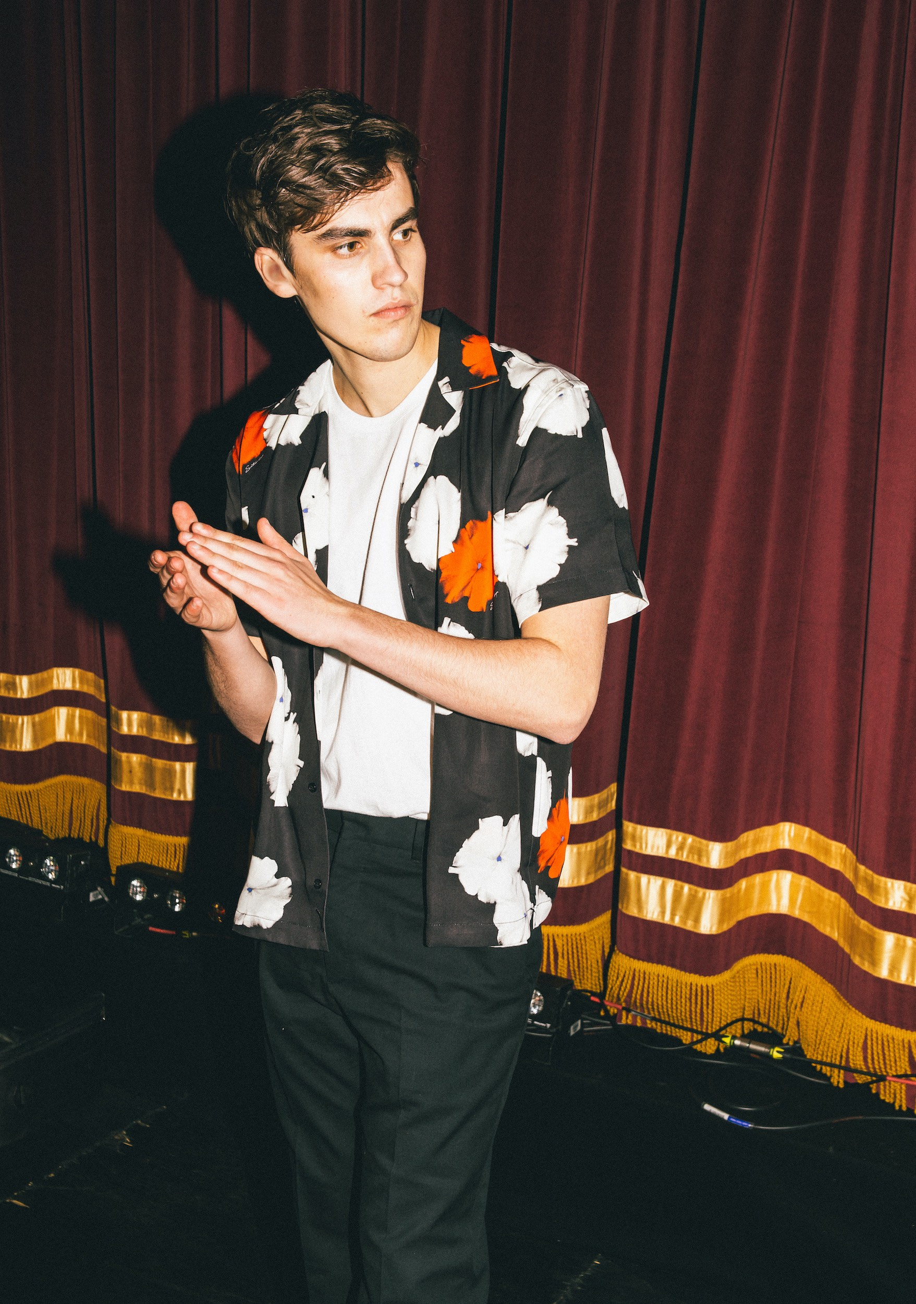

“Stewart excels at keening, heart-on-sleeve balladry that mixes raw emotion with classic pop chord progressions and a voice of angelic purity.” – Sunday Times Culture

“JC Stewart’s own ascent continues.” – Wonderland

“Supremely emotional.” – Clash

“With an instantly affecting voice and an unmistakable knack for crafting craftily infectious melodies, it’s overwhelmingly evident that JC Stewart is destined for big things.” – Euphoria

“Worthy of your attention.” – E! News

Elektra recording artist JC Stewart has shared an official music video for his latest single “I Need You To Hate Me”. Directed by Charlie Sarsfield (Stormzy, Sam Fender, Dermot Kennedy), the emotional clip stars JC alongside actress Emilia Jones (Kinsey from Netflix’s Lock & Key). Watch it HERE.

JC commented: “Honestly, when I asked if we could set a car on fire outside an old country house I was half-joking. But here we are. I’m so proud of this video and it represents everything I want this song to be. Epic, emotional, ambitious. It was amazing to have Emilia Jones involved as well. She’s an UNBELIEVABLE actress so it was an honour that she said yes! Hope you enjoy!”

As the fourth generation of JC Stewarts, the young musician was destined to continue the family business in Northern Ireland, but instead deviated on the road toward pop stardom by focusing on his songwriting craft since his mid-teens. Everything that JC does captures his ability to connect. That’s a lot to do with the purity - of emotion, texture and delivery - in his music. He possesses the ability to express deep emotion and universal truths in language that is consciously direct and uncluttered.

That ability to make a connection is quickly winning the hearts of fans and influential supporters alike. Upon its release, “I Need You To Hate Me” appeared on 29 New Music Friday playlists across the globe, elevating the young singer-songwriter to 2 million monthly listeners at Spotify. Apple Music also tipped him as a future star when they named him New Artist of the Week. JC recently participated in BBC Radio 1’s virtual Big Weekend, delivering an unforgettable live performance of the song. Watch it HERE.

JC’s touring highlights include shows with Lewis Capaldi, Lauv, Anne-Marie, Maisie Peters, and Freya Ridings, as well as an MTV Push event alongside Yungblud and Raye. His talents have also extended to co-writing with other artists, most notably “Hollywood” from Capaldi’s chart-topping debut album.

While his lyrics often hone in on the devastating minutiae of faltering relationships (both “I Need You To Hate Me” and “Have You Had Enough Wine?” tackled different stages of the same break-up), JC’s quick wit and self-deprecating sense of humour are immediately apparent. Those personality traits also resulted in him going viral on a global scale.

Bored during lockdown, JC filmed his quarantine-themed take on the Friends theme “I’ll Be There For You”, singing “It looks like we'll be inside for a year/ Or it might only be a day, a week or months it's really not clear.” It exploded after Jennifer Aniston shared it on Instagram. Suddenly the clip was featured on ABC’s Good Morning America and NBC’s TODAY. Nina Dobrev also shared it with her 20 million followers as it raced past 5 million views.

Official site
Spotify
Apple Music
YouTube
Instagram
Facebook
Twitter

PRESS CONTACT:
Collin Citron
CollinCitron@elektra.com

Glenn Fukushima
GlennFukushima@elektra.com

