POP ARTIST JORDY SHARES LIVELY NEW SINGLE,
“DRY SPELL”
ARRIVING JUST IN TIME FOR SUMMER AND PRIDE MONTH
LISTEN HERE | WATCH THE MUSIC VIDEO HERE
CURRENTLY ON TOUR SUPPORTING LAUREN SANDERSON
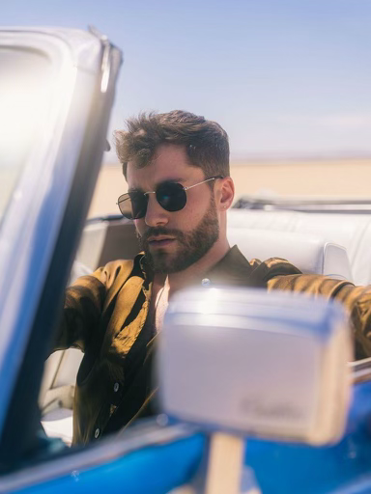
CREDIT: JOSHUA KIM
DOWNLOAD HI-RES PRESS IMAGE HERE
“…undeniably joyful pop” –TIME
“One of the most promising new voices in pop.” –CONSEQUENCE OF SOUND
“…fresh, angel-voiced” –VMAN
“…a sugar-sweet jolt of dopamine to the system” –BILLBOARD
“JORDY is the vulnerable pop singer we can’t help but fall for” – PRIDE.COM
(May 25, 2022) – LOS ANGELES, CA – Rising pop artist JORDY has shared his bright, upbeat new single “Dry Spell,” available today on all streaming platforms. Arriving just in time for summer and the kickoff of Pride Month, the track is a relatable anthem about the challenges of modern-day hookup culture, co-written with and produced by Brandon ‘B HAM’ Hamlin (Kim Petras, Saweetie) and Shae Jacobs (BTS, Gryffin). Additionally, the accompanying music video made its broadcast premiere on MTV Live and MTVU today and is available to watch HERE. Directed by Queerty Award-winning filmmaker Assaad Yacoub (Trixie Mattel, Aja), the visual was filmed out in the California desert, aptly tying in with the song title.
“‘Dry Spell’ is an anthem for anyone who has conflicting feelings about hookup culture,” said JORDY. “I’m an emotional person, but as my therapist says, I’m also in my ‘sexual prime.’ As funny as that sounds, it’s something I struggle with as an adult; I should be able to have fun (safely, of course) but sometimes it’s not as fun when there’s no emotion attached. Now that we have access to every type of app you can imagine, there’s easy access for fun, but also more room for encounters that don’t feel as fulfilling.”
Of the song’s sonic palette, he added, “As always, I love throwing the vulnerable lyrics on top of modern pop production, so that we can dance all of our worries away together. ‘Dry Spell’ is the beginning of a new era and chapter for me, and I couldn’t be more excited about it.”
Inspired by pop staples such as The Spice Girls, Michelle Branch, Avril Lavigne, and contemporaries such as Troye Sivan and Lauv, JORDY’s songs blend the glimmering, bouncy 90s pop sound with sincere, vulnerable, and conversational songwriting. The Chicago native unveiled his debut album Mind Games in November 2021, along with a companion acoustic EP in February.
JORDY’s heart-on-his-sleeve approach to modern pop music has resonated with fans nationwide, resulting in nearly 50M career streams, sold out shows across the U.S., and a devoted following on TikTok with his 2021 dance-pop hit “Long Distance” that went viral on the platform in 2021. The song, which details the heartache of a long-distance relationship during COVID, quickly found company as many listeners related to the uncertainty and loneliness of the pandemic. JORDY also delivered a stellar performance of the track during his national television debut on The TODAY Show, and this year, he nabbed a nomination at the iHeartRadio Music Awards in the “Social Star” category.
JORDY is currently on the road supporting Lauren Sanderson on her North American headline tour, which hits the El Rey in Los Angeles this evening and wraps in San Francisco tomorrow night at Cafe Du Nord. Following his performance at BottleRock Napa Valley this weekend, JORDY will also perform at several Pride Month events throughout the East Coast this summer, followed by a hometown performance at Lollapalooza. The full itinerary can be found below, with all tickets available HERE.
Stay tuned for more to come from this rising artist.
JORDY
“DRY SPELL”
AVAILABLE HERE
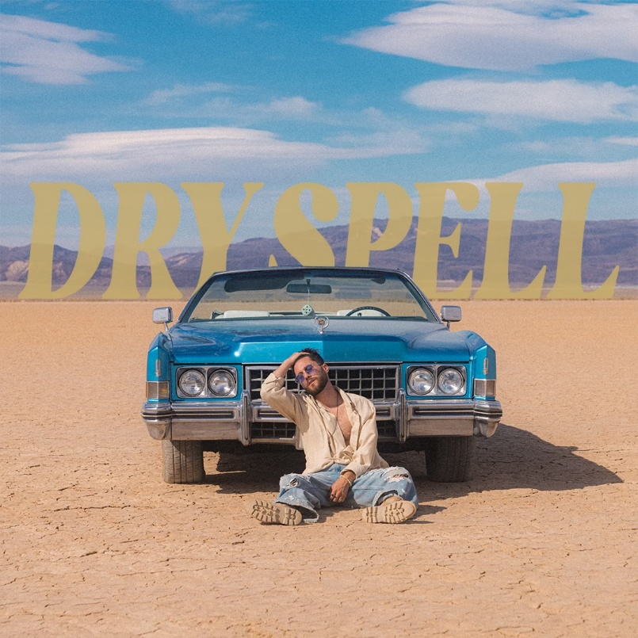
DOWNLOAD HI-RES ARTWORK HERE
JORDY ON TOUR:
5/25 – Los Angeles, CA @ El Rey *
5/26 – San Francisco, CA @ Cafe Du Nord *
5/28 – Napa County, CA @ BottleRock Napa Valley
6/4 – South Charleston, WV @ Rainbow Pride of West Virginia
6/11 – Montclair, NJ @ Montclair Pride ^
6/12 – Albany, NY @ Albany Capital Pride
6/25 – Cincinnati, OH @ Cincinnati Pride
6/26 – Washington, D.C. @ Giant National Capital BBQ Battle
7/29 – Chicago, IL @ Lollapalooza
* Supporting Lauren Sanderson
^ Supporting Betty Who
FOLLOW JORDY:
WEBSITE / INSTAGRAM / TWITTER / TIKTOK / FACEBOOK
# # #
MEDIA CONTACT:
Nathalie Rubin
nathalierubin@elektra.com

