RISING POP SINGER-SONGWRITER JAKE SCOTT
ANNOUNCES SIGNING TO ELEKTRA RECORDS

FIRST-EVER HEADLINING, NORTH AMERICAN TOUR COMPLETELY SOLD OUT,
INCLUDING STOPS AT NASHVILLE’S BASEMENT EAST,
Nyc’S MUSIC HALL OF WILLIAMSBURG, & La’s legendary troubadour

DATES begin FRIDAY JANUARY 14th

NEW MUSIC COMING VERY SOON

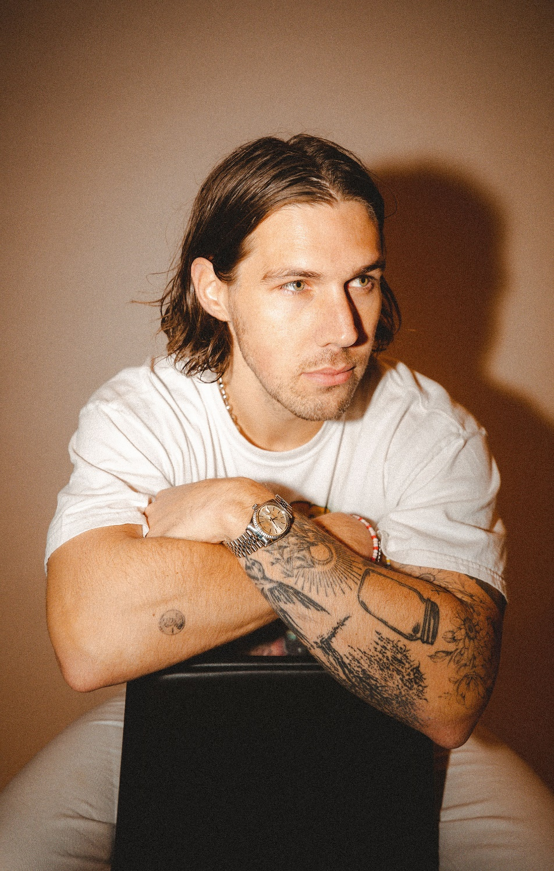
PHOTO CREDIT: RACHEL DEEB
PRESS ASSETS HERE

JANUARY 13, 2022 - Pop singer-songwriter, producer, and multi-instrumentalist Jake Scott has officially signed to Elektra Records—as announced today. After generating north of 400 million streams independently, selling out tours, and receiving praise from Forbes, Billboard, American Songwriter, and more, the Arkansas-born and Los Angeles-based artist kicks off the next chapter of his career and will be unveiling his first release under the newly minted deal very soon.

Jake spoke exclusively to Consequence about the signing, stating, “I’ve been waiting a long time to sign a record deal - it had to be the right timing, the right label, and most importantly, the right people. As soon as I met Gregg, Mike and the rest of the Elektra team, I knew I’d found the perfect partnership. To say I’m excited is an understatement. Signing with Elektra is a dream come true, and I cannot wait to continue my musical journey with them!”

Elektra Music Group Co-Presidents, Gregg Nadel and Mike Easterlin, remarked, “Jake is a tremendous talent with an unrivaled work ethic. A true songwriter, Jake has worked tirelessly to become the brilliant artist and performer he is today. We at Elektra are excited for the world to get to know him the way we have these last few months and couldn’t be more thrilled to be a part of his continued journey.”

This week, he launches his first-ever, headlining tour across North America [tour itinerary below]. The dates kick off at Cambridge Room in Dallas, TX on January 14, and includes stops at Basement East in Nashville, TN on January 20, Music Hall of Williamsburg in Brooklyn, NY on January 25, and the legendary Troubadour in West Hollywood, CA on February 10. A very limited number of tickets are available only for the Philadelphia, PA show on January 28 which was upgraded to the Ardmore Music Hall due to overwhelming demand. For tickets and more information on the upcoming dates, visit www.jakescottmusic.com.

Last year, he made major waves throughout popular music and culture. Beyond generating hundreds of millions of streams as an independent artist, his 2021 Goldenboy EP earned widespread acclaim. Billboard hailed it as “his most introspective music to date” and added, “Scott’s gradual rise matches his no-frills sound. With a knack for catchy melodies, his songs make for easy listening supported by buoyant pop production, heartfelt narratives, and a buttery voice to boot.” Meanwhile, American Songwriter observed, “he found a creative energy, voice, and songwriting perspective all his own,” and Forbes profiled him and plugged his virtual donut shop, Goldenboy, in partnership with Grubhub. He also performed on KTLA. Additionally, he canvased the country on tour with LANY throughout the fall. Not to mention, multiplatinum country star Russell Dickerson tapped him to feature on “She Likes It.”

Now, he’s gearing up for a massive 2022. Stay tuned for a whole lot more from Jake Scott very soon.

ABOUT JAKE SCOTT:
Delivering impactful anthems with impressive consistency and grinding tirelessly, Jake Scott has quietly arrived as a proven pop maverick with a dynamic style and a whole lot to say. Born in Fayetteville, Arkansas and based in Los Angeles, the singer-songwriter, producer, and multi-instrumentalist initially transformed into an independent phenomenon. Beyond co-writing for the likes of Jason Mraz, Aloe Blacc, and Carrie Underwood, he unveiled music at a prolific pace before doubling down and dropping one song per month from the beginning of 2018 until the end of 2020. Audiences embraced favorites such as “Like No One Does,” “Tuesdays,” “Favorite T-Shirt,” “She,” and “I Don’t Miss You.” He sold out his very first headline tour and built a diehard fan base, gathering 350 million global streams, averaging nearly 3 million monthly listeners on Spotify, and attracting hundreds of thousands of followers across social media. Along the way, he garnered praise from Billboard, Forbes, and American Songwriter. He opened up LANY’s 2021 fall tour and returns to the road for a sold out headline run in 2022. Signing to Elektra Records, Jake forges ahead yet again with new music very soon.

TOUR DATES:

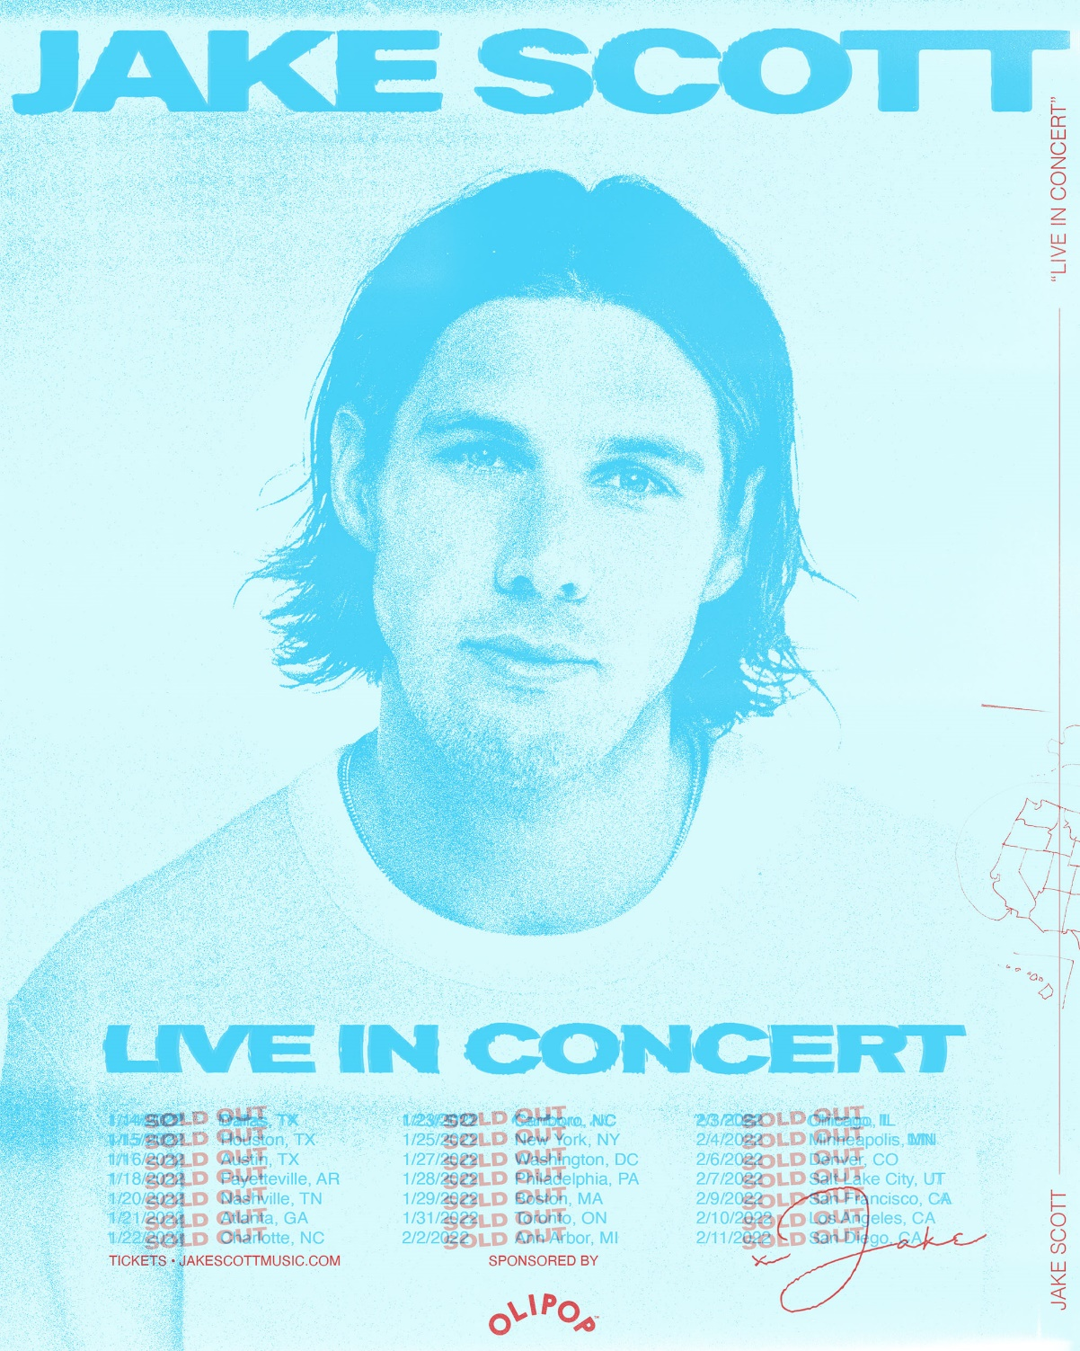

1/14 Dallas, TX Cambridge Room (SOLD OUT)
1/15 Houston, TX Bronze Peacock – House of Blues (SOLD OUT)
1/16 Austin, TX Antone’s (SOLD OUT)
1/18 Fayetteville, AR George’s Majestic Lounge (SOLD OUT)
1/20 Nashville, TN Basement East (SOLD OUT)
1/21 Atlanta, GA Terminal West (SOLD OUT)
1/22 Charlotte, NC The Underground (SOLD OUT)
1/23 Carrboro, NC Cat’s Cradle (SOLD OUT)
1/25 Brooklyn, NY Music Hall of Williamsburg (SOLD OUT)
1/27 Washington, DC DC9 (SOLD OUT)
1/28 Philadelphia, PA Ardmore Music Hall (VENUE UPGRADE)
1/29 Cambridge, MA Sonia (SOLD OUT)
1/31 Toronto, ON The Garrison (SOLD OUT)
2/2 Ann Arbor, MI Blind Pig (SOLD OUT)
2/3 Chicago, IL Bottom Lounge (SOLD OUT)
2/4 Minneapolis, MN 7th Street Entry (SOLD OUT)
2/6 Denver, CO Larimer Lounge (SOLD OUT)
2/7 Salt Lake City, UT Soundwell (SOLD OUT)
2/9 San Francisco, CA Brick & Mortar (SOLD OUT)
2/10 Los Angeles, CA Troubadour (SOLD OUT)
2/11 San Diego, CA Voodoo Room (SOLD OUT)

FOR MORE INFORMATION:
WEBSITE / INSTAGRAM / FACEBOOK / TWITTER / YOUTUBE / SPOTIFY / APPLE MUSIC

