JAKE SCOTT RELEASES HEARTFELT NEW SINGLE
“TEXAS GIRL”
LISTEN TO THE SONG HERE
SCOTT IS SET TO MAKE HIS NATIONAL TV DEBUT ON THE KELLY CLARKSON SHOW THIS MONTH, PERFORMING “TEXAS GIRL”
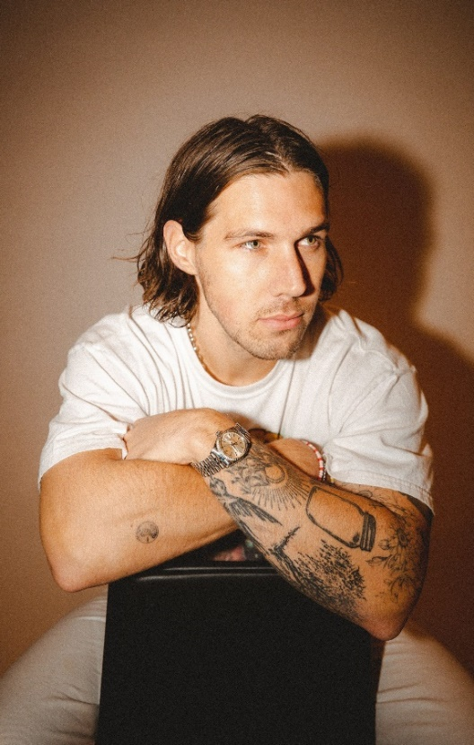
PHOTO CREDIT: RACHEL DEEB
HI-RES AVAILABLE HERE | PRESS ASSETS HERE

“With a knack for catchy melodies, his songs make for easy listening supported by buoyant pop production, heartfelt narratives, and a buttery voice to boot.” –BILLBOARD

“His R&B-infused pop sound is rounded out by lyrical sincerity.” –CONSEQUENCE OF SOUND

“Scott is humble, but extremely talented” –AMERICAN SONGWRITER

MARCH 18, 2022 – LOS ANGELES, CA – Pop singer-songwriter, producer, and multi-instrumentalist Jake Scott released his new single, “Texas Girl.” Penned by Scott and produced with Noah Conrad (Niall Horan, Ashe), the heartfelt, guitar-driven track is a love song about his wife Rachel. Scott hails from Arkansas – a state that rivals Texas – and ended up falling for a girl from there regardless. The pair’s love story was also showcased in a popular Jubilee episode in 2019 that resonated with fans nationwide. “Texas Girl” is live on all streaming services, with an accompanying visualizer available HERE.

“I grew up in Arkansas where an imaginary rivalry between Texas and us was a tale as old as time. Naturally, I never thought I’d end up with the enemy, a Texas girl. And then I met a girl named Rachel from Dallas, and I think anyone who knows anything about me knows the rest of the story – I fell head over heels for her instantly,” explained Jake. “This song is about the magic of that feeling. It’s the first single I’ve released in partnership with Elektra Records and the first of many upcoming releases this year. I hope you love it!”

Scott is also set to make his national television debut on The Kelly Clarkson Show this month, performing “Texas Girl.” Additionally, he will be hitting the road with indie hitmaker Ben Rector on The Joy of Music: Live U.S. tour this summer, which kicks off on Thursday, May 5 in Madison, Wisconsin. Scott will provide direct support for the first leg of dates, which wraps in Oklahoma City on Sunday, June 5. The full itinerary can be found below, with all tickets available on Scott’s official website. The forthcoming slew of shows follows Scott’s first-ever North American headline tour, which sold out in every city.
Last year, the Los Angeles-based artist made major waves throughout pop music. Beyond generating nearly 400 million global streams as an independent artist and touring non-stop – including a notable opening slot for LANY – his 2021 Goldenboy EP earned acclaim in the press and produced a stellar performance on KTLA. Furthermore, Scott collaborated with multi-platinum country star Russell Dickerson, who tapped him to feature on his track “She Likes It.”
Scott is gearing up for a massive 2022 and will be unveiling his first project with Elektra Records soon. Stay tuned for more details coming soon.

JAKE SCOTT
“TEXAS GIRL”
AVAILABLE HERE
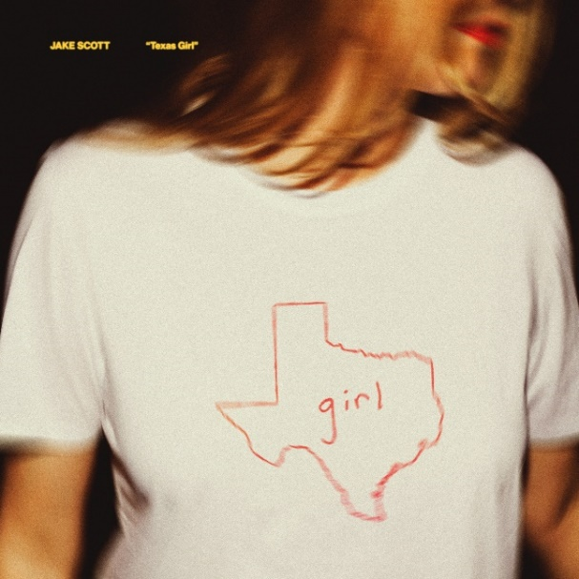
DOWNLOAD HI-RES ARTWORK HERE

ABOUT JAKE SCOTT:
Delivering impactful anthems with impressive consistency and grinding tirelessly, Jake Scott has quietly arrived as a proven pop maverick with a dynamic style and a whole lot to say. Born in Fayetteville, Arkansas and based in Los Angeles, the singer-songwriter, producer, and multi-instrumentalist initially transformed into an independent phenomenon. Beyond co-writing for the likes of Jason Mraz, Aloe Blacc, and Carrie Underwood, he unveiled music at a prolific pace before doubling down and dropping one song per month from the beginning of 2018 until the end of 2020. Audiences embraced favorites such as “Like No One Does,” “Tuesdays,” “Favorite T-Shirt,” “She,” and “I Don’t Miss You.” He sold out his very first headline tour and built a diehard fan base, gathering nearly 400M total global streams and attracting hundreds of thousands of followers across social media. Along the way, he garnered praise from Consequence of Sound, Billboard, Forbes, and American Songwriter. Signing to Elektra Records, Jake forges ahead yet again with new music very soon.
OPENING FOR BEN RECTOR:
5/5 Madison, WI The Sylvee
5/6 Minneapolis, MN Armory
5/7 Kansas City, MO Starlight Theater
5/13 Columbus, OH KEMBA LIVE! - Outdoor Amphitheater
5/14 Indianapolis, IN TCU Amphitheater at White River State Park
5/15 Louisville, KY Iroquois Amphitheater
5/19 Sandy, UT Sandy Amphitheater
5/20 Denver, CO The Mission Ballroom
5/21 Council Bluffs, IA Harrah’s Stir Cove
6/3 Houston, TX 713 Music Hall
6/4 Irving, TX The Pavilion at Toyota Music Factory
6/5 Oklahoma City, OK Zoo Amphitheatre
FOLLOW JAKE SCOTT:
WEBSITE | INSTAGRAM | FACEBOOK | TWITTER | YOUTUBE

# # #

JAKE SCOTT MEDIA CONTACTS:

Glenn Fukushima
GlennFukushima@Elektra.com
Ross Anderson
RossAnderson@Elektra.com
Nathalie Rubin
NathalieRubin@Elektra.com
Sydney Worden
SydneyWorden@Elektra.com

