JOHNNY YUKON SHARES FLIGHT PLAN 001
ELEKTRA RECORDS DEBUT PROJECT AVAILABLE NOW

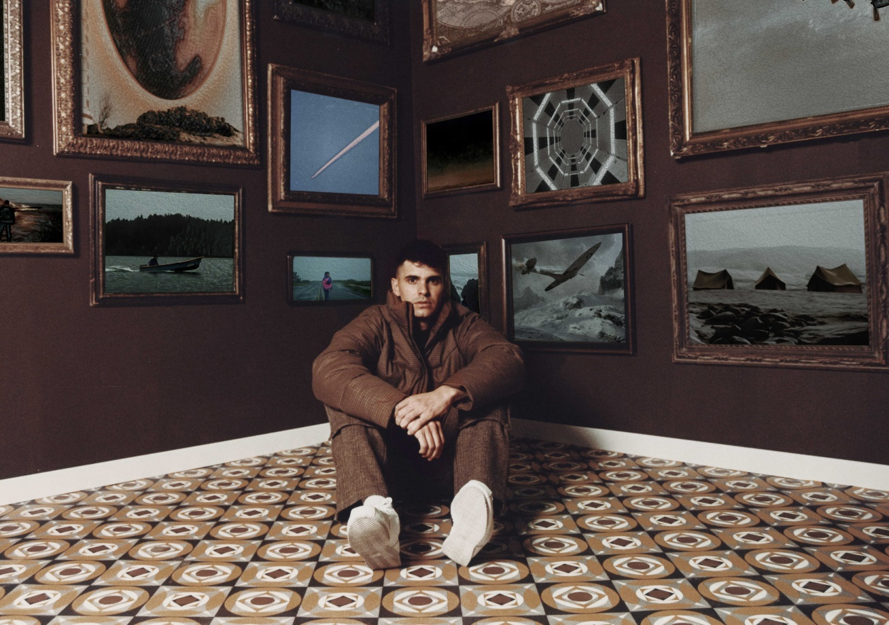

AUGUST 20, 2021 – Singer, songwriter and producer Johnny Yukon has shared Flight Plan 001. Marking the artist’s debut Elektra Records project, Flight Plan 001 is available now on all streaming platforms.
The release was heralded by singles “Mystery,” which quickly reached the top 25 on the SoundCloud Pop chart, and “Soon.” Produced by Jenius (Travis Scott, Jack Harlow, Pop Smoke), “Soon” is also accompanied by an official video directed by Brendan Vaughan (Lil Yachty, Oliver Tree, Charlie Puth), which finds the artist in isolation as the lone crewmember on a fishing boat.
Doubling as an offshoot of his Installation concept, Flight Plan 001 speaks both to Yukon’s lifelong fascination with aviation and opens a different channel for his endless creativity. Following fan demand for proper release, Flight Plan 001 integrates previously released Soundcloud favorites—“Grow,” “81 Nights” “Climate,” “Yes,” and “Night Like This”—into the tracklisting alongside seven new tracks.
After making waves from behind the scenes with songwriting placements for Young Thug, Ty Dolla $ign, Camila Cabello, and Leon Bridges, he made his formal artist debut with Installation I in 2018. Johnny’s influence only amplified throughout the global pandemic, co-writing Internet Money’s multiplatinum mega-smash “Lemonade” [feat. Gunna, Don Toliver, & NAV], Skepta & Pop Smoke’s F9 soundtrack standout “Lane Switcha” [feat. A$AP Rocky, Juicy J, & Project Pat], and co-producing “Trauma” from PARTYNEXTDOOR’s Partymobile, which bowed in the Top 10 of the Billboard Top 200. Signing to Elektra in early 2021, Johnny continued to write and record at a prolific pace, distilling post-breakup feelings, isolation, and hope into the sonic architecture.
(Album art/Tracklisting below)

JOHNNY YUKON
FLIGHT PLAN 001 – AVAILABLE AUGUST 20TH
AVAILABLE NOW
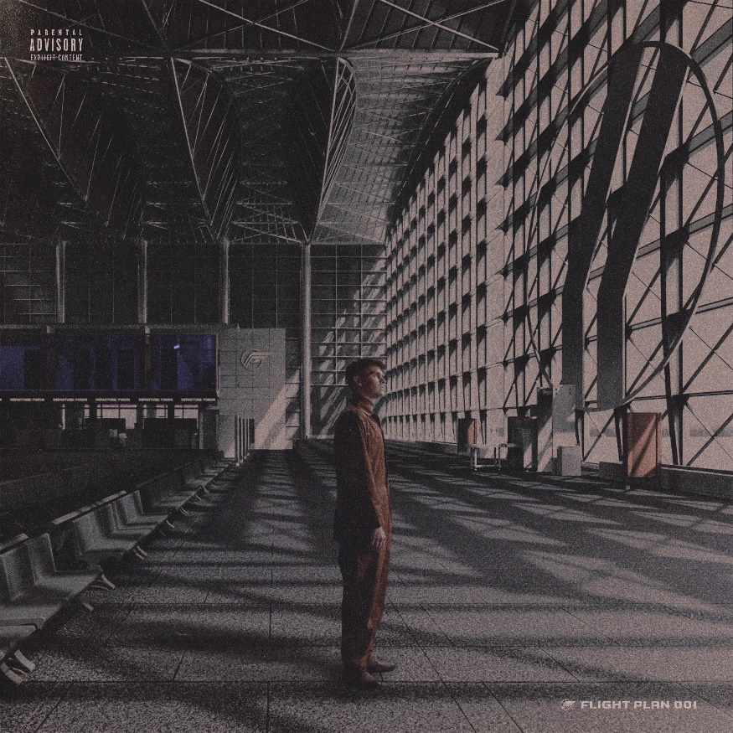

Tracklisting:
- FP001
- Night Like This
- Mystery
- Uptown
- Soon
- Can’t Stop
- Alibi
- Yes
- Climate
- Nights
- Don’t Blame Me
- Grow

ABOUT JOHNNY YUKON:
Much like the recordings of an airplane’s black box, the music of Johnny Yukon chronicles a cloud-scraping personal journey. Spun through a jet stream of lo-fi beatcraft, vintage world-building, hip-hop malleability, and alternative pop eloquence, the Pennsylvania-born and Los Angeles-based singer, songwriter, and producer navigates through raw emotions with acute storytelling, head-nodding rhymes, and fits of cathartic falsetto. Even though the ideas often gestate from an intimate personal studio, he projects his vision on the big screen with ambitious scope. After making waves from behind the scenes with songwriting placements for Young Thug, Ty Dolla $ign, Camila Cabello, and Leon Bridges, he made his formal debut with Installation I in 2018. Johnny’s influence only amplified throughout the global pandemic, co-writing Internet Money’s multiplatinum mega-smash “Lemonade” [feat. Gunna, Don Toliver, & NAV], Skepta & Pop Smoke’s F9 soundtrack standout “Lane Switcha” [feat. A$AP Rocky, Juicy J, & Project Pat], and co-producing “Trauma” from PARTYNEXTDOOR’s Partymobile, which bowed in the Top 10 of the Billboard Top 200. Signing to Elektra in early 2021, Johnny continued to write and record at a prolific pace, distilling post-breakup feelings, isolation, and hope into the sonic architecture. Constructing a hub where his emotions and songs may launch from, Johnny Yukon charts a new course forward on his 2021 project, Flight Plan 001.
###
CONNECT WITH JOHNNY YUKON
www.johnnyyukon.com
Instagram
Twitter
Facebook
YouTube

Press Contact:
Sarah Goldstein
SarahGoldstein@Elektra.com

