JOHNNY YUKON RETURNS WITH NEW SINGLE “MYSTERY”
ELEKTRA RECORDS DEBUT PROJECT FLIGHT PLAN 001
ARRIVES AUGUST 20TH

FLIGHT PLAN 001 OFFICIAL TRAILER STREAMING NOW

JULY 16, 2021 – Singer, songwriter and producer Johnny Yukon has returned with new track “Mystery,” the first single off his Elektra Records debut project, Flight Plan 001. In anticipation of the project, Yukon also shared an official trailer, previewing new music as the artist explores a Yukon-branded futuristic airport. Flight Plan 001 arrives August 20th and “Mystery” is available now on all streaming platforms.
Doubling as an offshoot of his Installation concept, Flight Plan 001 speaks both to Yukon’s lifelong fascination with aviation and opens a different channel for his endless creativity. Following fan demand for proper release, Flight Plan 001 integrates previously released Soundcloud favorites—“Grow,” “81 Nights” “Climate,” “Yes,” and “Night Like This”—into the tracklisting alongside seven new tracks.
Johnny adds, “This project is like my airport. Last year, I went through a lot of relationship issues. Sitting in one place isn’t ever good for me mentally or creatively. I need to escape. So, I’m escaping isolation with these tunes. Every song is like a plane, and there’s a flight for everyone.”
After making waves from behind the scenes with songwriting placements for Young Thug, Ty Dolla $ign, Camila Cabello, and Leon Bridges, he made his formal artist debut with Installation I in 2018. Johnny’s influence only amplified throughout the global pandemic, co-writing Internet Money’s multiplatinum mega-smash “Lemonade” [feat. Gunna, Don Toliver, & NAV], Skepta & Pop Smoke’s F9 soundtrack standout “Lane Switcha” [feat. A$AP Rocky, Juicy J, & Project Pat], and co-producing “Trauma” from PARTYNEXTDOOR’s Partymobile, which bowed in the Top 10 of the Billboard Top 200. Signing to Elektra in early 2021, Johnny continued to write and record at a prolific pace, distilling post-breakup feelings, isolation, and hope into the sonic architecture.
Stay tuned for more from Johnny Yukon soon.

(Album art/Tracklisting below)

JOHNNY YUKON
FLIGHT PLAN 001
AVAILABLE AUGUST 20TH
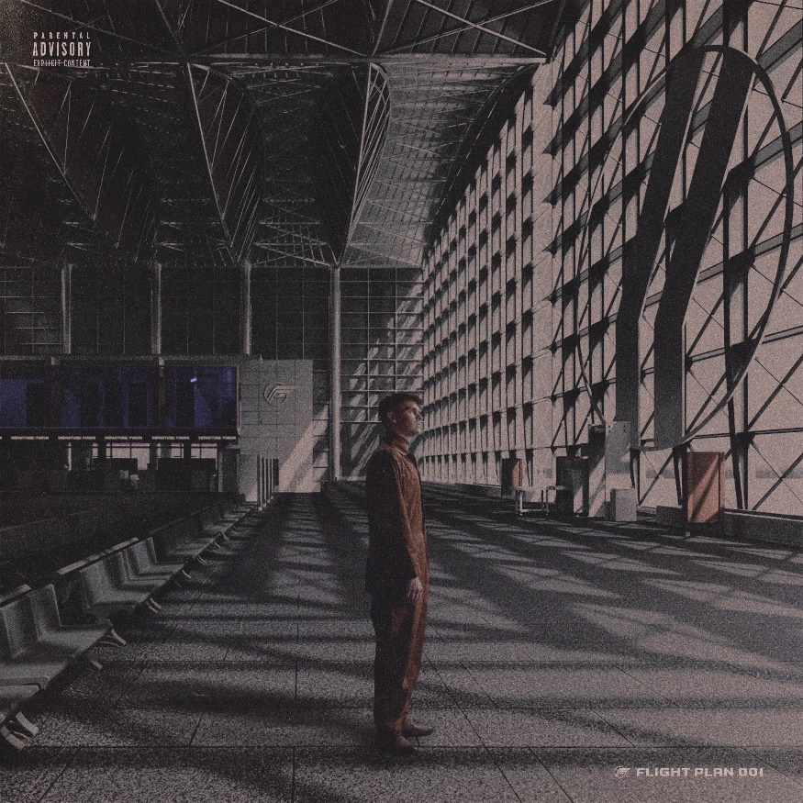

Tracklisting:
- FP001
- Night Like This
- Mystery
- Uptown
- Soon
- Can’t Stop
- Alibi
- Yes
- Climate
- Nights
- Don’t Blame Me
- Grow

ABOUT JOHNNY YUKON:
Much like the recordings of an airplane’s black box, the music of Johnny Yukon chronicles a cloud-scraping personal journey. Spun through a jet stream of lo-fi beatcraft, vintage world-building, hip-hop malleability, and alternative pop eloquence, the Pennsylvania-born and Los Angeles-based singer, songwriter, and producer navigates through raw emotions with acute storytelling, head-nodding rhymes, and fits of cathartic falsetto. Even though the ideas often gestate from an intimate personal studio, he projects his vision on the big screen with ambitious scope. After making waves from behind the scenes with songwriting placements for Young Thug, Ty Dolla $ign, Camila Cabello, and Leon Bridges, he made his formal debut with Installation I in 2018. Johnny’s influence only amplified throughout the global pandemic, co-writing Internet Money’s multiplatinum mega-smash “Lemonade” [feat. Gunna, Don Toliver, & NAV], Skepta & Pop Smoke’s F9 soundtrack standout “Lane Switcha” [feat. A$AP Rocky, Juicy J, & Project Pat], and co-producing “Trauma” from PARTYNEXTDOOR’s Partymobile, which bowed in the Top 10 of the Billboard Top 200. Signing to Elektra in early 2021, Johnny continued to write and record at a prolific pace, distilling post-breakup feelings, isolation, and hope into the sonic architecture. Constructing a hub where his emotions and songs may launch from, Johnny Yukon charts a new course forward on his 2021 project, Flight Plan 001.
###
CONNECT WITH JOHNNY YUKON
www.johnnyyukon.com
Instagram
Twitter
Facebook
YouTube

Press Contact:
Sarah Goldstein
SarahGoldstein@Elektra.com

