FOR IMMEDIATE RELEASE
APRIL 1, 2021

KALEO UNVEILS MUCH ANTICIPATED, NEW ALBUM RELEASE DATE
SURFACE SOUNDS SET TO ARRIVE EVERYWHERE APRIL 23

BRAND NEW TRACK “SKINNY” OUT NOW
LISTEN HERE

“FIGHT OR FLIGHT TOUR” DATES FOR 2022
ON-SALE NOW AT OFFICIALKALEO.COM

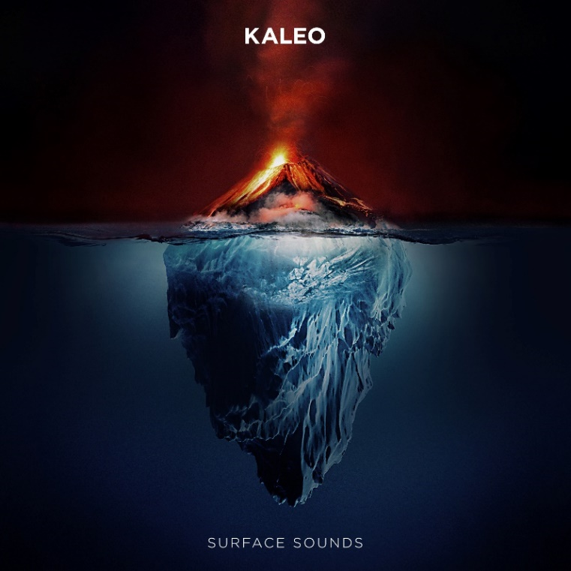

DOWNLOAD PRESS ASSETS HERE

GRAMMY-nominated rock band KALEO has announced details for their much-anticipated, second full length album. Surface Sounds is set to arrive everywhere on April 23, and available for pre-order now. To accompany the news, KALEO has unveiled another new track from their forthcoming album - “Skinny” - available now at all DSPs and digital retailers alongside an official lyric video.

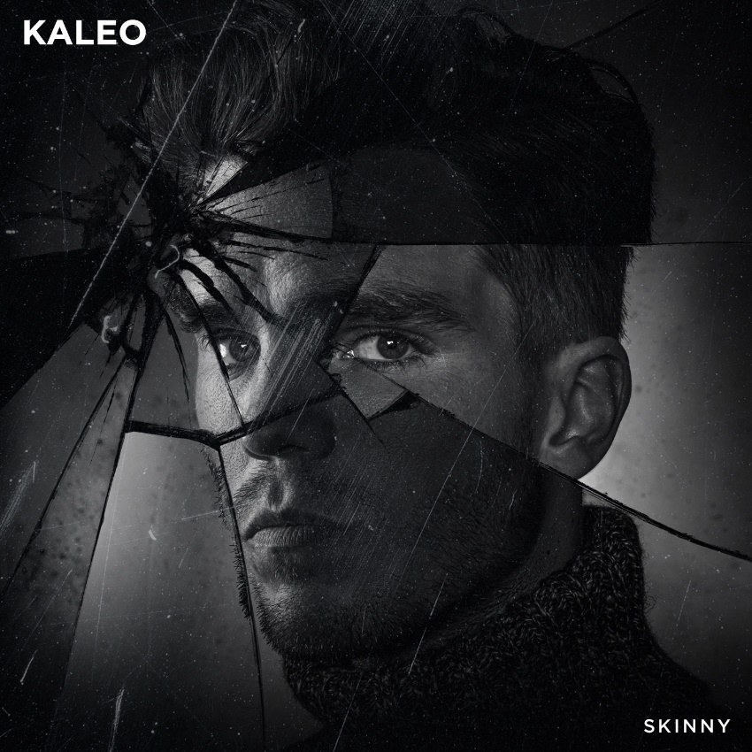

Captured in studios around the world, Surface Sounds is very much the brainchild of KALEO frontman, singer, and songwriter JJ Julius Son. Co-producing a majority of the album alongside GRAMMY winner Dave Cobb, Julius Son was able to execute his singular vision, leaning into his affinity for blues, folk, and rock. The album’s current single “Break My Baby” – produced by GRAMMY winner Mike Elizondo; written solely and co-produced by Julius Son - made an immediate impact at Triple A radio as the #1 most added song after its first week and continues to climb the format’s chart. Additionally, the band recently unveiled a breath-taking, live performance version of the track that was recorded and filmed at the iconic ÞRÍDRANGAR lighthouse, located atop a remote rock formation in the North Atlantic Ocean, several miles off the coast of their native Iceland. The stunning video (watch HERE) follows two previously released, live performance visuals that feature the beautiful, environmental landscapes found in Iceland: “Save Yourself (LIVE at Fjallsárlón)” and “Way Down We Go (LIVE in a Volcano),” which showcased the band’s 2x-Platinum smash. Last year, KALEO performed an acoustic version of “Break My Baby” for NBC’s “Late Night with Seth Meyers,” captured in the middle of picturesque Lake Ellidavatn near Julius Son’s home in Iceland.

KALEO recently announced 2022 dates for their “Fight or Flight Tour,” which now also includes a stop at the iconic Red Rocks Amphitheatre in Morrison, Colorado, on May 16, 2022. Initially set for the summer of 2020, but rescheduled due to the global pandemic, the worldwide tour’s North American leg – which kicks off at Seattle’s Showbox SoDo on February 22, 2022 (full itinerary below) – is on sale now. Nearly all of KALEO’s Fight or Flight Tour shows will take place in the originally scheduled venues, with previously purchased tickets being honored in most cases. For ticket info, individual show details, tour updates, and more, please visit www.OfficialKALEO.com.

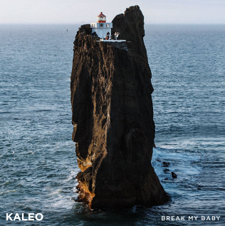

“Break My Baby” follows the band’s other single “I Want More,” which reached #6 on Billboard’s Triple A radio chart and was performed live in studio on CBS’ “The Late Show with Stephen Colbert.” Both tracks were delivered simultaneously last year to offer a first taste of new music since the band’s major label debut album, 2016’s RIAA-Gold certified A/B. KALEO subsequently released “Alter Ego” – which Julius Son calls “probably our most classic rock song” – and the brooding ballad “Backbone.” All four tracks will appear on the band’s forthcoming Elektra/Atlantic Records full length album Surface Sounds, set for release in the coming months. More details to be announced soon.

About KALEO
Since the release of their gold-certified breakthrough album, 2016’s A/B, Icelandic rock band KALEO—led by frontman/songwriter JJ Julius Son—has taken their music around the world. The album spawned three hit singles – the GRAMMY-nominated “No Good,” the Gold-selling “All The Pretty Girls” and the chart-topping, 2x RIAA Platinum-certified “Way Down We Go” which was used in over two dozen television shows from Grey’s Anatomy to Riverdale, leading the No. 1 single to top The Hollywood Reporter’s Top TV Songs chart. After amassing over 1 Billion global streams, 39 international certifications, and countless sold-out headline shows spanning from London to Moscow, KALEO has proven to be a worldwide phenomenon. Known for their electrifying live performances, KALEO completely sold out their first U.S. headline tour and was a standout at Coachella, Lollapalooza and Bonnaroo and recently were hand-picked to open stadium dates for the Rolling Stones. Since KALEO wrapped a nearly non-stop 3-year touring schedule in support of A/B in October 2018, Julius Son has been in the studio working on the highly anticipated follow-up, Surface Sounds on Elektra/Atlantic. Current single “Break My Baby” is available everywhere now, along with lead singles “I Want More,” “Alter Ego,” “Backbone,” and “Skinny.”

KALEO’s Surface Sounds Track Listing is as follows:
1. Brother Run Fast
2. Break My Baby (produced by Mike Elizondo and co-produced by JJ Julius Son)
3. Alter Ego
4. Free the Slave
5. Skinny
6. Hey Gringo
7. My Fair Lady
8. I Want More (produced by JJ Julius Son)
9. Backbone
10. I Walk on Water (co-written with David Antonsson)
11. Into My Mother’s Arms (produced by JJ Julius Son)

All music written solely by JJ Julius Son and produced by Dave Cobb and Julius Son unless otherwise noted.

KALEO “Fight or Flight Tour” 2022

2/22/2022 Seattle, WA Showbox SoDo*
3/2/2022 San Francisco, CA The Warfield
3/5/2022 Los Angeles, CA The Novo
3/11/2022 Las Vegas, NV House of Blues
3/12/2022 Phoenix, AZ The Van Buren
3/18/2022 Kansas City, MO The Midland
3/19/2022 Dallas, TX House of Blues
3/21/2022 Houston, TX House of Blues
3/22/2022 Austin, TX ACL Live
3/25/2022 New Orleans, LA The Fillmore
3/28/2022 Miami, FL The Fillmore
3/29/2022 Orlando, FL House of Blues
3/30/2022 Atlanta, GA Tabernacle
4/1/2022 Raleigh, NC The Ritz
4/2/2022 Charlotte, NC The Fillmore
4/4/2022 Nashville, TN The Ryman
4/6/2022 St. Louis, MO The Pageant
4/8/2022 Louisville, KY Palace Theatre
4/9/2022 Indianapolis, IN Murat Theatre
4/13/2022 Washington, DC The Anthem
4/15/2022 New York, NY Terminal 5
4/18/2022 Boston, MA House of Blues**
4/22/2022 Montreal, QC M Telus
4/24/2022 Toronto, ON TBD^^
4/27/2022 Detroit, MI The Fillmore
4/28/2022 Grand Rapids, MI 20 Monroe Live
4/30/2022 Chicago, IL Aragon Ballroom
5/9/2022 Vancouver, BC Doug Mitchell Thunderbird Sports Centre
5/16/2022 Morrison, CO Red Rocks Amphitheatre

* venue change, all tickets honored
** venue change, tickets on sale now
^^ postponed, new venue + on sale TBD

Connect with KALEO:
Official Website
Facebook
Twitter
Instagram
YouTube

# # #

CONTACT:

Glenn Fukushima
Elektra Music Group
(818) 238-6833
GlennFukushima@elektra.com

