FOR IMMEDIATE RELEASE
FEBRUARY 23, 2021

KALEO ANNOUNCES “FIGHT OR FLIGHT” TOUR FOR 2022

GRAMMY-NOMINATED BAND’S RESCHEDULED
NORTH AMERICAN DATES KICK OFF ON FEBRUARY 22

TICKETS ON-SALE NOW AT OFFICIALKALEO.COM

STUNNING LIVE PERFORMANCE OF “BREAK MY BABY” FILMED & RECORDED ATOP THE ICONIC ÞRÍDRANGAR LIGHTHOUSE IN ICELAND
WATCH HERE

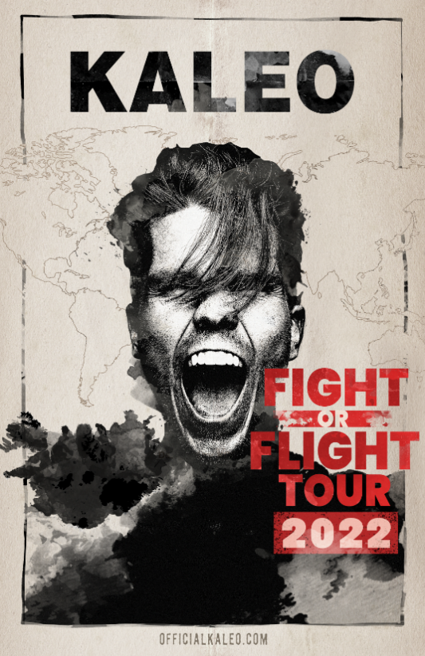

DOWNLOAD PRESS ASSETS HERE

GRAMMY-nominated rock band KALEO has announced details for their “Fight or Flight Tour” now taking place in 2022. Initially set for the summer of 2020, but rescheduled due to the global pandemic, the newly announced dates for the worldwide tour’s North American leg – which kicks off at Seattle’s Showbox SoDo on February 22, 2022 (full itinerary below) – are on sale now. Nearly all of KALEO’s Fight or Flight shows will take place in the originally scheduled venues, with previously purchased tickets being honored in most cases. For ticket info, individual show details, tour updates, and more, please visit www.OfficialKALEO.com.

KALEO’s current single “Break My Baby” – written solely by frontman, singer, and songwriter JJ Julius Son - has made an immediate impact at Triple A radio as the #1 most added song after its first week at the format. Additionally, the band recently unveiled a breath-taking, live performance version of the track that was recorded and filmed at the iconic ÞRÍDRANGAR lighthouse, located atop a remote rock formation in the North Atlantic Ocean, several miles off the coast of their native Iceland. The stunning video (watch HERE) follows two previously released, live performance visuals that feature the beautiful, environmental landscapes found in Iceland: “Save Yourself (LIVE at Fjallsárlón)” and “Way Down We Go (LIVE in a Volcano),” which showcased the band’s 2x-Platinum smash. Last year, KALEO performed an acoustic version of “Break My Baby” for NBC’s “Late Night with Seth Meyers,” captured in the middle of a picturesque lake near Julius Son’s home in Iceland.

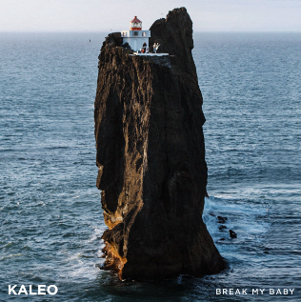

“Break My Baby” follows the band’s other single “I Want More,” which reached #6 on Billboard’s Triple A radio chart and was performed live in studio on CBS’ “The Late Show with Stephen Colbert.” Both tracks were delivered simultaneously last year to offer a first taste of new music since the band’s major label debut album, 2016’s RIAA-Gold certified A/B. KALEO subsequently released “Alter Ego” – which Julius Son calls “probably our most classic rock song” – and the brooding ballad “Backbone.” All four tracks will appear on the band’s forthcoming Elektra/Atlantic Records full length album Surface Sounds, set for release in the coming months. More details to be announced soon.

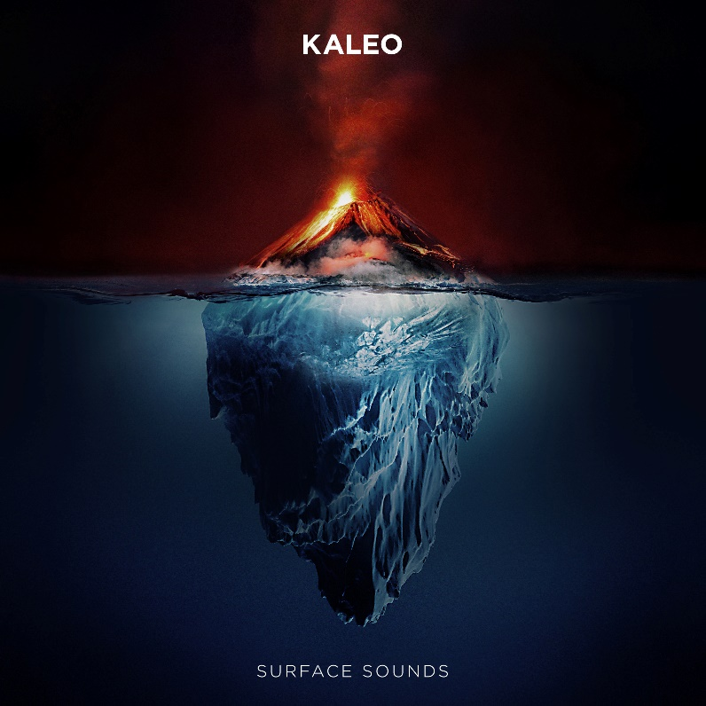

About KALEO
Since the release of their gold-certified breakthrough album, 2016’s A/B, Icelandic rock band KALEO—led by frontman/songwriter JJ Julius Son—has taken their music around the world. The album spawned three hit singles – the GRAMMY-nominated “No Good,” the Gold-selling “All The Pretty Girls” and the chart-topping, 2x RIAA Platinum-certified “Way Down We Go” which was used in over two dozen television shows from Grey’s Anatomy to Riverdale, leading the No. 1 single to top The Hollywood Reporter’s Top TV Songs chart. After amassing over 1 Billion global streams, 39 international certifications, and countless sold-out headline shows spanning from London to Moscow, KALEO has proven to be a worldwide phenomenon. Known for their electrifying live performances, KALEO completely sold out their first U.S. headline tour and was a standout at Coachella, Lollapalooza and Bonnaroo and recently were hand-picked to open stadium dates for the Rolling Stones. Since KALEO wrapped a nearly non-stop 3-year touring schedule in support of A/B in October 2018, Julius Son has been in the studio working on the highly anticipated follow-up, Surface Sounds on Elektra/Atlantic. Current single “Break My Baby” is available everywhere now, along with lead single “I Want More,” “Alter Ego” and “Backbone.”

KALEO “Fight or Flight Tour” 2022

7/19/2021 Morrison, CO Red Rocks Amphitheatre
2/22/2022 Seattle, WA Showbox SoDo*
3/2/2022 San Francisco, CA The Warfield
3/5/2022 Los Angeles, CA The Novo
3/11/2022 Las Vegas, NV House of Blues
3/12/2022 Phoenix, AZ The Van Buren
3/18/2022 Kansas City, MO The Midland
3/19/2022 Dallas, TX House of Blues
3/21/2022 Houston, TX House of Blues
3/22/2022 Austin, TX ACL Live
3/25/2022 New Orleans, LA The Fillmore
3/28/2022 Miami, FL The Fillmore
3/29/2022 Orlando, FL House of Blues
3/30/2022 Atlanta, GA Tabernacle
4/1/2022 Raleigh, NC The Ritz
4/2/2022 Charlotte, NC The Fillmore
4/4/2022 Nashville, TN The Ryman
4/6/2022 St. Louis, MO The Pageant
4/8/2022 Louisville, KY Palace Theatre
4/9/2022 Indianapolis, IN Murat Theatre
4/13/2022 Washington, DC The Anthem
4/15/2022 New York, NY Terminal 5
4/18/2022 Boston, MA House of Blues**
4/22/2022 Montreal, QC M Telus
4/24/2022 Toronto, ON TBD^^
4/27/2022 Detroit, MI The Fillmore
4/28/2022 Grand Rapids, MI 20 Monroe Live
4/30/2022 Chicago, IL Aragon Ballroom
5/9/2022 Vancouver, BC Doug Mitchell Thunderbird Sports Centre

* venue change, all tickets honored
** venue change, tickets on sale March 1
^^ postponed, new venue + on sale TBD

The Portland Show has been cancelled, a new date and venue will be announced soon.

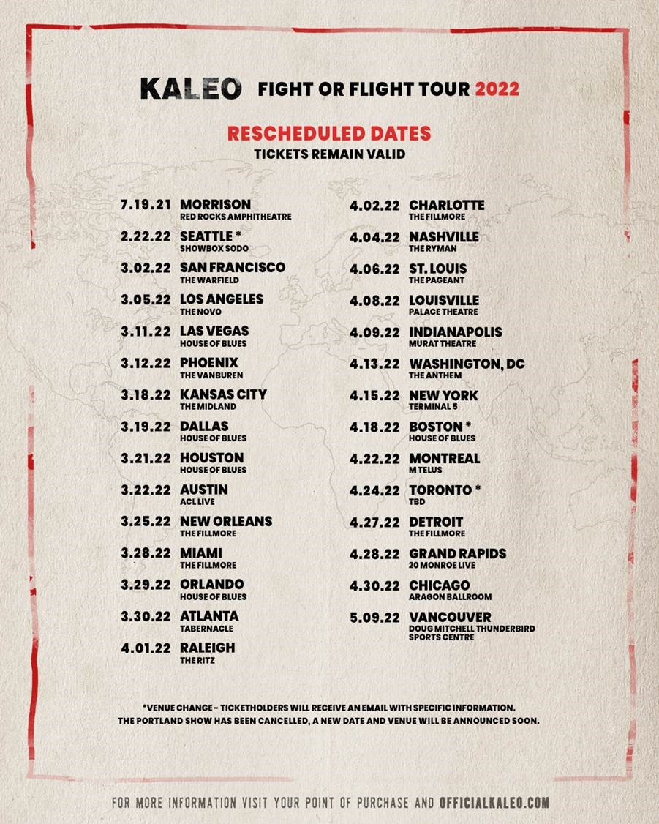

Connect with KALEO:
Official Website
Facebook
Twitter
Instagram
YouTube

# # #

CONTACT:

Glenn Fukushima
Elektra Music Group
(818) 238-6833
GlennFukushima@elektra.com

Ebie McFarland
Essential Broadcast Media
(615) 327-3259
ebie@ebmediapr.com

