FOR IMMEDIATE RELEASE
JUNE 9, 2021

KALEO ANNOUNCES ADDITIONAL DATES FOR THEIR FIGHT OR FLIGHT TOUR

NEWLY ADDED DATES ON SALE FRIDAY JUNE 18TH

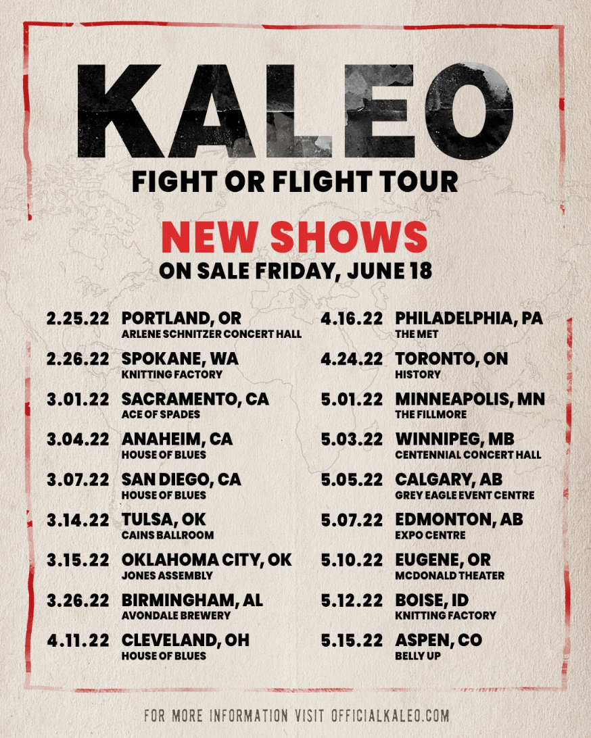

TICKETS AVAILABLE NOW FOR “FIGHT OR FLIGHT TOUR”
KICKING OFF ON FEBRUARY 22ND IN SEATTLE, WA

SURFACE SOUNDS IS AVAILABLE EVERYWHERE NOW
LISTEN HERE

DOWNLOAD PRESS ASSETS HERE

GRAMMY-nominated rock band KALEO has announced additional dates for their “Fight or Flight Tour” taking place in 2022 (full itinerary below). Pre-sale tickets for newly added dates will be available beginning Tuesday, June 15th and general on sale begins Friday, June 18th at 10:00am local time. For ticket info, individual show details, tour updates, and more, please visit www.OfficialKALEO.com.

Initially set for the summer of 2020, but rescheduled due to the global pandemic, the worldwide tour’s North American leg – which kicks off at Seattle’s Showbox SoDo on February 22, 2022 – are on sale now. Nearly all of KALEO’s Fight or Flight shows will take place in the originally scheduled venues, with previously purchased tickets being honored in most cases.

KALEO recently unveiled their highly anticipated album Surface Sounds, available everywhere via Elektra/Atlantic. Listen HERE. The band celebrated the release with a stunning, live performance of their current single “Break My Baby” on ABC’s Jimmy Kimmel Live!. Watch HERE.

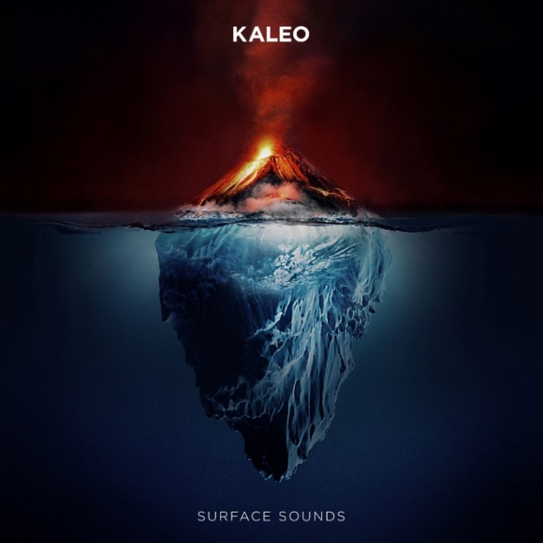

Recorded on and off the road, all around the world, the album is very much the brainchild of KALEO frontman, singer, and songwriter JJ Julius Son. Co-producing the majority of it alongside GRAMMY winner Dave Cobb, Julius Son was able to execute his singular vision, leaning into his affinity for blues, folk, and rock. The album’s current single “Break My Baby” – produced by GRAMMY winner Mike Elizondo; written solely and co-produced by Julius Son - made an immediate impact at Triple A radio as the #1 most added song after its first week and continues to climb the format’s chart.

The band recently shared an incredible, live performance video of the album track “Skinny,” shot in front of Falgradalsfjall during a magnificent volcanic eruption. The incredible footage – which features Julius Son with a backdrop of molten lava - was captured at the end March within days of the start of the volcanic eruption, which had made headlines around the world after remaining dormant for nearly 800 years. Watch HERE.

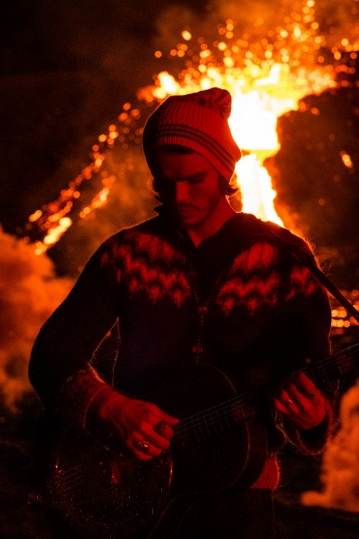

The video follows several like-minded visuals that showcase the breathtaking landscape of the band’s native Iceland. Earlier this year, KALEO unveiled a live performance version of “Break My Baby” that was recorded and filmed at the iconic ÞRÍDRANGAR lighthouse, located atop a remote rock formation in the North Atlantic Ocean, several miles off the country’s southern coast (watch HERE). The clip joins two previously released, live performance videos, currently streaming on the band’s YouTube channel: “Save Yourself (LIVE at Fjallsárlón)” which was shot atop a glacier and “Way Down We Go (LIVE in a Volcano),” featuring the band’s 2x-Platinum smash. Last year, KALEO performed a special, acoustic version of “Break My Baby” for NBC’s “Late Night with Seth Meyers,” captured in the middle of picturesque Lake Ellidavatn near Julius Son’s home.

About KALEO
Since the release of their gold-certified breakthrough album, 2016’s A/B, Icelandic rock band KALEO—led by frontman/songwriter JJ Julius Son—has taken their music around the world. The album spawned three hit singles – the GRAMMY-nominated “No Good,” the Gold-selling “All The Pretty Girls” and the chart-topping, 2x RIAA Platinum-certified “Way Down We Go” which was used in over two dozen television shows from Grey’s Anatomy to Riverdale, leading the No. 1 single to top The Hollywood Reporter’s Top TV Songs chart. After amassing over 1 Billion global streams, 39 international certifications, and countless sold-out headline shows spanning from London to Moscow, KALEO has proven to be a worldwide phenomenon. Known for their electrifying live performances, KALEO completely sold out their first U.S. headline tour and was a standout at Coachella, Lollapalooza and Bonnaroo and recently were hand-picked to open stadium dates for the Rolling Stones. After wrapping up nearly 3 years of non-stop touring in support of A/B in October 2018, Julius Son began working on the highly anticipated follow-up to the band’s major label debut. In 2020, they unveiled the first taste of Surface Sounds with the simultaneous release of “Break My Baby” and “I Want More,” which reached #6 on Billboard’s Triple A radio chart and was performed live in studio on CBS’ “The Late Show with Stephen Colbert.” KALEO subsequently released “Alter Ego” (which Julius Son calls “probably our most classic rock song”), the brooding ballad “Backbone,” and, most recently, “Skinny.” All five tracks appear on the band’s recent full length album Surface Sounds, available now via Elektra/Atlantic.

KALEO “Fight or Flight Tour” 2022
New Dates in BOLD

2/22/2022 Seattle, WA Showbox SoDo*
2/25/2022 Portland, OR Arlene Schnitzer Concert Hall
2/26/2022 Spokane, WA Knitting Factory
3/1/2022 Sacramento, CA Ace of Spades
3/2/2022 San Francisco, CA The Warfield
3/4/2022 Anaheim, CA House of Blues
3/5/2022 Los Angeles, CA The Novo
3/7/2022 San Diego, CA House of Blues
3/11/2022 Las Vegas, NV House of Blues
3/12/2022 Phoenix, AZ The Van Buren
3/14/2022 Tulsa, OK Cain's Ballroom
3/15/2022 Oklahoma City, OK Jones Assembly
3/18/2022 Kansas City, MO The Midland
3/19/2022 Dallas, TX House of Blues
3/21/2022 Houston, TX House of Blues
3/22/2022 Austin, TX ACL Live
3/25/2022 New Orleans, LA The Fillmore
3/26/2022 Birmingham, AL Avondale Brewery
3/28/2022 Miami, FL The Fillmore
3/29/2022 Orlando, FL House of Blues
3/30/2022 Atlanta, GA Tabernacle
4/1/2022 Raleigh, NC The Ritz
4/2/2022 Charlotte, NC The Fillmore
4/4/2022 Nashville, TN The Ryman
4/6/2022 St. Louis, MO The Pageant
4/8/2022 Louisville, KY Palace Theatre
4/9/2022 Indianapolis, IN Murat Theatre
4/11/2022 Cleveland, OH House of Blues
4/13/2022 Washington, DC The Anthem
4/15/2022 New York, NY Terminal 5
4/16/2022 Philadelphia, PA The Met
4/18/2022 Boston, MA House of Blues**
4/22/2022 Montreal, QC M Telus
4/24/2022 Toronto, ON History**
4/27/2022 Detroit, MI The Fillmore
4/28/2022 Grand Rapids, MI 20 Monroe Live
4/30/2022 Chicago, IL Aragon Ballroom
5/1/2022 Minneapolis, MN Fillmore
5/3/2022 Winnipeg, MN Centennial Concert Hall
5/5/2022 Calgary, AB Grey Eagle Resort
5/7/2022 Edmonton, AB Edmonton Expo Centre
5/9/2022 Vancouver, BC Doug Mitchell Thunderbird Sports Centre
5/10/2022 Eugene, OR McDonald Theater
5/12/2022 Boise, ID Knitting Factory
5/15/2022 Aspen, CO Belly Up
5/16/2022 Morrison, CO Red Rocks Amphitheatre

* venue change, all tickets honored
** venue change, tickets on sale now

Connect with KALEO:
Official Website
Facebook
Twitter
Instagram
YouTube

# # #

CONTACT:

Glenn Fukushima
Elektra Music Group
(818) 238-6833
GlennFukushima@elektra.com

