FOR IMMEDIATE RELEASE
Friday, April 17, 2020

KALEO RELEASES NEW SONG “BACKBONE” FROM HIGHLY-ANTICIPATED ALBUM SURFACE SOUNDS

“I Want More” Currently Top-10-And-Climbing at Triple A

GRAMMY-Nominated Band Recently Performed “I Want More” with a String Ensemble on “TARATATA”

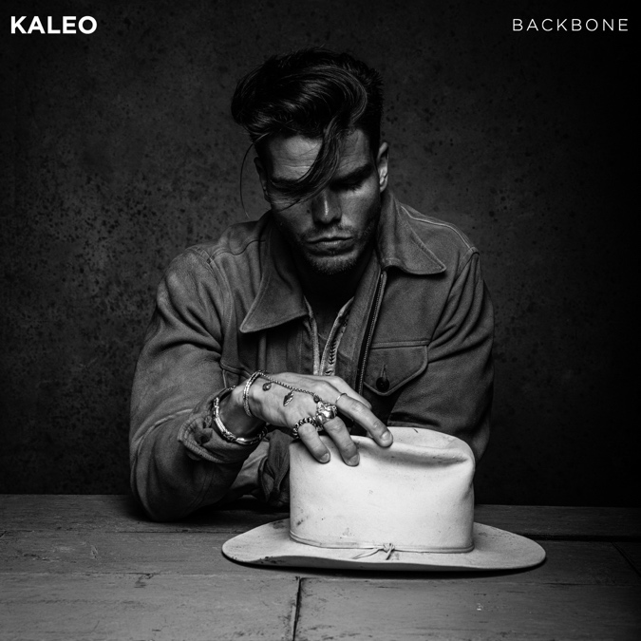
Cover Artwork for KALEO’s “Backbone” (Elektra/Atlantic); KALEO’s JJ Julius Son | Photo Credit: Dan Winters | Size: 1 MB | Type: JPG | > Download

Elektra/Atlantic recording artists KALEO released new song “Backbone” today from their highly-anticipated follow-up Surface Sounds, written solely by frontman, lead singer and songwriter JJ Julius Son, available everywhere for sale and streaming.

Julius Son has been in the studio off-and-on for two years, allowing for a combination of globe-trotting and meticulous tinkering, resulting in a spectrum of sounds recorded around the world – in North America, South America and across Europe. The final product is refreshingly free of calculation, with Julius Son allowing each tune to dictate its path while simultaneously leaning-in to his blues, folk and rock inclinations.

“It’s been a puzzle for me,” Julius Son shared with House of Solo. “I started working on [Surface Sounds] while still touring around the world, and then in the last year or so I have mostly split my time in studios in Nashville, L.A. and NYC. It has been very interesting as the songs are very different from each other and I have been able to work with a lot of great people.”

In addition to “Backbone,” the GRAMMY-nominated band released two singles in January, “I Want More,” praised by Texas Monthly as a “tender-yet-tough anthem,” and currently Top 10 and climbing the Triple A chart, and “Break My Baby,” described by Loudwire as “hooky and groovy, showcasing the range of [Julius Son’s] vocal and a gritty, bluesy approach.” With the announcement of Surface Sounds, the follow-up to 2016’s globally successful A/B, KALEO released a third track “Alter Ego,” which Julius Son calls “probably the most classic rock and roll song” on the album.

Earlier this year, Julius Son filmed a special performance of his single “I Want More” with a string ensemble, which aired on the acclaimed French television show “TARATATA” this month. Watch it HERE.

After amassing over 1 Billion global streams, 39 international certifications, and countless sold-out headline shows spanning from London to Moscow, KALEO wrapped a nearly non-stop 3-year touring schedule in support of their breakout Gold-certified album A/B in October 2018.
A/B spawned three hit singles for the Icelandic rock band – the GRAMMY-nominated “No Good,” the gold-selling “All The Pretty Girls,” and the chart-topping, 2x Platinum-certified “Way Down We Go,” which was used in over two dozen television shows, leading it to No. 1 on The Hollywood Reporter’s Top TV Songs chart.

For more information, visit OfficialKALEO.com, or follow on Facebook.com/OfficialKALEO, Twitter @OfficialKALEO, Instagram @OfficialKALEO and YouTube.com/KALEOOfficial.

KALEO’s Surface Sounds Track Listing is as follows:
- Brother Run Fast
- Break My Baby (produced by Mike Elizondo and co-produced by JJ Julius Son)
- Alter Ego
- Free the Slave
- Skinny
- Hey Gringo
- The USA Today (produced by Shawn Everett and JJ Julius Son)
- My Fair Lady
- I Want More (produced by JJ Julius Son)
- Backbone
- I Walk on Water (co-written with David Antonsson)
- Into My Mother’s Arms (produced by JJ Julius Son)
All music written solely by JJ Julius Son and produced by Dave Cobb and Julius Son unless otherwise noted.

About KALEO
Since the release of their gold-certified breakthrough album, 2016’s A/B, Icelandic rock band KALEO—led by frontman/songwriter JJ Julius Son—has taken their music around the world. The album spawned three hit singles – the GRAMMY-nominated “No Good,” the gold-selling “All The Pretty Girls” and the chart-topping, 2x Platinum-certified “Way Down We Go” which was used in over two dozen television shows from Grey’s Anatomy to Riverdale, leading the No. 1 single to top The Hollywood Reporter’s Top TV Songs chart. After amassing over 1 Billion global streams, 39 international certifications, and countless sold-out headline shows spanning from London to Moscow, KALEO has proven to be a worldwide phenomenon. Known for their electrifying live performances, KALEO completely sold out their first U.S. headline tour and was a standout at Coachella, Lollapalooza and Bonnaroo and recently were hand-picked to open stadium dates for the Rolling Stones. Since KALEO wrapped a nearly non-stop 3-year touring schedule in support of A/B in October 2018, Julius Son has been in the studio working on the highly anticipated follow-up, Surface Sounds, due out summer 2020 on Elektra/Atlantic. “I Want More,” “Break My Baby,” “Alter Ego” and “Backbone” are out now. Online at www.officialKALEO.com, @officialKALEO and on YouTube @KALEOofficial.

# # #

Media Contacts for KALEO
Ebie McFarland
Essential Broadcast Media
(615) 327-3259
ebie@ebmediapr.com
Glenn Fukushima
Elektra Music Group
(818) 238-6833
GlennFukushima@elektra.com

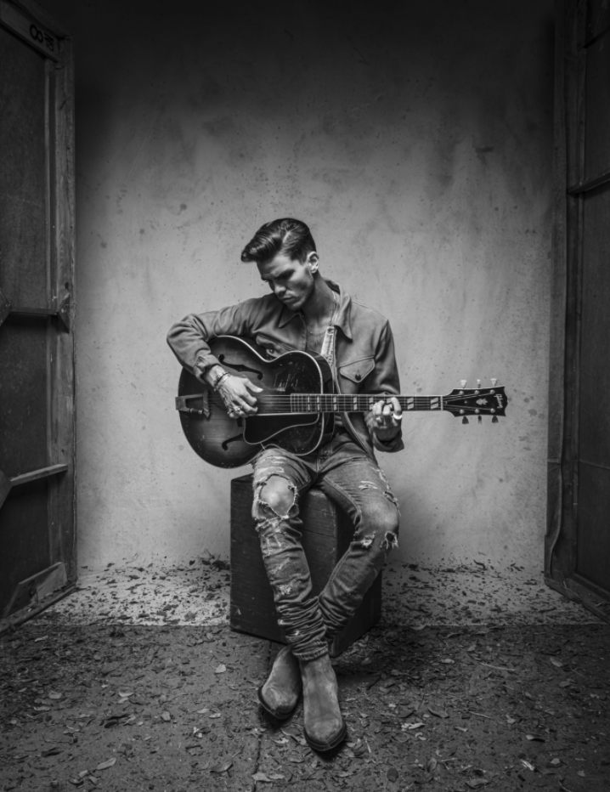
KALEO’s JJ Julius Son | Photo Credit: Dan Winters | Size: 8 MB | Type: JPG | > Download

