FOR IMMEDIATE RELEASE
APRIL 14, 2021

GRAMMY-NOMINATED ROCK BAND KALEO CAPTURES
STUNNING LIVE PERFORMANCE VIDEO SHOT IN FRONT OF AN ERUPTING VOLCANO

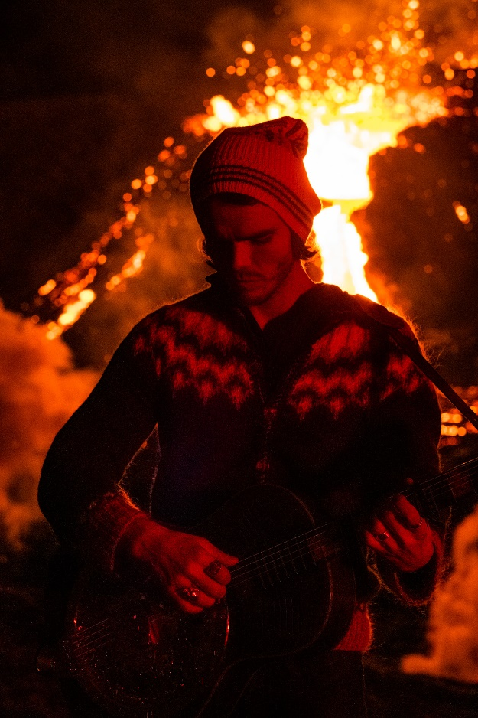

“SKINNY” (LIVE PERFORMANCE FROM FALGRADALSFJALL VOLCANIC ERUPTION)
WATCH HERE

NATIONALLY TELEVISED APPEARANCE ON ABC’S JIMMY KIMMEL LIVE!
SET FOR APRIL 22

MUCH-ANTICIPATED, NEW ALBUM SURFACE SOUNDS
ARRIVES EVERYWHERE APRIL 23

DOWNLOAD PRESS ASSETS HERE

GRAMMY-nominated rock band KALEO has unveiled a stunning, live acoustic performance of their recently released track “Skinny,” shot in front of Falgradalsfjall during a magnificent volcanic eruption. The incredible footage – which features frontman, singer, and songwriter JJ Julius Son with a backdrop of molten lava - was captured at the end of last month within days of the start of the volcanic eruption, which has since made headlines around the world after remaining dormant for nearly 800 years.

Watch “Skinny” (LIVE Performance from Fagradasfjall Volcanic Eruption) HERE.

Julius Son recalls: "It was an amazing and surreal experience to film and record this video in front of the live eruption. It was very challenging and required a difficult hike, carrying the equipment with our bare hands. We filmed it during the night, so fortunately there weren't many people there.”

The studio recording of “Skinny” appears on the band’s much-anticipated, second full length album Surface Sounds, arriving everywhere on April 23 via Elektra/Atlantic, and available for pre-order now.

Recorded on and off the road, all around the world, the album is very much the brainchild of Julius Son. Co-producing the majority of it alongside GRAMMY winner Dave Cobb, Julius Son was able to execute his singular vision, leaning into his affinity for blues, folk, and rock. The album’s current single “Break My Baby” – produced by GRAMMY winner Mike Elizondo; written solely and co-produced by Julius Son - made an immediate impact at Triple A radio as the #1 most added song after its first week and continues to climb the format’s chart. To celebrate the arrival of Surface Sounds, KALEO is set to perform “Break My Baby” on ABC’s “Jimmy Kimmel Live!” on April 22, the eve of the album’s release.

“Skinny” (LIVE Performance from Fagradasfjall Volcanic Eruption) follows several like-minded visuals that showcase the breathtaking landscape of the band’s native Iceland. Earlier this year, KALEO unveiled a live performance version of “Break My Baby” that was recorded and filmed at the iconic ÞRÍDRANGAR lighthouse, located atop a remote rock formation in the North Atlantic Ocean, several miles off the country’s southern coast (watch HERE). The clip joins two previously released, live performance videos, currently streaming on the band’s YouTube channel: “Save Yourself (LIVE at Fjallsárlón)” which was shot atop a glacier and “Way Down We Go (LIVE in a Volcano),” featuring the band’s 2x-Platinum smash. Last year, KALEO performed a special, acoustic version of “Break My Baby” for NBC’s “Late Night with Seth Meyers,” captured in the middle of picturesque Lake Ellidavatn near Julius Son’s home.

KALEO will make their triumphant return to the road in 2022 with their “Fight or Flight Tour.” Initially set for the summer of 2020, but rescheduled due to the global pandemic, the worldwide tour’s North American leg – which kicks off at Seattle’s Showbox SoDo on February 22, 2022 (full itinerary below) – is on sale now. Nearly all of KALEO’s Fight or Flight Tour shows will take place in the originally scheduled venues, with previously purchased tickets being honored in most cases. For ticket info, individual show details, tour updates, and more, please visit www.OfficialKALEO.com.

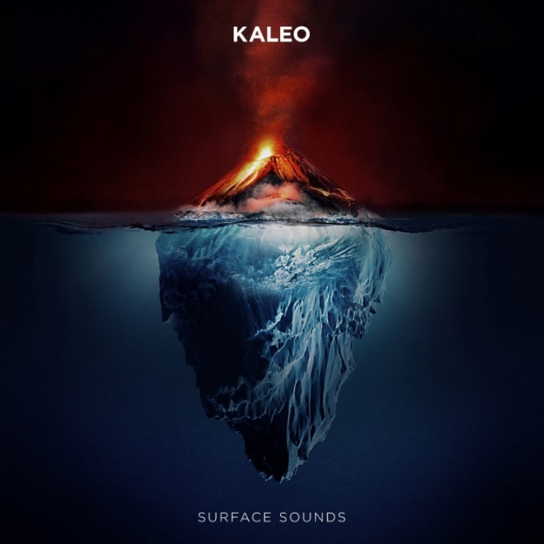

About KALEO
Since the release of their gold-certified breakthrough album, 2016’s A/B, Icelandic rock band KALEO—led by frontman/songwriter JJ Julius Son—has taken their music around the world. The album spawned three hit singles – the GRAMMY-nominated “No Good,” the Gold-selling “All The Pretty Girls” and the chart-topping, 2x RIAA Platinum-certified “Way Down We Go” which was used in over two dozen television shows from Grey’s Anatomy to Riverdale, leading the No. 1 single to top The Hollywood Reporter’s Top TV Songs chart. After amassing over 1 Billion global streams, 39 international certifications, and countless sold-out headline shows spanning from London to Moscow, KALEO has proven to be a worldwide phenomenon. Known for their electrifying live performances, KALEO completely sold out their first U.S. headline tour and was a standout at Coachella, Lollapalooza and Bonnaroo and recently were hand-picked to open stadium dates for the Rolling Stones. After wrapping up nearly 3 years of non-stop touring in support of A/B in October 2018, Julius Son began working on the highly anticipated follow-up to the band’s major label debut. In 2020, they unveiled the first taste of Surface Sounds with the simultaneous release of “Break My Baby” and “I Want More,” which reached #6 on Billboard’s Triple A radio chart and was performed live in studio on CBS’ “The Late Show with Stephen Colbert.” KALEO subsequently released “Alter Ego” (which Julius Son calls “probably our most classic rock song”), the brooding ballad “Backbone,” and, most recently, “Skinny.” All five tracks will appear on the band’s forthcoming, full length album Surface Sounds, set for release on April 23 via Elektra/Atlantic.

KALEO’s Surface Sounds Track Listing is as follows:
1. Brother Run Fast
2. Break My Baby (produced by Mike Elizondo and co-produced by JJ Julius Son)
3. Alter Ego
4. Free the Slave
5. Skinny
6. Hey Gringo
7. My Fair Lady
8. I Want More (produced by JJ Julius Son)
9. Backbone
10. I Walk on Water (co-written with David Antonsson)
11. Into My Mother’s Arms (produced by JJ Julius Son)

All music written solely by JJ Julius Son and produced by Dave Cobb and Julius Son unless otherwise noted.

KALEO “Fight or Flight Tour” 2022

2/22/2022 Seattle, WA Showbox SoDo*
3/2/2022 San Francisco, CA The Warfield
3/5/2022 Los Angeles, CA The Novo
3/11/2022 Las Vegas, NV House of Blues
3/12/2022 Phoenix, AZ The Van Buren
3/18/2022 Kansas City, MO The Midland
3/19/2022 Dallas, TX House of Blues
3/21/2022 Houston, TX House of Blues
3/22/2022 Austin, TX ACL Live
3/25/2022 New Orleans, LA The Fillmore
3/28/2022 Miami, FL The Fillmore
3/29/2022 Orlando, FL House of Blues
3/30/2022 Atlanta, GA Tabernacle
4/1/2022 Raleigh, NC The Ritz
4/2/2022 Charlotte, NC The Fillmore
4/4/2022 Nashville, TN The Ryman
4/6/2022 St. Louis, MO The Pageant
4/8/2022 Louisville, KY Palace Theatre
4/9/2022 Indianapolis, IN Murat Theatre
4/13/2022 Washington, DC The Anthem
4/15/2022 New York, NY Terminal 5
4/18/2022 Boston, MA House of Blues**
4/22/2022 Montreal, QC M Telus
4/24/2022 Toronto, ON TBD^^
4/27/2022 Detroit, MI The Fillmore
4/28/2022 Grand Rapids, MI 20 Monroe Live
4/30/2022 Chicago, IL Aragon Ballroom
5/9/2022 Vancouver, BC Doug Mitchell Thunderbird Sports Centre
5/16/2022 Morrison, CO Red Rocks Amphitheatre

* venue change, all tickets honored
** venue change, tickets on sale now
^^ postponed, new venue + on sale TBD

Connect with KALEO:
Official Website
Facebook
Twitter
Instagram
YouTube

# # #

CONTACT:

Glenn Fukushima
Elektra Music Group
(818) 238-6833
GlennFukushima@elektra.com

