For Review Only
Friday, March 11, 2022

KALEO DEBUT STRIKING LIVE PERFORMANCE OF
“BACKBONE” FROM BREIÐARMERKURJÖKULL ICE CAVE

“Backbone (Live at Breiðarmerkurjökull)” Available Everywhere Now
Listen HERE {link} + Watch HERE

Fight Or Flight Tour Continues Tonight in Las Vegas at House of Blues;
Tickets Available at OfficialKALEO.com

{embed video}
WATCH: KALEO’s “Backbone (Live at Breiðarmerkurjökull)”

After kicking off their Fight Or Flight Tour with multiple sold-out shows, GRAMMY-nominated Elektra/Atlantic rock band KALEO debut a live performance video of “Backbone” from an ice cave located on Breiðarmerkurjökull, part of the larger glacier Vatnajökull. Watch the video HERE and listen to the live recording HERE {link}.

Filmed in January 2021, the performance video opens with a stirring view of the Vatnajökull ice cap juxtaposed with some of Iceland’s native wildlife running across the plateau. The viewer follows KALEO as they trudge over long stretches of desolate, mesmerizing glacier. The instrumental builds as the band arrives at the Breiðarmerkurjökull ice cave before front man and songwriter JJ Julius Son plays the opening chords to “Backbone,” from their latest album Surface Sounds.

Drenched in pedal steel, the stripped-down version of “Backbone” showcases the brooding balladry of the song and Julius Son’s knack for storytelling allusions. As the camera pans out and the scene fades away, a message appears:

“The ice cave where this live performance was filmed has melted and disappeared. By the year 2100, the entire glacier will be gone.”

Today’s release follows “Skinny (Live from Fagradalsfjall Volcanic Eruption),” a fan-favorite track from Surface Sounds and another in a series of live performances from some of Iceland’s spectacular landscapes, including “Break My Baby (Live from ÞRÍDRANGAR),” recorded and filmed at the iconic ÞRÍDRANGAR lighthouse, located atop a remote rock formation in the North Atlantic Ocean.

From their 2016 breakout global success A/B, KALEO released “Save Yourself (Live at Fjallsárlón)” and “Way Down We Go (Live in a Volcano),” which showcased the band’s 2x-Platinum smash.

Captured in studios around the world, Surface Sounds is very much the brainchild of Julius Son. Co-producing a majority of the album alongside GRAMMY winner Dave Cobb, Julius Son was able to execute his singular vision, leaning heavily into his affinity for blues, folk and rock.

Major label debut A/B spawned three hit singles for the Icelandic band – the GRAMMY-nominated “No Good,” the Gold-selling “All The Pretty Girls” and the chart-topping, RIAA Double Platinum-certified “Way Down We Go,” which was used in over two dozen television shows, leading it to No. 1 on The Hollywood Reporter’s Top TV Songs chart.

KALEO made their triumphant homecoming to live entertainment earlier this year, with the 50+ date North American leg of the Fight or Flight Tour continuing tonight at House of Blues in Las Vegas (full itinerary below). The world-wide tour is on sale now. For ticket info, individual show details, tour updates and more, visit OfficialKALEO.com.
For more information, visit OfficialKALEO.com, or follow on Facebook.com/OfficialKALEO, Twitter @OfficialKALEO, Instagram @OfficialKALEO and YouTube.com/KALEOOfficial.

KALEO’s North American Fight or Flight Tour 2022

March 11 House of Blues Las Vegas Las Vegas, Nev.
March 12 The Van Buren Phoenix, Ariz.
March 14 Cain’s Ballroom Tulsa, Okla.
March 15 The Jones Assembly Oklahoma City, Okla.
March 18 Arvest Bank Theater At the Midland Kansas City, Kan.
March 19 House of Blues Dallas Dallas, Texas
March 21 House of Blues Houston Houston, Texas
March 22 ACL Live at the Moody Theater Austin, Texas
March 25 The Fillmore New Orleans New Orleans, La.
March 26 Avondale Brewing Company Birmingham, Ala.
March 28 The Fillmore Miami Beach Miami Beach, Fla.
March 29 House of Blues Orlando Orlando, Fla.
March 30 Tabernacle Atlanta, Ga.
April 1 The Ritz Raleigh, N.C.
April 2 The Fillmore Charlotte Charlotte, N.C.
April 4 Ryman Auditorium Nashville, Tenn.
April 6 The Pageant St. Louis, Mo.
April 8 The Louisville Palace Louisville, Ky.
April 9 Murat Theatre Indianapolis, Ind.
April 11 House of Blues Cleveland Cleveland, Ohio
April 13 The Anthem Washington, D.C.
April 15 Terminal 5 New York, N.Y.
April 16 The Met Philadelphia, Pa.
April 18 House of Blues Boston Boston, Mass.
April 19 State Theatre Portland, Maine
April 21 Mtelus Montreal, Quebec
April 22 Mtelus Montreal, Quebec
April 24 History Toronto, Ontario
April 25 History Toronto, Ontario
April 27 The Fillmore Detroit Detroit, Mich.
April 28 GLC Live at 20 Monroe Grand Rapids, Mich.
April 30 Aragon Ballroom Chicago, Ill.
May 1 The Fillmore Minneapolis Minneapolis, Minn.
May 3 Centennial Concert Hall Winnipeg, Manitoba
May 5 Grey Eagle Resort and Casino Calgary, Alberta
May 7 Edmonton Expo Centre Edmonton, Alberta
May 9 Doug Mitchell Thunderbird Sport Centre Vancouver, British Columbia
May 10 McDonald Theatre Eugene, Ore.
May 12 Knitting Factory Concert House Boise, Idaho
May 15 Belly Up Aspen, Colo.
May 16 Red Rocks Amphitheatre Morrison, Colo.

About KALEO
Since the release of their Gold-certified breakthrough album, 2016’s A/B, Icelandic rock band KALEO—led by frontman/songwriter JJ Julius Son—has taken their music around the world. The album spawned three hit singles – the GRAMMY-nominated “No Good,” the Gold-selling “All The Pretty Girls” and the chart-topping, 2x Platinum-certified “Way Down We Go” which was used in over two dozen television shows from “Grey’s Anatomy” to “Riverdale,” leading the No. 1 single to top The Hollywood Reporter’s Top TV Songs chart. After amassing over 1 Billion global streams, 39 international certifications, and countless sold-out headline shows spanning from London to Moscow, KALEO has proven to be a worldwide phenomenon. Known for their electrifying live performances, KALEO completely sold out their first U.S. headline tour and was a standout at Coachella, Lollapalooza and Bonnaroo and were hand-picked to open stadium dates for the Rolling Stones. Since KALEO wrapped a nearly non-stop 3-year touring schedule in support of A/B in October 2018, Julius Son went into the studio to work on the highly anticipated follow-up, Surface Sounds on Elektra/Atlantic, available everywhere now. KALEO’s Fight or Flight Tour 2022 launches Feb. 22 in Seattle, Wash., featuring 50+ dates across North America before wrapping at the iconic Red Rocks Amphitheatre in Morrison, Colo. on May 16. For more information, visit OfficialKALEO.com or follow on Instagram and Twitter @OfficialKALEO and Facebook.com/OfficialKALEO.
# # #
Media Contacts for KALEO
Ebie McFarland | Ashley Gaskin
Essential Broadcast Media
615-327-3259
ebie@ebmediapr.com | ashley@ebmediapr.com
Glenn Fukushima
Elektra Music Group
818-238-6833
GlennFukushima@elektra.com

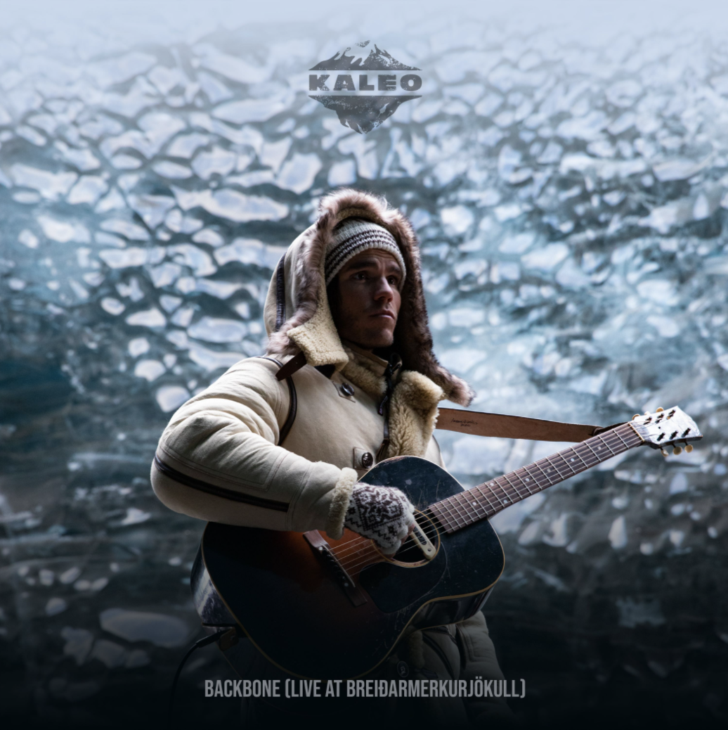
Cover Art for KALEO’s “Backbone (Live from Breiðamerkurjökull)” (Elektra/Atlanic) | Photo Credit: | Size: 3.5 MB | Type: JPG | >Download

Tickets are on sale now for KALEO’s Fight Or Flight 2022 Tour | Size: 1 MB | Type: JPG | >Download

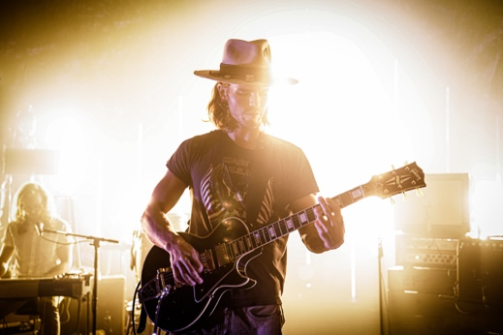
KALEO | Photo Credit: Evan Kaufmann | Size: 5 MB | Type: JPG | >Download

