LŪN RETURNS WITH NEW EP fuck ya go us
LISTEN NOW

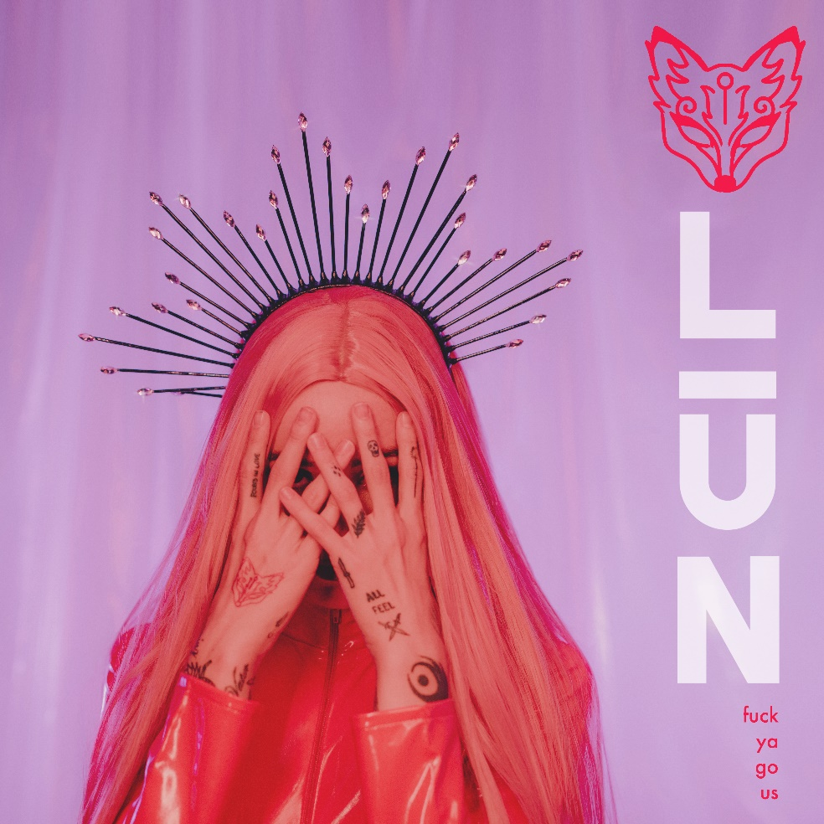
DOWNLOAD PRESS ASSETS HERE

MAY 6, 2022 – LŪN has returned with her new EP, fuck ya go us. The five-track offering showcases LŪN’s production prowess, highlighting her ethereal vocals and driving beat drops. The EP includes previously released singles “fisticuffs (featuring tiLLie)” and “myyyy medssss.” fuck ya go us is available now on all streaming platforms.

LŪN’s debut EP, haha i like it, arrived last year and was revealed to be the new creative project from alt-pop icon Lights. The six-track, bass-heavy collection was heralded by singles “bitches” and “y2k2k.” Billboard praised “bitches” for its “hefty siren call chorus that makes us feel like we can shoot lightning through our fingertips,” while EDM.com commended “y2k2k” for “transitioning seamlessly from a space of control into one of beautiful mania.” Following EP release, LŪN shared “demolition (feat. Lights) [ruined by Glass Petals],” a club-ready remix by Glass Petals–the brainchild of Felix Cartal and Johnny Jover.

(EP art/Tracklisting below)

LŪN
fuck ya go us EP
AVAILABLE NOW

Tracklist
1. ctrl alt dislike
2. it’s called faith, honey (featuring MYTH)
3. fisticuffs (featuring tiLLie)
4. myyyy medssss
5. monotony (featuring Party Nails)

###
CONNECT WITH LŪN:
INSTAGRAM
FACEBOOK
TWITTER
YOUTUBE

Press Contact:
Sarah Goldstein
sarahgoldstein@elektra.com

