LIGHTS SHARES DEAD END REMIX LP
FEATURES THREE NEW ORIGINALS AND FIVE REIMAGINED HITS
AVAILABLE NOW

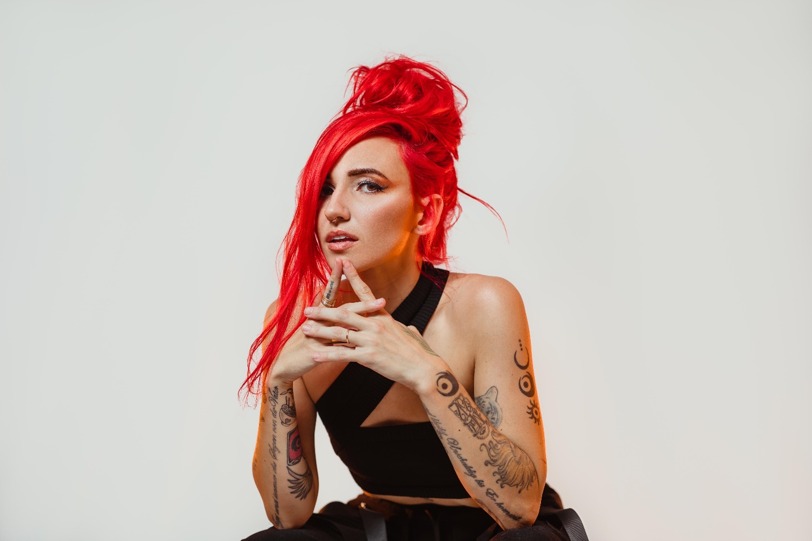

AUGUST 7TH – Alt-pop artist Lights has shared new remix LP Dead End. Available now on all streaming platforms, Dead End boasts three original tracks and five remixes (co-produced by Lights and MYTH) that completely reimagine fan favorites, including a new take on Lights’ platinum smash “Up We Go” (see attached tracklisting). Fans will recognize the dance-infused interpretations from their appearance in Lights x MYTH’s remix set on the US leg of deadmau5’s cubeV3 tour earlier this year.

The release was heralded by singles “Batshit” and “Dead End.” The title track, which has been streamed over one million times to date, was praised by Billboard as “ridiculously catchy,” with Idolator attesting the single “perfectly straddles the pop and electronic worlds.” Dead End continues Lights’ prolific hot streak this year, as she crosses genre boundaries and captivates listeners. In May, she unveiled AM 444, a collaborative EP with i_o—shared via mau5trap. She also took home her fourth JUNO Award, winning 2020’s “Dance Record of the Year” for the platinum smash “Love Me” with Felix Cartal. Earlier this year, Lights collaborated with Steve Aoki and Linkin Park’s Mike Shinoda on the track “Last One To Know,” featured on Aoki’s star-studded new album Neon Future IV.

Lights has boldly become an inescapable presence throughout pop, alternative, and electronic music. Over the course of her career, the artist has built an incredibly passionate fanbase – selling out tours around the world, racking up over 100M in U.S. streams and earning four JUNO Awards, including “Pop Album of the Year” for Skin&Earth, the Canadian singer’s fourth record and her most open and vulnerable to date. Along the way, she has collaborated with everyone from Travis Barker, deadmau5, and Steve Aoki to Mike Shinoda of Linkin Park, Kaskade, and more.

(Album art / tracklisting attached)

LIGHTS
DEAD END
AVAILABLE NOW
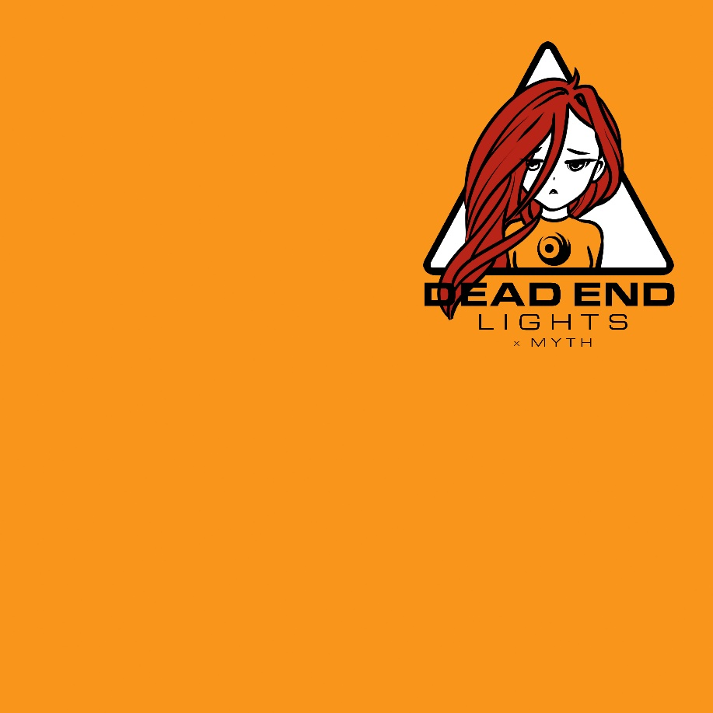

TRACKLISTING
- Dead End
- Outdoor Sports
- Batshit
- We Were Here [Remix]
- Fight Club [Remix]
- Up We Go [Remix]
- Almost Had Me [Remix]
- Savage [Remix]

###
CONNECT WITH LIGHTS:
WEBSITE
FACEBOOK
INSTAGRAM
TWITTER
YOUTUBE

Press Contact:
Sarah Goldstein
sarahgoldstein@elektra.com
212-707-2146

