LIGHTS SHARES NEW SINGLE “IN MY HEAD (FT. JOSH DUN)”
OFFICIAL VIDEO STREAMING NOW

NEW ALBUM PƎP ARRIVES APRIL 1ST

“BABY I’M BACK” NORTH AMERICAN HEADLINE TOUR
KICKS OFF APRIL 3 IN PORTLAND, OR

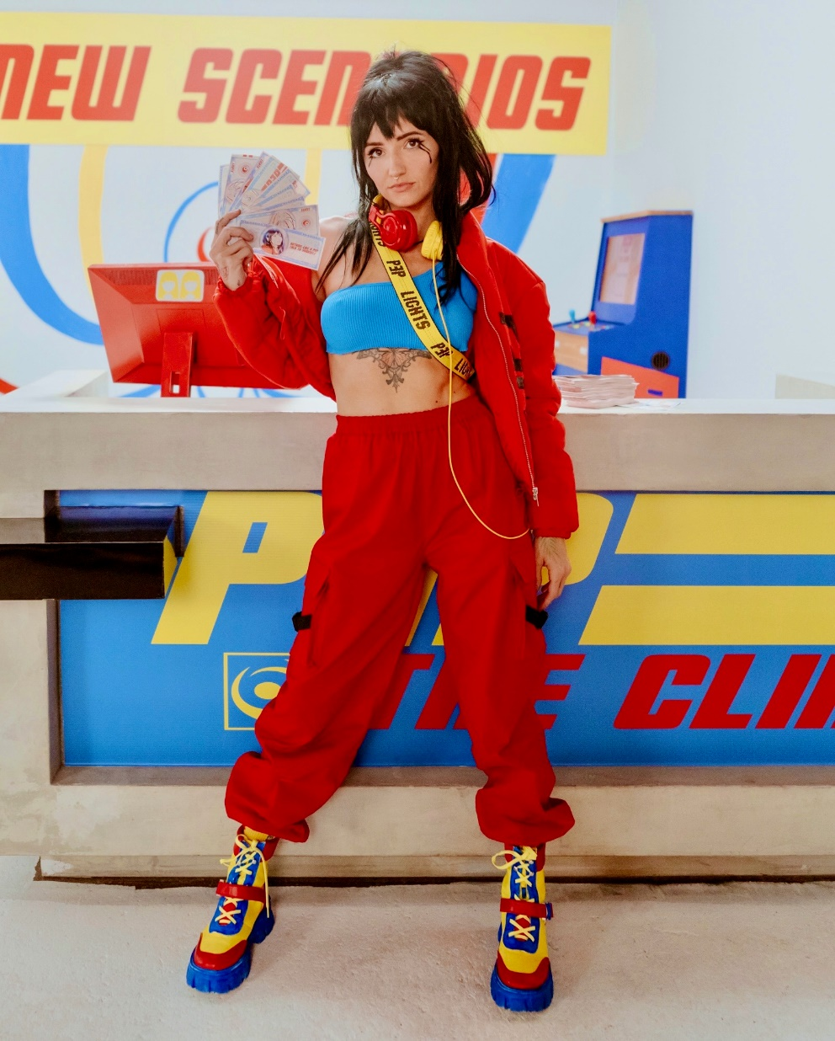

MARCH 17, 2022 – Alt-pop icon Lights has shared new single and video “In My Head (ft. Josh Dun).” The track, featuring drummer Josh Dun of Twenty One Pilots, premiered this morning via Consequence, who raved about the “anthemic” new song and praised the accompanying video which takes “…the unusual and avant garde to a new level.” The official video is streaming now on Lights’ official YouTube channel. Lights’ highly-anticipated new album PƎP arrives April 1st via Fueled By Ramen and is available for pre-order now.

Lights expanded on the single, “‘In My Head’ in a few words is about tuning out the chaos and the thousand voices telling us how to feel and act and look, and just doing things your way. The “In My Head” video is visually and conceptually the culmination of the previous three songs that I released leading up. The color scheme of PƎP is primary, so the first PƎP video (‘Prodigal Daughter’) was thematically red, ‘Real Thing (featuring Elohim)’ was blue, and ‘Salt and Vinegar’ was yellow. ‘In My Head’ was always meant to be all three, and it sums up the series conceptually as well.”

In celebration of the record, Lights’ “Baby I’m Back” North American headline tour will kick off April 3 in Portland, OR, making stops at The Fonda in Los Angeles and New York City’s Irving Plaza before wrapping up in Toronto, Ontario on May 7th (see attached tour itinerary). Tickets for all dates are available now. For more information, please visit www.iamlights.com.

Last month, the artist shared the hypnotic “Salt and Vinegar,” which EDM.com praised for “bringing [Lights’] artistic vision full circle.” In December, Lights shared the new track and video “Real Thing feat. Elohim.” The track followed her acclaimed fall single “Prodigal Daughter,” with Consequence attesting, “‘Prodigal Daughter’ is a driving, infectious pop cut that shows off Lights’ enigmatic and soulful voice… she’s never sounded so uninhibited.” Rock Sound celebrated the “vibrantly joyous” track and attested, “it's Lights at her most dominant, confident and unstoppable.”

Lights also shared “The Clinic,” a new side story based off Lights’ Skin&Earth comic series. Written and illustrated exclusively by Lights herself, the entire story is available to read now at www.visittheclinic.com.

About Lights:
Lights is many things all at once: Singer. Songwriter. Producer. Multi-instrumentalist. Comic book author. DJ. Artist. She’s also unabashedly honest and unapologetically confident. Weaving in and out of alternative, indie, electronic, and dance, she makes manic pop irreverent of boundaries, yet reverent of truth. She speaks her heart musically and her mind lyrically. It’s why her shadow over alternative music and culture continues to grow with streams in the hundreds of millions and widespread critical acclaim. Over the course of career thus far, the Canada-born disruptor has garnered four JUNO Awards, including 2020’s “Dance Recording of the Year” for the platinum smash “Love Me” with Felix Cartal and “Pop Album of the Year” for her previous two albums, Skin&Earth and Little Machines. She has sold out tours on multiple continents and powered collaborations with Travis Barker, deadmau5, Kaskade, Steve Aoki, Mike Shinoda of Linkin Park, and more. Now, she captivates like never before, kickstarting a new era with PƎP.

(Tour itinerary/album art/tracklisting below)

LIGHTS
2022 NORTH AMERICAN HEADLINE TOUR DATES
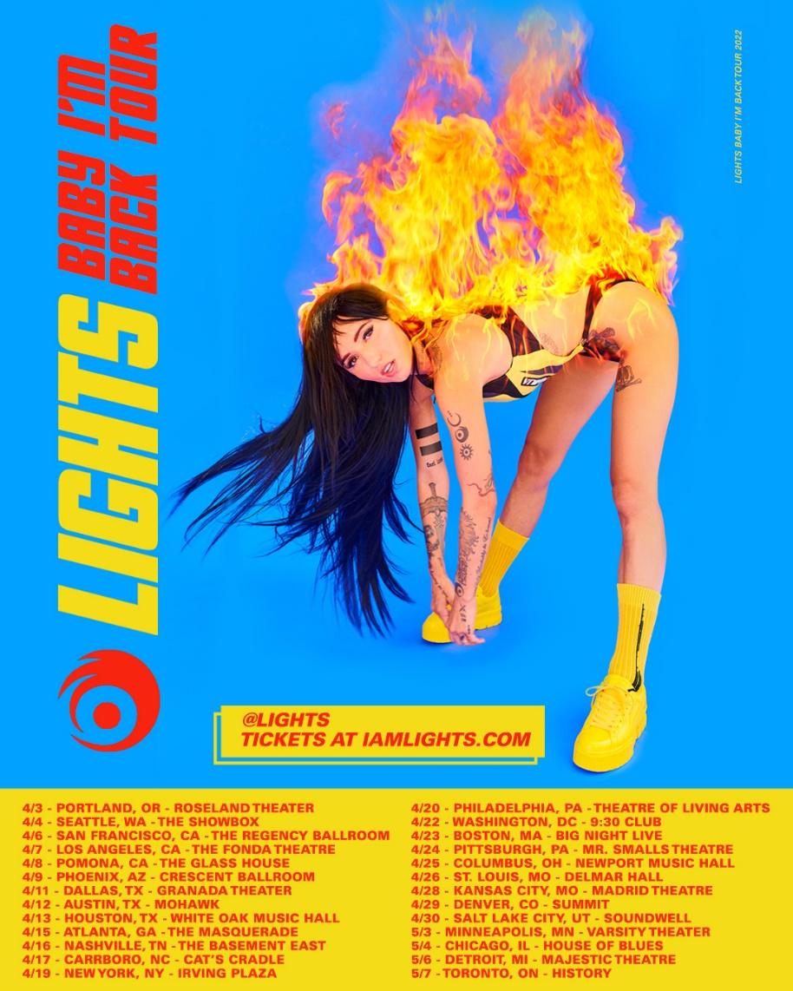

APRIL
3 Portland, OR Roseland Theater
4 Seattle, WA The Showbox
6 San Francisco, CA The Regency Ballroom
7 Los Angeles, CA The Fonda Theatre
8 Pomona, CA The Glass House
9 Phoenix, AZ Crescent Ballroom
11 Dallas, TX Granada Theater
12 Austin, TX Mohawk
13 Houston, TX White Oak Music Hall
15 Atlanta, GA The Masquerade
16 Nashville, TN The Basement East
17 Carrboro, NC Cat's Cradle
19 New York, NY Irving Plaza
20 Philadelphia, PA Theatre of Living Arts
22 Washington, DC 9:30 Club
23 Boston, MA Big Night Live
24 Pittsburgh, PA Mr. Smalls Theatre
25 Columbus, OH Newport Music Hall
26 St. Louis, MO Delmar Hall
28 Kansas City, MO Madrid Theatre
29 Denver, CO Summit
30 Salt Lake City, UT Soundwell

MAY
3 Minneapolis, MN Varsity Theater
4 Chicago, IL House of Blues Chicago
6 Detroit, MI Majestic Theatre
7 Toronto, ON History

LIGHTS
PƎP - ARRIVING APRIL 1ST
PREORDER NOW
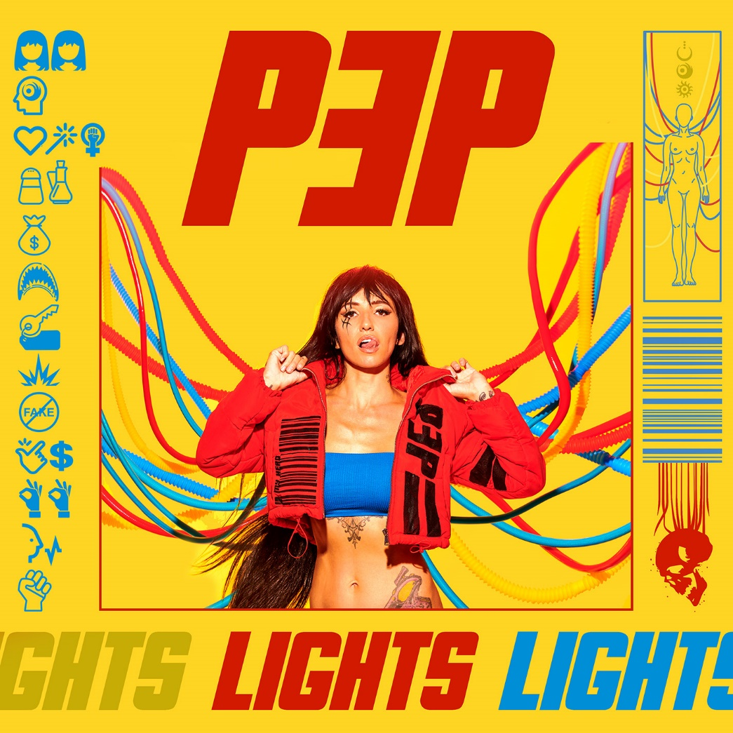

Tracklisting:
- Beside Myself
- In My Head (ft. Josh Dun)
- Prodigal Daughter
- Salt and Vinegar
- Money in the Bag (ft. Kiesza)
- Jaws
- Rent
- Sparky
- Real Thing (feat. Elohim)
- Easy Money
- Okay Okay
- Voices Carry
- Grip

###
CONNECT WITH LIGHTS:
WEBSITE
FACEBOOK
INSTAGRAM
TWITTER
YOUTUBE

Press Contact:
Sarah Goldstein
sarahgoldstein@elektra.com
212-707-2146

