LIGHTS x MYTH PRESENT
“DEAD END IN JOSHUA TREE”
PERFORMANCE STREAMING ON YOUTUBE NOVEMBER 18TH

DEAD END REMIX LP
AVAILABLE NOW
FEATURES THREE NEW ORIGINALS AND FIVE REIMAGINED HITS

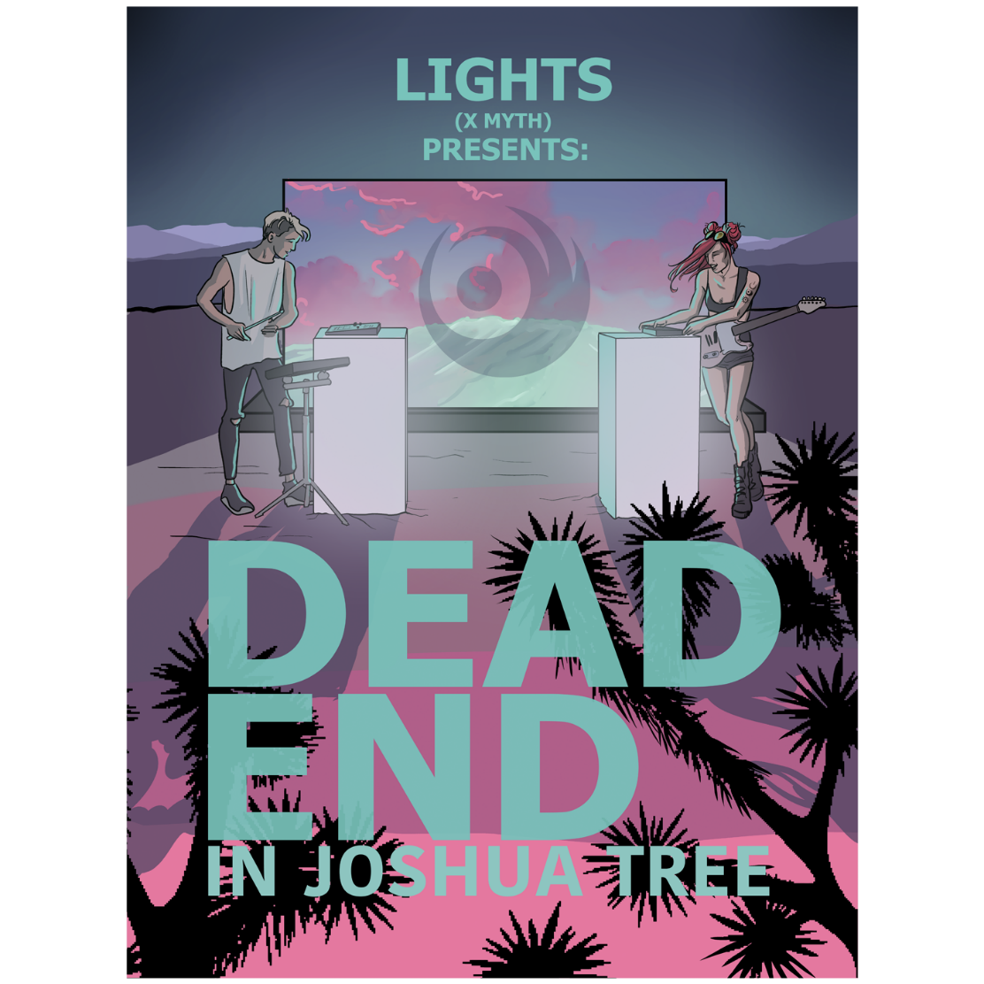

NOVEMBER 12TH – Lights x MYTH have announced “DEAD END In Joshua Tree,” a livestream performance premiering on Lights’ official YouTube channel November 18th at 8pm ET. Following the release of Lights’ Dead End remix LP this August, the artist prepped her first (and only) livestream event of the year – a continuous dance-mix Dead End set, shot from day to night with full LED production in the Joshua Tree desert. Lights shared a teaser clip of the performance, which fans can check out HERE.

Lights expanded on the event, stating, “I’ve never had the time or resources to build out an epic streamed show like this, but in a year when it’s the only option, we create moments and memories that will be markedly 2020. There were parts of the set that gave me chills in temperatures just shy of 100, like it was the first time I'd played in years."

Available now on all streaming platforms, the Dead End remix LP boasts three original tracks and five remixes (co-produced by Lights and MYTH) that completely reimagine fan favorites, including a new take on Lights’ platinum smash “Up We Go” (see attached tracklisting). Fans will recognize the dance-infused interpretations from their appearance in Lights x MYTH’s remix set on the US leg of deadmau5’s cubeV3 tour earlier this year.

Heralded by singles “Batshit” and “Dead End,” the title track has been praised by Billboard as “ridiculously catchy,” with Idolator attesting the single “perfectly straddles the pop and electronic worlds,” and EDM.com declaring “Dead End” is “an expertly crafted blend of pop and electronica with a chorus that will be locked in your head all day long.” Dead End continues Lights’ prolific hot streak this year, as she crosses genre boundaries and captivates listeners. In May, she unveiled AM 444, a collaborative EP with i_o—shared via mau5trap. She also took home her fourth JUNO Award, winning 2020’s “Dance Record of the Year” for the platinum smash “Love Me” with Felix Cartal. Earlier this year, Lights collaborated with Steve Aoki and Linkin Park’s Mike Shinoda on the track “Last One To Know,” featured on Aoki’s star-studded new album Neon Future IV.

Lights has boldly become an inescapable presence throughout pop, alternative, and electronic music. Over the course of her career, the artist has built an incredibly passionate fanbase – selling out tours around the world, racking up over 100M in U.S. streams and earning four JUNO Awards, including “Pop Album of the Year” for Skin&Earth, the Canadian singer’s fourth record and her most open and vulnerable to date. Along the way, she has collaborated with everyone from Travis Barker, deadmau5, and Steve Aoki to Mike Shinoda of Linkin Park, Kaskade, and more.

(Album art / tracklisting attached)

LIGHTS
DEAD END
AVAILABLE NOW

TRACKLISTING
- Dead End
- Outdoor Sports
- Batshit
- We Were Here [Remix]
- Fight Club [Remix]
- Up We Go [Remix]
- Almost Had Me [Remix]
- Savage [Remix]

###
CONNECT WITH LIGHTS:
WEBSITE
FACEBOOK
INSTAGRAM
TWITTER
YOUTUBE

Press Contact:
Sarah Goldstein
sarahgoldstein@elektra.com
212-707-2146

