LIGHTS ANNOUNCES NEW ALBUM PEP
RECORD ARRIVES APRIL 1ST

NEW TRACK AND OFFICIAL VIDEO
“SALT AND VINEGAR” STREAMING NOW
WATCH HERE

“BABY I’M BACK” NORTH AMERICAN HEADLINE TOUR
KICKS OFF APRIL 3 IN PORTLAND, OR

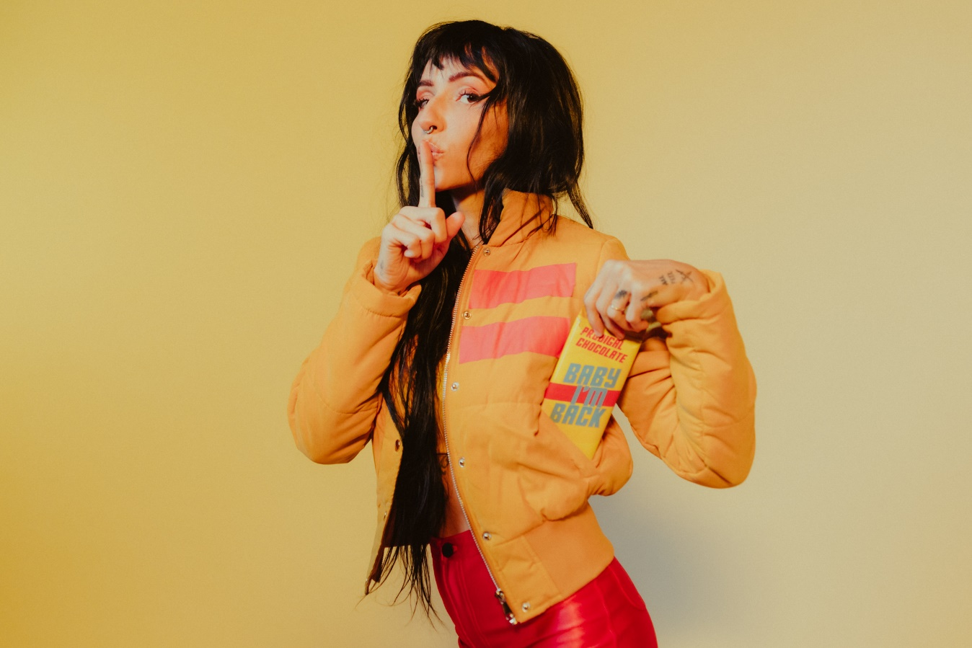

FEBRUARY 4, 2022 – Alt-pop icon Lights has announced her highly-anticipated new album PEP, arriving April 1st. The news is heralded by the release of hypnotic new track “Salt and Vinegar,” which is accompanied by an official music video streaming now on Lights’ official YouTube channel. PEP is available for pre-order now via Fueled By Ramen.

Lights expanded, “I’ve never understood the task more than I did when I was making this record. My vision feels complete, and every single component comes from this very intense evolution I’ve experienced in my personal life over the last few years.” She adds, “We’re all products, we all market ourselves every single day. The idea behind ‘PEP’ is if you’re going to brand yourself, then brand yourself to happiness.”

In celebration of the record, Lights’ “Baby I’m Back” North American headline tour will kick off April 3 in Portland, OR, making stops at The Fonda in Los Angeles and New York City’s Irving Plaza before wrapping up in Toronto, Ontario on May 7th (see attached tour itinerary). Tickets for all dates are available now. For more information, please visit www.iamlights.com.

In December, Lights shared the new track and video “Real Thing feat. Elohim.” The track followed fall single “Prodigal Daughter,” which drew praise from Consequence, who raved, “‘Prodigal Daughter’ is a driving, infectious pop cut that shows off Lights’ enigmatic and soulful voice… she’s never sounded so uninhibited.” Rock Sound celebrated the “vibrantly joyous” track and attested, “it's Lights at her most dominant, confident and unstoppable.”

Lights also shared “The Clinic,” a new side story based off Lights’ Skin&Earth comic series. Written and illustrated exclusively by Lights herself, the entire story is available to read now at www.visittheclinic.com.

(Tour itinerary and album art/tracklisting below)

LIGHTS
2022 NORTH AMERICAN HEADLINE TOUR DATES
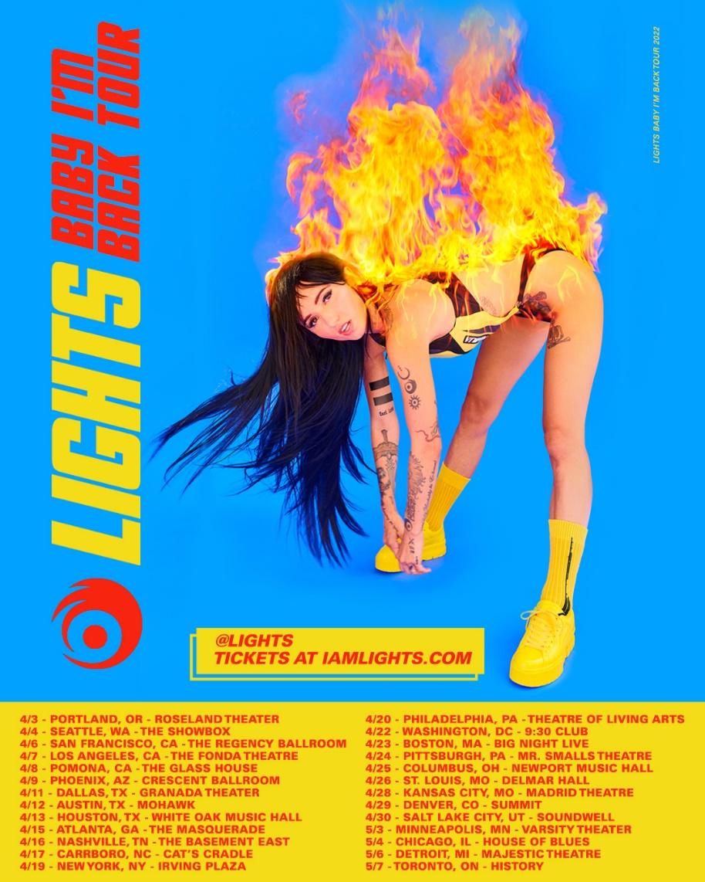

APRIL
3 Portland, OR Roseland Theater
4 Seattle, WA The Showbox
6 San Francisco, CA The Regency Ballroom
7 Los Angeles, CA The Fonda Theatre
8 Pomona, CA The Glass House
9 Phoenix, AZ Crescent Ballroom
11 Dallas, TX Granada Theater
12 Austin, TX Mohawk
13 Houston, TX White Oak Music Hall
15 Atlanta, GA The Masquerade
16 Nashville, TN The Basement East
17 Carrboro, NC Cat's Cradle
19 New York, NY Irving Plaza
20 Philadelphia, PA Theatre of Living Arts
22 Washington, DC 9:30 Club
23 Boston, MA Big Night Live
24 Pittsburgh, PA Mr. Smalls Theatre
25 Columbus, OH Newport Music Hall
26 St. Louis, MO Delmar Hall
28 Kansas City, MO Madrid Theatre
29 Denver, CO Summit
30 Salt Lake City, UT Soundwell

MAY
3 Minneapolis, MN Varsity Theater
4 Chicago, IL House of Blues Chicago
6 Detroit, MI Majestic Theatre
7 Toronto, ON History

LIGHTS
PEP - ARRIVING APRIL 1ST
PREORDER NOW
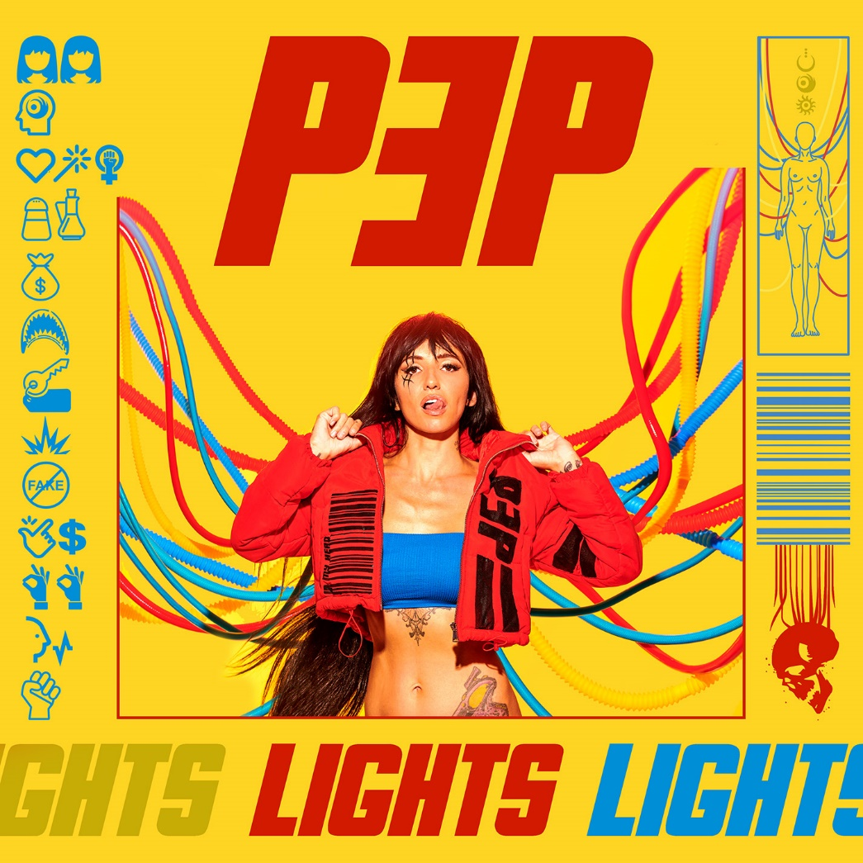

Tracklisting:
- Beside Myself
- In My Head
- Prodigal Daughter
- Salt and Vinegar
- Money in the Bag
- Jaws
- Rent
- Sparky
- Real Thing (feat. Elohim)
- Easy Money
- Okay Okay
- Voices Carry
- Grip

###
CONNECT WITH LIGHTS:
WEBSITE
FACEBOOK
INSTAGRAM
TWITTER
YOUTUBE

Press Contact:
Sarah Goldstein
sarahgoldstein@elektra.com
212-707-2146

