LIGHTS DEBUTS NEW ALBUM PƎP
LISTEN HERE

“BABY I’M BACK” NORTH AMERICAN HEADLINE TOUR
KICKS OFF THIS WEEKEND

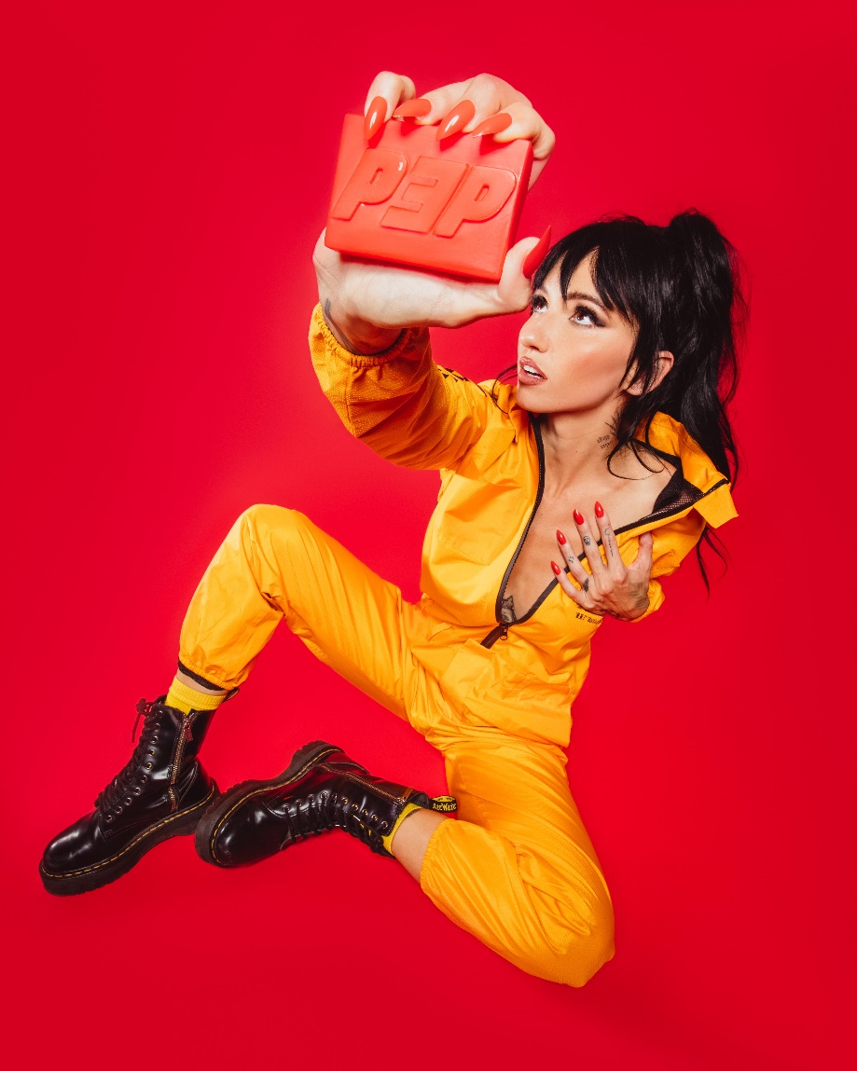

APRIL 1, 2022 – Alt-pop icon Lights has debuted her highly anticipated new album PƎP. The album has already received early praise from NPR, who lauded the collection’s “insanely catchy hooks” and tipped the artist as “ready for world domination.” The 13-track record is available now via Fueled By Ramen.

In celebration of the release, Lights’ “Baby I’m Back” North American headline tour kicks off this Sunday in Portland, OR. The trek will make stops at The Fonda in Los Angeles and New York City’s Irving Plaza before wrapping up in Toronto, Ontario on May 7th (see attached tour itinerary). Tickets for all dates are available now. For more information and VIP packages, please visit www.iamlights.com.

PƎP was heralded by early singles “In My Head (ft. Josh Dun),” “Salt and Vinegar,” “Real Thing feat. Elohim,” “Prodigal Daughter.” The tracks have racked up praise, with “In My Head (ft. Josh Dun),” premiering via Consequence, who raved about the “anthemic” new song and praised the accompanying video which takes “…the unusual and avant garde to a new level.” EDM.com celebrated “Salt and Vinegar” for “bringing [Lights’] artistic vision full circle,” while Consequence attested single “Prodigal Daughter” “…is a driving, infectious pop cut that shows off Lights’ enigmatic and soulful voice… she’s never sounded so uninhibited.” Rock Sound hailed the “vibrantly joyous” track and asserted, “it's Lights at her most dominant, confident and unstoppable.”

Lights is celebrating release weekend with a PƎP themed installation at Vancouver, BC’s famous “dankest bodega,” Dank Mart. Fans were granted early access to purchase physical copies of the album, while posing in Lights’ famed “Salt and Vinegar” vending machine, constructed by Lights herself.

Lights also shared “The Clinic,” a new side story based off Lights’ Skin&Earth comic series. Written and illustrated exclusively by Lights herself, the entire story is available to read now at www.visittheclinic.com.

About Lights:
Lights is many things all at once: Singer. Songwriter. Producer. Multi-instrumentalist. Comic book author. DJ. Artist. She’s also unabashedly honest and unapologetically confident. Weaving in and out of alternative, indie, electronic, and dance, she makes manic pop irreverent of boundaries, yet reverent of truth. She speaks her heart musically and her mind lyrically. It’s why her shadow over alternative music and culture continues to grow with streams in the hundreds of millions and widespread critical acclaim. Over the course of career thus far, the Canada-born disruptor has garnered four JUNO Awards, including 2020’s “Dance Recording of the Year” for the platinum smash “Love Me” with Felix Cartal and “Pop Album of the Year” for her previous two albums, Skin&Earth and Little Machines. She has sold out tours on multiple continents and powered collaborations with Travis Barker, deadmau5, Kaskade, Steve Aoki, Mike Shinoda of Linkin Park, and more. Now, she captivates like never before, kickstarting a new era with PƎP.

(Tour itinerary/album art/tracklisting below)

LIGHTS
2022 NORTH AMERICAN HEADLINE TOUR DATES
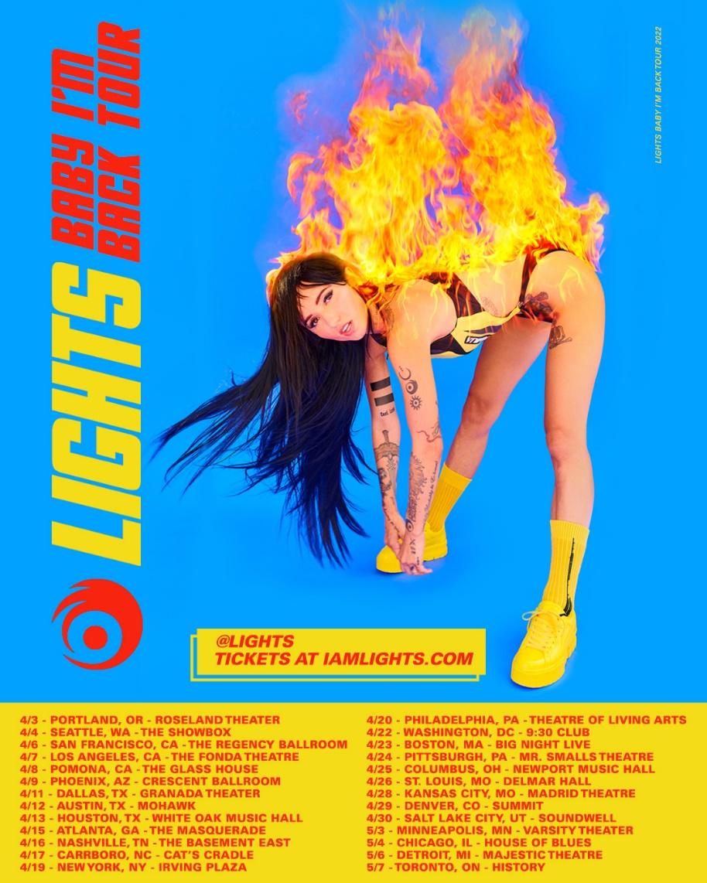

APRIL
3 Portland, OR Roseland Theater
4 Seattle, WA The Showbox
6 San Francisco, CA The Regency Ballroom
7 Los Angeles, CA The Fonda Theatre
8 Pomona, CA The Glass House
9 Phoenix, AZ Crescent Ballroom
11 Dallas, TX Granada Theater
12 Austin, TX Mohawk
13 Houston, TX White Oak Music Hall
15 Atlanta, GA The Masquerade
16 Nashville, TN The Basement East
17 Carrboro, NC Cat's Cradle
19 New York, NY Irving Plaza
20 Philadelphia, PA Theatre of Living Arts
22 Washington, DC 9:30 Club
23 Boston, MA Big Night Live
24 Pittsburgh, PA Mr. Smalls Theatre
25 Columbus, OH Newport Music Hall
26 St. Louis, MO Delmar Hall
28 Kansas City, MO Madrid Theatre
29 Denver, CO Summit
30 Salt Lake City, UT Soundwell

MAY
3 Minneapolis, MN Varsity Theater
4 Chicago, IL House of Blues Chicago
6 Detroit, MI Majestic Theatre
7 Toronto, ON History

LIGHTS
PƎP
AVAILABLE NOW
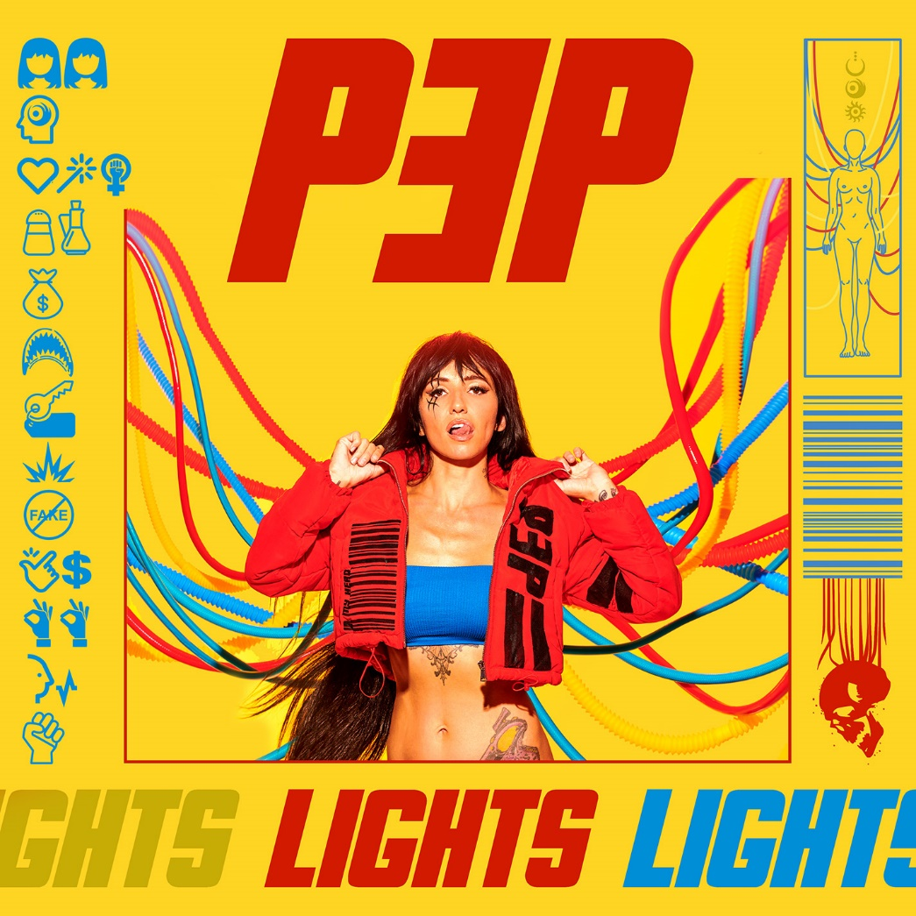

Tracklisting:
- Beside Myself
- In My Head (ft. Josh Dun)
- Prodigal Daughter
- Salt and Vinegar
- Money in the Bag (ft. Kiesza)
- Jaws
- Rent
- Sparky
- Real Thing (feat. Elohim)
- Easy Money
- Okay Okay
- Voices Carry
- Grip

###
CONNECT WITH LIGHTS:
WEBSITE
FACEBOOK
INSTAGRAM
TWITTER
YOUTUBE

Press Contact:
Sarah Goldstein
sarahgoldstein@elektra.com
212-707-2146

