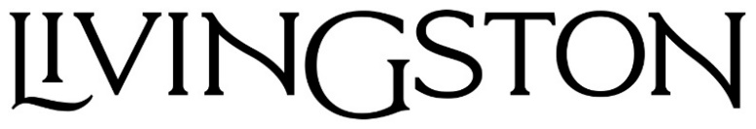
RETURNS WITH NEW SINGLE “THE AUTHOR”
OFFICIAL LYRIC VIDEO STREAMING NOW

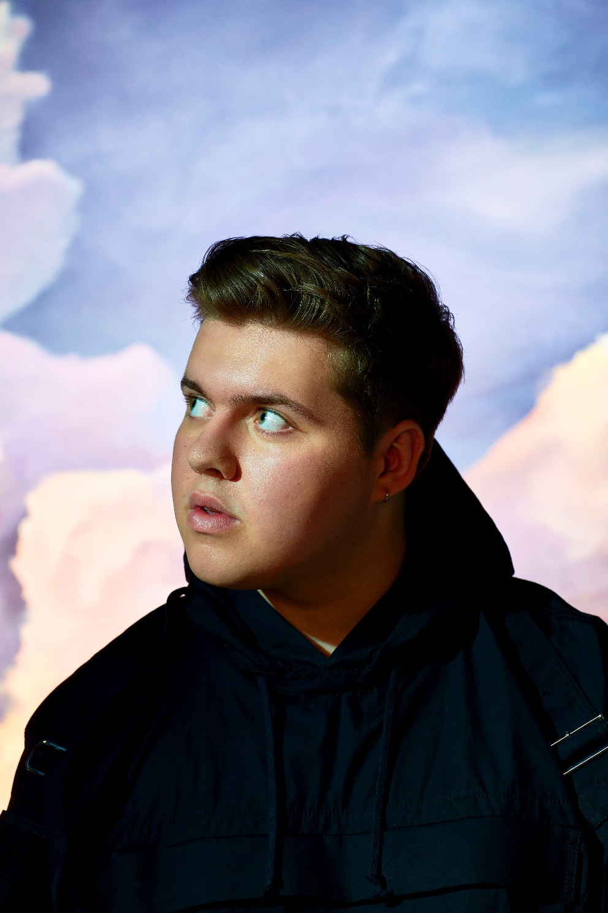
MAY 25, 2022 – After racking up nearly 100 million global streams and over 2 million followers on Tik Tok, rising artist Livingston has returned with highly anticipated new single “The Author.” The infectious track is bolstered by Livingston’s soaring vocals and arrives alongside an official lyric video, which is streaming now on the artist’s official YouTube channel. “The Author” is available now on all streaming services via Elektra Records.
Livingston expanded on the single, “This song is the moment I fell in love for the first time. It’s the feeling of not caring how far I have to go or how much I have to lose. I was 13 when I locked eyes with someone who made me feel that way, and it was the first time I felt like I would risk a life I was comfortable with to have even the most dangerous life with them. There’s something really beautiful about being so young and not having an agenda – you just meet someone that makes you truly see the world in a new way, and any walls you have built up just shatter into pieces. As I’ve gotten older, I’ve become more scared to love purely – because someday love will mean loss. This song takes me back to a time when I just didn’t care; when a feeling could be permanent, instant, and so idiotic – that to actually believe in it you have to be completely fearless.”
In the fall, Livingston was featured on Louis The Child’s track “Hole In My Heart.” Dancing Astronaut praised Livingston’s “velvety vocals,” while YourEDM crowned the single a “vibrant heartbreak anthem.” Prior to the collaboration, the 19-year-old shared single “Message In A Bottle” and made his live performance debut supporting Fitz and the Tantrums on select dates. The dates followed the release of his sophomore EP, An Unlikely Origin Story, which was heralded by singles “The Giver,” “Hercules,” and “Superkid.” “Hercules” – a song about fearing change and embracing vulnerability – was co-produced by Jorgen Odegard (Justin Bieber, Yungblud, Quinn XCII, Imagine Dragons) and co-written by Odegard and Chloe George. The track followed single “Superkid,” which was accompanied by a powerful visual written and directed by Livingston himself.
In 2020, the self-taught singer, songwriter, producer and engineer shared his debut EP Lighthouse, praised as “uplifting and inspiring” by PopularTV and earning Livingston the title of “pop star in the making” from Ones To Watch. The eight-track collection is available now at all DSPs via Elektra Records and features standout track “Carnival” in addition to singles “Home,” “Say The Word,” and “Fairytale” – the latter of which was shared by Billboard alongside the artist’s Elektra Records signing announcement.
Growing up in Denton, Texas, Livingston was faced with bullying, anxiety, and relentless self-doubt. Throughout his childhood, he struggled to fit in and faced a constant battle to find his place in the world – finally finding the connection and understanding he sought when he poured his feelings of loneliness, isolation and inadequacy into song. Drawing inspiration for his “orchestral cinematic pop” from a wide range of artists in pop, hip hop and film scores, Livingston combines instantly memorable melodies with sweeping orchestral compositions and is first and foremost driven by honest storytelling.

[Single art below]

###

LIVINGSTON
“The Author”
AVAILABLE NOW
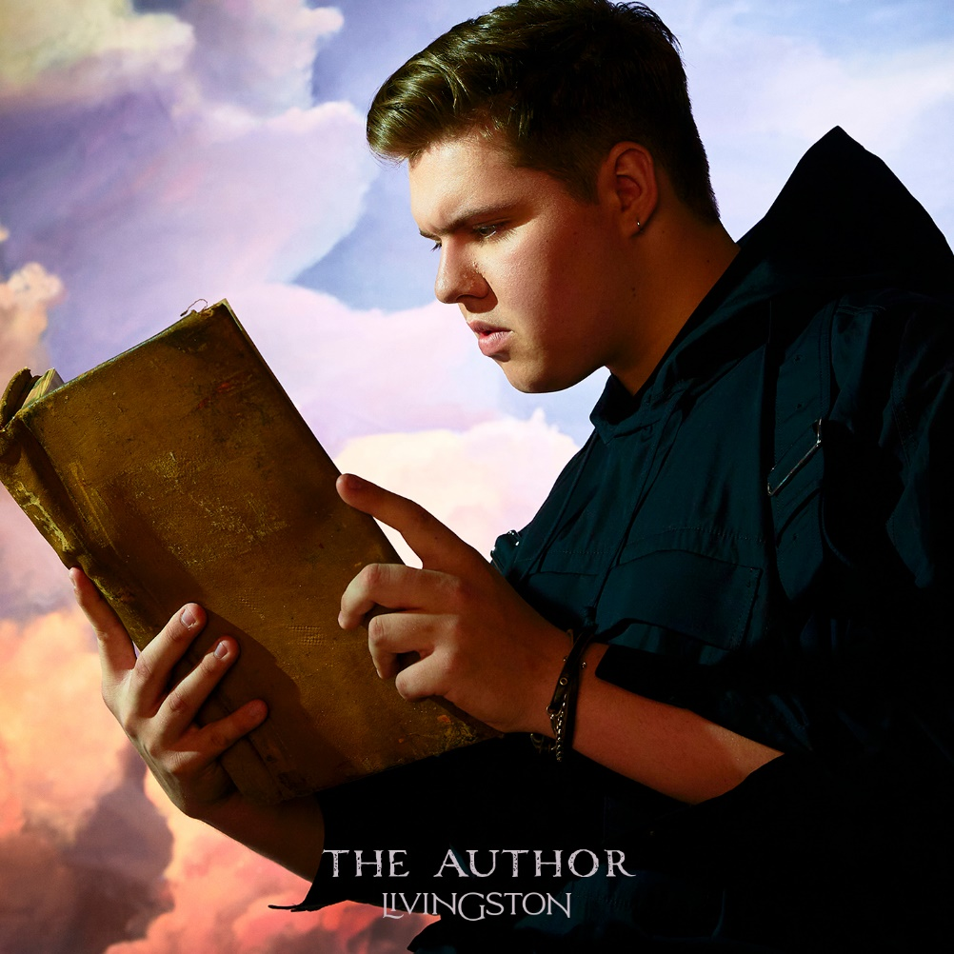

CONNECT WITH Livingston
www.livingstonofficial.com
TIK TOK
YOUTUBE
INSTAGRAM
TWITTER
FACEBOOK

CONTACT:
Sarah Goldstein
SarahGoldstein@elektra.com

