DEBUTS NEW SINGLE “THE GIVER”

NEW EP AN UNLIKELY ORIGIN STORY ARRIVING MAY 14TH
AVAILABLE FOR PREORDER NOW

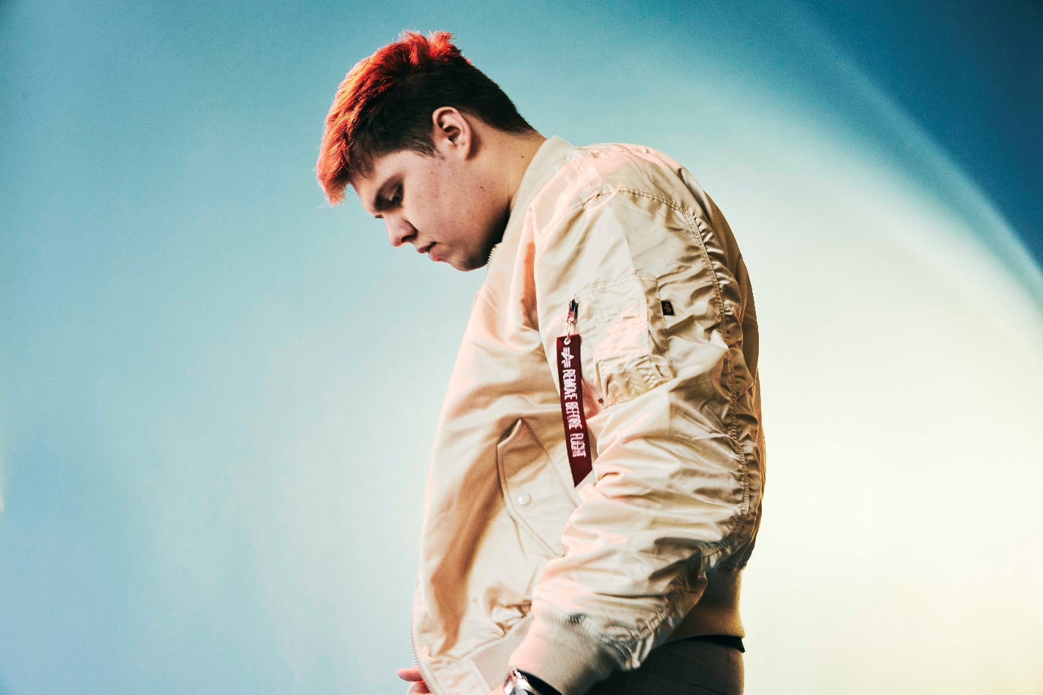

APRIL 7, 2021 – Elektra Records artist Livingston has debuted new single “The Giver,” ahead of his upcoming EP, An Unlikely Origin Story, set for release on May 14th. “The Giver” is available now on all streaming platforms and fans can preorder An Unlikely Origin Story HERE.
Livingston expanded on the track, "‘The Giver’ is a song about feeling like you don’t deserve to be loved – and looking at the one who chooses to love you, despite your flaws, and questioning why they still stand by your side. To me personally, it’s a song about accepting my past and realizing that love is not an expectation of perfection, but to grow alongside another person that’s just as broken as I am. Learning to accept change and to move on from the past is a huge part of my next EP, so I’m excited to lead with it on this next song."
In March, the artist shared “Hercules” – a song about fearing change and embracing vulnerability – co-produced by Jorgen Odegard (Justin Bieber, Yungblud, Quinn XCII, Imagine Dragons) and co-written by Odegard and Chloe George. The track followed December single “Superkid,” which is accompanied by a powerful visual written and directed by Livingston himself. Livingston has racked up over 25 million streams on DSPs and nearly 2 million followers on Tik Tok all in less than year – cementing his status as an artist on the rise.
Last summer, the self-taught singer, songwriter, producer and engineer shared his debut EP Lighthouse, praised as “uplifting and inspiring” by PopularTV and earning Livingston the title of “pop star in the making” from Ones To Watch. The eight-track collection is available now at all DSPs via Elektra Records and features standout track “Carnival” in addition to singles “Home,” “Say The Word,” and “Fairytale” – the latter of which was shared by Billboard alongside the artist’s Elektra Records signing announcement.
Growing up in Denton, Texas, Livingston was faced with bullying, anxiety, and relentless self-doubt. Throughout his childhood, he struggled to fit in and faced a constant battle to find his place in the world – finally finding the connection and understanding he sought when he poured his feelings of loneliness, isolation and inadequacy into song. Drawing inspiration for his “orchestral cinematic pop” from a wide range of artists in pop, hip hop and film scores, Livingston combines instantly memorable melodies with sweeping orchestral compositions and is first and foremost driven by honest storytelling.

[EP Art + Tracklisting Below]

LIVINGSTON
AN UNLIKELY ORIGIN STORY EP
PREORDER NOW
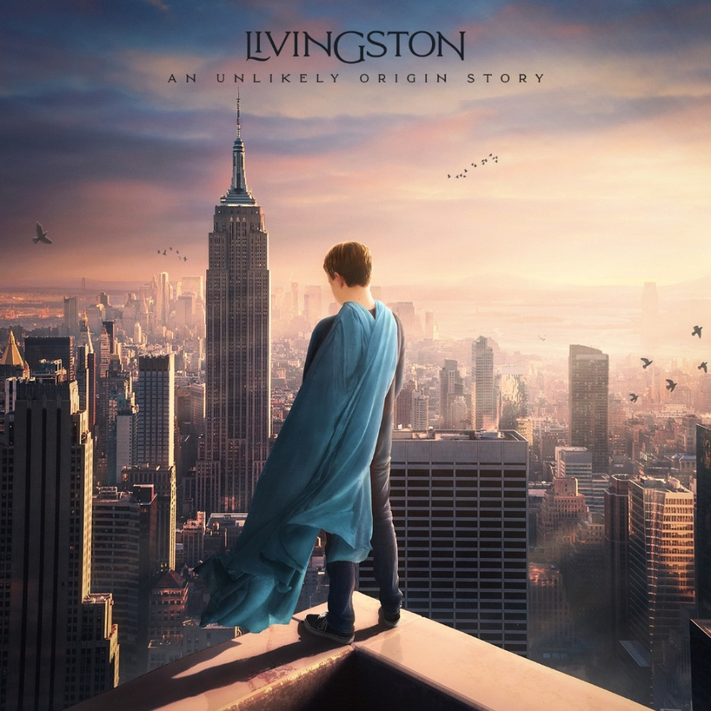

Tracklisting:
- Superkid
- The Giver
- Hercules
- Echo
- Atlas
- Icarus
- Toy Soldier

CONNECT WITH Livingston
www.livingstonofficial.com
TIK TOK
YOUTUBE
INSTAGRAM
TWITTER
FACEBOOK

CONTACT:
Sarah Goldstein
SarahGoldstein@elektra.com
212-707-2146

