FOR IMMEDIATE RELEASE
MAY 7, 2021

MASKED WOLF ENLISTS SUPERSTARS G-EAZY & DDG
FOR SPECIAL REMIX OF HIS GLOBAL SMASH

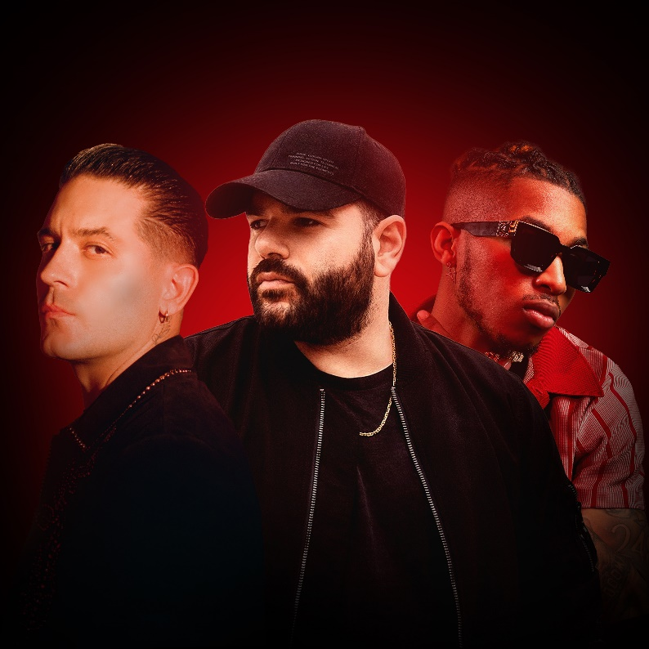

“ASTRONAUT IN THE OCEAN” (REMIX) FEAT. G-EAZY & DDG
ARRIVES TODAY
LISTEN HERE

AUSTRALIAN RAPPER’S BREAKOUT SINGLE
“ASTRONAUT IN THE OCEAN” HAS ALREADY HIT #1 IN 6 COUNTRIES AROUND THE WORLD WITH OVER HALF A BILLION STREAMS TO DATE

WORLD TELEVISION DEBUT PERFORMANCE ON
“THE TONIGHT SHOW STARRING JIMMY FALLON”
WATCH HERE

DOWNLOAD PRESS ASSETS HERE

Elektra recording artist Masked Wolf has enlisted superstars G-Eazy and DDG for a special re-imagining of his global smash. “Astronaut In The Ocean” (remix) feat. G-Eazy & DDG arrives today at all streaming services. Listen HERE.

Masked Wolf explains: “I’ve always wanted to do a remix of Astro, but it had to be right. The song means a lot to me so I really thought about who I wanted on it. As soon as I heard DDG on ‘Moonwalking,’ I was like, ‘I need this guy.’ He’s so talented and I knew he would rip a crazy verse. I’m a huge fan of G-Eazy, and, sonically, he fits the song perfectly - he just has that swag about him, but can also talk about real things too.”

DDG adds: “The song is so fire. I heard it like 6 months ago and was like, ‘Damn, I gotta hop on it.’ My boy Masked Wolf is going crazy and is the next big superstar up fasho. I’m honored to be a part of such a big record.”

The Australian rapper’s breakout single – also available now on all streaming platforms - has already amassed over half a billion streams to date, and climbed to #1 in 6 countries around the world. In the U.S.. “Astronaut In The Ocean” currently sits at #8 on Billboard’s Hot 100, and is quickly proving to be a multi-format success at radio, hitting the Top 15 at both Rhythmic and Pop, and Top 30 at Hot AC. Meanwhile, the official music video has logged over 100 million views on YouTube alone. Last month, Masked Wolf made his world television debut with an epic performance on NBC’s “The Tonight Show Starring Jimmy Fallon.” The collaboration with G-Eazy and DDG arrives on the heels of the release of Brazilian superstar Alok’s remix of “Astronaut In The Ocean.”

Look out for much more to come from Masked Wolf in 2021.

About MASKED WOLF:
Transforming from a mild-mannered man by day into an unrestrained beast in the studio, Masked Wolf (aka, Harry Michael) has unassumingly established himself as a powerful, passionate, and primal hip-hop force. After graduating from school, the Sydney, Australia native tirelessly worked in sales to fund recording. He even took out a loan to build a home studio as he cut hundreds of songs and logged thousands of hours in the lab. In 2018, he dropped his independent debut “Speed Racer.” It gathered millions of streams and turned heads across Australia. Following “Night Rider” and “Water Walkin,” he unveiled “Astronaut in the Ocean.” Awash in airy guitar, jagged 808s, neon keys, and deft wordplay, he submerged himself in honest lyricism, facing depression head-on. That one-two-punch of a recognizable riff and chantable chorus organically caught fire online. It quickly incited 350,000-plus Tik Tok videos, spanning everything from footage of U.S. military Blackhawk chopper crews to welders and ice fisherman (far from your typical Tik Tok fare!). Meanwhile, Kansas City Chief Super Bowl champ quarterback Patrick Mahomes even incorporated the tune into an Instagram post, fueling its explosion in early 2021. Amassing streams in the hundreds of millions and counting , the buzzing rapper and singer unleashes a torrent of personal truths and emotions on his 2021 debut for Elektra Records and more to come.

About G-EAZY:
Multi-platinum recording artist and producer G-Eazy has established himself as a leading force in the music and touring world. His third full-length studio album The Beautiful & Damned (2017) debuted at No. 3 on the Billboard 200, garnered two No. 1 radio hits – “No Limit” ft. A$AP Rocky & Cardi B and “Him & I” ft. Halsey – and has since been certified platinum by the RIAA. The 5x platinum single “No Limit” has been streamed over 1 billion times worldwide to date. The Beautiful & Damned followed his platinum-certified sophomore album When It’s Dark Out (2015), which featured the 5x platinum single “Me, Myself & I” with Bebe Rexha.

Known for his smooth raps, pristine production and dexterous range, the Bay-area rapper has performed on Saturday Night Live, MTV Video Music Awards, The Tonight Show Starring Jimmy Fallon, Jimmy Kimmel Live! and many more. He has won a People’s Choice Award for “Favorite Hip-Hop Artist”, named one of Forbes “30 Under 30” and covered publications such as GQ Italia, XXL, Flaunt and Rollacoaster. Additionally, he will continue his partnership with PUMA, recently announcing their first collaborative shoe is in the works. PUMA will also continue to support his philanthropy, The Endless Summer Fund – a non-profit dedicated to helping Bay Area under-served youth reach their full potential and strengthening the community – and their joint program, “From The Bay to the Universe” in which G-Eazy selects a group of developing musicians to support their artistic efforts.

About DDG:
DDG’s story remains a rarity for rap. The high school valedictorian turned himself into a self-made multi-millionaire by hustling on YouTube as he simultaneously rapped his way to the forefront of hip-hop. However, he consistently shakes up the status quo with unpredictable and undeniable bangers. After 2018’s Take Me Serious, he rose to the top of the hip-hop class on VALEDICTORIAN. Within just a year, the single “ARGUMENTS” scored his first gold certification. Igniting 2020, he achieved a major breakthrough with the gold certified record “Moonwalking In Calabasas (Remix)” [feat. BLUEFACE], earning a ubiquitous hit and his second gold plaque in the process. In the aftermath, he appeared in features by the likes of Esquire and more, while Lyrical Lemonade professed him to be a “Rap Star in the Making.” Generating over half-a-billion total streams and views and building a rabid fan base, DDG’s influence proves downright inescapable. His story has only just begun to get really interesting.

Connect with MASKED WOLF

YouTube
Instagram
Twitter
Facebook
MaskedWolf.com

CONTACT:

Glenn Fukushima
Elektra Music Group
GlennFukushima@elektra.com

