MASKED WOLF UNVEILS NEW SINGLE “MADHOUSE” FEATURING MIKE POSNER
LISTEN HERE | WATCH THE VISUALIZER HERE
“MADHOUSE” ADDS TO MASKED WOLF’S IMPRESSIVE ROSTER OF COLLABORATIONS WITH G-EAZY, BRING ME THE HORIZON, BEBE REXHA, ALEX GASKARTH & MORE
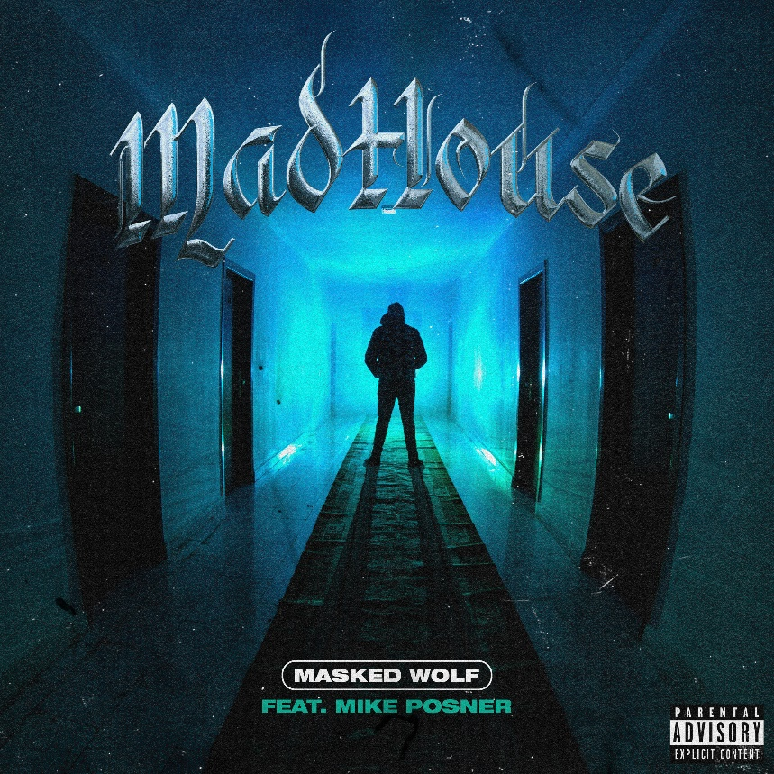
DOWNLOAD HI-RES ARTWORK HERE
MASKED WOLF PRESS ASSETS HERE

(July 22, 2022) – LOS ANGELES, CA) – Multi-Platinum hip-hop artist Masked Wolf today unveiled his new single “Madhouse” featuring GRAMMY® Award-nominated, multi-Platinum artist, songwriter, and producer Mike Posner. The song is available now on all streaming services, along with an official visualizer. Blending electro-infused beats and dark sonic undertones, the song continues to underscore why the two artists are among the most sought-after collaborators in the industry. Masked Wolf has teamed up with a diverse array of acts such as G-Eazy, Bring Me the Horizon, Bebe Rexha, Alex Gaskarth (of All Time Low), and more, while Posner has collaborated with a number of industry staples including Justin Bieber, Maroon 5, Big Sean, Nick Jonas, and more.
Following the success of the Australian rapper’s debut 17-track mixtape Astronomical – which includes the RIAA Certified double-Platinum smash “Astronaut In The Ocean” – Masked Wolf earned three nominations at this year’s Billboard Music Awards including “Top New Artist,” “Top Viral Song,” and “Top Rap Song.” “Astronaut In The Ocean” continues to be a worldwide phenomenon, surpassing one billion global streams to date, not to mention becoming the eighth most-consumed song of 2021.
Masked Wolf made his world television debut last year with a stellar performance of “Astronaut In The Ocean” on The Tonight Show Starring Jimmy Fallon, followed by his first primetime television appearance of the song on The Voice and then on The Kelly Clarkson Show. He also performed Astronomical standout track “Pandemonium” on Jimmy Kimmel Live! and on Dick Clark’s New Year’s Rockin’ Eve with Ryan Seacrest.
About MASKED WOLF:
Transforming from a mild-mannered man by day into an unrestrained beast in the studio, Masked Wolf (aka, Harry Michael) has unassumingly established himself as a powerful, passionate, and primal hip-hop force. After graduating from school, the Sydney, Australia native tirelessly worked in sales to fund recording. He even took out a loan to build a home studio as he cut hundreds of songs and logged thousands of hours in the lab. In 2018, he dropped his independent debut “Speed Racer.” It gathered millions of streams and turned heads across Australia. Following “Night Rider” and “Water Walkin,” he unveiled “Astronaut In The Ocean.” Awash in airy guitar, jagged 808s, neon keys, and deft wordplay, he submerged himself in honest lyricism, facing depression head-on. Re-released via Elektra Records at the top of 2021, “Astronaut In The Ocean” has become a global phenomenon, amassing over one BILLION streams and hitting #1 in 8 countries around the world.
About MIKE POSNER:
Since 2009, multi-platinum singer and songwriter Mike Posner has quietly become one of the world’s most successful and recognizable voices. In addition to being nominated for the 2017 GRAMMY® Award for “Song of The Year,” Mike Posner songs have been streamed over 10 billion times globally and he’s amassed 30 platinum certifications. In addition to his own music, Mike has written hit songs for some of the world’s biggest artists including Maroon 5’s nine-times platinum “Sugar,” Justin Bieber’s 6-times platinum “Boyfriend,” and Labrinth ft. Emeli Sandé ‘s “Beneath Your Beautiful.” In 2019, Mike walked almost 3,000 miles across the continent of North America, got bit by a rattlesnake along the way and still completed the cross country trek. While walking across America, Mike set his sights on his next challenge, summiting Mount Everest. On June 1st, 2021, Mike made it to the peak of the highest mountain in the world, while raising over $250,000 for the Detroit Justice Center. Earlier this year, Mike became a certified Wim Hof Method instructor. Mike said, “sharing this practice has become one of the most fulfilling and beautiful parts of my life”. Now, Mike kicks off the next era with “Home” and “Turn Up” with more new music to come in 2022 via Arista Records.

Connect with MASKED WOLF:
MaskedWolf.com
YouTube
Instagram
Twitter
Facebook

Connect with MIKE POSNER:
Website
YouTube
Instagram
Twitter
Facebook
TikTok

# # #

MEDIA CONTACTS FOR MASKED WOLF:
Glenn Fukushima
Glenn.Fukushima@300Elektra.com

Nathalie Rubin
Nathalie.Rubin@300Elektra.com
MEDIA CONTACT FOR MIKE POSNER:
Nadia Ali
nadia.ali@aristarecordings.com

