FOR IMMEDIATE RELEASE
AUGUST 12, 2021

MASKED WOLF RELEASES NEW TRACK “BOP”
ALONGSIDE OFFICIAL MUSIC VIDEO
LISTEN HERE
WATCH HERE

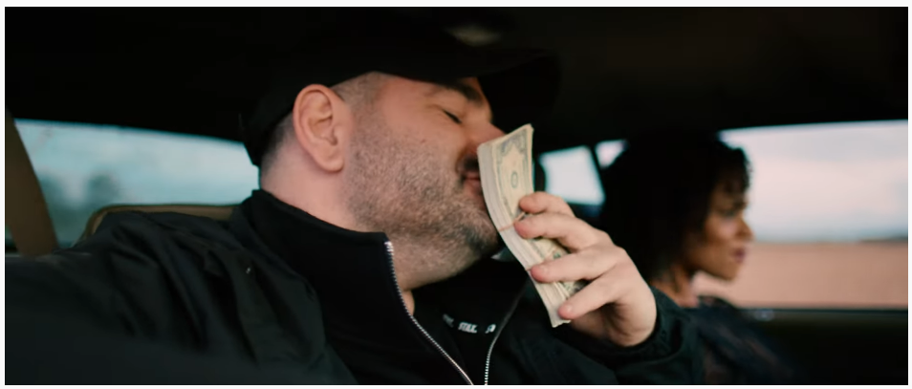

LATEST SINGLE “SAY SO” FOLLOWS THE AUSTRALIAN RAPPER’S BREAKOUT HIT “ASTRONAUT IN THE OCEAN”

“SAY SO” AVAILABLE EVERYWHERE NOW
LISTEN HERE

DOWNLOAD PRESS ASSETS HERE

Elektra recording artist Masked Wolf has released a new track, “Bop,” available today on all DSPs. The brooding track – written with longtime collaborator/producer Tyron Hapi – is accompanied by an official music video, streaming on his YouTube channel now – WATCH HERE. The entertaining clip sees the Australian rapper working with directors Nick Kozakis and Cameron Zayec of Visible Studios, the production company that helmed Masked Wolf’s most recent videos for “Gravity Glidin’” and current single “Say So.”

Masked Wolf said: “As simple as it is, I just wanted to make a song that had an uptempo feel, that typical hip hop style, and gave you a bit of an adrenaline rush - “Bop” is just a great, feel good song.”

Described by Billboard as “a two minute romp with the type of hook that glistens on top 40 radio,” “Say So” - available now on all DSPs HERE - is already setting itself up as an early contender for song of the summer and beginning its ascent on the pop radio charts. The buoyant track marks Masked Wolf’s much anticipated, follow up to his global smash “Astronaut In The Ocean” which has already gone to #1 in 8 countries around the world and amassed over a BILLION streams to date.

“Astronaut In The Ocean” has also proven to be a multi-format phenomenon in the U.S., climbing to #1 on the Rhythmic radio chart as well as the Top 10 at Top 40 radio. The song has spent 22 weeks and counting on the Billboard Hot 100, peaking at #6. Meanwhile, the official music video has logged over 200 million views on YouTube alone. Masked Wolf made his world television debut with an epic performance on “The Tonight Show Starring Jimmy Fallon” followed by his first, primetime television appearance on “The Voice” and, most recently, on “The Kelly Clarkson Show.”

Look out for much more to come from Masked Wolf in 2021.

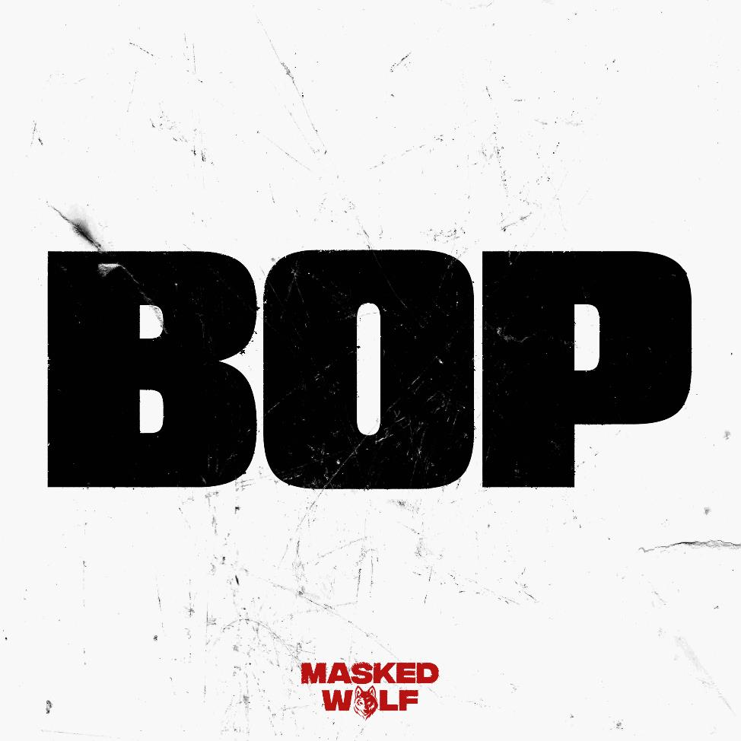

About MASKED WOLF:
Transforming from a mild-mannered man by day into an unrestrained beast in the studio, Masked Wolf (aka, Harry Michael) has unassumingly established himself as a powerful, passionate, and primal hip-hop force. After graduating from school, the Sydney, Australia native tirelessly worked in sales to fund recording. He even took out a loan to build a home studio as he cut hundreds of songs and logged thousands of hours in the lab. In 2018, he dropped his independent debut “Speed Racer.” It gathered millions of streams and turned heads across Australia. Following “Night Rider” and “Water Walkin,” he unveiled “Astronaut In The Ocean.” Awash in airy guitar, jagged 808s, neon keys, and deft wordplay, he submerged himself in honest lyricism, facing depression head-on. Re-released via Elektra Records at the top of 2021, “Astronaut In The Ocean” has become a global phenomenon, amassing over a BILLION streams to date and hitting #1 in 8 countries around the world. Masked Wolf recently released his follow-up single “Say So” and buzz track “Gravity Glidin’” with much more music to come.

Connect with MASKED WOLF

YouTube
Instagram
Twitter
Facebook
MaskedWolf.com

CONTACT:

Glenn Fukushima
Elektra Music Group
GlennFukushima@elektra.com

