FOR IMMEDIATE RELEASE
JULY 9, 2021

MASKED WOLF RETURNS WITH MUCH ANTICIPATED NEW SINGLE “SAY SO”
LISTEN HERE

SONG OF THE SUMMER CONTENDER ARRIVES ON THE HEELS OF
THE AUSTRALIAN RAPPER’S BREAKOUT HIT “ASTRONAUT IN THE OCEAN”

“ASTRONAUT IN THE OCEAN” CROSSES OVER A BILLION STREAMS GLOBALLY, FOLLOWING HIGH PROFILE, NATIONAL TELEVISION PERFORMANCES ON
“THE TONIGHT SHOW STARRING JIMMY FALLON, “THE VOICE,”
AND “THE KELLY CLARKSON SHOW”

“SAY SO” AVAILABLE EVERYWHERE NOW

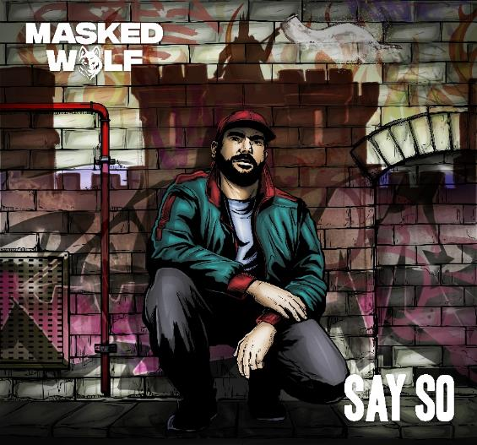

DOWNLOAD PRESS ASSETS HERE

Elektra recording artist Masked Wolf has unveiled his brand new single “Say So,” available today on all DSPs HERE. The buoyant track is an early contender for song of the summer, and marks the Australian rapper’s much anticipated, follow up to his global smash “Astronaut In The Ocean” which has already gone to #1 in 8 countries around the world and amassed over a BILLION streams to date. “Say So” sees Masked Wolf collaborating once again with “Astronaut” producer Tyron Hapi. Watch the companion lyric video for “Say So” HERE.

Masked Wolf explains: “It’s always important for me to say something with my music, even if the deeper message is hidden inside of what sounds like a fun, upbeat song. In ’Say So,’ I was writing about how, in times of trouble, we often try to act like we’re still okay, even when we really aren’t. No matter how bad the situation is or how close we are to self-destructing, we think that, if we keep telling ourselves we’re ok, then maybe we will be. We think ‘if we say so, then we say so..’ but really we need help.”

“Astronaut In The Ocean” has also proven to be a multi-format phenomenon in the U.S., climbing into #1 on the Rhythmic chart while remaining a mainstay in the Top 10 at Top 40 radio. The song has spent 20 weeks and counting on the Billboard Hot 100, peaking at #6 and holding at 12 this week. Meanwhile, the official music video has logged over 180 million views on YouTube alone. Masked Wolf made his world television debut with an epic performance on “The Tonight Show Starring Jimmy Fallon” followed by his first, primetime television appearance on “The Voice” and, most recently, on “The Kelly Clarkson Show.” Last month, Masked Wolf released “Gravity Glidin’,” a track that he explained as “…the response to Astro. Where ‘Astronaut In The Ocean’ is about not being where I should be, this song is about me feeling like I’ve found my place and finally gliding through the environment I was born to be in.”

Look out for much more to come from Masked Wolf in 2021.

About MASKED WOLF:
Transforming from a mild-mannered man by day into an unrestrained beast in the studio, Masked Wolf (aka, Harry Michael) has unassumingly established himself as a powerful, passionate, and primal hip-hop force. After graduating from school, the Sydney, Australia native tirelessly worked in sales to fund recording. He even took out a loan to build a home studio as he cut hundreds of songs and logged thousands of hours in the lab. In 2018, he dropped his independent debut “Speed Racer.” It gathered millions of streams and turned heads across Australia. Following “Night Rider” and “Water Walkin,” he unveiled “Astronaut in the Ocean.” Awash in airy guitar, jagged 808s, neon keys, and deft wordplay, he submerged himself in honest lyricism, facing depression head-on. That one-two-punch of a recognizable riff and chantable chorus organically caught fire online. It quickly incited 350,000-plus Tik Tok videos, spanning everything from footage of U.S. military Blackhawk chopper crews to welders and ice fisherman (far from your typical Tik Tok fare!). Meanwhile, Kansas City Chief Super Bowl champ quarterback Patrick Mahomes even incorporated the tune into an Instagram post, fueling its explosion in early 2021. Amassing streams in the hundreds of millions and counting , the buzzing rapper and singer unleashes a torrent of personal truths and emotions on his 2021 debut for Elektra Records and more to come.

Connect with MASKED WOLF

YouTube
Instagram
Twitter
Facebook
MaskedWolf.com

CONTACT:

Glenn Fukushima
Elektra Music Group
GlennFukushima@elektra.com

