FOR IMMEDIATE RELEASE
JUNE 4, 2021

MASKED WOLF UNVEILS BRAND NEW SONG/VIDEO “GRAVITY GLIDIN’”

FIRST NEW MUSIC FROM THE AUSTRALIAN RAPPER SINCE THE RELEASE OF HIS GLOBAL SMASH “ASTRONAUT IN THE OCEAN”

“ASTRONAUT IN THE OCEAN” CONTINUES TO ASCEND THE U.S. CHARTS FOLLOWING HIGH PROFILE, NATIONAL TELEVISION PERFORMANCES ON
“THE TONIGHT SHOW STARRING JIMMY FALLON” AND “THE VOICE”

“GRAVITY GLIDIN’” AVAILABLE EVERYWHERE NOW
WATCH HERE
LISTEN HERE

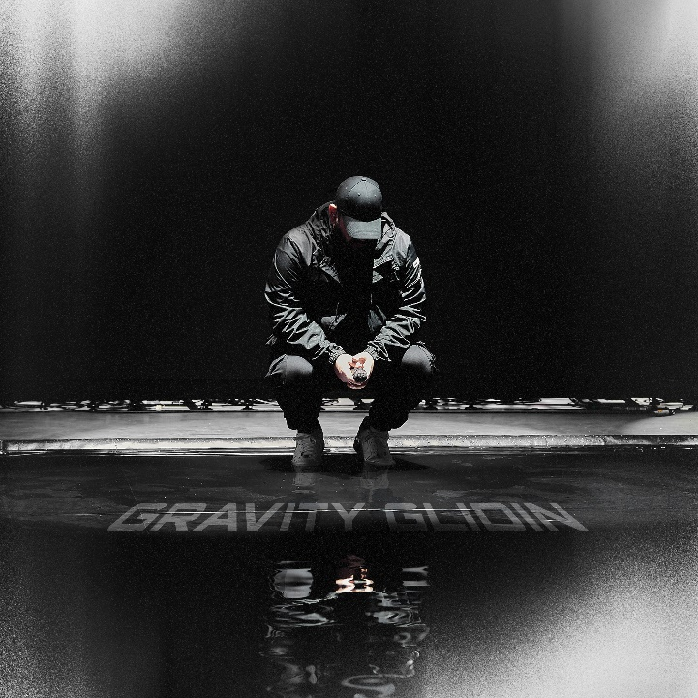

DOWNLOAD PRESS ASSETS HERE

Elektra recording artist Masked Wolf has unveiled a brand new track “Gravity Glidin’,” available today on all DSPs HERE. The infectious track marks the Australian rapper’s first new music since exploding onto the music scene with his global smash “Astronaut In The Ocean” which has already gone to #1 in 8 countries around the world and amassed over 750 million streams to date. “Gravity Glidin’” sees Masked Wolf collaborating once again with “Astronaut” producer Tyron Hapi. Watch the companion music video for “Gravity Glidin’” HERE.

Masked Wolf comments, “‘Gravity Glidin’ is the response to Astro. Where ‘Astronaut In The Ocean’ is about not being where I should be, this song is about me feeling like I’ve found my place and finally gliding through the environment I was born to be in.”

“Astronaut In The Ocean” has also proven to be a multi-format phenomenon in the U.S., climbing into the top 5 on the Rhythmic chart while remaining a mainstay in the Top 10 at Top 40 radio. The song has spent 14 weeks and counting on the Billboard Hot 100, peaking at #6 and holding at #11 this week. Meanwhile, the official music video has logged over 140 million views on YouTube alone. Masked Wolf made his world television debut with an epic performance on “The Tonight Show Starring Jimmy Fallon” followed by his first, primetime television appearance on “The Voice.” Masked Wolf recently enlisted superstars G-Eazy and DDG for a special re-imagining of his global smash. Listen to “Astronaut In The Ocean” (remix) feat. G-Eazy & DDG HERE.

Look out for much more to come from Masked Wolf in 2021.

About MASKED WOLF:
Transforming from a mild-mannered man by day into an unrestrained beast in the studio, Masked Wolf (aka, Harry Michael) has unassumingly established himself as a powerful, passionate, and primal hip-hop force. After graduating from school, the Sydney, Australia native tirelessly worked in sales to fund recording. He even took out a loan to build a home studio as he cut hundreds of songs and logged thousands of hours in the lab. In 2018, he dropped his independent debut “Speed Racer.” It gathered millions of streams and turned heads across Australia. Following “Night Rider” and “Water Walkin,” he unveiled “Astronaut in the Ocean.” Awash in airy guitar, jagged 808s, neon keys, and deft wordplay, he submerged himself in honest lyricism, facing depression head-on. That one-two-punch of a recognizable riff and chantable chorus organically caught fire online. It quickly incited 350,000-plus Tik Tok videos, spanning everything from footage of U.S. military Blackhawk chopper crews to welders and ice fisherman (far from your typical Tik Tok fare!). Meanwhile, Kansas City Chief Super Bowl champ quarterback Patrick Mahomes even incorporated the tune into an Instagram post, fueling its explosion in early 2021. Amassing streams in the hundreds of millions and counting , the buzzing rapper and singer unleashes a torrent of personal truths and emotions on his 2021 debut for Elektra Records and more to come.

Connect with MASKED WOLF

YouTube
Instagram
Twitter
Facebook
MaskedWolf.com

CONTACT:

Glenn Fukushima
Elektra Music Group
GlennFukushima@elektra.com

