MILES TEAMS UP WITH LØLØ ON UPBEAT NEW SINGLE, “THE INTERNET”
LISTEN HERE AND WATCH THE MUSIC VIDEO HERE
MILES IS CURRENTLY IN THE STUDIO WORKING ON MORE NEW MUSIC, SLATED FOR RELEASE THIS SUMMER
PHOTO CREDIT: Mickey Mars
DOWNLOAD HI-RES IMAGE HERE | MILES PRESS ASSETS HERE
(May 13, 2022) – LOS ANGELES, CA – LA-based singer/songwriter and rapper MILES has today unveiled his new single “THE INTERNET,” featuring LA by-way-of Toronto pop-punk artist LØLØ. Punctuated by bouncy guitars, breezy beats, and a melodic flow, the track is a sunny anthem leading into the summer season. Listen HERE. The accompanying music video is also out today and highlights the challenges of dating in the modern era. Of the song’s inspiration, MILES explained with a laugh, “It’s about scrolling online during quarantine, seeing beautiful women, and knowing there’s no chance.” Watch the new visual HERE.
Of the new collaboration, LØLØ added, “I got connected with MILES through my manager and label, and we instantly hit it off in a session. A few weeks later, I saw him tease a song concept on TikTok, and I made a duet to it, without thinking too much into it. He saw it, felt there was something there, and we got back into the studio and actually turned it into a collab.”
MILES creates big, high-energy tracks that people can relate to when navigating life and relationships. Early Rising called “MISS INDEPENDENT,” MILES’ first-released single of 2022, a “brilliant feel-good track that continues his exciting trajectory to becoming a household name,” while MUD Magazine praised his “unique sound” that is setting him up to be “one of [their] favorite artists.” MILES is also currently in the studio working on new original music, slated for release this summer. Stay tuned for more to come.
ABOUT MILES:
MILES’ story might be almost as wild as his fusion of breezy hip-hop, earthshaking pop, and grimy rock. The St. Louis-born and Los Angeles-based singer and rapper bobs and weaves past genre lines with an unpredictable and undeniable style of his own. Predestining their son for music, mom and dad named him in homage to jazz icon Miles Davis. In turn, MILES cranked his old man’s jazz records as well as Kirk Franklin, Bill Withers, Lauryn Hill, Black Eyed Peas, and Lil Wayne. Slowly, but surely MILES developed a following online before cooking up “WHAT IN TARNATION” (2020) back in St. Louis. Beyond inspiring thousands of TikTok videos, it raked in millions of streams as he signed to Elektra Records. He maintained his momentum with the captivating, high-energy follow up singles “DESPERADOS” and “MOSH PIT.” His new releases with Elektra kickstart a new era for this exciting artist to watch.
ABOUT LØLØ:
Born and raised in Toronto and now calling LA home, LØLØ has become an undeniable presence in the pop-punk genre. The singer-songwriter has created a striking presence both online and on stage with her effortlessly cool attitude and sharp lyricism. In 2020, LØLØ created a buzz on TikTok where she reimagined music’s biggest hits. Putting her adept lyrical skills to use, she rewrote verses from the opposite perspective of the song's subject, while still maintaining the original integrity of each song’s tempo and rhyme scheme. Most notably, her take on Taylor Swift’s “Betty” from “Betty’s perspective" caught the attention of Swifties and went viral on the platform. In late 2021, LØLØ released her electric EP “overkill,” which came directly on the heels of her 36-stop US tour with pop-punk titans New Found Glory and Less Than Jake. LØLØ has been compared to Paramore and Avril Lavigne by Billboard, as well as receiving critical acclaim from Paper Magazine, MTV, Kerrang!, American Songwriter, Ones to Watch, Alternative Press, and many more. People Magazine called her an “Emerging Artist making their mark in music” and to date she's amassed over 35 million streams on Spotify with her numbers continuing to climb exponentially. LØLØ is on the brink of superstardom, so stay tuned as there’s much more to come.
MILES FEAT. LØLØ:
“THE INTERNET”
AVAILABLE HERE
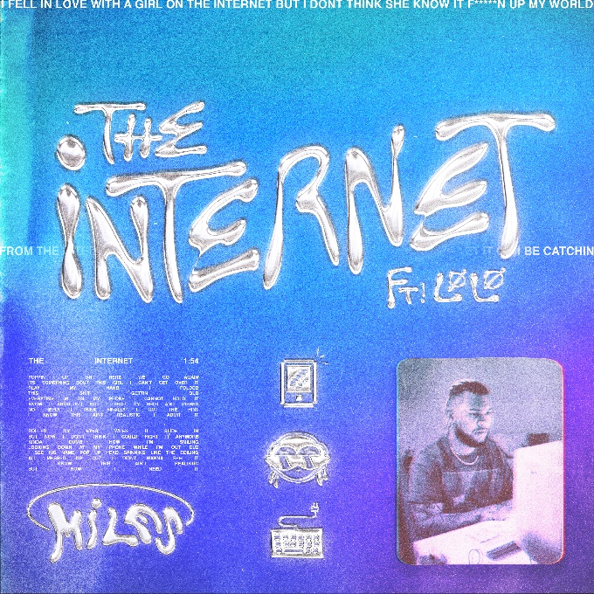
DOWNLOAD HI-RES ARTWORK HERE
FOLLOW MILES:
Instagram
Twitter
YouTube
TikTok
FOLLOW LØLØ:
Website
Instagram
Twitter
YouTube
TikTok
# # #
PRESS CONTACT FOR MILES:
Nathalie Rubin
NathalieRubin@elektra.com
PRESS CONTACTS FOR LØLØ:
Nancy Lu & Sean Kayden, Fancy PR
nancyl@fancypr.com | skayden@fancypr.com

